

DOCTORAL RESEARCH PLAN

AI-Driven Big Data Governance for Multi-Modal Healthcare Data

— Building a trusted, governable, and assetable big data governance base for hospital multi-source heterogeneous data

Applicant: Yan Chengzhi (鄢承志)
Degree: Doctor of Philosophy (PhD)
Education: University of Bristol — Integrated BSc & MSc, Computer Science and Technology
Graduation: July 2027
Research Direction: AI Big Data Governance

September 2026

Table of Contents

Table of Contents I
Abstract 3
1. Research Background and Significance 3
1.1 Big Data Governance in the Data-Element Era 3
1.2 Real-World Challenges of Healthcare Big Data Governance 4
1.3 Research Significance 5
2. Related Work and Analysis 5
2.1 Big Data Governance Theories and Frameworks 5
2.2 Healthcare Data Standardization and Interoperability 5
2.3 AI-Driven Data Governance 6
2.4 Data Security and Privacy Computing 6
2.5 Research Gaps and Our Entry Point 7
3. Scientific Questions and Research Objectives 7
3.1 Scientific Questions 7
3.2 Overall Objectives 7
3.3 Specific Objectives 8
4. Research Contents and Technical Route 8
4.1 Study 1: Standardization and Unified Governance Base for Multi-source Heterogeneous Healthcare Data 8
4.2 Study 2: AI-Driven Data Quality Assessment and Intelligent Governance 9
4.3 Study 3: Privacy Protection and Secure Sharing Mechanisms 10
4.4 Study 4: Data Assetization and Real-World Data Support 10
4.5 Overall Technical Route 11
5. Key Technologies and Innovations 12
5.1 Key Technologies 12
5.2 Innovations 12
6. Research Foundation and Feasibility Analysis 12
6.1 Academic and Technical Foundation 12
6.2 Data and Computing Resources 13
6.3 Team and Industry Collaboration Foundation 13
7. Research Schedule 14
7.1 Year 1: Foundation and Data Platform Construction 14
7.2 Year 2: Intelligent Governance and Security Mechanisms 14
7.3 Year 3: Deepening and Outcome Synthesis 15
8. Expected Outcomes 15
9. References 15

Abstract
This plan focuses on the frontier direction of AI big data governance, targeting the typical and complex application scenario of multi-modal healthcare data. It builds upon a four-in-one systematic research framework covering "data standardization and governance base - AI-driven intelligent governance - privacy protection and secure sharing - data assetization". The applicant studied Computer Science and Technology at the University of Bristol in an integrated Bachelor’s and Master’s program, acquiring systematic training in computer science, artificial intelligence, data mining, and distributed systems, together with solid capability in algorithm design, engineering development, and data modeling. During an internship at Radtech Imaging Technology (Shenzhen) Co., Ltd., the applicant was deeply involved in the strategic planning of a hospital-wide AI data governance base, accumulating practical experience in applying big data governance technologies to real business scenarios. Building on this background, this plan proposes four interrelated research studies: (1) constructing a standardization and unified governance base for multi-source heterogeneous healthcare data, breaking down data silos among HIS, EMR, LIS, RIS, PACS, medical records, insurance, and follow-up systems; (2) developing AI-driven data quality assessment and intelligent governance methods, covering multi-dimensional quality scoring, anomaly detection, semantic alignment, and knowledge graph construction; (3) investigating privacy protection and secure sharing mechanisms, covering de-identification, federated learning, differential privacy, and access auditing; and (4) exploring key technologies for data assetization and real-world data support, serving medical quality regulation, insurance intelligent auditing, and research data platform construction. The research is expected to advance through a closed-loop path of "method research - system construction - multi-center validation", yielding results with both academic value and application prospects.
The plan comprises approximately seven thousand words across nine chapters, covering research background, related work, scientific questions, research contents and technical route, key technologies and innovations, research foundation, schedule, and expected outcomes, accompanied by visual diagrams of the overall architecture, governance technical framework, data governance base, and progress planning.

1. Research Background and Significance

1.1 Big Data Governance in the Data-Element Era
With the advancement of digital transformation, data has become a key factor of production alongside land, labor, capital, and technology. Industries have accumulated vast, diverse, and structurally heterogeneous data resources during informatization, yet they commonly face the issue of "prioritizing construction over governance": data are scattered across different business systems as silos, lacking unified format and semantic standards; quality varies significantly; security and compliance are hard to guarantee; and the value of data cannot be fully released. Big data governance aims to transform raw data into high-quality, trusted, reusable, and operable data assets through a comprehensive system encompassing organization, standards, processes, and technologies. It is a key prerequisite for releasing the value of data elements and supporting business intelligence and data-driven decision-making. The Data Management Body of Knowledge defines data governance as the overall process of exercising authority and control over data assets, covering multiple knowledge areas including data architecture, data quality, data security, data standards, metadata, and data lineage^{[1]}.
This proposition is particularly salient in the healthcare domain. Healthcare data are characterized by multiplicity, heterogeneity, high sensitivity, and strong regulation: hospital information systems are numerous with inconsistent formats and terminology; unstructured data such as free-text reports and imaging metadata account for a high proportion and cannot be directly leveraged by algorithms and business systems; clinical data involve personal health privacy and impose stringent security and compliance requirements; meanwhile, healthcare data also carry substantial research and operational value. How to release the value of healthcare data elements through systematic and intelligent big data governance methods has become a major issue of common concern for academia and industry.

1.2 Real-World Challenges of Healthcare Big Data Governance
The implementation of healthcare big data governance faces multiple practical challenges, which can be summarized into the following four aspects.
First, data silos and heterogeneous system barriers. Hospitals run numerous heterogeneous systems such as HIS, EMR, LIS, RIS, PACS, medical records, insurance, and follow-up systems. Imaging data, text reports, laboratory results, and medical record front pages belong to different systems with varying field definitions, coding specifications, and time granularities, lacking a unified master index and time-axis alignment mechanism, making trusted cross-system integration difficult.
Second, uneven data quality and high governance cost. The completeness, accuracy, consistency, and timeliness of real clinical data fluctuate significantly, with missing, redundant, conflicting, and noisy data. Traditional rule-based and manual cleaning methods are costly and poorly scalable, making it difficult to cope with massive, dynamically evolving data environments.
Third, prominent pressure on security, compliance, and privacy protection. Healthcare data are highly sensitive, involving personal information and clinical privacy, and must satisfy strict compliance requirements during sharing and circulation. Balancing data usability with data security is an obstacle that must be overcome for data sharing and assetization.
Fourth, unclear paths for data value transformation. After governance, how to further assetize data and serve research and regulation, forming a sustainable value loop, still lacks mature methodologies and technical support.

1.3 Research Significance
This research takes AI big data governance as its core direction and multi-modal healthcare data as a typical application scenario. Its scientific significance lies in systematically studying the key theories and methods of unified governance of multi-source heterogeneous data, intelligent data quality assessment, privacy-preserving secure sharing, and data assetization, thereby providing a new technical framework for intelligent data governance. Its application significance lies in building a hospital-wide AI big data governance base that effectively improves data quality and consistency, supports insurance cost control and quality regulation, serves research data asset construction, and helps release the value of healthcare data elements. Its industrial significance lies in responding to the trends of data-element marketization and healthcare data infrastructure construction, with the potential to form reproducible and promotable data governance technical solutions for hospitals, health administration, and insurance scenarios.

2. Related Work and Analysis

2.1 Big Data Governance Theories and Frameworks
The theoretical system of data governance has matured. The Data Management Body of Knowledge proposes a comprehensive framework covering knowledge areas such as data architecture, data modeling, data storage and operations, data security, data quality, master data management, metadata management, and data lineage, providing methodological guidance for conducting data governance in an organized and systematic manner^{[1]}. In the area of data quality, researchers have proposed systematic methodologies for data quality assessment and improvement, characterizing and measuring data quality from dimensions such as accuracy, completeness, consistency, and timeliness^{[2]}. Data lineage and metadata management, as key technologies supporting data traceability and auditability, have also attracted wide attention. However, existing frameworks tend to focus on the process and specification level; how to embed artificial intelligence into all stages of data governance to achieve intelligent and automated governance remains a direction that warrants in-depth research.

2.2 Healthcare Data Standardization and Interoperability
Interoperability of healthcare data is the cornerstone of data governance. At the standards level, the DICOM standard defines the storage and transmission specification for medical imaging, the HL7 family of standards supports the exchange and interoperability of healthcare information, and SMART on FHIR further provides a standards-based, interoperable, and extensible app platform paradigm that enables third-party applications to access electronic health records in a standardized way^{[3]}. Domestic healthcare informatization has also formed a set of industry standards such as medical record front pages and medical insurance settlement. Nevertheless, coding specifications, terminology systems, and data models across multiple systems remain difficult to unify in real environments. Systematic solutions for structuring and semantically standardizing unstructured data such as free text and imaging metadata are still lacking, and cross-institution, cross-region data interoperability and multi-center consistency governance remain challenging in both research and practice.

2.3 AI-Driven Data Governance
Artificial intelligence provides new technical means for data governance. In intelligent cleaning and quality improvement, deep learning and statistical methods are used for anomaly detection, missing value imputation, and duplicate record identification. At the semantic level, pre-trained language models possess strong semantic understanding capabilities^{[4]} and can be used for automatic terminology standardization, entity alignment, and text structuring. In knowledge organization, knowledge graphs support efficient data association and semantic query through modeling entities and their relationships, and relational machine learning methods provide the theoretical foundation for knowledge graph construction and completion^{[5]}. Meanwhile, agent-based paradigms built upon large language models can combine reasoning with tool invocation to plan and execute multi-step governance tasks^{[6]}, offering new ideas for automated orchestration of governance processes. However, AI-driven governance methods still suffer from deficiencies in accuracy, controllability, and auditability, and building trustworthy intelligent governance mechanisms is a key research problem.

2.4 Data Security and Privacy Computing
Data security and privacy protection are indispensable components of data governance. Differential privacy provides quantifiable privacy protection for individual information by injecting controlled noise into queries and training processes, and has been extended to deep learning frameworks^{[7-8]}. Federated learning enables multiple parties to collaboratively train models without sharing raw data, effectively alleviating the joint modeling problem under the constraint that data do not leave their domain^{[9]}. In addition, technologies such as data de-identification, encrypted computing, and access auditing play important roles in the circulation and sharing of sensitive data. Nevertheless, existing privacy computing technologies still face challenges in practical data governance scenarios, including the trade-off between utility and privacy, and the cost and trustworthiness of cross-party collaboration.

2.5 Research Gaps and Our Entry Point
Overall, existing research has the following deficiencies. First, data governance frameworks and intelligent technologies are separated from each other, lacking a unified methodology that deeply embeds AI into the entire governance process. Second, systematic standardization and interoperability solutions for hospital-wide multi-source heterogeneous healthcare data are lacking. Third, data quality assessment mostly relies on static rules and cannot adapt to dynamically evolving data and long-tail distributions. Fourth, the collaboration mechanisms among privacy protection, data sharing, and data assetization are not yet mature. The entry point of this research is to take AI big data governance as the core, use multi-modal healthcare data as the application scenario, and connect the four stages of "data standardization - intelligent governance - privacy security - data assetization" to build a unified, closed-loop, and verifiable intelligent data governance research framework.

3. Scientific Questions and Research Objectives

3.1 Scientific Questions
Around the research theme, this plan formulates the following three interrelated scientific questions:
- How can unified data standardization and interoperability methods be constructed over heterogeneous, unstructured, multi-source, and multi-modal healthcare data to achieve trusted cross-system data integration with controllable quality?
- How can artificial intelligence be deeply embedded into the entire data governance process to achieve intelligent and automated multi-dimensional quality assessment, anomaly detection, semantic alignment, and knowledge graph construction?
- How can trusted data sharing and assetization be achieved under the premise of ensuring data security and privacy, balancing data usability and compliance?

3.2 Overall Objectives
The overall objective of this research is to construct a key technical system for AI big data governance for multi-modal healthcare data. Specifically, with the healthcare data governance base as the foundation, an overall technical architecture of "one base, two platforms, three governance engines, and four scenarios" will be built - namely, taking the hospital-wide AI big data governance base as the foundation, relying on the two pillars of the medical data governance platform and the AI intelligent governance platform, targeting the four scenarios of in-hospital quality control, insurance cost control, research data assetization, and regional medical cloud, and forming three governance capabilities of the data quality and semantic engine, the knowledge graph and alignment engine, and the privacy computing and security engine, thereby advancing healthcare data from "scattered silos" to "trusted data assets".

3.3 Specific Objectives
- Build a standardization and unified governance base for multi-source heterogeneous healthcare data, breaking down barriers among HIS, EMR, LIS, RIS, PACS, medical records, insurance, and follow-up systems, and realizing governance capabilities including data cleaning, standardization, de-identification, tagging, semantic vectorization, master index, time-axis alignment, quality scoring, lineage tracking, and access auditing.
- Develop AI-driven data quality assessment and intelligent governance methods, achieving intelligent and automated multi-dimensional quality scoring, anomaly detection, missing and inconsistency identification, semantic alignment, and medical knowledge graph construction.
- Construct privacy protection and secure sharing mechanisms, achieving effective synergy among data de-identification, federated learning, differential privacy, and access auditing, and supporting trusted sharing and joint modeling under the constraint that data do not leave their domain.
- Explore key technologies for data assetization and real-world data support, forming a methodology for data asset inventory, multi-center data standardization integration, and real-world data governance.

4. Research Contents and Technical Route

4.1 Study 1: Standardization and Unified Governance Base for Multi-source Heterogeneous Healthcare Data
This study aims to address scientific question 1 and provides a high-quality, governable data foundation for AI big data governance. Following the basic principles of "do not replace core systems, prefer read-only access, start with edge governance, human confirmation for key operations, and full-process audit trail", the research studies methods for data access, cleaning, standardization, de-identification, tagging, semantic vectorization, master index matching, multi-system time-axis alignment, data quality scoring, data lineage tracking, and access auditing across heterogeneous systems including HIS, EMR, LIS, RIS, PACS, medical records, insurance, and follow-up systems.
Specifically, in the direction of imaging data governance, the research studies DICOM metadata cleaning and structuring, sequence standardization, and quality assessment. In text data governance, it studies the structuring of radiology reports and medical records, diagnostic terminology standardization, and medical terminology normalization. In insurance and medical record data governance, it studies ICD coding quality control, DRG/DIP grouping standardization, and identification of data related to rejection risks. In research data governance, it studies case enrollment screening, automatic variable extraction, baseline table generation, and multi-center data standardization integration. Through these studies, a multi-modal data governance base covering the full chain of "access - governance - application" is formed, whose layered architecture is shown in Figure 1.
Figure 1 Layered architecture of the hospital-wide AI big data governance base (redrawn from Radtech Imaging Technology strategic planning materials)
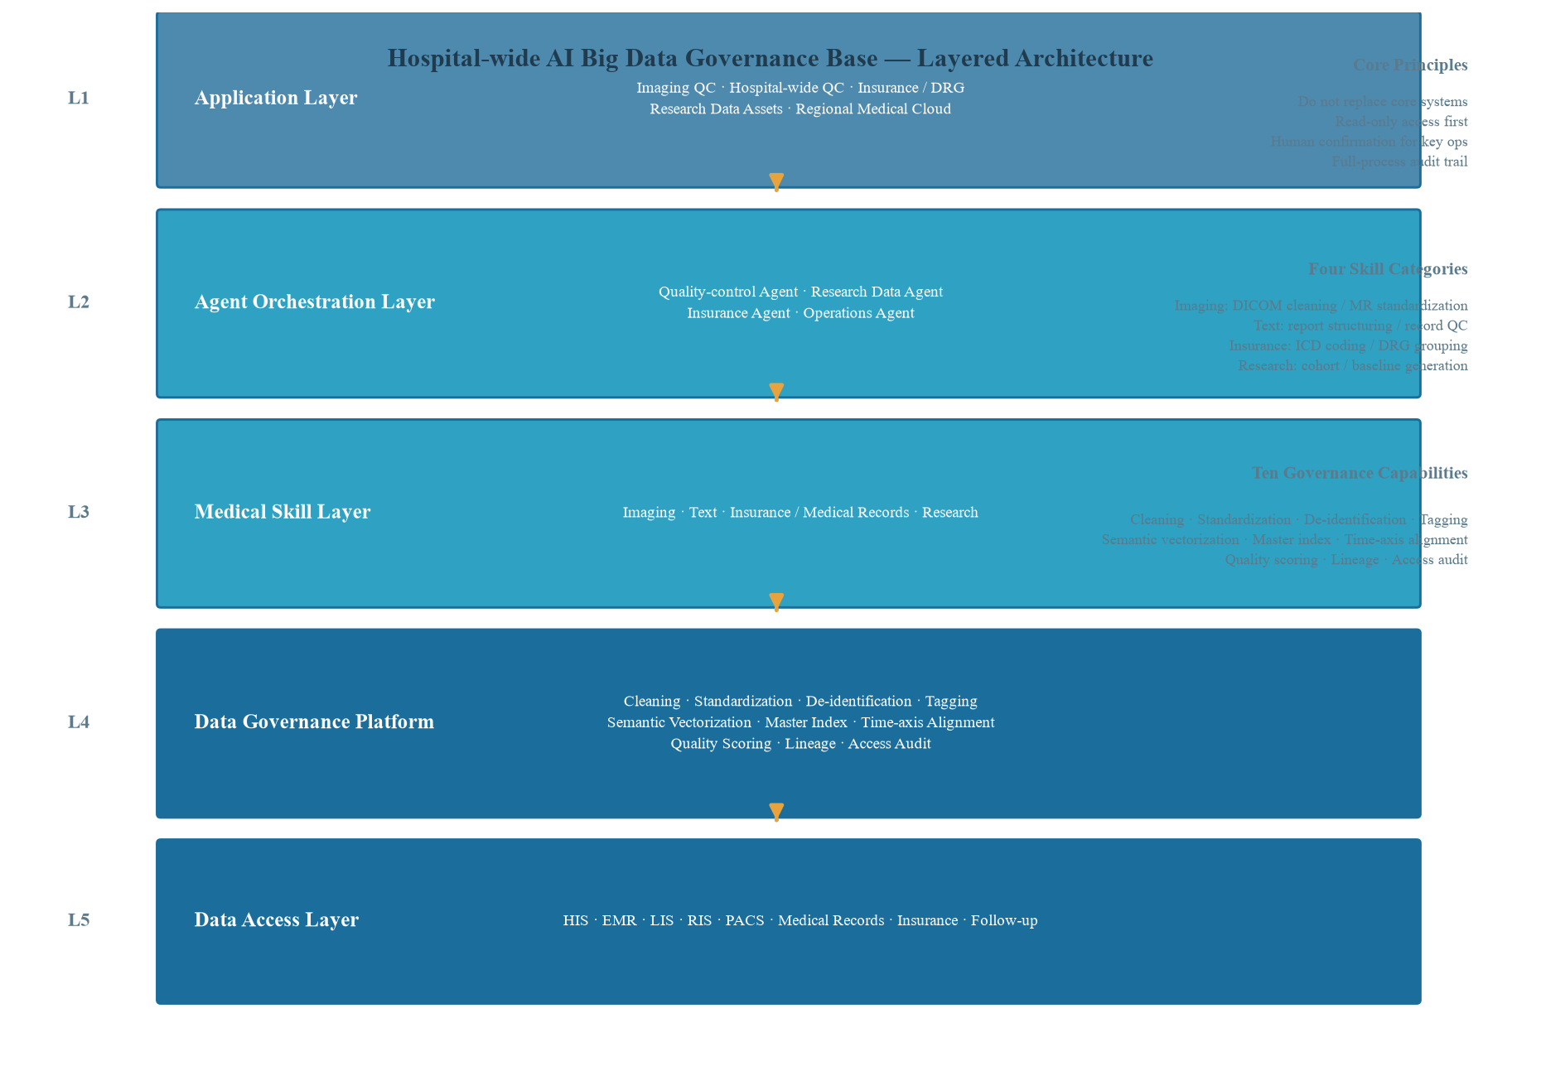

4.2 Study 2: AI-Driven Data Quality Assessment and Intelligent Governance
This study aims to address scientific question 2 and investigates methods for deeply embedding artificial intelligence into the entire data governance process. In data quality assessment, a multi-dimensional data quality indicator system is constructed, integrating rule validation and machine learning to achieve dynamic scoring and anomaly detection across quality dimensions such as accuracy, completeness, consistency, and timeliness, and to study intelligent repair methods for missing, redundant, conflicting, and noisy data. In semantic governance, the research studies terminology standardization and entity alignment methods based on pre-trained language models to achieve semantic unification across systems and institutions, and studies the construction and completion methods of medical knowledge graphs to support efficient data association, semantic query, and governance decision-making^{[4-5]}. In governance automation, the research studies an agent-based paradigm with a reasoning-and-acting synergy mechanism to integrate data quality assessment, anomaly handling, and governance process orchestration into an auditable and traceable automated workflow^{[6]}. The core technical framework of AI-driven big data governance is shown in Figure 2.
Figure 2 Core technical framework of AI-driven big data governance
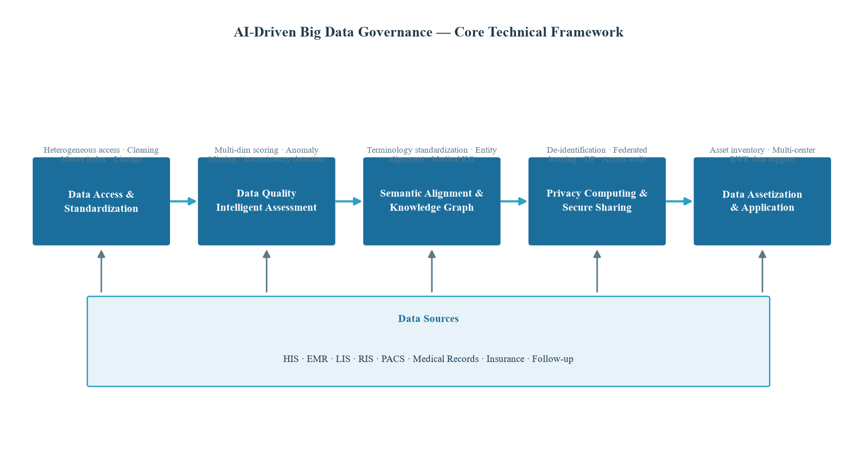

4.3 Study 3: Privacy Protection and Secure Sharing Mechanisms
This study aims to address scientific question 3 and investigates trustworthy sharing methods under data security and privacy protection. In data de-identification, the research studies tiered de-identification strategies and sensitive information identification techniques for healthcare data. In privacy computing, it studies the utility-privacy trade-off mechanisms of differential privacy in data publication and modeling^{[7-8]}, and investigates joint modeling and governance methods under federated learning frameworks where multiple centers do not share raw data^{[9]}. In secure governance, it studies full-process security mechanisms based on data lineage and access auditing, achieving trusted governance in which every operation is audited and key operations require human confirmation. The research adheres to the security principle that data do not leave their domain, exploring how privacy protection technologies can guarantee both data usability and compliance.

4.4 Study 4: Data Assetization and Real-World Data Support
This study explores methods and technologies for transforming governed data into data assets and real-world research value. Based on the governance base, the research constructs a data asset platform to achieve data asset inventory, cataloging, quality rating, and value assessment, forming an operable data asset catalog. It studies multi-center data standardization integration and consistency governance methods to support real-world research, insurance intelligent auditing, and regional medical quality regulation. Facing users such as research offices, key specialties, principal investigator teams, and pharmaceutical companies/CROs, the research studies key methods including case enrollment screening, multi-modal variable extraction, and baseline table generation, and further studies data lineage and quality traceability mechanisms to provide technical support for high-quality data asset operations.

4.5 Overall Technical Route
This research adopts the overall architecture of "one base, two platforms, three governance engines, and four scenarios". The four scenarios cover in-hospital quality control, insurance cost control, research data assetization, and regional medical cloud. The three governance engines include the data quality and semantic engine, the knowledge graph and alignment engine, and the privacy computing and security engine. The two platforms are the medical data governance platform and the AI intelligent governance platform, and the one base is the hospital-wide AI big data governance base. Following the route of "taking the data governance base as the entry point, building intelligent governance capabilities, and finally entering insurance cloud, health administration cloud, and regional data asset operations", the overall technical architecture is shown in Figure 3.
Figure 3 Overall technical architecture of AI big data governance for multi-modal healthcare data
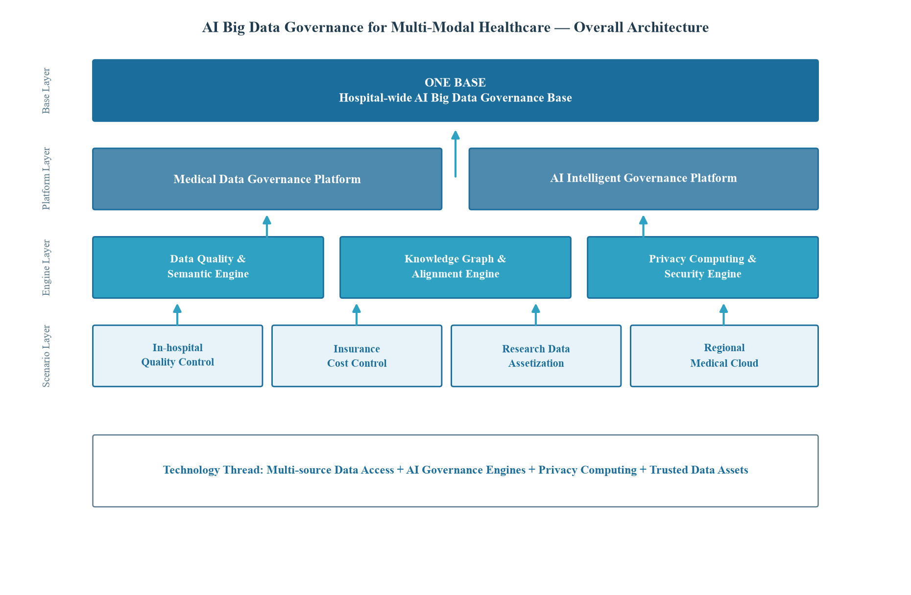
The relationships among the four studies are as follows: Study 1 provides the underlying data infrastructure, Study 2 provides the core intelligent governance capability, Study 3 ensures security, compliance, and trusted sharing, and Study 4 achieves value realization and assetization. The four studies advance layer by layer and support each other, jointly forming a complete, closed-loop, and verifiable research system.

5. Key Technologies and Innovations

5.1 Key Technologies
- Unified governance technology for multi-source heterogeneous healthcare data: research on data access, cleaning, standardization, de-identification, tagging, and master index matching across heterogeneous systems such as HIS, EMR, LIS, RIS, and PACS, achieving multi-system time-axis alignment and data lineage tracking.
- Intelligent data quality assessment and repair technology: constructing a multi-dimensional data quality indicator system that integrates rule validation and machine learning to achieve dynamic quality scoring, anomaly detection, and intelligent repair.
- Semantic alignment and knowledge graph construction technology: achieving terminology standardization and entity alignment based on pre-trained language models, constructing medical knowledge graphs, and supporting semantic query and governance decision-making.
- Privacy protection and secure sharing technology: researching effective synergy among data de-identification, federated learning, differential privacy, and access auditing to support trusted sharing and joint modeling without data leaving their domain.
- Data assetization and multi-center governance technology: researching methods for data asset inventory, cataloging, quality rating, and multi-center data standardization integration to achieve data assetization and real-world data support.

5.2 Innovations
- Framework innovation: proposing a four-in-one unified research framework of "data standardization - AI intelligent governance - privacy security - data assetization", overcoming the separation between governance frameworks and intelligent technologies, and building a trusted AI big data governance closed-loop system for multi-modal healthcare data.
- Method innovation: for dynamically evolving data and long-tail distributions, proposing an intelligent governance method integrating multi-dimensional quality scoring, anomaly detection, semantic alignment, and knowledge graph construction, balancing governance accuracy and automation.
- System innovation: constructing a governance automation workflow based on an agent-based paradigm and reasoning-acting synergy mechanism, achieving secure automation of governance processes through auditable skill encapsulation and process orchestration.
- Application innovation: for regional medical cloud and real-world research scenarios, exploring technical paths for data assetization and multi-center standardization under privacy protection, serving medical quality regulation, insurance intelligent auditing, and research data platform construction.

6. Research Foundation and Feasibility Analysis

6.1 Academic and Technical Foundation
The applicant studied Computer Science and Technology at the University of Bristol in an integrated Bachelor’s and Master’s program, expected to graduate in July 2027. The computer science discipline at the University of Bristol enjoys a deep academic tradition and strong research strength, with a curriculum covering data structures and algorithms, machine learning, deep learning, data mining, distributed systems, database systems, and software engineering. Through systematic coursework and project practice, the applicant has acquired solid capabilities in algorithm design, program development, data modeling, and system implementation, and has mastered mainstream big data processing frameworks, machine learning and deep learning toolchains, and engineering development methods for large-scale data systems, laying a solid foundation in computer science and data science for doctoral research in AI big data governance.
In terms of project and industrial experience, during the internship at Radtech Imaging Technology (Shenzhen) Co., Ltd., the applicant was deeply involved in the strategic planning of a hospital-wide AI data governance base and related technical research. Radtech Imaging Technology focuses on radiology intelligent quality control and medical data governance, and has planned a hospital-wide data governance base architecture of "one base, two platforms, three agents, and four scenarios", covering governance capabilities including data access, cleaning, standardization, de-identification, tagging, semantic vectorization, master index matching, and lineage tracking, and has accumulated technical expertise in governance of imaging, text, insurance/medical record, and research data. This experience enabled the applicant to form a systematic and in-depth understanding of the composition of multi-source heterogeneous healthcare data, the pain points of governance, and the technical system of the data governance base, and also provided real application scenarios and engineering validation channels for doctoral research.

6.2 Data and Computing Resources
In terms of data resources, the research can rely on public healthcare data standards and evaluation datasets for method validation, and can conduct multi-center validation using local medical imaging cloud data, adhering to the security principle that data do not leave their domain, thereby ensuring the availability, compliance, and diversity of data. In terms of computing resources, the research intends to rely on the university’s high-performance computing cluster and GPU servers for large-scale data governance experiments and model training and tuning, and to leverage the industrial partner’s private deployment environment for system-level validation, ensuring the computing requirements of data governance and modeling.

6.3 Team and Industry Collaboration Foundation
The applicant intends to build a research team based on the computer science and data management research directions of the university, covering multi-disciplinary backgrounds including big data, artificial intelligence, databases, and information security. Meanwhile, Radtech Imaging Technology has formed a clear strategic layout and product planning in medical data governance and medical cloud, which can provide real business scenarios, engineering platforms, and industrialization validation channels for the research, forming an industry-academia-research closed loop of "university basic research - enterprise engineering transformation - industry scenario validation", which structurally guarantees the high feasibility of the research.

7. Research Schedule
The three-year research schedule is shown in Figure 4, which generally follows the rhythm of "building foundations - tackling core problems - deepening and expansion - outcome synthesis", while also accommodating the requirements of coursework, mid-term assessment, and thesis training.
Figure 4 Three-year research schedule
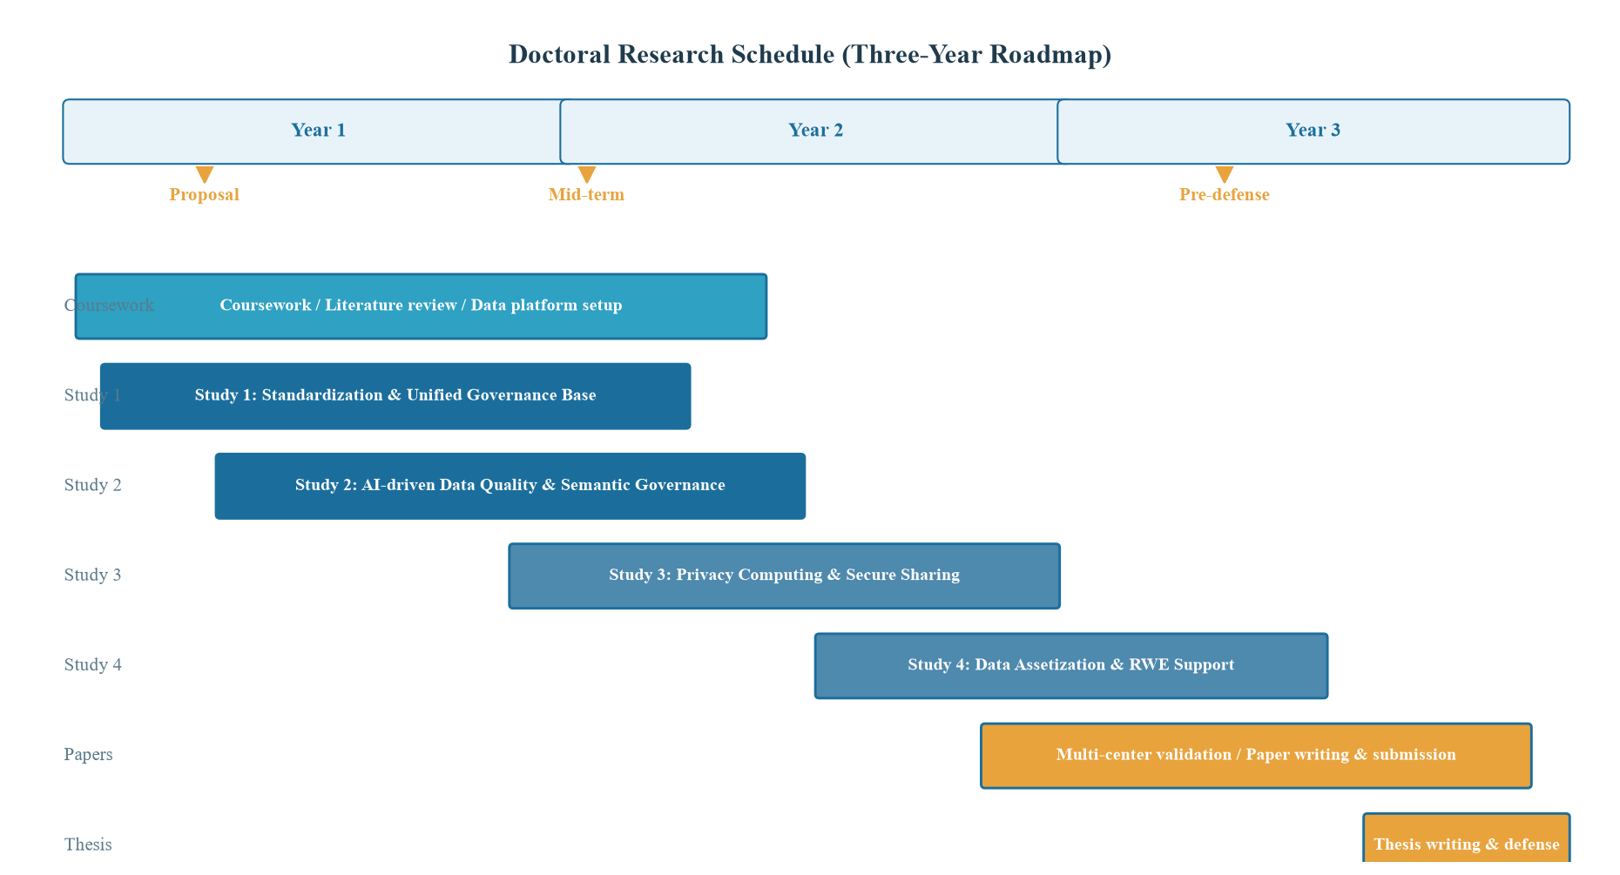

7.1 Year 1: Foundation and Data Platform Construction
Complete doctoral coursework and literature review, systematically sort out the research landscape of AI big data governance, data quality, semantic alignment, and privacy computing; build a prototype of the standardization and unified governance base for multi-source heterogeneous healthcare data, completing basic modules such as data access, cleaning, standardization, and master index matching; complete the research proposal, formulate scientific questions, and determine the technical route.

7.2 Year 2: Intelligent Governance and Security Mechanisms
Complete research on AI-driven data quality assessment and intelligent governance methods, realizing the integration and optimization of multi-dimensional quality scoring, anomaly detection, semantic alignment, and knowledge graph construction, and conducting systematic evaluation on real datasets; carry out research on privacy protection and secure sharing mechanisms, achieving effective synergy among data de-identification, federated learning, differential privacy, and access auditing; advance the mid-term assessment and mid-term research summary.

7.3 Year 3: Deepening and Outcome Synthesis
Complete research on data assetization and real-world data support, deepening multi-center data standardization integration and quality traceability technologies; conduct multi-center validation using relevant local healthcare data; complete the writing and submission of high-level academic papers, integrate the research contents to complete the draft of the doctoral thesis, and pass the pre-defense; finally complete the final version of the thesis and the defense.
Phase | Time | Key Tasks | Milestone
Foundations | Year 1 | Coursework, literature review, data platform | Research proposal
Core Problems | Year 2 | Intelligent governance, privacy security | Mid-term assessment
Expansion | Year 3 | Data assetization, multi-center validation | Journal papers
Synthesis | End of Year 3 | Thesis writing, pre-defense, defense | Defense passed

8. Expected Outcomes
- Academic papers: publish several high-level academic papers in authoritative international journals and conferences in data management, artificial intelligence, and medical informatics, covering topics such as data governance, data quality, semantic alignment, privacy computing, and data assetization.
- Methodology: form a key technical system for AI big data governance for multi-modal healthcare data, including methods for data standardization, intelligent governance, privacy security, and data assetization.
- System prototype: construct a demonstrable, pilotable, and verifiable hospital-wide AI big data governance base system prototype covering typical scenarios of quality control, insurance, research, and operations.
- Data assets: relying on authoritative public datasets and multi-center local data, construct standardized, reusable, and traceable data assets and research datasets.
- Doctoral thesis: complete a high-quality doctoral thesis systematically elaborating the research results and scientific contributions.

9. References
[1] DAMA International. DAMA-DMBOK: Data Management Body of Knowledge (2nd Edition)[M]. Technics Publications, 2017.
[2] Batini C, Cappiello C, Francalanci C, et al. Methodologies for Data Quality Assessment and Improvement[J]. ACM Computing Surveys, 2009, 41(3): 1-52.
[3] Mandl K D, Mandel J C, Kohane I S. Driving Innovation in Health Systems through an Apps-Based Information Economy[J]. Cell Systems, 2015, 1(1): 8-13.
[4] Devlin J, Chang M W, Lee K, et al. BERT: Pre-training of Deep Bidirectional Transformers for Language Understanding[C]. Conference of the North American Chapter of the Association for Computational Linguistics, 2019: 4171-4186.
[5] Nickel M, Murphy K, Tresp V, et al. A Review of Relational Machine Learning for Knowledge Graphs[J]. Proceedings of the IEEE, 2016, 104(1): 11-33.
[6] Yao S, Zhao J, Yu D, et al. ReAct: Synergizing Reasoning and Acting in Language Models[C]. International Conference on Learning Representations, 2023.
[7] Dwork C. Differential Privacy[C]. International Colloquium on Automata, Languages, and Programming, 2006: 1-12.
[8] Abadi M, Chu A, Goodfellow I, et al. Deep Learning with Differential Privacy[C]. ACM SIGSAC Conference on Computer and Communications Security, 2016: 308-318.
[9] McMahan B, Moore E, Ramage D, et al. Communication-Efficient Learning of Deep Networks from Decentralized Data[C]. International Conference on Artificial Intelligence and Statistics, 2017: 1273-1282.

