Software Development 2

*Assessment 2 Project: Application Description*

Jackson Hayes

NMIT ID - 13521772

SDV602

S2 2023

Table of Contents

Application Description 2

Storyboard: 4

Storyboard Descriptions: 5

Screen 1: Login 5

Screen 2: Home page 6

Screens 3, 4 and 5: Data Explorer Screens 7

Navigation bar: 7

Chart summary: 8

Chatbox: 8

Chart settings: 8

Set/Upload data buttons: 9

Chart Zoom/Pan: 9

Chart/Graph display: 9

Screen 4: DES 2 10

Screen 5: DES 3 11

# Application Description

The purpose of this application is to provide users with a way of easily viewing and interpreting data in a chart/graph like form and to discuss the data with other users through the built-in chat box.

The application will be using a dataset from the New Zealand data.govt.nz website on the past and present monetary fish stock accounts dating from 1996 - 2018. There are 3 main sections within this dataset, annual monetary values of fish species, amount caught in Tonnes and the TACC per fish species (Total Allowable Commercial Catch) also in Tonnes. The motivation for this application and its dataset could be seen as both business and scientific with fisheries being an important sector within New Zealand, meaning both a business and scientific analyst could find the application insightful or interesting.

The application will initially land the user on a simple login page which will allow for multiple users to be active on the application at once. This gives the users a way of collaborating with each other and a place to discuss the data being displayed. Once logged in to an account, the user will be redirected to a home screen where they will have the option to display 3 different screens, each screen being a different comparison within the dataset but containing the same core functionality and interactive components.

Each DES will contain the following:

* **Data view** – This will be the main section of the screen and the purpose for this application. The view will visually display selected data from the dataset and may compare 2 or more areas within the dataset and present them in this area.
* **Summary** – A basic summary for each field of data that is being displayed, for example, Min/Max values, Mean, etc.
* **Chat box** – This will be a section for users to leave a comment or to discuss the current DES with other active users as a form of collaboration between analysts.
* **Home button** – A button for the user to return to the home screen.
* **Next/Previous button** – Each DES screen will have a button, or buttons to allow the user to open and view another DES screen.
* **Pan button** – A button for the user to pan the current graph or chart across the data view section either left or right. This allows the user to analyze different areas within the view.
* **Zoom +/- button** – A button to allow the user to zoom in or out of the data view section. This can allow the user to get a more precise look at the data.
* **Data upload** **button** – A section or button for the user to input a dataset of their own.
* **Set data button –** A button for the user to set what data is currently being displayed. This could show the user a list of existing datasets or graphs to choose from.
* **Chart settings button** – Chart settings that the user can interact with and change how the data is being displayed.

# Storyboard:

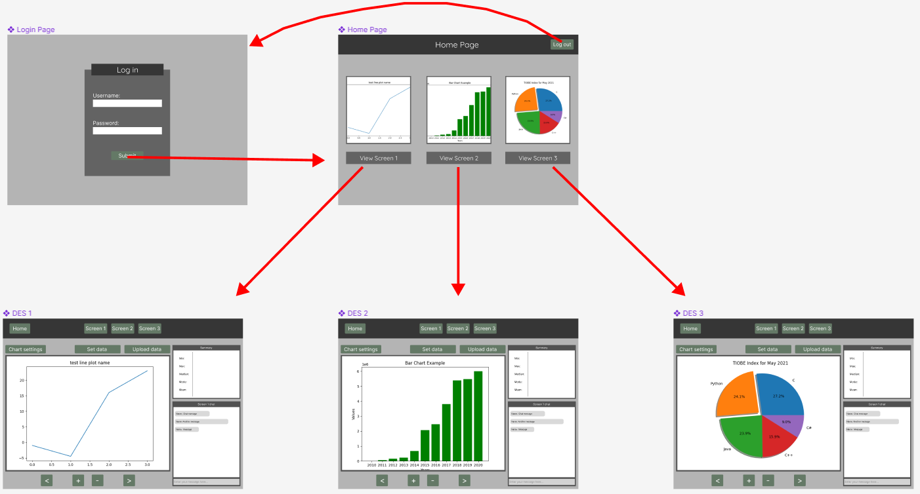

# Storyboard Descriptions:

The General workflow of the 5-screen application is as follows: Login 🡪 Home screen 🡪 DES 1, 2 and 3.

The application starts with the login screen, where the user must enter valid login credentials to further use the application. If login is successful, they are moved on to the home screen which acts as a hub for the application, where the user will have option to view data explorer screens 1, 2 or 3, or all 3 at once.

A more detailed look into each screen and their components are included below:

## Screen 1: Login

s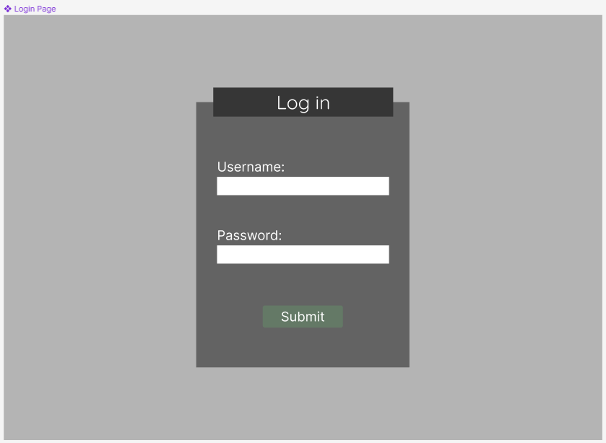

Once the application is run, the login screen will be displayed as the first screen of the application. The user must enter a valid username and password, then click on the “Submit” button. Currently there is no way for a user to make their own account and will rely on the 3 hardcoded accounts to login, which will be given to the user.

The potential outcomes for the login page include:

* Entered credentials are valid and links to an existing account. The user will be successfully logged in and redirected to the home page.
* Username entered is valid and links to an account, but password is incorrect. This will cause an error message to be displayed.
* Invalid credentials or the account with the entered username does not exist. This will cause an error message to be displayed.

## Screen 2: Home page

This is the home page of the application and will appear once the user has successfully logged into an account. The home page works as a hub for the application, giving the user the option to view one of the 3 data screens or to log out of the account using the button in the top-right corner.

Description of the possible interactions:

* **View Screen 1** – When clicked, another window will open, and redirect the user to the DES 1 screen.
* **View Screen 2** – When clicked, another window will open, and redirect the user to the DES 2 screen.
* **View Screen 3** – When clicked, another window will open, and redirect the user to the DES 3 screen.
* **Log out button** – When clicked, the application will exit any open windows and re-open the login screen. This will "Log out” the user and require they log in to an account to continue.

## Screens 3, 4 and 5: Data Explorer Screens

This is the general layout and expected components for each data explorer screen. DES 1, 2 and 3 will be using the same layout as shown above, with the only difference being the chart/graph and data that is being displayed, incase users need to have multiple windows open to compare the data.

The main purpose of the data explorer screen is to provide a graphical view of a dataset and allow the user to chat with other users currently viewing the same screen. Each DES will have its own separate chat.

Here is a breakdown of the components included in each data explorer screen:

### Navigation bar:

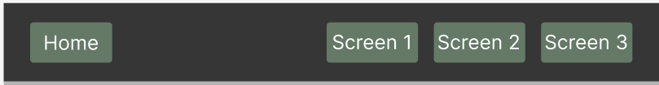

The navigation bar shown at the top of each screen provides the user with the option to navigate through the other data explorer screens and should open an additional window rather than redirecting the current screen.

The buttons include:

* **Home button:** Focuses or opens the home page, if not already open.
* **Screen 1:** Will appear on the DES 2 and 3 and will open the DES 1 when clicked.
* **Screen 2:** Will appear on the DES 1 and 3 and will open the DES 2 when clicked.
* **Screen 3:** Will appear on the DES 1 and 2 and will open the DES 2 when clicked.

### Chart summary:

The chart summary section will show basic information relating to the currently displayed chart or graph. The purpose of the summary section is to give the user a simple overview of the statistics of the chart/graph. There should be no user interaction with this component.

### Chatbox:

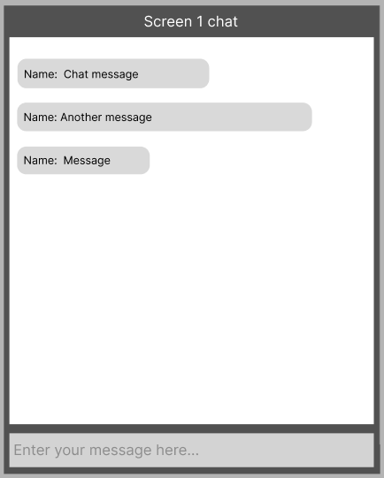

The chat feature implemented into each DES is a place for users to discuss the current graph/chart. Each DES will have their own chat, meaning that users will need to be on the same screen to discuss it with each other. The name displayed with each message will/should be the username used to login to the account.

### Chart settings:

The chart settings button will provide the user with a list of options for the current chart. The options could include switching between bar chart or line graph, etc.

### Set/Upload data buttons:



The set/upload data buttons allow the user to upload their own CSV dataset or select one that is currently stored in the database. The graph/chart and its summary will change to the respective dataset being used.

### Chart Zoom/Pan:



These buttons give the user more functionality and to analyze the currently displayed chart/graph in more detail. The two arrow buttons on either side are for panning left or right respectively. While the plus and minus buttons will zoom in or out of the current display.

### Chart/Graph display:

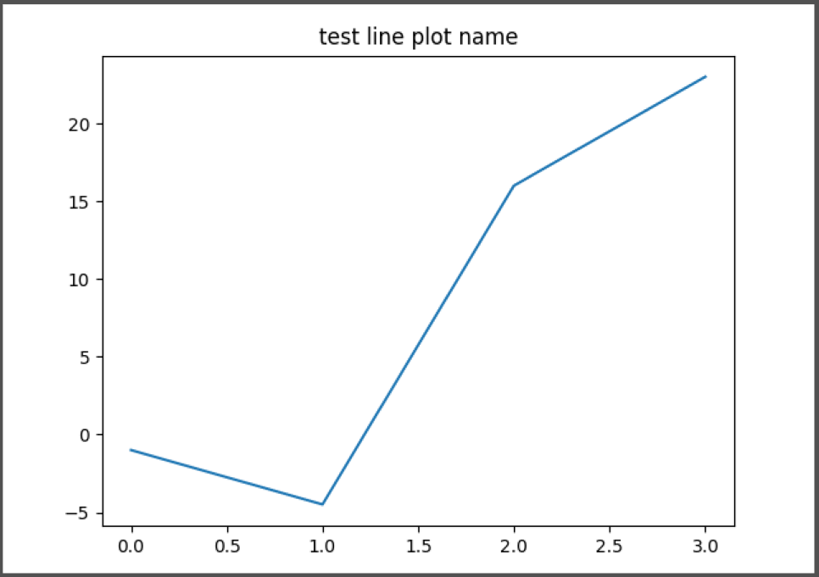

This is the section where the dataset displays the chart/graph and is the main feature of the application. This display ties into all other components previously mentioned and will be what the user uses to analyze the dataset uploaded. Through the chart settings, the user has the option to change what type of chart/graph is displayed and what data it is comparing.