180. The following letter is from a group of Linford College alumni to the chair of the art department at the college.
"In a recent survey of college graduates, 90 percent agreed that participating in an internship increased their chances of finding a job after graduation, but last year, only 40 percent of Linford’s graduating art students had completed an internship. Skyway Designs, located in nearby Linford City, is the perfect company for students to intern with for a number of reasons: They offer internships in all of their departments, so every student is sure to find work that they are interested in. Additionally, their internships offer flexible working hours. Finally, Skyway Designs is known for being one of the best in the design business, as over 80 percent of businesses in Linford City have used the services of Skyway Designs for their design needs. Given the vital role that work experience plays in a student’s success after graduation, we recommend that our art department require all art students to complete an internship with Skyway Designs before graduation."

Write a response in which you discuss what questions would need to be answered in order to decide whether the recommendation and the argument on which it is based are reasonable. Be sure to explain how the answers to these questions would help to evaluate the recommendation.

文章结构图
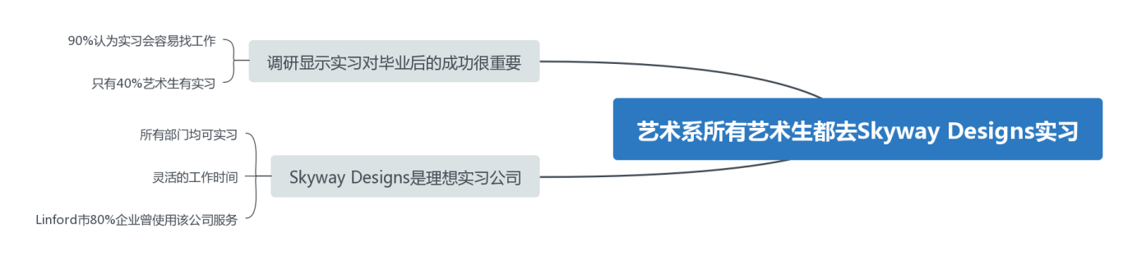

评价与错误
首先，关于那项针对大学毕业生的调查，90%的参与者认为实习会增加他们毕业后找到工作的机会，这项调研的结果是否有代表性？可能参与者人数很少，也可能认为实习对找工作重要的毕业生基本都不是艺术生。毕竟，很多艺术生开始自己的艺术事业是通过作品参赛、举办展览等等，并不一定需要去公司实习。此外，毕业后找到工作等于成功么？特别是学习艺术专业的学生，其中绘画、雕塑、电影等等专业的学生，可能毕业后会通过自身努力获得独立艺术家的身份。他们成功的判定标准就比较多元了，可以是重大奖项、收藏纪录、拍卖纪录、参展次数等等。（证据瑕疵类）

尽管不排除这样的可能：Linford大学的艺术生大多需要去公司实习，那么Skyway Designs是不是唯一的选择？文中陈述了Skyway Designs作为理想实习地点的原因是不是站得住脚？虽然Skyway Designs所有部门均提供实习机会，但这间公司是以什么服务知名？现实中，有装修设计、户外广告设计、网络广告创意策划等等不同类型的设计公司，如果Skyway Designs仅仅是提供公路广告牌(billboard)的公司，对于学习动画艺术设计的学生来说可能就不那么有吸引力了，同样，学习艺术史的同学可能更希望进入画廊或博物馆实习。（必要条件类问题）

虽然可能Skyway Designs与Linford大学的设计生专业对口(a job in their field of study)，文中也指出Skyway Designs能为Linford市80%以上的企业提供设计服务，但是这一市场优势能否使学生们受益？一方面，如果Skyway Designs真如前面所说，是一间公路广告牌的设计公司，可能由于它有比较多的广告牌资源，所以吸引了很多公司来使用它的服务，然而需要考虑未来公路广告牌的传统市场需求是否会下滑。另一方面，这一论据也从侧面说明了Skyway Designs的业务许多在本地，此类企业很可能不是国际知名企业。因此，想要成功的艺术生们可能更偏向于进入更国际化、创新型的大公司。（必要条件类问题）

