Derivative_Midterm_extra

112357038童思謙

2024-01-17

計算以EUR/USD為標的的外匯選擇權(以2024/1/16為例)

資料來源:

選擇權價格、限價(1.0877)、履約價(0.9963)、到期日(12M)、隱含波動度(8.47%)

<https://www.investing.com/currencies/forex-options>

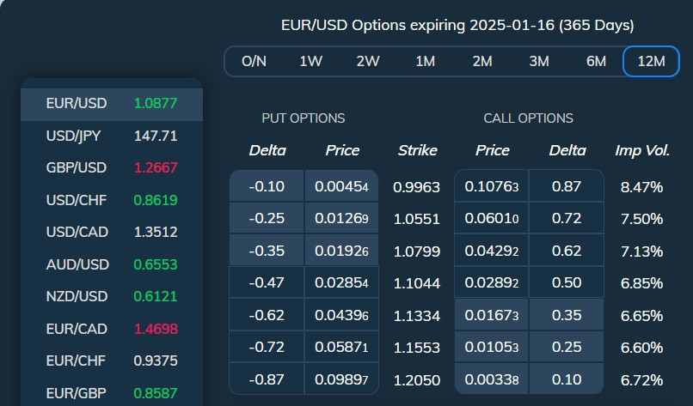

美債利率(r):

<https://hk.investing.com/rates-bonds/u.s.-1-year-bond-yield>

  
歐債利率(rf):

<https://www.ecb.europa.eu/stats/financial_markets_and_interest_rates/euro_area_yield_curves/html/index.en.html>



(a)

BS_model <- function(s = 100,k = 110, T = 1, sigma = 0.2, r = 0.01){  
 d1 <- (log(s/k)+(r+((sigma^2)/2))*T)/(sigma*sqrt(T))  
 d2 <- d1 - (sigma*sqrt(T))  
 C <- s*pnorm(d1)-k*exp(-r*T)*pnorm(d2)  
 P <- k*exp(-r*T)*pnorm(-d2)-s*pnorm(-d1)  
   
 return(c('call option=',C,'put option=',P))  
}  
#bs_model初始模型對於fx option訂價與市場價格不同  
BS_model(s=1.0877,k=0.9963,T=1,sigma=0.0824,r=0.04766)

## [1] "call option=" "0.139524014581723" "put option="   
## [4] "0.00175412798586061"

#修改初始模型，且修改後的模型較貼近市場價格  
BS_model_ad <- function(s = 100,k = 110, T = 1, sigma = 0.2, r = 0.01,rf = 0.02){  
 d1 <- (log(s/k)+(r-rf +((sigma^2)/2))*T)/sigma*sqrt(T)  
 d2 <- d1 - (sigma*sqrt(T))  
 C <- s*pnorm(d1)*exp(-rf*T)-k*exp(-r*T)*pnorm(d2)  
 P <- k*exp(-r*T)*pnorm(-d2)-s*pnorm(-d1)*exp(-rf*T)  
  
 return(c('call option=',C,'put option=',P))  
}  
  
BS_model_ad(s=1.0877,k=0.9963,T=1,rf=0.0312,sigma=0.0824,r=0.04766)

## [1] "call option=" "0.108398110836636" "put option="   
## [4] "0.00404052203358095"

(b)

由上可知，初始BS model 計算出來的買權價格為0.1395，賣權為0.0017

修正後的BS model計算出來的買權價格為0.10839，賣權為0.00404

(c)

市場的買權價格為0.10763，賣權為0.00454。由此可知，修正後的BS model和市場價格較為貼近(如a小題所示)