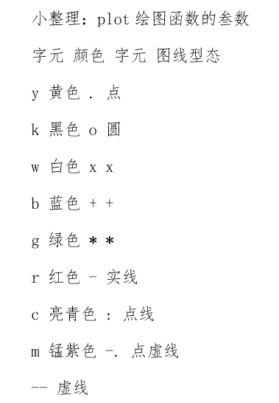

Lagrange:
function y=lagrange(x0,y0,x);
n=length(x0);m=length(x);
for i=1:m
z=x(i);
s=0.0;
for k=1:n
p=1.0;
for j=1:n
if j~=k
p=p*(z-x0(j))/(x0(k)-x0(j));
end
end
s=p*y0(k)+s;
end
y(i)=s;
end

例1：
>> h=1:12;
>> t=[5,8,9,15,25,29,31,30,22,25,27,24];
>> h0=1:0.1:12;
>> t_nearest=interp1(h,t,h0,'nearest');
>> t_linear=interp1(h,t,h0,'linear');
>> t_spline=interp1(h,t,h0,'spline');
>> t_pchip=interp1(h,t,h0,'pchip');
>> subplot(2,3,1),plot(h,t,'r*');
>> subplot(2,3,1),plot(h0,t_nearest,'r');
>> subplot(2,3,1),plot(h,t,'r*');
>> subplot(2,3,2),plot(h0,t_nearest,'r');
>> subplot(2,3,3),plot(h0,t_linear,'r');
>> subplot(2,3,4),plot(h0,t_spline,'r');
>> subplot(2,3,5),plot(h0,t_pchip,'r');

例2：
>> x=0:0.3:3;
>> y=(x.^2-4*x+2).*sin(x);
>> x0=0:0.01:3;
>> y_spline=interp1(x,y,x0,'spline');
>> y_pchip=interp1(x,y,x0,'pchip');
>> plot(x,y,'o');
>> hold on
>> plot(x0,y_spline,'r');
>> hold on
>> plot(x0,y_pchip,'b');

例3：
x=1:5;
>>y=1:3;
>> t=[82 81 80 82 84;79 63 61 65 81;84 84 82 85 86];
>> [xx,yy]=meshgrid(x,y);
>> mesh(xx,yy,t);
>> x0=1:0.1:5;
>> y0=1:0.1:3;
>> [xxx,yyy]=meshgrid(x0,y0);
>> t_spline=interp2(x,y,t,xxx,yyy,'spline');
>> mesh(xxx,yyy,t_spline);
>> t_cubic=interp2(x,y,t,xxx,yyy,'cubic');
>> mesh(xxx,yyy,t_cubic);

例5：
>> x=[129 140 103.5 88 185.5 195 105 157.5 107.5 77 81 162 162 117.5];
y=[7.5 141.5 23 147 22.5 137.5 85.5 -6.5 -81 3 56.5 -66.5 84 -33.5];
z=-[ 4 8 6 8 6 8 8 9 9 8 8 9 4 9];
>> plot3(x,y,z,'o')
>> hold on
>>cx=75:0.5:200;
>> cy=-70:0.5:150;
>> cz=griddata(x,y,z,cx,cy','cubic');
>> meshz(cx,cy,cz)
>> [xx,yy]=meshgrid(cx,cy);
>> cz=griddata(x,y,z,xx,yy,'cubic');
>> mesh(xx,yy,cz)
>> z_linear=griddata(x,y,z,xx,yy,'linear');
>> mesh(xx,yy,z_linear);

例6：
x=[0.3 0.4 0.7 0.9 1.2 1.9 2.8 3.2 3.7 4.5];
y=[1 2 3 4 2 6 9 2 7 8];
r1=polyfit(x,y,1);
r2=polyfit(x,y,2);
s1=polyval(r1,x);
s2=polyval(r2,x);
plot(x,y,'*',x,s1,'r',x,s2,'b');
>> a1=[x' ones(10,1)];
>> a2=[x.^2' x' ones(10,1)];
>> r11=a1\y';
>> r21=a2\y';

例7：
>> x=1:20;
>> y=x+3*sin(x);
>> p=polyfit(x,y,4);
>> v=polyval(p,x);
>> plot(x,y,'o',x,v,'b');
>> legend('原始数据','4阶曲线');
>> r=[x.^4' x.^3' x.^2' x' ones(20,1)];
>> s=r\y';

例8：
function f=fun1(x,tdata)
f=x(1)+x(2)*exp(-0.02*x(3)*tdata)
end
>> tdata=100:100:1000;
>> cdata=0.001*[4.54 4.99 5.35 5.65 5.90 6.10 6.26 6.39 6.50 6.59];
>> x0=[0.1 0.1 0.1];
>> x=lsqcurvefit('fun11',x0,tdata,cdata);
>> c=f-cdata;
>> plot(tdata,cdata,'*',tdata,f)；

function f=fun22(x)
tdata=100:100:1000;
cdata=0.001*[4.54 4.99 5.35 5.65 5.90 6.10 6.26 6.39 6.50 6.59];
f=x(1)+x(2)*exp(-0.02*x(3)*tdata)-cdata;

end
>> x0=[0.2 0.05 0.05];
>> x=lsqnonlin('fun22',x0);
f=fun22(x);

