**2021/12/07 陳嘉政 r10922171 HW8**

1. **Gaussian noise of amplitude 10**

**雜訊圖**

**SNR = 13.5988**

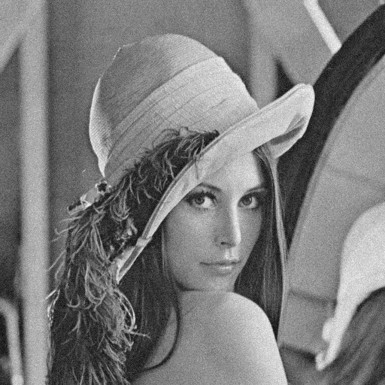

**(1)3x3 box filter**

**SNR = 17.7372**

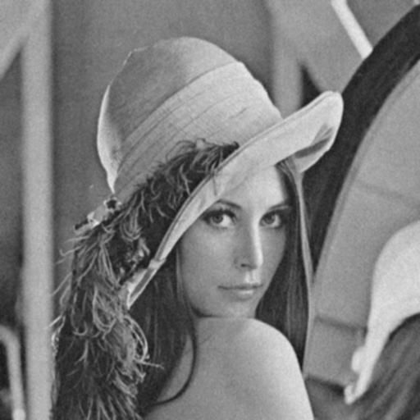

**(2)5x5 box filter**

**SNR = 14.8614**

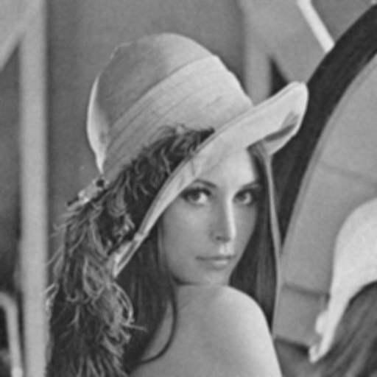

**(3)3x3 median filter**

**SNR = 17.6762**

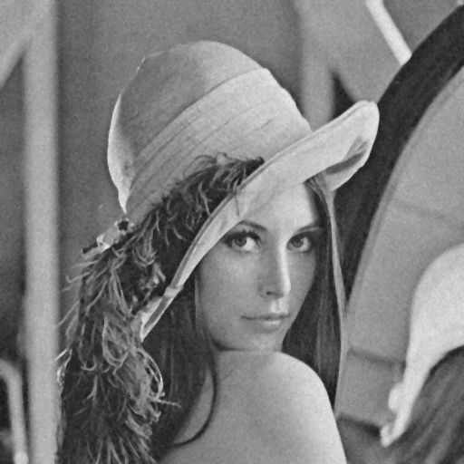

**(4)5x5 median filter**

**SNR = 16.0041**

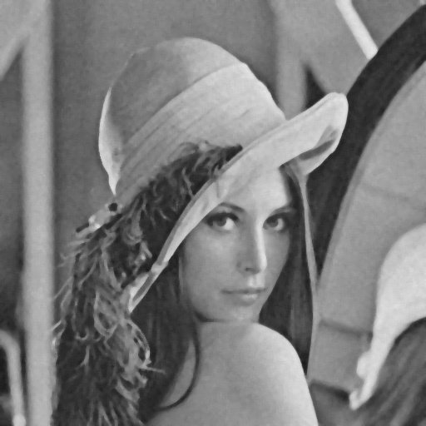

**(5) opening then closing**

**SNR = 13.2449**

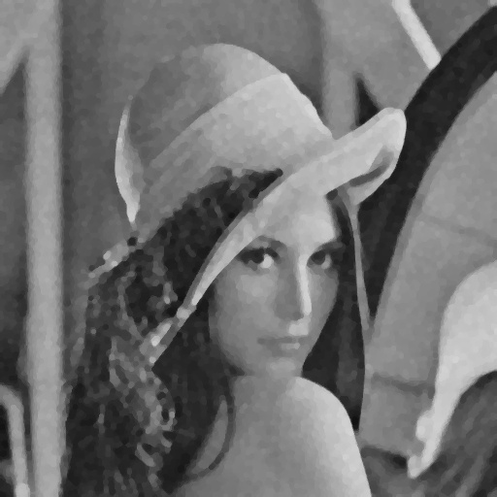

**(6) closing and opening**

**SNR = 13.6037**



1. **Gaussian noise of amplitude 30**

**雜訊圖**

**SNR = 4.17281**

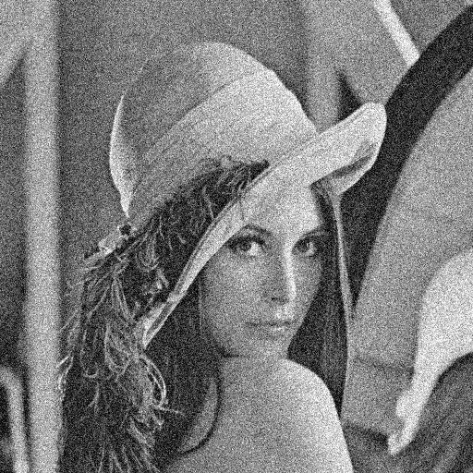

**(1)3x3 box filter**

**SNR = 12.6067**

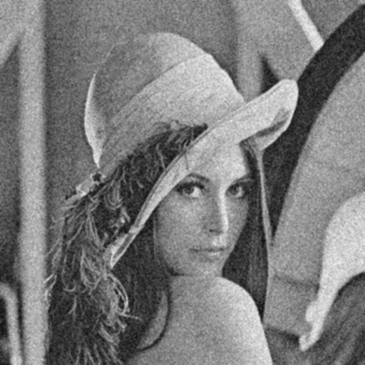

**(2)5x5 box filter**

**SNR = 13.2879**

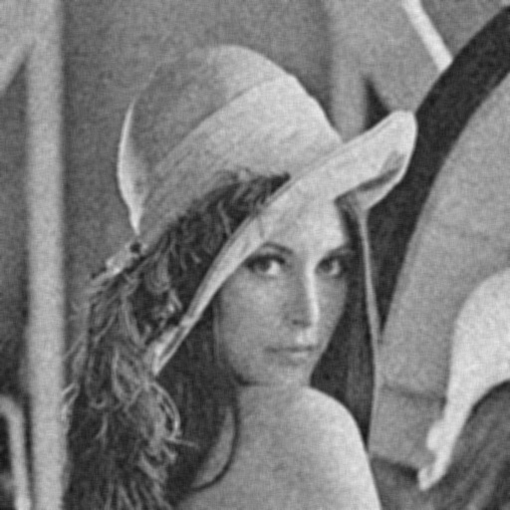

**(3)3x3 median filter**

**SNR = 11.102**

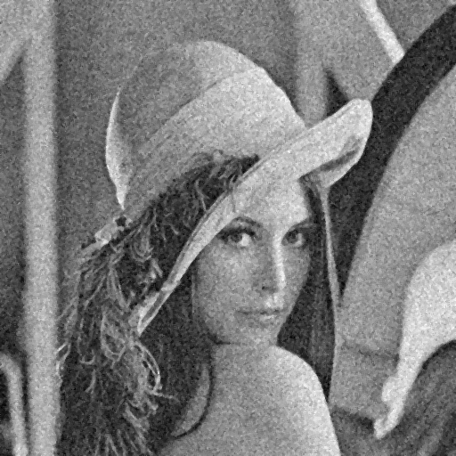

**(4)5x5 median filter**

**SNR = 12.8922**

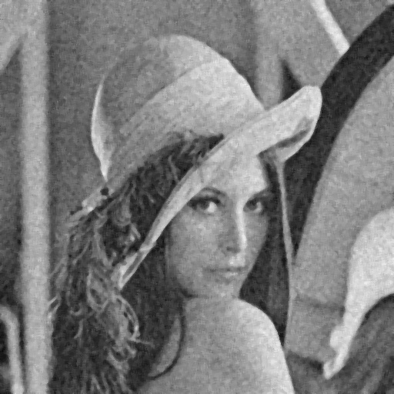

**(5) opening then closing**

**SNR = 11.1734**



**(6) closing then opening**

**SNR = 11.2145**

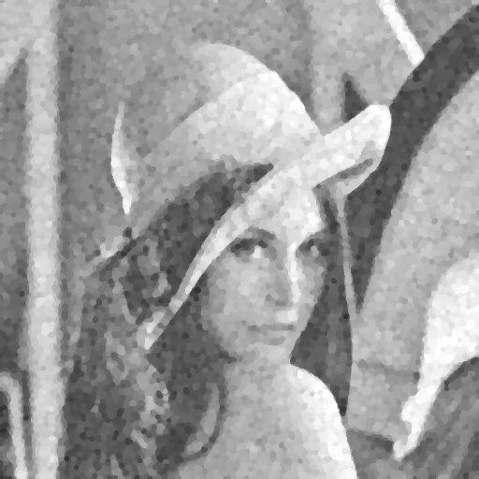

1. **Salt and pepper of probability 0.05**

**雜訊圖**

**SNR = 1.01534**

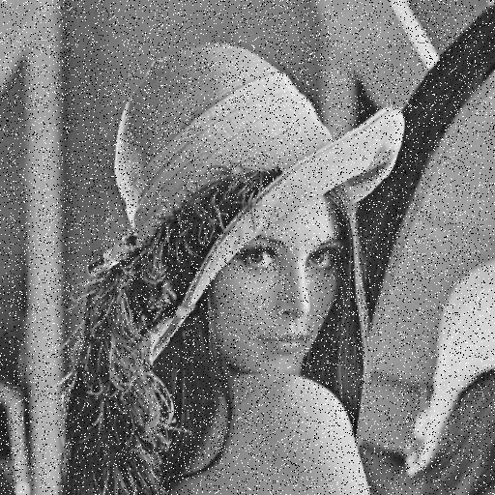

**(1)3x3 box filter**

**SNR = 9.53373**

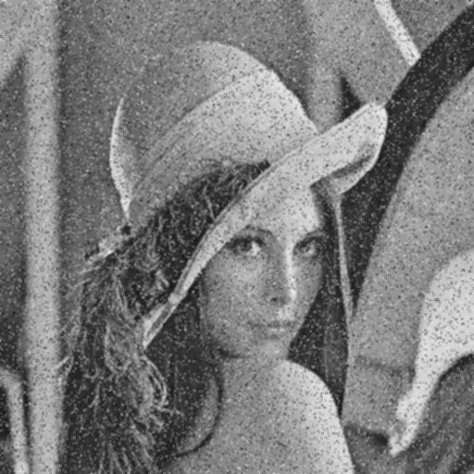

**(2)5x5 box filter**

**SNR = 11.2015**



**(3)3x3 median filter**

**SNR = 19.1263**

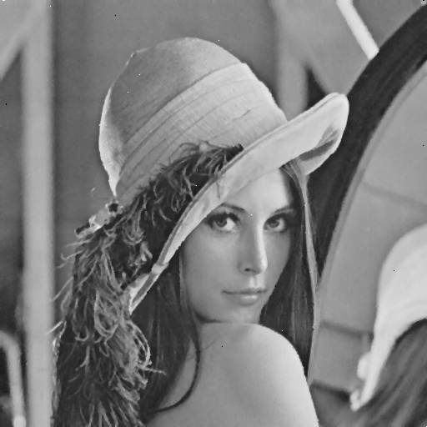

**(4)5x5 median filter**

**SNR = 16.3716**

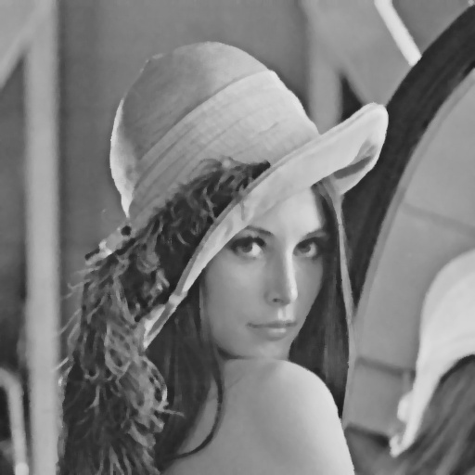

**(5) opening then closing**

**SNR = 5.69555**

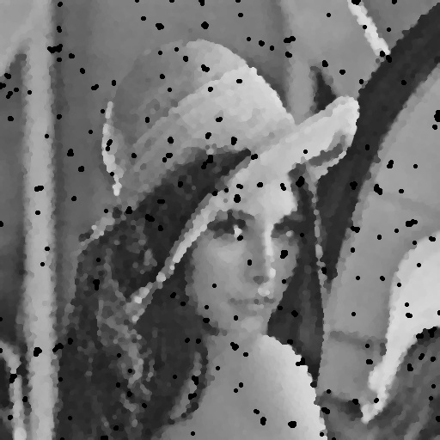

**(6) closing then opening**

**SNR = 5.58735**



1. **Salt and pepper of probability 0.10**

**雜訊圖**

**SNR = -1.87318**



**(1)3x3 box filter**

**SNR = 6.56892**

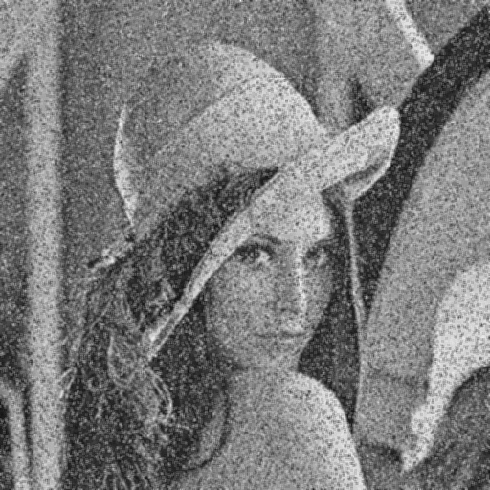

**(2)5x5 box filter**

**SNR = 8.71012**

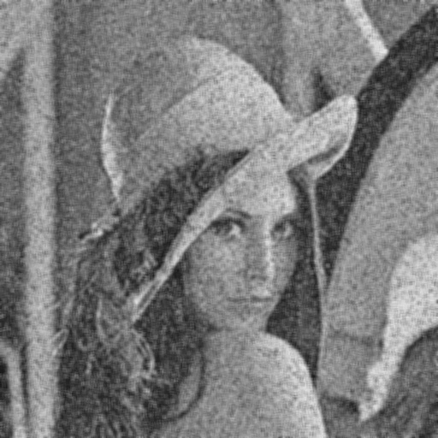

**(3)3x3 median filter**

**SNR = 15.3722**

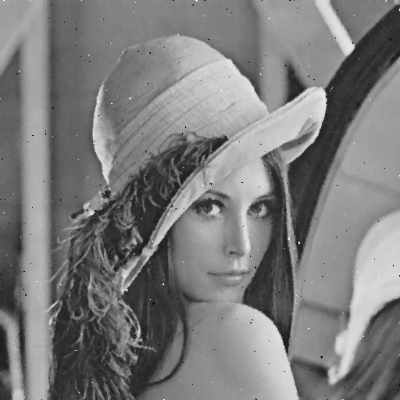

**(4)5x5 median filter**

**SNR = 15.7797**

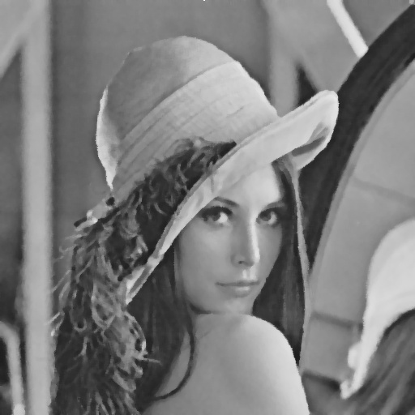

**(5) opening then closing**

**SNR = -2.14207**

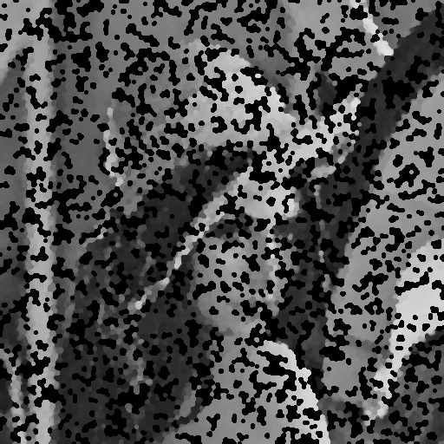

**(6) closing then opening**

**SNR = -1.95822**

