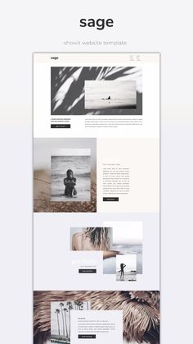

1. Cover page (Pic 1 + name)
   1. A picture containing text, person, indoor, crowd

      Description automatically generated
2. About me (Pic 2)
   1. Graphical user interface, application, website

      Description automatically generated
   2. 3-5 sentences to describe myself
   3. Basic info
      1. Birthday, age, address, email, phone etc
   4. Life + hobbies
3. Skills
   1. Graphical user interface

      Description automatically generated
4. Working experience (display as pro card)