Sign In & Main Dashboard
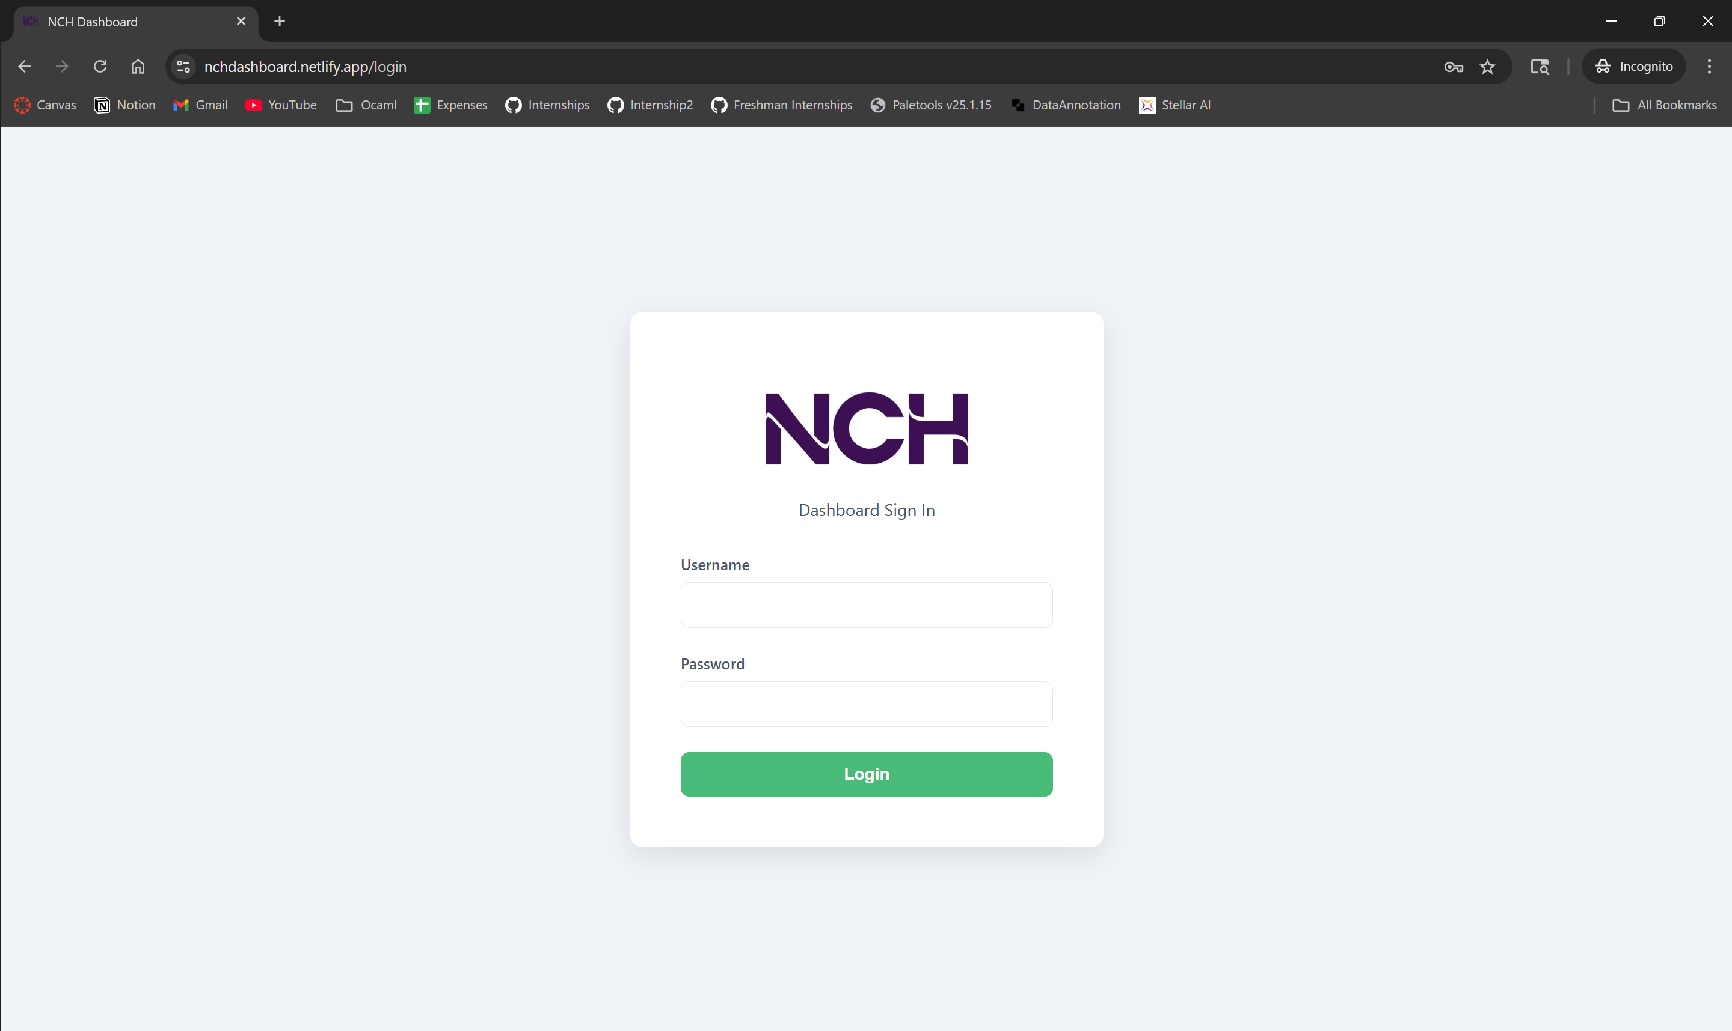
- Sign in using the given username and password
This will take you to the main dashboard, which includes a toggle-able sidebar, and 4 graphs
Note: Due to the free online hosting, the web page will take ~1 minute to ‘spin up’ the first time it is accessed after 30 minutes of idling.
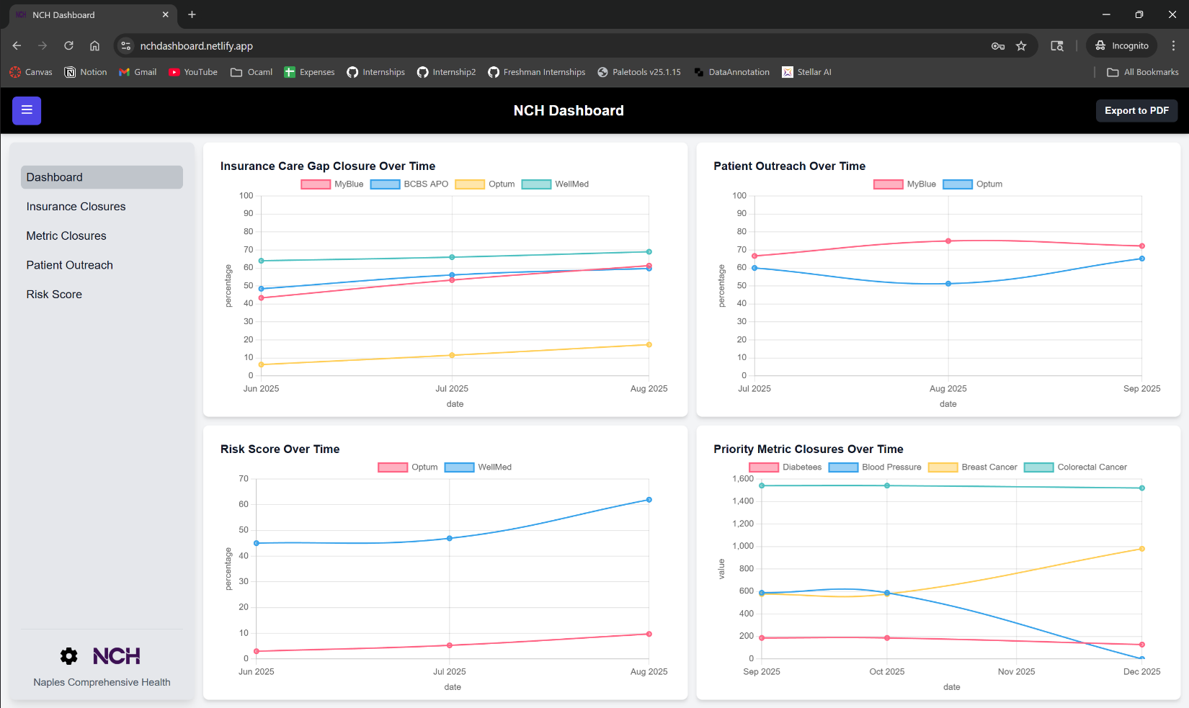
Features on main dashboard:
- Toggle-sidebar (blue)
- Current page indicator (yellow)
- Export to PDF—prints all graphs/titles onto one pdf download (red)
- Settings page (green)

Individual Dashboards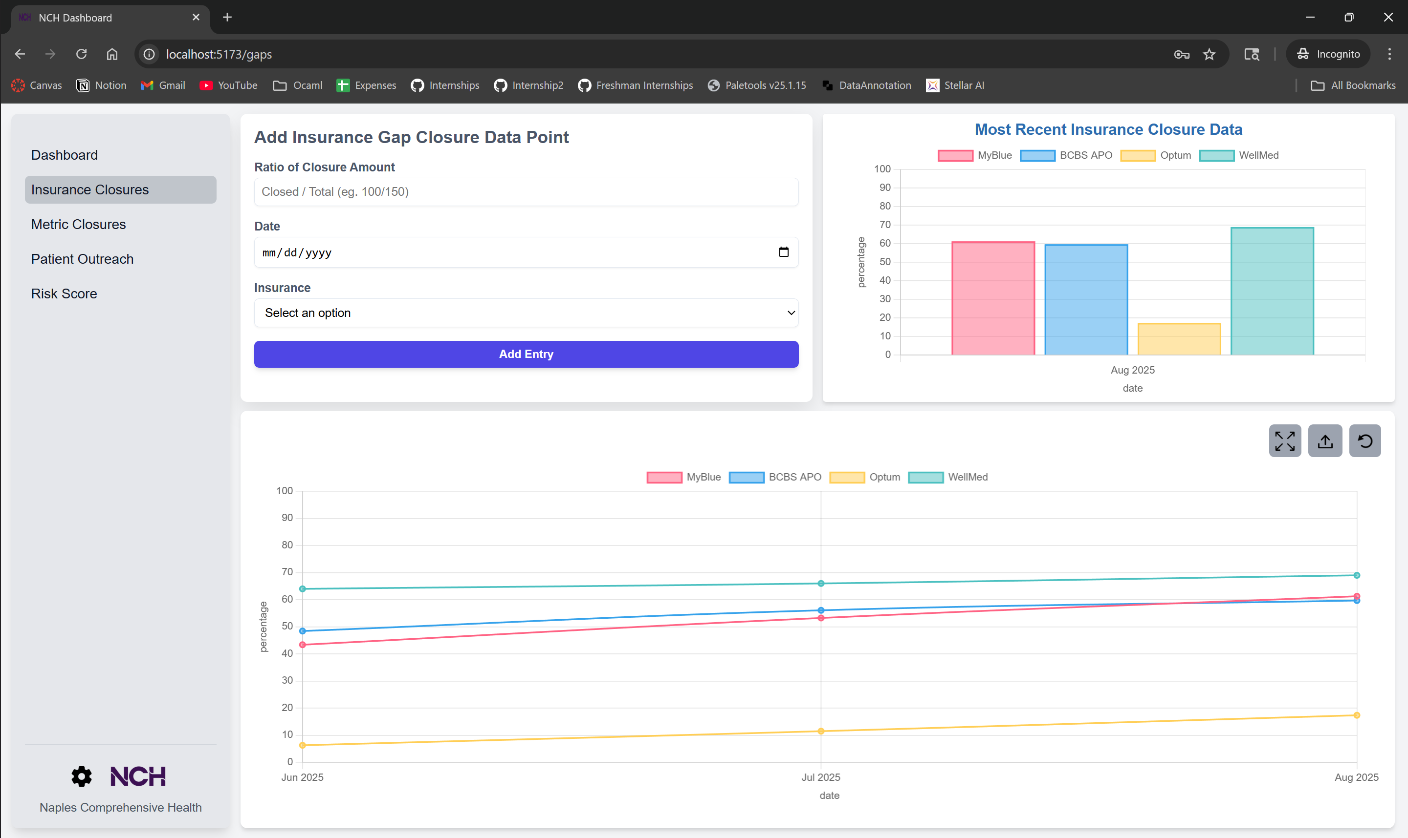
Features on individual dashboard:
- Rotate graph type—rotates between line (default), bar, and pie (red)
- Export data to csv—exports graph data onto downloadable excel file (green)
- Fullscreen—displays the graph in an enlarged format (blue)
- Main graph at the bottom displaying all available data
- Recent graph at the top right displaying the most recent month’s data—finds the most recent month that has any data point and displays all data found within that month.
To add data points:
Input all required data in the data form in the top left corner. If asked for a ratio, use the format [numerator]/[denominator] with no spaces. Percentages should be input as a percentage (67 instead 0.67). If you did not input all required information, a pop-up will appear showing what fields are missing. Once all data is input, press the add entry button to add the data point. The data will instantly populate on the database but make a second to re-display the update graph. In order to ‘refresh’ the graph if it is not done automatically, open the main dashboard using the sidebar then navigate back to the desired page.

Metric Closure Dashboard
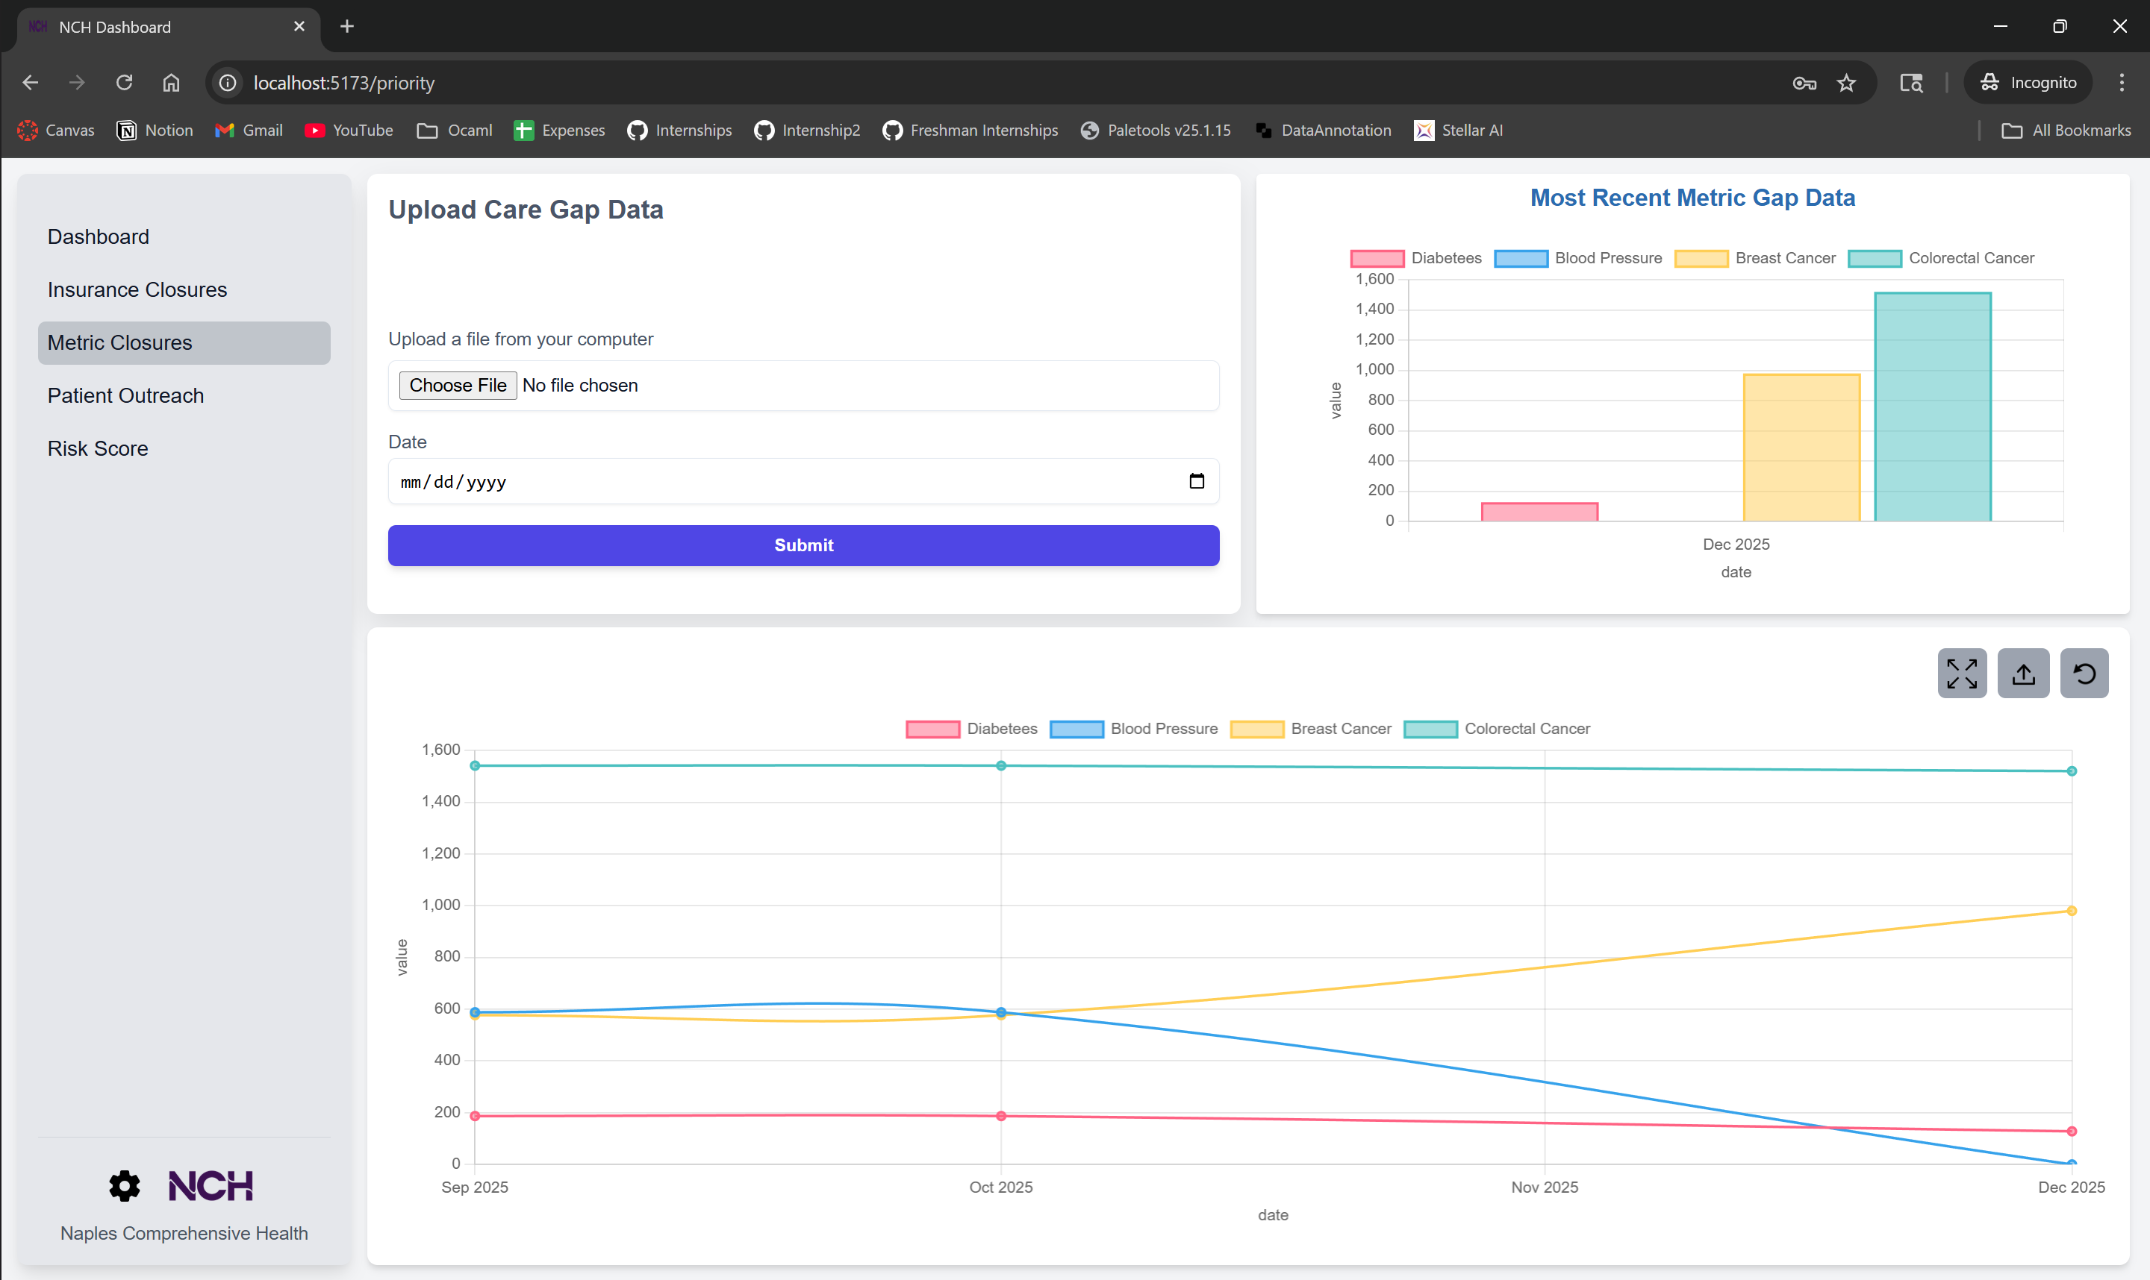
To add data points:
Adding data to this dashboard requires the uploading of a master care gap sheet that contains all current gaps. Download the current master care gap sheet from OneDrive, then click “Choose File” and select the master sheet that was just downloaded. Then select the current date/month that the sheet corresponds to. Click submit to add the data points found from the master sheet. This upload requires more CPU processing; after clicking submit, the page will load briefly and then the data points will be added.

Settings Page
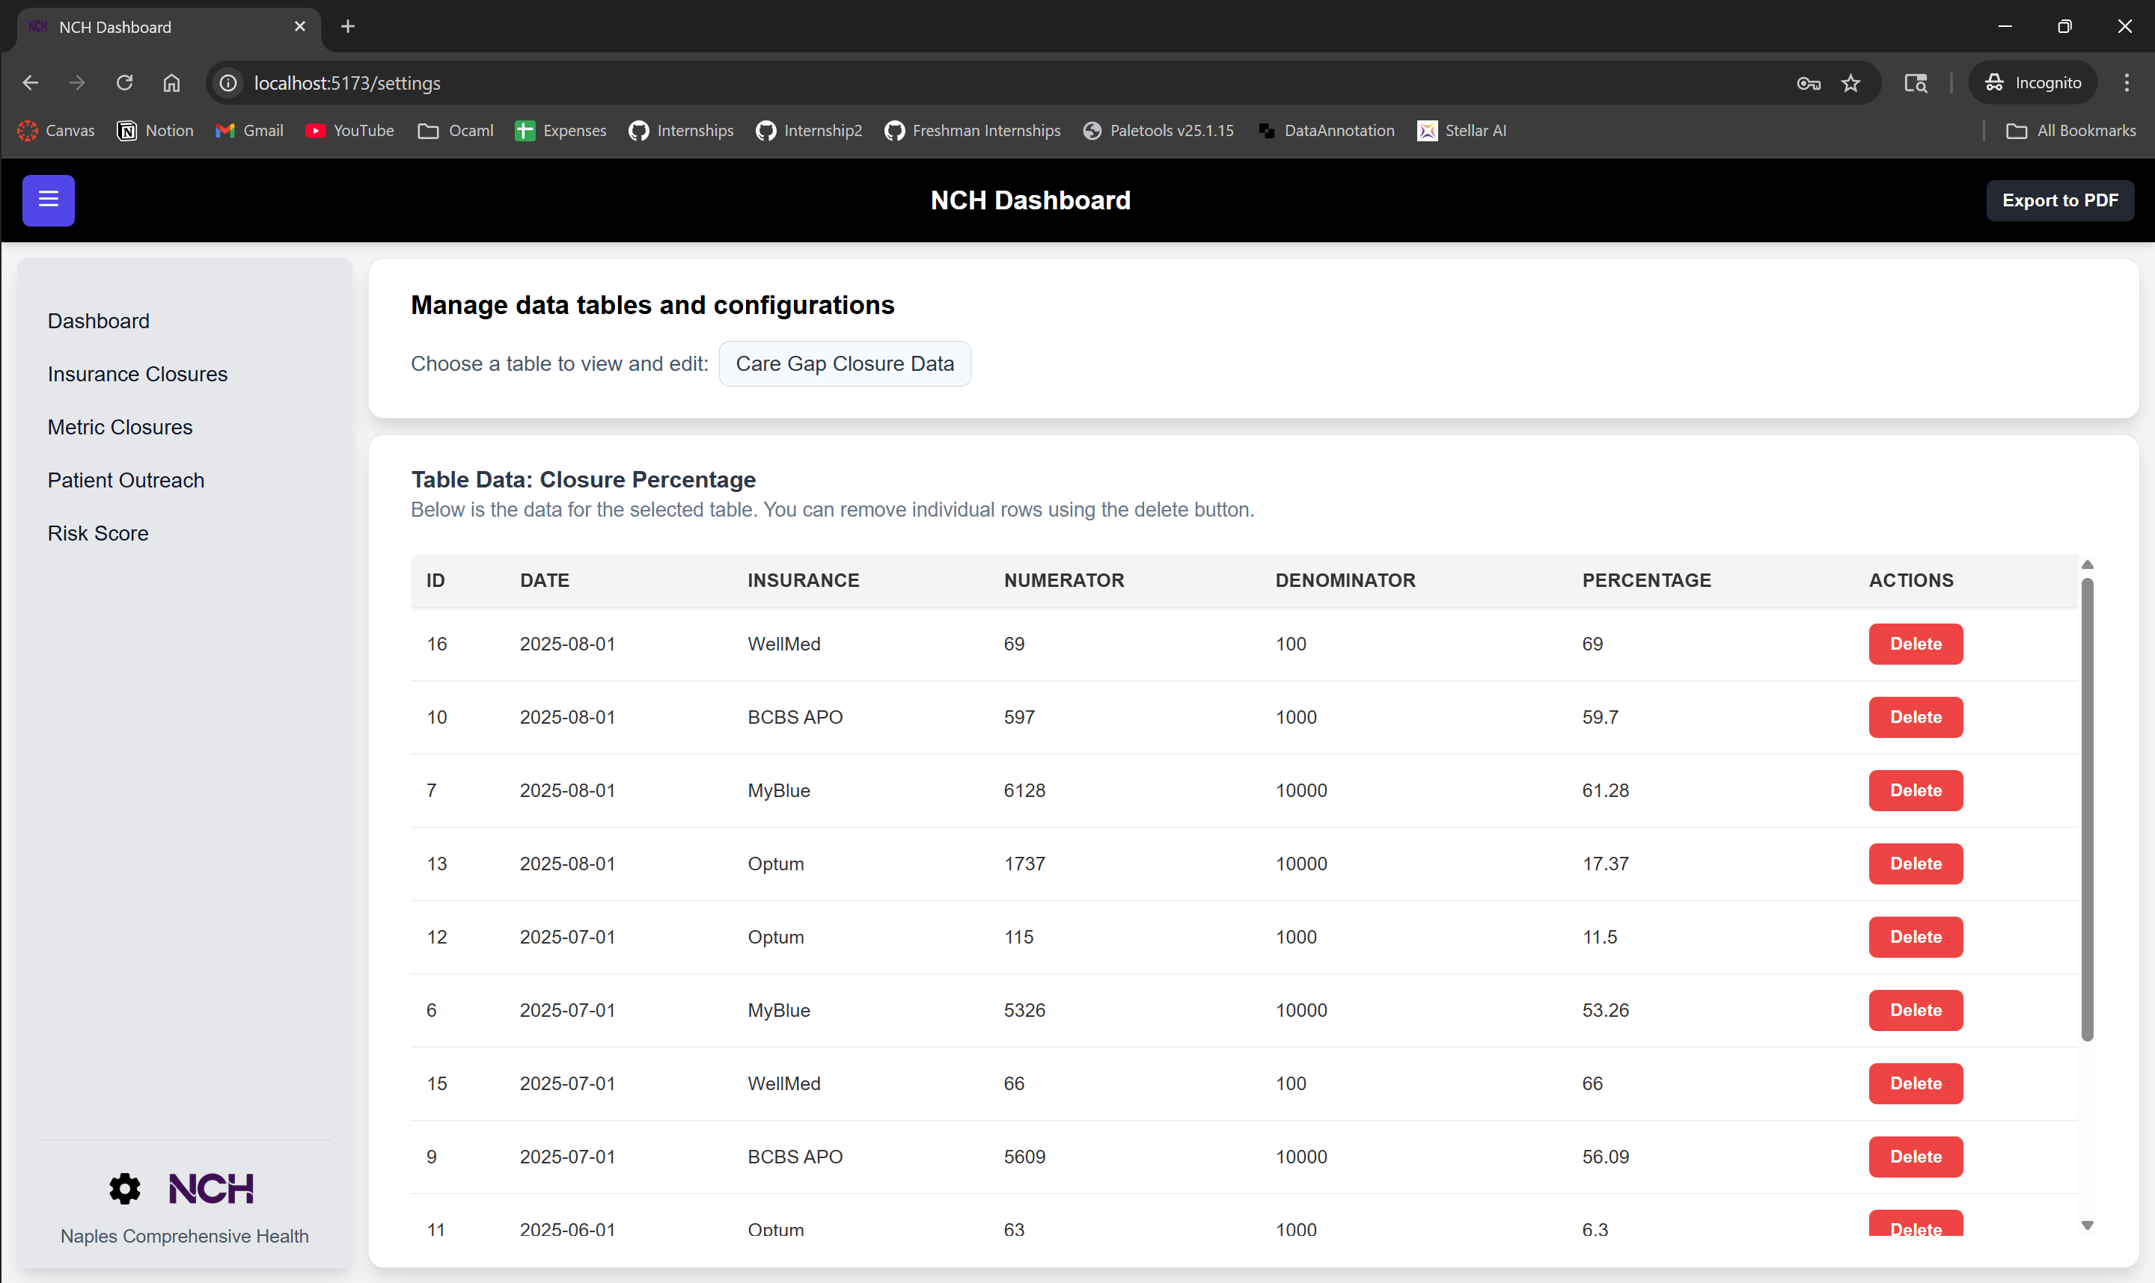
Features on settings page:
- Delete data point (blue)
- Table selector (red)
To delete data points:
Find the data point you want to delete by selecting the respective table and/or scrolling on the table. Then press the delete button. A popup will appear reading “Are you sure you want to delete this record? This action cannot be undone”—press ‘OK’ to confirm deletion.
To change tables:
Click on the current table name/selector. A drop-down will appear with the current available tables. Click on the table you want to change to.
Note: Each table in settings shows ALL columns that are stored; not every column is displayed/graphed on the dashboard pages. For example, ‘Care Gap Closure Data’ displays numerator and denominator metrics, but the graph/dashboard page only shows the percentage metric.

