INFO3315

**Human-Computer Interaction**

**Project Phase 1**

Group Members (SID):

XIAOHAN LI(470011746)

XIHE HU(460047977)

ZELIN YE(490444409)

R16C - Group 5

# 1. Observation

Observation method: direct observation - think aloud

Summary:

1. For nearby area students, if they want to find the fastest way to school, navigation software such as Google Map can be a good choice since it can find the shortest road for walking. However, sometimes software cannot notice some small paths or roads which are under maintenance.
2. For new students, they have to use navigation software to check the distance from home to school first. Then they need to choose one of transportation normally between train, bus, walk or bicycle. They have to watch on the software to ensure they are on the right track or they do not sit over the station.
3. For students with a poor sense of direction, they may use both navigation software and transportation timetable software such as TripView to ensure accuracy. After leaving transportation, they will take lots of time to find their building and classroom since regular navigation software do not offer precise in-school information.
4. For students with a strong sense of direction, they only use transportation timetable to confirm the time. They can independently find when to get on and get off, and where the classroom is.
5. For students who drive to school, they need to open the navigation software all along the way. The software can give the fast and right way to the normal driver. Even for the student with a strong sense of direction, it is still necessary for avoiding the crowded road or the road under maintenance.
6. For students who ride to school, since they cannot watch their phone while riding, the voice prompts become vital. It should be both time accurate and position accurate without any delay. What’s more, the voice should be clear enough under the interference of outside environment.

Copy of original notes is attached below in appendix 1.

# 2.Interview Question Design

Interview method: semi-structured interview

Draft interview:

1. Do you use navigation software? Yes or No?
2. How do you usually go to school?
3. Which navigation software do you most commonly use? Why do you choose it?
4. How often do you use the navigation software? Usually, Often, Sometimes, Seldom or Never？Why?
5. Do you think the navigation software is easy for you? Very Easy, Easy, Normal, Hard or Very Hard? Why do you think so?
6. Do you think there is any defect in the navigation software? What is it if yes?
7. On a scale of one to five, how would you rate the impact on the defect?
8. Do you think navigation software is essential to you? Why/Why not？
9. Is there an irreplaceable navigation software for you? Why/Why not？

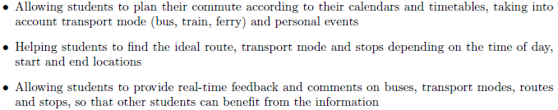

1. If somebody recommend you a new navigation software with features above, would you like to try it? Why/Why not?
2. What other features do you want to have?

Final interview:

Note: The navigation software mentioned below is aimed to the software you use for navigating you from home to the classroom or classroom to home.

1. How do you judge your sense of direction? Very Poor, Poor, Medium, Strong or Very Strong?
2. How do you usually go to school?
3. Which navigation software do you most commonly use? Why do you choose that APP instead of others?

Note: The navigation software mentioned in Question 4-7 is based on the navigation software you mentioned in question 3.

1. How often do you use the navigation software? Usually, Often, Sometimes, Seldom or Never？Why?
2. Do you think the navigation software is easy for you? Very Easy, Easy, Normal, Hard or Very Hard? Why do you think so?
3. Do you think there is any defect in the navigation software? What is it if yes?
4. On a scale of one to five, how would you rate the impact on the defect?
5. Do you think navigation software is essential to you? Why/Why not？
6. Is there an irreplaceable navigation software for you? Why/Why not？



1. If there is a new navigation software with features above, would you like to try it? Why/Why not?
2. What other features do you want to have?

Reason for change:

1. The first ‘Note’ is added because the feature of the software is only aim to the way from home to the classroom and vice versa. As a result, Google Map may not be main navigation application since there is USYD Map, Opal Travel and other application.
2. The second ‘Note’ is used for avoiding misunderstanding of what is ‘the navigation software’ stand for.
3. The question 1 in draft is deleted because if the person does not even use navigation software, the following questions is meaningless.
4. The added question of testing sense of direction is used to better distinguish different target users. Additionally, it is also used to find out what kind of situation when a person with a strong sense of direction will use the navigation.
5. The original intention of question 3 is which let respondents compare different software to identify the unique feature of particular one.

# 3.Conduct interview

To conduct the interview, seven people with five different contexts who are not in the project are invited to complete the survey. During the interview, they are allowed either speaking to the interviewer or typing on the computer based on the question. Since most people go to school alone due to different class time, contexts of single male and single female are interviewed twice. The raw interview notes are attached below in appendix 2.

Key findings:

1. Users need higher navigation accuracy since current navigation cannot be so real-time accurate. (P1, P2, P4)
2. Users who travel by public transportation needs high accuracy of the timetable. (P5, P7)
3. Friend feature is recommended to add as it has been mentioned twice. (P1, P5)
4. Public utilities around or in the school should be pointed on the map with congestion as similar feature has been mentioned three times. (P3, P4, P6)
5. The new navigation software can have a high usage rate among students since most students with different content think they will try it with current features. (P1, P2, P3, P5, P7)
6. Google map is still the most popular software among students. As a result, the new software can learn from Google Map for special features. (P1, P2, P3, P4, P5)
7. In-school navigation is an essential feature that can distinguish the software to others. (P1, P2, P6)

# 4.Existing Approach Research

Apps:

1. Google map
2. Waze

Problem to solve:

The traditional maps only give the user an overall feeling about the area around the user, and the user need to have some basic knowledge to read it. The traditional maps also can’t tell the user the current situation and come out a new plan. But these problems can all be solved by Google map or Waze. The GPS system makes it possible to tell the current location, the Artificial Intelligence algorithm can analyze the traffic data and come out the best way to send the user to the place they want to be.

Relation to the observations:

As our observations, For students who drive to school, the software analyze the traffic data which can give the driver the best route to avoid crowded road or the road under maintenance which can save a lot of times.

For students with a poor sense of direction, it’s very hard for them to figure out how traditional map works, but navigation apps give them a second chance by giving them the accurate position of where they are and the relative distance of nearby buildings and roads.

# 5.Stakeholders

Main stakeholders:

1. The International students would need the commute planning apps the most, being in a different country makes them hard to find a friend, so it’s hard for them to find the place they don’t know how to go, because there’s no one they can ask.

2. The first-year students comes from another city(domestic) also need the commute planning apps, at first, they are in an unfamiliar environment, they don’t know how public transportation works, if there is an app can tell them how to do, it would be very nice. But when time passes, they won’t need it anymore.

3. The project manager, which is in charge of the research and development of the app, need to have an overall view of the whole process. And lead this team to a right way.

4. The team members have different division of work, some of them need to do the market research, some of them need to design the app’s UI, also the programmer in the team need to write code to make the app come true.

Personas:

Fictional name: Student A

Job title/Major responsibilities: Undergraduate Student

Demographics: 20 years old studying Bachelor of Computer Science

Goals and tasks: Student A are an ambitious girl, even before she comes to Australia, she’s always a top student in school, but now, being in a different country makes her a little bit nervous, sometimes she can’t find the place she wants to go to, and she hesitated to ask for a stranger’s help. This sometimes waste her a lot of time which is unacceptable to her.

1.She never wants to waste her time. Time controlling is very important to her.

2.Her main goal is to focus on study.

3.But she also wants to meet with different people.

Environment: She lives in school campus, surrounded by international students from different countries. She wants to talk to these people.

Persona: First year undergraduate student of University of Sydney

Fictional name: Student B

Job title/Major responsibilities: First year Undergraduate Student

Demographics: 19 years old studying Bachelor of Mechanical Engineering

Goal and tasks: He choose to study Mechanical Engineering because he loves cars, he used to have a lot of friends in Melbourne also love cars. So sometimes he feels a little bit lonely in Sydney. And he is not familiar with the city at all. But he thinks 2 months later at least, he will adapt all these and won’t struggle anymore.

1.He wants to know the best way to go to the university from his apartment.

2.He wants to meet more friends.

Environment: He lives in Burwood, which is a little bit far from the university, so it’s a little hard for him to be at class on time.

# 6.Scenarios

1. Student A wakes up in the morning, she knows that she has an on-class quiz to do today, and after that there is a campus meeting launch wait for her to attend, but she has no idea where is the place she’ll go after she finishes her courses. There’s only 10 minutes for her to head to the meeting after classes. She’s a little anxious and even will interrupt her quiz performance. She thinks it would be really great if someone can plan her schedule today.. So she downloads a software which is described as can navigate her route at campus. So she starts to use it, after log in with her uni-keys, the apps immediately list her courses timetable at that day, and with each course show on it, there’s a map icon which indicate each courses’ location. If she turns on the GPS function of her phone, the apps can give her the best route to get to that place. And she also finds out that she can put her own activity on that list and the app can give her the same function too. She’s happy now and feels like this app really saves her day.

2. It is the first-time student B goes to school from his apartment. He chooses Google Map for supporting his route by train and walk. When he arrives Redfern station, he plans to walk to the classroom. However, when he arrives at the school and the navigation stops to navigate, he starts to get confused about which classroom in which building he should go. When he puts the building name in Google Map, it gives no response and it is only 5 minutes before the class. As a result, he tries the new software which can provide detailed information of the exact classroom and building. It successfully leads him to the classroom in time. What’s more, he notices that there is a cafe around the building which is pointed out by the application so that he can go to the cafe for some coffee and sandwich in such a busy morning.

# 7.Use Cases

Use case:

1. The product asks for Unikey and password.

1.1. If the user already logged in and choose to remember the account.

1.1.1. The product jumps to step 3.

1. The user provides Unikey and password.
2. The product checks that if the Unikey matches the password.
3. The product asks for the destination.

4.1. If the Unikey does not match the password.

4.1.1. The product provides an error message.

4.1.2. The product returns to step 1.

1. The user provides destination details.

5.1. If the user has already set a location as star collection.

5.1.1. The user clicks the location.

5.2. If the user does not know the details but location.

5.2.2. The user points it on the map

1. The product checks the destination.
2. The product gives some exact location choices of destination.

7.1. If the destination is invalid.

7.1.1. The product provides an error message.

7.1.2. The product returns to step 5.

1. The user makes the choice.
2. The product confirms for user’s current location.
3. The user confirms the location.

10.1. If the location is not right.

10.1.1. The user points it on the map.

1. The product provides several ways such as driving, bus, train, walk or riding for travelling including the shortest time.
2. The user selects one way.
3. The product confirms the way.
4. The product provides several routes in chronological order.
5. The user selects one route.
6. The product confirms the route.
7. The product starts navigating.
8. The product keeps navigating.

18.1. If the user wants to change an alternative route.

18.1.1 The user points another route on the map

18.1.2 The product starts navigating.

1. The user arrives at the destination.
2. The product provides both message and voice prompts.

# 8.Requirements

Requirements:

1. Functional Requirements:

- The time prediction to a destination should control the error within 10 percentage and be real-time updated. (must-to-have)

- The system should lead the user to the correct route. (must-to-have)

- The system should provide user several choices of routes depend on different transportation. (must-to-have)

- The system should be fast enough such that 90% of the users are satisfied with the speed. (should-have)

- The system should be easy to use such that 90% of the users can understand the system on their first try. (should-have)

1. Data Requirements:

- Timetable and traffic information should be real-time uploaded. (should-have)

- Personal data should be accurate and persist over at least three months. (must-have)

- Location and private details should be kept secure. (must-have)

- Information of public utilities around or in the school should be kept and real-time uploaded. (nice-to-have)

1. Environmental Requirements:

- Have a friend feature so that they can see each other’s location and send a message to each other. (nice-to-have)

- It should support both audible prompt and silent prompt to adopt different environments. (should-have)

- The user can put comments on the transportation or utilities situation to share information with others. (must-have)

- The software can recommend nearby utilities such as library, cafe or restaurant for suggestion. (nice-to-have)

1. User Characteristics Requirements:

- The system should design different kind of background or context so that the user can change it depending on his/her preference. (nice-to-have)

- The users can edit their own profile photo and nickname. (nice-to-have)

- The users can change their preferred map display mode from 3-D to 2-D. (nice-to-have)

- The photo of the destination should be saved so that the student to the place can confirm if the place is their true destination. (should-have)

# 9.Appendix

Appendix 1:

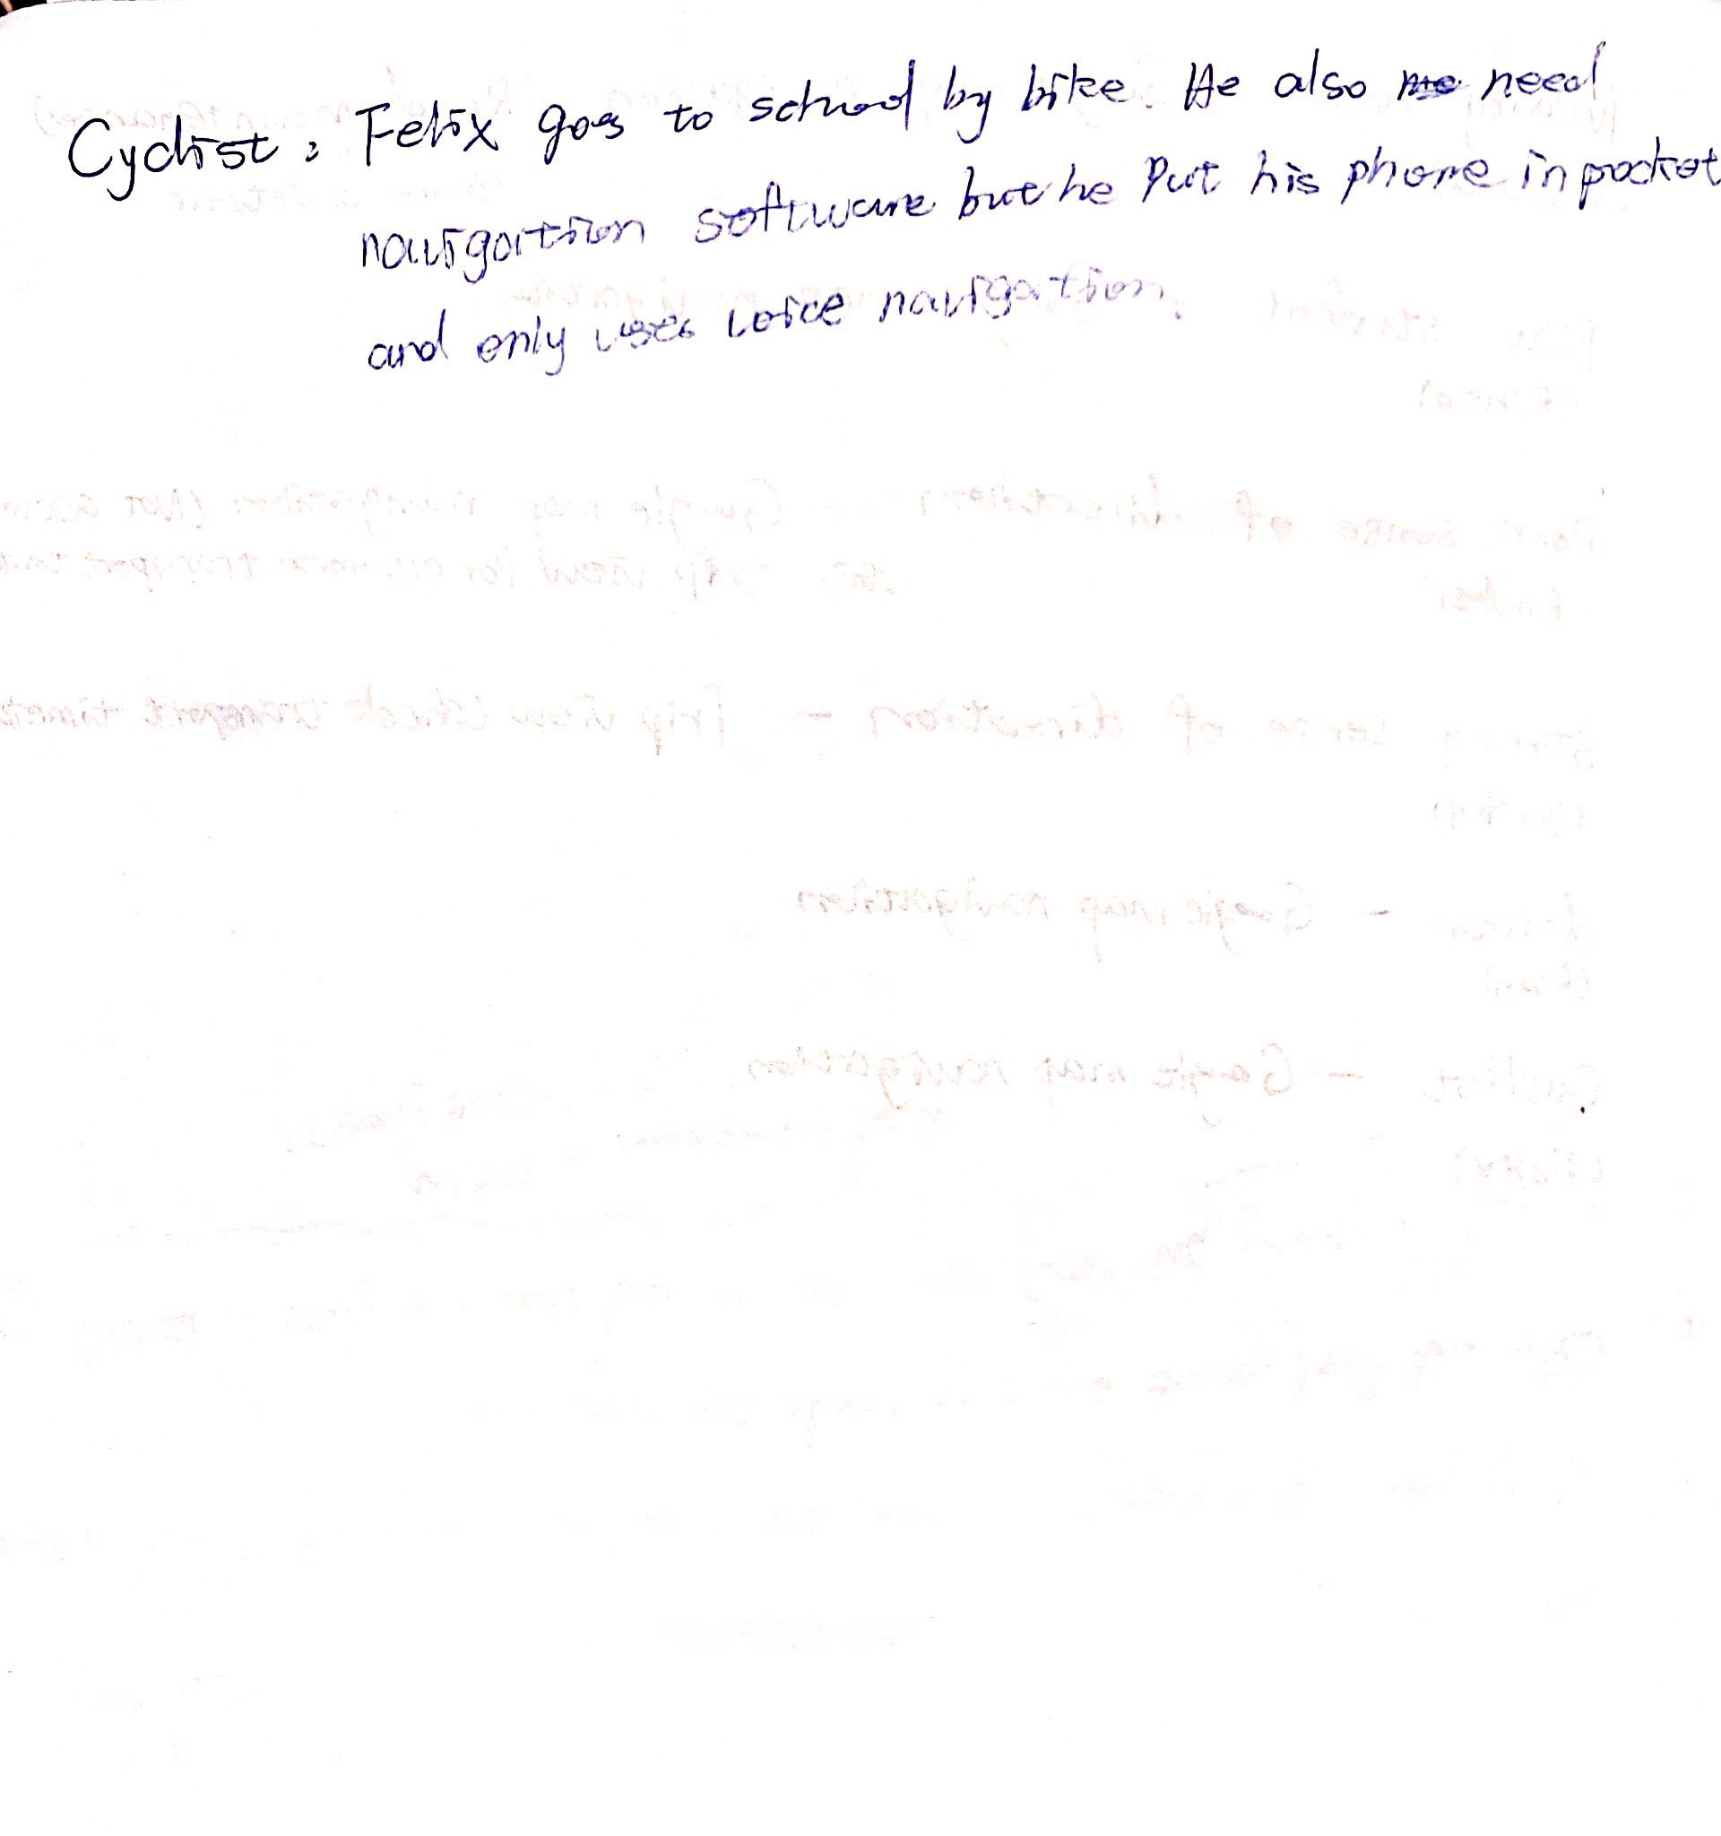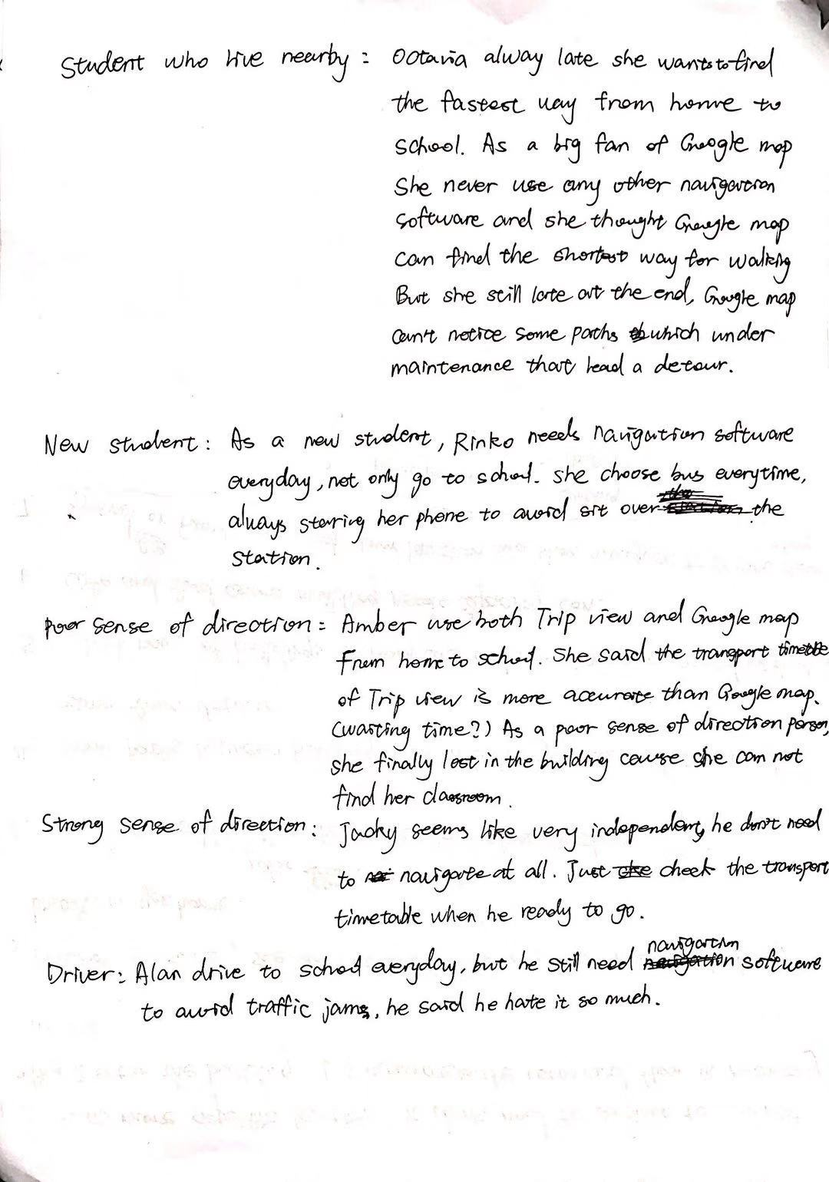

Appendix2: 