Single female P2

Note: The navigation software mentioned below is aimed to the software you use for navigating you from home to the classroom or classroom to home.

1. How do you judge your sense of direction? Very Poor, Poor, Medium, Strong or Very Strong?

Strong.

1. How do you usually go to school?

Walk.

1. Which navigation software do you most commonly use? Why do you choose that APP instead of others?

Google map，everyone is using this, I think there should be some reason.

Note: The navigation software mentioned in Question 4-7 is based on the navigation software you mentioned in question 3.

1. How often do you use navigation software? Usually，Often，Sometimes，Seldom or Never？Why?

Seldom I think, I don’t use it anymore since I know how to get there.

1. Do you think navigation software is easy for you? Very Easy, Easy, Normal, Hard or Very Hard? Why do you think so?

It’s easy for me, because it is much like a software I have used before.

1. Do you think there is any defect in your navigation software? What is it if yes?

Yes, sometimes the paths under maintenance does not noticed, it could lead a detour.

1. On a scale of one to five, how would you rate the impact on the defect?

3.

1. Do you think navigation software is essential to you? Why/Why not？

Not anymore, I’ve already known how to go to school.

1. Is there an irreplaceable navigation software for you? Why/Why not？

Yes, I haven’t heard about any other navigation software is better than Google map.

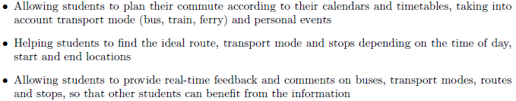

1. If somebody recommend you a new navigation software with features above, would you like to try it? Why/Why not?

I think I will, it is designed for student isn’t it?

1. What other features do you want to have?

I want to have a up timetable features, so the app can plan the route from class to class.