Single female P7

Note: The navigation software mentioned below is aimed to the software you use for navigating you from home to the classroom or classroom to home.

1. How do you judge your sense of direction? Very Poor, Poor, Medium, Strong or Very Strong?

Medium.

1. How do you usually go to school?

Train and walk.

1. Which navigation software do you most commonly use? Why do you choose that APP instead of others?

NextThere. Because the high accuracy of timetable of train in the software.

Note: The navigation software mentioned in Question 4-7 is based on the navigation software you mentioned in question 3.

1. How often do you use navigation software? Usually，Often，Sometimes，Seldom or Never？Why?

Usually. Because I have to check it every day since train schedule is not frequent.

1. Do you think navigation software is easy for you? Very Easy, Easy, Normal, Hard or Very Hard? Why do you think so?

Easy. Because there is only one way from home to the school.

1. Do you think there is any defect in your navigation software? What is it if yes?

No.

1. On a scale of one to five, how would you rate the impact on the defect?

None.

1. Do you think navigation software is essential to you? Why/Why not？

Yes, it can save my time if I can catch the train on time.

1. Is there an irreplaceable navigation software for you? Why/Why not？

Not yet, other applications like TripView also have same function as NextThere.

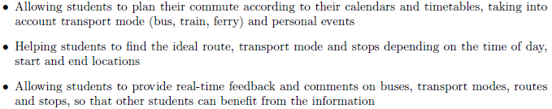

1. If somebody recommend you a new navigation software with features above, would you like to try it? Why/Why not?

Yes, if it can locate the certain classroom.

1. What other features do you want to have?

The application can display if the train is crowded or not.