Single male P6

Note: The navigation software mentioned below is aimed to the software you use for navigating you from home to the classroom or classroom to home.

1. How do you judge your sense of direction? Very Poor, Poor, Medium, Strong or Very Strong?

Strong

1. How do you usually go to school?

Bus

1. Which navigation software do you most commonly use? Why do you choose that APP instead of others?

USYD Map. Because is can show the way in-school and where the exact classroom is.

Note: The navigation software mentioned in Question 4-7 is based on the navigation software you mentioned in question 3.

1. How often do you use navigation software? Usually，Often，Sometimes，Seldom or Never？Why?

Sometime. I use it when I first go to a classroom.

1. Do you think navigation software is easy for you? Very Easy, Easy, Normal, Hard or Very Hard? Why do you think so?

Hard. Sometimes the software cannot locate the input building correctly since it has different calling methods.

1. Do you think there is any defect in your navigation software? What is it if yes?

Yes. Same as Q5.

1. On a scale of one to five, how would you rate the impact on the defect?

3.

1. Do you think navigation software is essential to you? Why/Why not？

Yes, I need it to find the correct classroom.

1. Is there an irreplaceable navigation software for you? Why/Why not？

Yes, it is irreplaceable currently since no other applications can help me locate the particular classroom.

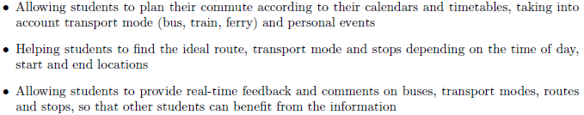

1. If somebody recommend you a new navigation software with features above, would you like to try it? Why/Why not?

Yes, if the problem in Q5 can be solved.

1. What other features do you want to have?

All in-school restaurant or library can be marked in the map.