Single male P1

Note: The navigation software mentioned below is aimed to the software you use for navigating you from home to the classroom or classroom to home.

1. How do you judge your sense of direction? Very Poor, Poor, Medium, Strong or Very Strong?

Very strong

1. How do you usually go to school?

Drive

1. Which navigation software do you most commonly use? Why do you choose that APP instead of others?

Google map, I only know this navigation software.

Note: The navigation software mentioned in Question 4-7 is based on the navigation software you mentioned in question 3.

1. How often do you use navigation software? Usually，Often，Sometimes，Seldom or Never？Why?

Usually, I need to check road condition.

1. Do you think navigation software is easy for you? Very Easy, Easy, Normal, Hard or Very Hard? Why do you think so?

It’s very easy，this is not difficult at all since it is easy understanding.

1. Do you think there is any defect in your navigation software? What is it if yes?

I think all the navigation software have accurate problem, but I don’t think it does matter.

1. On a scale of one to five, how would you rate the impact on the defect?

2.

1. Do you think navigation software is essential to you? Why/Why not？

Yes, I drive every day, so it is necessary.

1. Is there an irreplaceable navigation software for you? Why/Why not？

Yes, it is because I do not know other software.

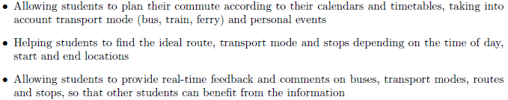

1. If somebody recommend you a new navigation software with features above, would you like to try it? Why/Why not?

Yes, I’ll try it, it looks very suitable for student.

1. What other features do you want to have?

I would like to have a friend feature, it’s like we can see each other’s location so we can have lunch during the break or go home ect.