With friends P5

Note: The navigation software mentioned below is aimed to the software you use for navigating you from home to the classroom or classroom to home.

1. How do you judge your sense of direction? Very Poor, Poor, Medium, Strong or Very Strong?

Poor

1. How do you usually go to school?

Bus

1. Which navigation software do you most commonly use? Why do you choose that APP instead of others?

Google map，all my friends are using this, normally I just follow my friends.

Note: The navigation software mentioned in Question 4-7 is based on the navigation software you mentioned in question 3.

1. How often do you use navigation software? Usually，Often，Sometimes，Seldom or Never？Why?

Usually，I can't remember the way.

1. Do you think navigation software is easy for you? Very Easy, Easy, Normal, Hard or Very Hard? Why do you think so?

Normal, I felt a bit complicated at first, and now I am getting used to it.

1. Do you think there is any defect in your navigation software? What is it if yes?

Sometimes the waiting time of the bus is not accurate enough, once I waited for half of an hour.

1. On a scale of one to five, how would you rate the impact on the defect?

4.

1. Do you think navigation software is essential to you? Why/Why not？

Yes, thought I can follow my friends, sometimes I have to go to school alone.

1. Is there an irreplaceable navigation software for you? Why/Why not？

No, now I use one more application for checking bus timetable.

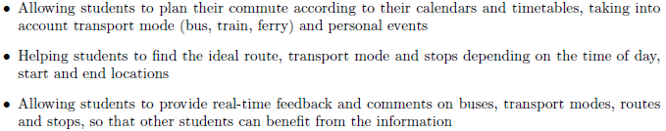

1. If somebody recommend you a new navigation software with features above, would you like to try it? Why/Why not?

Yes, it seems just suitable for me.

1. What other features do you want to have?

Having friend function is nice so that I can go back with friends.