With parents P4

Note: The navigation software mentioned below is aimed to the software you use for navigating you from home to the classroom or classroom to home.

1. How do you judge your sense of direction? Very Poor, Poor, Medium, Strong or Very Strong?

Strong

1. How do you usually go to school?

Drive

1. Which navigation software do you most commonly use? Why do you choose that APP instead of others?

Google map，I have not heard that other software is better than this.

Note: The navigation software mentioned in Question 4-7 is based on the navigation software you mentioned in question 3.

1. How often do you use navigation software? Usually，Often，Sometimes，Seldom or Never？Why?

Often, because I know the road in Sydney is always in maintenance, you know

1. Do you think navigation software is easy for you? Very Easy, Easy, Normal, Hard or Very Hard? Why do you think so?

just normal, cause sometimes there are defects, so it's not that easy.

1. Do you think there is any defect in your navigation software? What is it if yes?

I have been navigating into the path several times, and then I can't get through it. There are still a few road repairs or one-way roads. I think there are quite a lot of places for improvement

1. On a scale of one to five, how would you rate the impact on the defect?

6.

1. Do you think navigation software is essential to you? Why/Why not？

Not really，I’m living nearby ,it is not hard to find the way.

1. Is there an irreplaceable navigation software for you? Why/Why not？

Yes, Google Map is the best navigating software, at least for the driver.

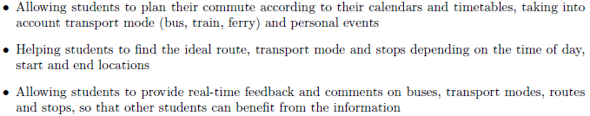

1. If somebody recommend you a new navigation software with features above, would you like to try it? Why/Why not?

Not sure. It seems more depend on public transportation.

1. What other features do you want to have?

The parking space around the school since it is really hard to find a space to park.