INFO3315

**Human-Computer Interaction**

**Project Phase 3**

R16C – Group5

Group Members (SID):

470011746

460047977

490444409

2. Horizontal prototype

(a) Platform: iOS

(b) As the paper prototype shows, this app is designed to work on iPhone, so the app is based on iOS system, the basic UI colors is black and white, which can give users a simple and nice experience, and let the user more focus on the app’s core functions. At most of all scenarios, the map is always the key element with the biggest size in the screen, which can achieve the functions of being a commute planning app easily. Like the route planning feature, the user can simply place two marks on the map to represent starting points and destinations. The route can be automatically generated on the map with the time taken, nearby café, nearby gas station shown below. So, it let the user immediately know what to do after they see the map. The app is needed to log on with user’s school e-mail and password, but they can decide to keep themselves logged on for 30 days. If some users forgot the passwords, they can easily reset the password by using the school e-mail address. Users can upload their feedbacks to the developers of the app too.

(c) PDF name: INFO3315_ProjectPhase3_HorizontalPrototype_R16C – Group5.pdf

3. Vertical prototype

(b) 1. The route function gives users both recommended routes and also different choices according different situations.

2. The search functions in Map make sure users can locate the right places and prediction arrive time that need to go before setting off.

3. The option function of setting routes make sure routes can be generated according the times.

4. The Bookmark helps users to store their frequent destination and preferences and the Calendar helps users better in planning their daily routines.

5. The tracking functions using GPS to let the user know if they are on the right route they set.

6. When the user approach to some important places like café, gas station, the system can show these places nearby.

7. The feedback system can provide users and interact with other users with very specific and real-time information because users are involved in the situation.

8. Users can get real-time information of transportation and road condition so that they can change their route at any time.

(c) According to the storyboard in project2, Mike need to change his normal route to school because of climate change, and the system will automatically generate a route change interface and give Mike they recommend routes, and if he want, he can also set the routes manually. He can also choose the way to go to school, like on foot or by train, by bus, the system can give him the best route according to his situation.

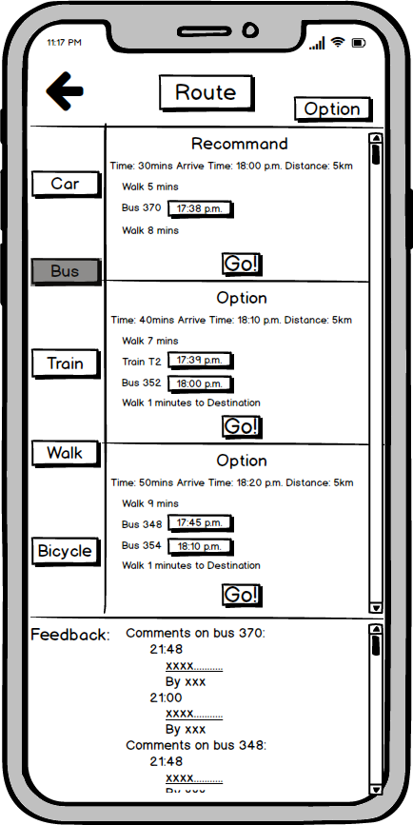

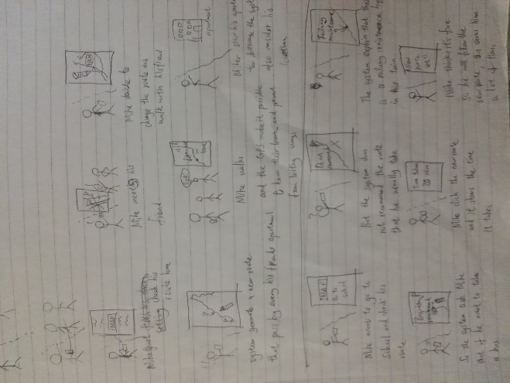

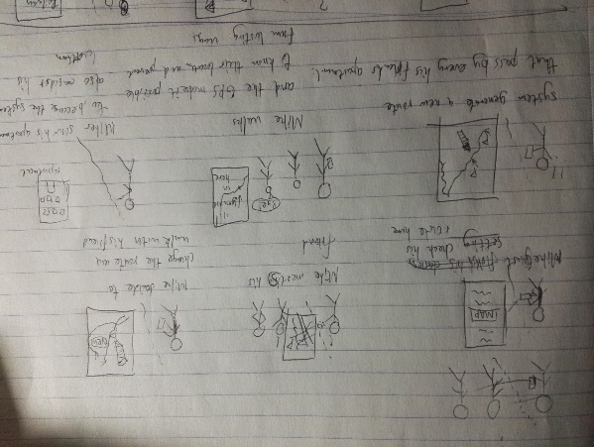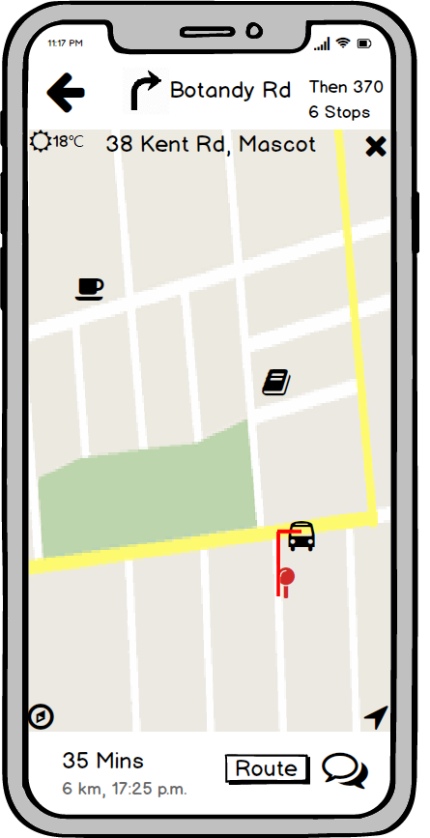According to the storyboard in project2, Mike need to walk with his friends and know his current location, to achieve that Mike only need to keep watching his route on his phone, the yellow line is the pass he is walking, by using the GPS system in the app, he can track his current location easily.

For the persona Judo who wakes up at the morning and find it’s a bit late for him go to school. He gets to hurry up. What he should do is open the Application to the main entrance, click the ‘Time Table’ option and choose the unit of study. After clicking ‘Go’ which leads him to the ‘Map’ page, he should firstly confirm the remaining time with different transportation. Then he can click ‘Route’ bottom and choose the ‘Recommend Route’ for pre-defined best-route option. After that, he can follow the navigation and watch for the feedback if there is any sudden situation. He can change the route any time on his way. Finally, he should click ‘x’ bottom to completely quit the navigation mode.

For the persona Miya whose first day to the school. She should firstly type her student email and password to confirm she is a student from the USYD. After that, she can enter the ‘Map’ option to search for the address of the school. She may not be confused because when she is typing, there will be similar address come out for her convenience. After determining the destination, she can choose the route to go and follow the navigation closely. In her way, she can also provide some feedback for transportation’s situation or just her first-day mood. It is a good way for her to be familiar with the application and the city. She can follow it until get into the classroom and turn it off.

Using your concept from Project Phase 1 and sketches from Project Phase 2, identify all screens you need to implement for a user to click through the scenarios.

(e)  1. Give users different choices in different scenarios with real-time information:

- Route function for users to make different choices once determine the transport type;

- Distinct interface of different transportation;

- Feedback function involved as a part of navigation;

- Real-time data of transportation and road condition;

- Other available routes with predication arrive time;

- Route Option for users to choose with less walk distance, less money spent or less travel time.

2. The system should work logically with non-designer's vision and need to coherent with different kind of users:

- Link system to almost every icon in main ‘Map’ part of prototype;

- Provide 5 different travel modes to satisfy different demands from different users and allow them to change modes while traveling;

- Allow users stop navigating at mid-way since their mobile devices are out of battery or they already kept remaining way in their mind;

- Provide ‘Point at the map’ function.

3. During the end of prtotyping, different types of users are invited to do the test and according to the result, we make sure the icons in the app can be easily understand and fast learned by users:

- For the icon which is hard to understand, text explanation is used;

- The font and icon size are adjusted to be suitable and clear;

- Add a ‘View Feedback’ page to support for original ‘Feedback’ page more understandable and practical.

- System design of ‘Map’ part is a bit similar to ‘GOOGLE MAP’.

(f) PDF name: INFO3315_ProjectPhase3_R16C – Group5_FV.pdf