*The comparison of user’s performances between the* ***prototype*** *and the local commute planning app* ***Opal Travel***

**PARTICIPANT CONSENT FORM**

I, ....Mike Wu............................................................................... [PRINT NAME], agree to take part in this research study.

In giving my consent I state that:

* I understand the purpose of the study, what I will be asked to do, and any risks/benefits involved.
* I have read the Participant Information Statement and have been able to discuss my involvement in the study with the researchers if I wished to do so.
* The researchers have answered any questions that I had about the study and I am happy with the answers.
* I understand that being in this study is completely voluntary and I do not have to take part. My decision whether to be in the study will not affect my relationship with the researchers or anyone else at the University of Sydney now or in the future.
* I understand that I can withdraw from the study at any time.
* I understand that I may leave the focus group at any time if I do not wish to continue. I also understand that it will not be possible to withdraw my comments once the group has started as it is a group discussion.
* I understand that my questionnaire responses cannot be withdrawn once they are submitted, as they are anonymous and therefore the researchers will not be able to tell which one is mine.
* I understand that personal information about me that is collected over the course of this project will be stored securely and will only be used for purposes that I have agreed to. I understand that information about me will only be told to others with my permission, except as required by law.

I understand that the results of this study may be published, but these publications will not contain my name or any identifiable information about me unless I consent to being identified using the ‘**Yes**’ checkbox below.

**Yes**, I am happy to be identified.

**No**, I don’t want to be identified. Please keep my identity anonymous.

I consent to:

* **Being contacted about future studies** YES NO

**I would like to review my interview transcripts** YES NO

**I would like to receive feedback about my personal results** YES NO

**I would like to receive feedback about the overall results of this study**

YES NO

If you answered **YES**, please indicate your preferred form of feedback and address:

Postal: _______________________________________________________

___________________________________________________

Email: ____2316148756@qq.com____________________________

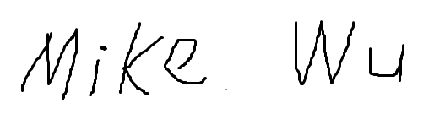

...................................................................

**Signature**

Mike Wu

....................................................

**PRINT name**

**2019/11/05**

..................................................................................

**Date**