Task 1

|  |  |  |
| --- | --- | --- |
| KMO and Bartlett's Test | | |
| Kaiser-Meyer-Olkin Measure of Sampling Adequacy. | | .803 |
| Bartlett's Test of Sphericity | Approx. Chi-Square | 5215.601 |
| df | 190 |
| Sig. | .000 |

Exploratory factor analysis showed that the value of KMO was 0.803, which was very suitable for factor analysis.Bartlett's Test of Sphericity showed a significance of less than 0.05.

|  |  |  |
| --- | --- | --- |
| Communalities | | |
|  | Initial | Extraction |
| Q1 | 1.000 | .725 |
| Q2 | 1.000 | .918 |
| Q3 | 1.000 | .874 |
| Q4 | 1.000 | .943 |
| Q5 | 1.000 | .913 |
| Q6 | 1.000 | .913 |
| Q7 | 1.000 | .511 |
| Q8 | 1.000 | .981 |
| Q9 | 1.000 | .728 |
| Q10 | 1.000 | .869 |
| Q11 | 1.000 | .829 |
| Q12 | 1.000 | .964 |
| Q13 | 1.000 | .805 |
| Q14 | 1.000 | .838 |
| Q15 | 1.000 | .776 |
| Q16 | 1.000 | .960 |
| Q17 | 1.000 | .796 |
| Q18 | 1.000 | .801 |
| Q19 | 1.000 | .769 |
| Q20 | 1.000 | .955 |
| Extraction Method: Principal Component Analysis. | | |

The results from the Communalities show that most of the variables are well explained by common factors, and the value of Q7 is greater than 0.5, which can be retained.

|  |  |  |  |  |  |  |  |  |  |
| --- | --- | --- | --- | --- | --- | --- | --- | --- | --- |
| Total Variance Explained | | | | | | | | | |
| Component | Initial Eigenvalues | | | Extraction Sums of Squared Loadings | | | Rotation Sums of Squared Loadings | | |
| Total | % of Variance | Cumulative % | Total | % of Variance | Cumulative % | Total | % of Variance | Cumulative % |
| 1 | 9.682 | 48.411 | 48.411 | 9.682 | 48.411 | 48.411 | 3.787 | 18.935 | 18.935 |
| 2 | 2.637 | 13.187 | 61.597 | 2.637 | 13.187 | 61.597 | 3.506 | 17.529 | 36.464 |
| 3 | 1.674 | 8.371 | 69.969 | 1.674 | 8.371 | 69.969 | 3.471 | 17.356 | 53.820 |
| 4 | 1.582 | 7.908 | 77.876 | 1.582 | 7.908 | 77.876 | 3.229 | 16.144 | 69.964 |
| 5 | 1.291 | 6.455 | 84.331 | 1.291 | 6.455 | 84.331 | 2.873 | 14.367 | 84.331 |
| 6 | .571 | 2.857 | 87.188 |  |  |  |  |  |  |
| 7 | .434 | 2.172 | 89.360 |  |  |  |  |  |  |
| 8 | .388 | 1.942 | 91.302 |  |  |  |  |  |  |
| 9 | .374 | 1.872 | 93.174 |  |  |  |  |  |  |
| 10 | .267 | 1.333 | 94.506 |  |  |  |  |  |  |
| 11 | .251 | 1.254 | 95.760 |  |  |  |  |  |  |
| 12 | .221 | 1.105 | 96.865 |  |  |  |  |  |  |
| 13 | .208 | 1.038 | 97.903 |  |  |  |  |  |  |
| 14 | .151 | .754 | 98.657 |  |  |  |  |  |  |
| 15 | .145 | .726 | 99.383 |  |  |  |  |  |  |
| 16 | .040 | .198 | 99.581 |  |  |  |  |  |  |
| 17 | .026 | .130 | 99.711 |  |  |  |  |  |  |
| 18 | .024 | .118 | 99.829 |  |  |  |  |  |  |
| 19 | .019 | .095 | 99.924 |  |  |  |  |  |  |
| 20 | .015 | .076 | 100.000 |  |  |  |  |  |  |
| Extraction Method: Principal Component Analysis. | | | | | | | | | |

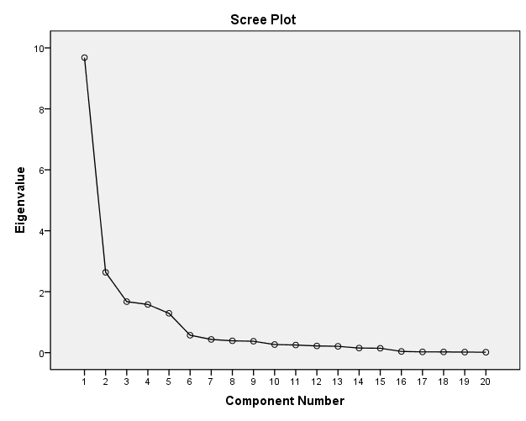retain the first five factors.

|  |  |  |  |  |  |
| --- | --- | --- | --- | --- | --- |
| Component Matrixa | | | | | |
|  | Component | | | | |
| 1 | 2 | 3 | 4 | 5 |
| Q16 | .800 | .017 | -.221 | .182 | -.488 |
| Q20 | .796 | -.054 | -.422 | -.083 | .366 |
| Q15 | .772 | -.097 | -.270 | .155 | -.270 |
| Q3 | .761 | -.274 | .277 | -.373 | -.061 |
| Q14 | .759 | -.036 | -.215 | .224 | -.405 |
| Q1 | .747 | -.227 | .145 | -.303 | -.041 |
| Q19 | .743 | -.035 | -.326 | -.091 | .318 |
| Q17 | .739 | -.081 | -.374 | -.066 | .316 |
| Q4 | .732 | -.316 | .324 | -.435 | -.114 |
| Q8 | .709 | -.202 | .371 | .516 | .185 |
| Q18 | .698 | -.059 | -.444 | -.088 | .323 |
| Q13 | .695 | .091 | -.258 | .169 | -.467 |
| Q5 | .689 | -.142 | .379 | .506 | .136 |
| Q2 | .688 | -.316 | .368 | -.447 | -.098 |
| Q6 | .688 | -.169 | .330 | .491 | .249 |
| Q7 | -.669 | .231 | -.047 | .088 | -.017 |
| Q12 | .537 | .800 | .160 | -.089 | .026 |
| Q10 | .480 | .768 | .192 | -.039 | .102 |
| Q11 | .529 | .722 | .115 | -.111 | -.047 |
| Q9 | .571 | .619 | .107 | -.070 | .048 |
| Extraction Method: Principal Component Analysis. | | | | | |
| a. 5 components extracted. | | | | | |

|  |  |  |  |  |  |
| --- | --- | --- | --- | --- | --- |
| Rotated Component Matrixa | | | | | |
|  | Component | | | | |
| 1 | 2 | 3 | 4 | 5 |
| Q2 | .920 | .136 | .090 | .131 | .164 |
| Q4 | .918 | .175 | .095 | .183 | .163 |
| Q3 | .850 | .239 | .128 | .194 | .204 |
| Q1 | .721 | .313 | .129 | .242 | .182 |
| Q7 | -.497 | -.343 | -.053 | -.262 | -.274 |
| Q20 | .233 | .886 | .173 | .238 | .172 |
| Q18 | .185 | .828 | .127 | .230 | .108 |
| Q17 | .232 | .799 | .134 | .235 | .175 |
| Q19 | .254 | .771 | .190 | .210 | .173 |
| Q12 | .087 | .116 | .958 | .136 | .077 |
| Q10 | .042 | .108 | .914 | .056 | .134 |
| Q11 | .117 | .107 | .874 | .198 | .031 |
| Q9 | .135 | .193 | .794 | .164 | .120 |
| Q16 | .255 | .225 | .206 | .875 | .191 |
| Q13 | .162 | .204 | .229 | .819 | .116 |
| Q14 | .218 | .249 | .144 | .805 | .243 |
| Q15 | .248 | .384 | .097 | .712 | .225 |
| Q8 | .248 | .182 | .100 | .212 | .912 |
| Q6 | .213 | .234 | .120 | .162 | .879 |
| Q5 | .232 | .133 | .147 | .232 | .875 |
| Extraction Method: Principal Component Analysis.  Rotation Method: Varimax with Kaiser Normalization.a | | | | | |
| a. Rotation converged in 6 iterations. | | | | | |

As can be seen from the figure, Q2, Q4, Q3, Q1 and Q7 are factor1, Q20, Q18, Q17 and Q19 are factor2, Q12, Q10, Q11 and Q9 are factor3, Q16, Q13, Q14 and Q15 are factor4, and Q8, Q6 and Q5 are factor5.

|  |  |  |  |  |  |
| --- | --- | --- | --- | --- | --- |
| Component Transformation Matrix | | | | | |
| Component | 1 | 2 | 3 | 4 | 5 |
| 1 | .502 | .494 | .357 | .471 | .394 |
| 2 | -.381 | -.095 | .899 | -.014 | -.194 |
| 3 | .440 | -.626 | .218 | -.375 | .475 |
| 4 | -.623 | -.122 | -.121 | .295 | .704 |
| 5 | -.144 | .583 | .052 | -.742 | .293 |
| Extraction Method: Principal Component Analysis.  Rotation Method: Varimax with Kaiser Normalization. | | | | | |