Task2

|  |  |
| --- | --- |
| Reliability Statistics | |
| Cronbach's Alpha | N of Items |
| .921 | 20 |

The value is 0.921, which has an internal consistency reliability.

|  |  |  |
| --- | --- | --- |
| Communalities | | |
|  | Initial | Extraction |
| SAT1 | 1.000 | .770 |
| SAT2 | 1.000 | .881 |
| SAT3 | 1.000 | .787 |
| SAT4 | 1.000 | .666 |
| PEER1 | 1.000 | .927 |
| PEER2 | 1.000 | .936 |
| PEER4 | 1.000 | .986 |
| OSUP1 | 1.000 | .647 |
| OSUP2 | 1.000 | .881 |
| OSUP3 | 1.000 | .874 |
| OSUP4 | 1.000 | .957 |
| PU1 | 1.000 | .720 |
| PU2 | 1.000 | .856 |
| PU3 | 1.000 | .795 |
| PU4 | 1.000 | .951 |
| PEOU1 | 1.000 | .741 |
| PEOU2 | 1.000 | .814 |
| PEOU3 | 1.000 | .733 |
| PEOU4 | 1.000 | .951 |
| PEER3r | 1.000 | .154 |
| Extraction Method: Principal Component Analysis. | | |

As you can see, PEER3r needs to be removed

|  |  |  |
| --- | --- | --- |
| KMO and Bartlett's Test | | |
| Kaiser-Meyer-Olkin Measure of Sampling Adequacy. | | .806 |
| Bartlett's Test of Sphericity | Approx. Chi-Square | 4789.250 |
| df | 171 |
| Sig. | .000 |

|  |  |  |
| --- | --- | --- |
| Communalities | | |
|  | Initial | Extraction |
| SAT1 | 1.000 | .775 |
| SAT2 | 1.000 | .887 |
| SAT3 | 1.000 | .812 |
| SAT4 | 1.000 | .708 |
| PEER1 | 1.000 | .935 |
| PEER2 | 1.000 | .942 |
| PEER4 | 1.000 | .988 |
| OSUP1 | 1.000 | .679 |
| OSUP2 | 1.000 | .878 |
| OSUP3 | 1.000 | .870 |
| OSUP4 | 1.000 | .960 |
| PU1 | 1.000 | .717 |
| PU2 | 1.000 | .876 |
| PU3 | 1.000 | .828 |
| PU4 | 1.000 | .957 |
| PEOU1 | 1.000 | .763 |
| PEOU2 | 1.000 | .829 |
| PEOU3 | 1.000 | .729 |
| PEOU4 | 1.000 | .955 |
| Extraction Method: Principal Component Analysis. | | |

|  |  |  |  |  |  |  |  |  |  |
| --- | --- | --- | --- | --- | --- | --- | --- | --- | --- |
| Total Variance Explained | | | | | | | | | |
| Component | Initial Eigenvalues | | | Extraction Sums of Squared Loadings | | | Rotation Sums of Squared Loadings | | |
| Total | % of Variance | Cumulative % | Total | % of Variance | Cumulative % | Total | % of Variance | Cumulative % |
| 1 | 8.842 | 46.536 | 46.536 | 8.842 | 46.536 | 46.536 | 3.402 | 17.904 | 17.904 |
| 2 | 2.722 | 14.326 | 60.862 | 2.722 | 14.326 | 60.862 | 3.340 | 17.577 | 35.481 |
| 3 | 1.865 | 9.814 | 70.675 | 1.865 | 9.814 | 70.675 | 3.304 | 17.387 | 52.868 |
| 4 | 1.399 | 7.363 | 78.038 | 1.399 | 7.363 | 78.038 | 3.197 | 16.825 | 69.693 |
| 5 | 1.259 | 6.627 | 84.664 | 1.259 | 6.627 | 84.664 | 2.844 | 14.971 | 84.664 |
| 6 | .516 | 2.718 | 87.383 |  |  |  |  |  |  |
| 7 | .423 | 2.227 | 89.610 |  |  |  |  |  |  |
| 8 | .396 | 2.086 | 91.695 |  |  |  |  |  |  |
| 9 | .353 | 1.858 | 93.553 |  |  |  |  |  |  |
| 10 | .333 | 1.752 | 95.305 |  |  |  |  |  |  |
| 11 | .217 | 1.142 | 96.447 |  |  |  |  |  |  |
| 12 | .185 | .974 | 97.421 |  |  |  |  |  |  |
| 13 | .165 | .868 | 98.289 |  |  |  |  |  |  |
| 14 | .136 | .717 | 99.007 |  |  |  |  |  |  |
| 15 | .100 | .526 | 99.533 |  |  |  |  |  |  |
| 16 | .031 | .166 | 99.698 |  |  |  |  |  |  |
| 17 | .026 | .134 | 99.832 |  |  |  |  |  |  |
| 18 | .019 | .098 | 99.930 |  |  |  |  |  |  |
| 19 | .013 | .070 | 100.000 |  |  |  |  |  |  |
| Extraction Method: Principal Component Analysis. | | | | | | | | | |

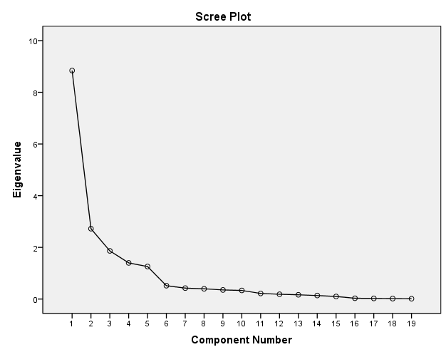

Extract five factors

|  |  |  |  |  |  |
| --- | --- | --- | --- | --- | --- |
| Component Matrixa | | | | | |
|  | Component | | | | |
| 1 | 2 | 3 | 4 | 5 |
| PU4 | .815 | -.171 | -.127 | -.165 | -.469 |
| PU3 | .788 | -.168 | -.195 | -.112 | -.357 |
| PU2 | .765 | -.135 | -.168 | -.210 | -.447 |
| PEOU1 | .753 | -.151 | -.094 | -.134 | -.382 |
| PEOU4 | .744 | -.004 | -.546 | .013 | .320 |
| SAT2 | .741 | -.268 | .271 | .436 | .053 |
| PEER4 | .741 | -.140 | .430 | -.415 | .249 |
| PEER1 | .740 | -.134 | .407 | -.395 | .221 |
| SAT3 | .736 | -.244 | .204 | .410 | -.034 |
| PEER2 | .711 | -.133 | .411 | -.419 | .273 |
| PEOU3 | .702 | .007 | -.421 | -.003 | .245 |
| PEOU2 | .679 | -.018 | -.524 | .067 | .297 |
| PU1 | .675 | -.011 | -.434 | .023 | .271 |
| SAT1 | .649 | -.242 | .262 | .447 | .164 |
| SAT4 | .602 | -.230 | .264 | .454 | -.129 |
| OSUP4 | .490 | .842 | .092 | .021 | -.046 |
| OSUP3 | .447 | .816 | .011 | .024 | -.062 |
| OSUP2 | .504 | .766 | .183 | .062 | -.017 |
| OSUP1 | .523 | .603 | .141 | .139 | -.052 |
| Extraction Method: Principal Component Analysis. | | | | | |
| a. 5 components extracted. | | | | | |

|  |  |  |  |  |  |
| --- | --- | --- | --- | --- | --- |
| Rotated Component Matrixa | | | | | |
|  | Component | | | | |
| 1 | 2 | 3 | 4 | 5 |
| OSUP4 | .961 | .130 | .096 | .017 | .097 |
| OSUP3 | .912 | .160 | .107 | -.023 | .031 |
| OSUP2 | .911 | .090 | .065 | .112 | .149 |
| OSUP1 | .772 | .118 | .120 | .212 | .098 |
| PEOU4 | .144 | .912 | .242 | .156 | .140 |
| PEOU2 | .119 | .856 | .210 | .178 | .085 |
| PU1 | .136 | .774 | .220 | .175 | .146 |
| PEOU3 | .163 | .763 | .255 | .167 | .168 |
| PU4 | .125 | .246 | .878 | .252 | .217 |
| PU2 | .129 | .259 | .849 | .169 | .205 |
| PU3 | .104 | .340 | .777 | .255 | .181 |
| PEOU1 | .123 | .237 | .761 | .254 | .220 |
| SAT2 | .085 | .215 | .212 | .852 | .250 |
| SAT1 | .068 | .231 | .074 | .808 | .240 |
| SAT3 | .099 | .214 | .293 | .796 | .190 |
| SAT4 | .087 | .060 | .270 | .783 | .101 |
| PEER4 | .133 | .163 | .238 | .248 | .909 |
| PEER2 | .124 | .173 | .207 | .223 | .897 |
| PEER1 | .139 | .165 | .256 | .251 | .871 |
| Extraction Method: Principal Component Analysis.  Rotation Method: Varimax with Kaiser Normalization. | | | | | |
| a. Rotation converged in 6 iterations. | | | | | |

You can see the grouping of variables by factors

|  |  |  |  |  |  |
| --- | --- | --- | --- | --- | --- |
| Component Transformation Matrix | | | | | |
| Component | 1 | 2 | 3 | 4 | 5 |
| 1 | .343 | .483 | .508 | .464 | .419 |
| 2 | .919 | -.022 | -.194 | -.308 | -.150 |
| 3 | .153 | -.715 | -.206 | .378 | .529 |
| 4 | .092 | .040 | -.274 | .739 | -.607 |
| 5 | -.079 | .504 | -.766 | .020 | .391 |
| Extraction Method: Principal Component Analysis.  Rotation Method: Varimax with Kaiser Normalization. | | | | | |

