INFS3050

**Business Intelligence for Managers**

**Practical Group Assignment**

Group 2 (SID):

470011746

470200281

470278394

470041259

470336557

470073113

460463166

**2. Descriptions of the Personas and Visualizations**

**2.1. Persona 1**

**2.1.1. Description**

|  |  |
| --- | --- |
| **Persona:** | Assistant for the European Commissioner of Energy |
| **Role:** | General Assistant for the European Commissioner, The Energy Union  Bachelor of Environment, The University of Edinburgh  Master of Marketing, Imperial College Business School  6 years of experience as the staff and 3 years as the manager of the marketing department, Places for People Energy |
| **Context of work:** | * Understand and develop the union’s strategic plan * Handle and maintain relationships with partner companies * Organize, supervise and be responsible for project investigation * Lead the team to organize and implement the union’s objectives * Organize all the staff of the team to conduct marketing, project management, and customer management to ensure that all tasks are completed. * Coordinate, formulate, decompose, and evaluate the union’s goals and objectives according to the union’s tasks |
| **Key activities:** | * Deal with the energy dispute between member countries of commission * Hold daily, weekly, monthly and emergency meeting * Turn on the final report of the profit and efficiency of low-carbon and clean energy in the market to decide their substitutability * Make daily, weekly and monthly report about the current situation and plan to the commissioner * Investigate the safety and security of nuclear power * Develop new energy policy * Investigate the energy efficiency among member countries * Develop different energy plans for each member country * Look for the energy problem among member countries |
| **Data Visualisation Questions:** | Question 1: Will the current trend of carbon emissions be reduced by 40% in 2030 compared to 2005 which is the current union’s strategy?  Question 2: Looking for energy-poor members and discussing assistance programs for the future.  Question 3: Which countries can achieve power interoperability to achieve power diversification? |

**2.1.2. Data model (dimensional model) - figure 1**

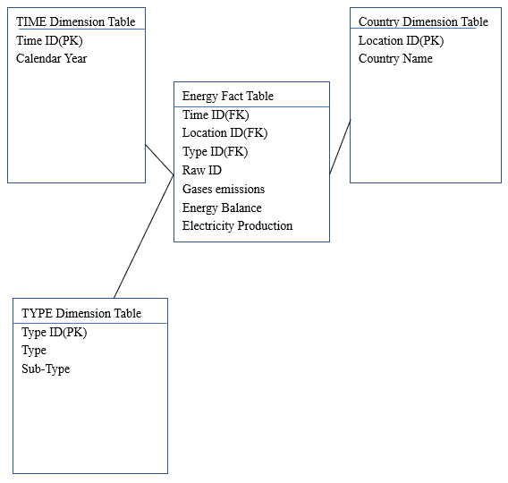

*Figure 1. Star schema for General Assistant for the European Commissioner, The Energy Union*

**2.1.3. Data visualizations (figure 2)**

Q1: Dimension:

Year: 2005-2016

Type: CO2 Commissions, Carbon-related Energy Consumption (total energy consumption - renewable energy consumption - nuclear consumption)

Country: European Union - 28

The Line Chart gives predictions for the next 14 years depends on the CO2 emissions data from 2005-2016 in the European Union with 5 percent float. It should show if the value is larger than 60% of the carbon emissions in 2005 which is 2660.4 (4434 * 0.6) mio tons or not.

The downtrend of consumption of carbon-related energy is the supporting evidence that the number of emissions of CO2 is and will be falling as the prediction.

The result turns out the carbon emissions in 2030 will be 2717 mio tons with the float of 2581.15 to 2852.85 mio tons. The target value is a bit lower than prediction which is in the lower float.

Insight(Solution) :

Reduce the permission of carbon emissions of countries in the EU28 to make the value of top float meets 2660.4 mio tons. It takes 7 percent (1 - 2660.4 / 2852.85) fewer in permission to achieve the expected value.

Q2: Dimension:

Year: 2016

Type: Total Energy (Net Imports + Production), Import Rate (Net Imports / Total Energy), Energy Remain (Total Energy - Gross Inland Consumption)

Country: All member countries in the EU28 exclude EU28

The treemaps shows the total energy reserve in each member country in 2016 as size and import rate is shown as color from 7.44% to 99.25% as green to red with 7 stages. A country is judged as a energy-poor country if import rate is larger than 60%. It grades countries in different levels with the total amount of energy.

The bar chart is used to plan and solve the problems of poor-energy country which shows the energy remain of each country after consumption.

Insight(Solution):

Assistance Program

1. For the low level energy-poor countries(on the right and below of Portugal): Emphasis on development and construction of new energy sources to be self-sufficient through funding, since it demands for energy is low.
2. For the medium level energy-poor countries(on the right and below of Poland till Portugal): Emphasis on exporting energy from the same or upper level countries with sufficient energy remaining at a lower price through negotiation or subsides.
3. For the high level energy-poor countries(on the right and below of Germany till Poland): Emphasis on exporting energy from other countries not in EU28 with a reasonable price through subsidies.

Q3: Dimension:

Year: 2016

Type: Gross Electricity Generation with 11 different fuel types

Country: All member countries in the EU28 exclude EU28

The symbol maps and filter shows that the whole EU28 is lack of electricity generation of the type of Tide, Wave and Ocean after processing the data. Germany has the most resourceful electricity generation which only lack of geothermal which only Italy has the considerable production among the EU8. United Kingdom, Italy, France and Germany are resourceful in electricity generation.

Insight(Solution):

Since the electricity is transported by lines and pipes, the physical distance is an important fact of cost saving. The resourceful member countries can be repaid by other types of electricity or subsides.

*Figure2: Data visualizations for General Assistant for the European Commissioner, The Energy Union*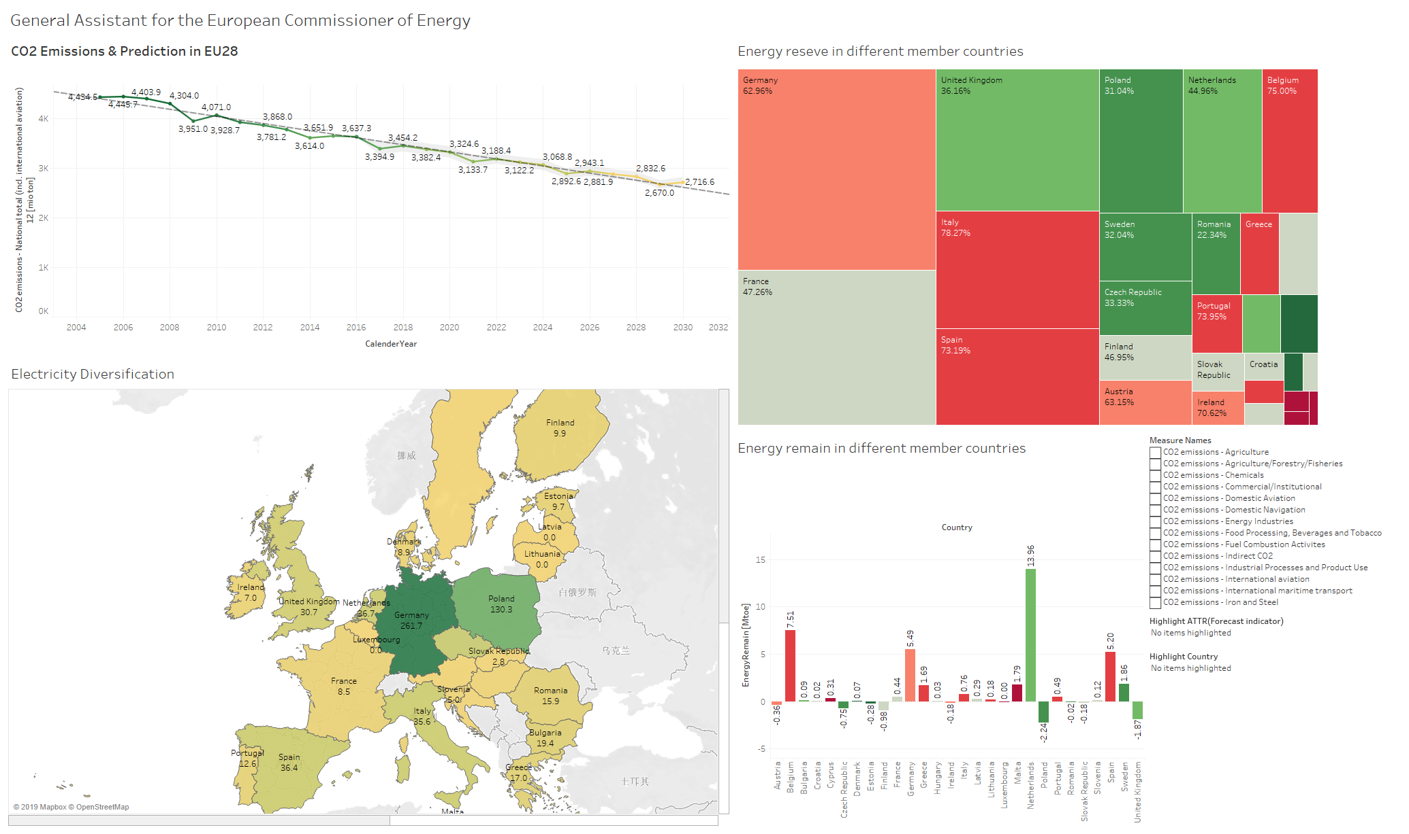

**2.2. Persona 2**

**2.2.1. Description**

|  |  |
| --- | --- |
| **Persona:** | Green party member in Sweden |
| **Role:** | A normal party member, Green Party(Sweden)  Bachelor of Science, Stockholm University  3 years of experience as the staff of the Swedish Environmental Protection Agency  Was participated in energy conservation activities in Stockholm  6 years of experience as a member of The Green Party(Sweden) |
| **Context of work:** | * The Green Party is a political party dedicated to protecting the Earth’s ecological environment * Is a member of New Energy Policy Discussion Group in Sweden * Participate in the formulation of policies to promote renewable energy in Sweden  1. Subsidy benefits for companies developing renewable energy sources 2. Benefiting the people who purchase renewable energy products |
| **Key activities:** | * Collect public feedback on upcoming renewable energy welfare policies * Organize the collected data and write the report * Proposal to amend the new policy based on the conclusions of the report at the group meeting * Interfacing with departments related to the implementation of new policy |
| **Data Visualisation Questions:** | Question 1: Whether the development of renewable energy has an impact on consumption of non-renewable energy from 2006 to 2016.  Question 2: In the generation of Heat energy, is it possible for renewable energy to completely replace non-renewable energy?  Question 3: Whether renewable energy is becoming more and more important in the proportion of electricity generation(2003 to 2016) . |

**2.2.2. Data model (dimensional model) - figure 3**

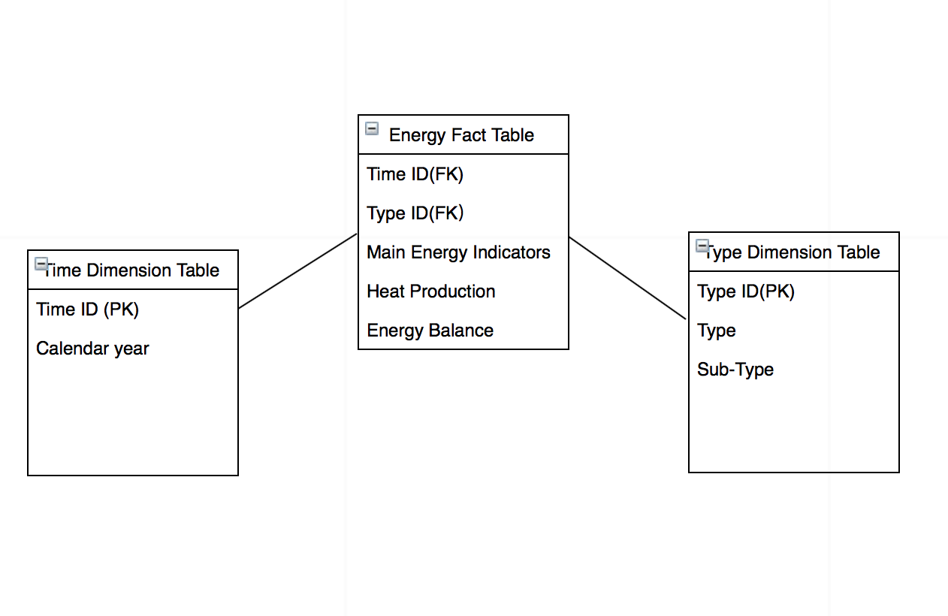 *Figure 3. Star schema for Green party member in Sweden, Green Party*

**2.2.3. Data visualizations - figure 4**

Q1: Dimension:

Year: 2006-2016

Type: Non-Renewable Energy(Solid Fuels + Petroleum and Products + Gases), Renewable

The Line Chart shows the final energy consumption by two different type, Non-renewable and Renewable energy. From this line chart, it tells that the consumption of Non-renewable energy was decreasing but Renewable energy was increasing. Although the magnitude of change of two lines is not large, the development of Renewable energy actually has an impact on consumption of Non-renewable energy.

Q2: Dimension:

Year: 1990-2016

Type: Non-Renewable Energy(Solid Fuels + Petroleum and Products + Gases), Renewable

The Dual-Line Chart gives a prediction on the next 20 years depends on the Gross Heat Generation data from 1990-2016 in Sweden. In 1995, the heat generation by use of renewable energy has exceeded the use of non-renewable energy. The use of renewable energy has dramatically increased in the past 25 years and in contrast, the use of non-renewable energy has decreased. According to the prediction in 2037, the use of non-renewable energy will decrease to 0.15. Therefore, it is very possible that non-renewable energy will be completely replaced by renewable energy in heat generation.

Q3: Dimension:

Year: 2003-2016

Type: Non-Renewable Energy(Solid Fuels + Petroleum and Products + Gases + Nuclear), Renewable

It is clear from this bar chart that the proportion of non-renewable energy in electricity generation has been decreasing, while the proportion of renewable energy in electricity generation has been increasing from 2003 to 2016，the gap between the two reached the maximum.thus can be concluded that in renewable energy electricity generation is becoming an increasingly important role.

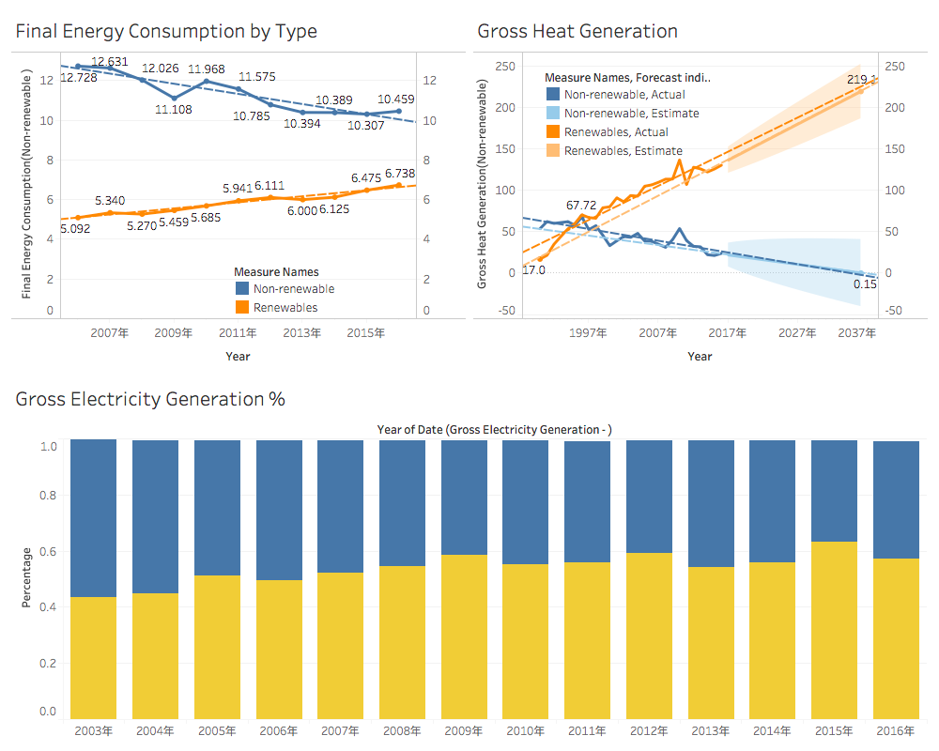

*Figure 4. Star schema for Green party member in Sweden, Green Party*

**3. Reflection and Teamwork Assessment**

* **Processes of development**

Within the development in this case, the project group had been analyzed and identified the relevant characteristics of the given personas, subsequently, the group members initiated the design stage followed the four steps of a BI solution design framework. Amid the implementation phase, some BI tools such as Star Schema and Tableau were utilized for constructing specialized modelling and visualization for the intelligent decision support of the European energy. Then the last development process was constructing the BI architecture which fulfil the alignment between the major BI components and the project materials respectively.

Firstly, from the study of the behaviors of an assistant for the European Commissioner of Energy, the main goals and tasks were performing analysis and reporting about the operation of energy among the European countries, also involves in planning for further superior level strategies. For the other user, a Swedish Green party member, the duties and key activities are more focusing on monitoring the impacts of energy consumption and implement analysis on renewable energy. Follow by that was the design processes to differentiate the solution comprehensively. The first step was to identify the business process, that the facts and dimensions of the proposed questions had acquired from the individuality research; and the second step requested the developer to define the exact outputs with numeric aspect as a fact table related to the potential questions; to continue, dimension table generated as the third step to determine the dimensions for analyzing the facts; the last step to design the precise solution was indicating the primary keys and foreign keys between facts and dimensions, where the accurate data for the deliverable of the BI solution was selected from the large data source about European energy. Precisely, the design stage developed the business processes from assistant and Green Party member to dimensional modelling on the energy statistics, then Tableau assisted our group to completely deliver the entire BI solution to be equipped for solving different tasks of relevant European energy problems. Eventually, those tools assist for the procedures within general data warehouse, in addition, customized function was approaching to be architecting business analytics for the users, finally the interactive dashboards as the user interfaces were furnished for further decision making.

* **Challenge:**

To supply interactive dashboards for intelligent business works between assistant from European Commission of Energy and Green Party member in Sweden, our project team had conquered the challenges of persona measurements and data cleansing.

Significantly, rather than collecting objective requirements from the raw data of European energy, personas urged the development of the BI solution to be more human-centered, that the specific requests were not only retrieved from the basic knowledge models of our designers, it also claimed sufficient number of external and internal resources to prevent the bias from BI solution designers and limited perspectives from users. In order to gather requirements for further visualization design in the project, we started to identify the roles of the assigned personas, and deeply explored the key topics around their works, in this case, both personas are nearly concerning the issues of energy consumption and climate problems. The team members stood on the views of a real assistant of commissioner and a Green Party member, our designers strived to reduce the constraints on the traditional business process, and guaranteed to convey opportune BI resolution for the users. Through narrative persona description process, we learned that analysis on characteristics of different users is imperative in customizing solutions for specific clients, especially on a BI project.

Furthermore, ad hoc user interfaces for the assorted businesspeople demanded high dimensional data quality, where data cleansing processes should be executed rigorously, and it challenged the project group to offer appropriate dashboards in a limited project time. However, dimension frameworks and demonstrative data cleansing guidelines supported our team to extract desirable data from raw data source. After we defined the responsibilities of the two personas, interpretability and integrity of the data were the focal point to import forms from excel into Tableau. Moreover, those dimensional modelling lead to a rapid initiation of data cleansing, and then we strictly followed the matching and consolidating processes from the guideline to maintain the values of the data to the specific users. From the achievement of data integration and migration, it motivated that understanding the properties of the present data is important, which it can conduct to correct direction in an insight creation.

* **Reflection:**

Our group number is 2 and our group members are: Essie, Allen, Victor, Jacky, Ricky, Sunny and Isaac. Since our group has 7 students, the tasks can be distributed more evenly, so each member can have more time focusing on their activity. At the beginning of the assignment, we have divided all the tasks into three parts: persona, reflection and presentation, with four of us focusing on personas, two of the group observed the development and extended reflection on it, the rest was working on congregating information for presentation, which all the tasks were divided on average. As a result, everyone had been distributed almost the same contribution to this assignment, tasks were assigned according to individual preferences and ability of the group members, that impelled everyone acquire their favourite part and everyone is willing to do it. The final decision was that Essie and Jacky will do one persona, Allen and Victor will work on the other persona. Reflection will be done by Sunny and Ricky. At last, Isaac was assigned to be in charge of the project closing, which collects all the information and make them as a power point. After allocating all the tasks, our team leader Sunny suggested to do the assignment together at school which can help us communicate with each other more convenience and can also have a higher efficiency. During the meeting, everyone was focused on their own part. Whenever someone is stuck, the member will discuss with his/her partner, and if they all have no clues, the rest of the team will come to aid. Also, while working on the assignment at school, we found that there were some problems that we did not consider before. Besides, while analyzing personas, group members were having contradicting views upon the personas and it was difficult to determine which view is more suitable, but we reacted immediately on the conflicts and seeked for help from consultant, that the confusion had been solved in a short time, which allowed us to enhance the speed of processing the BI solution, and save time to evaluate the deliverables before submission. In conclusion, we are all satisfied with our teamwork due to the excellent cooperation among members.While not learning much new skills, this experience did remind us again that teams are formed such that ideas and various skills between different individuals can clash and work together to produce results that are unobtainable if the task were done individually.