The AWS server security group releases the corresponding port

For example, http://3.135.198.81:85 uses IP access, the default port is 85, and the security group needs to release port 85 permissions

Front-end VUE code packaging: npm run build, after packaging, the corresponding folder will be generated in the project directory
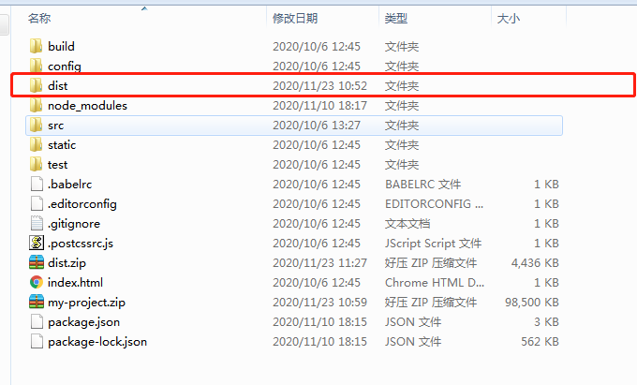

After the dist folder is generated, this folder is the folder placed on the server, and the server only needs this one.

Upload the dist folder to /www/wwwroot

Server install web server (nginx /apache), here is nginx. Note: Only install one of them

After the nginx installation is complete, configure the corresponding domain name, specifically the configuration of nginx
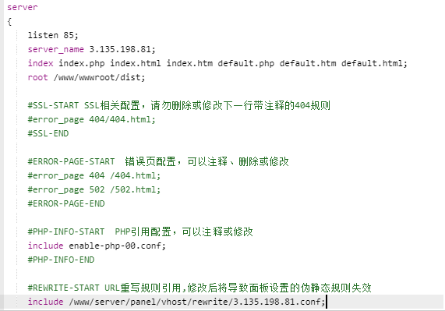

After the nginx website configuration is complete, restart the nginx service, and then ip and port access

After updating the front-end code next time, directly overwrite the dist folder or directly delete the dist folder and upload again.

