DHARMARAM ❀ VELGATOOR ❀ NASPUR ❀ LUXETTIPET ❀ MEDARIPET ❀ GOLLAPALLY
ANSWER SHEET
Name: Formative Assessment - 1 Class: UKG Roll No: ______
Sub: Maths. Name of the Examination: ______ | 25m

I. Write the numbers from 1-50 | 10M

II. Count and write the correct number | 5x1=5

1. | 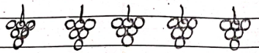 | = __________
2. |  | = __________
3. | 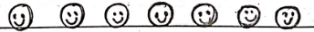 | = __________
4. | 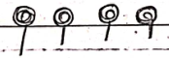 | = __________
5. | 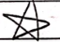 | = __________

III. Write the numbers in words | 5x1=5

1. 5 = __________________
2. 8 = __________________
3. 10 = _________________
4. 3 = __________________
5. 12 = _________________
IV. Match the following | 5x1=5

1. Thirteen | 15
2. Twenty | 13
3. Nineteen | 20
4. Sixteen | 19
5. Fifteen | 16

