Name: Formative Assessment - 1 Class: UKG, Roll No. ________
Sub. Maths. Name of the Examination ____________________ 25m
I. Write the numbers from 1-50 | 10M.

II. Count and write the correct number | 5x1=5.

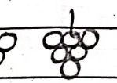  2. | 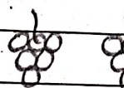  3. | 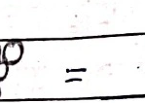  4. | 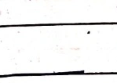  5.

1. 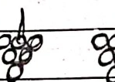 ☐ = ________
2. 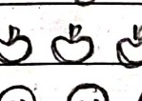 ☐ = ________
3. 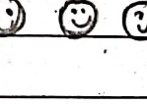 ☐ = ________
4. 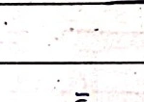 ☐ = ________
5. 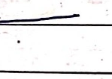 ☐ = ________
III. Write the numbers in words | 5x1=5

1 5 = ________
2 8 = ________
3 10 = ________
4 3 = ________
5 12 = ________
IV. Match the following | 5x1=5

1 Thirteen | ( ) | 15
2 Twenty | ( ) | 13
3 Nineteen | ( ) | 20
4 sixteen | ( ) | 19
5 Fifteen | ( ) | 16

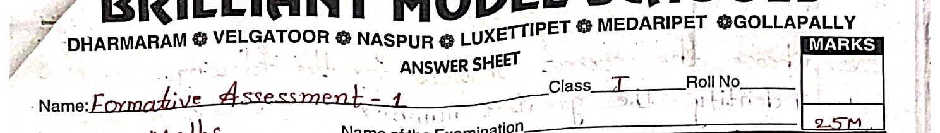
Name: Formative Assessment - 1 Class: 1 Roll No: ___________
Sub. Maths Name of the Examination ____________________ 25M
I Write the number name for the following numbers. | 6x1=6

1. 15 = ____________________________________________________
2. 20 = ____________________________________________________
3. 18 = ____________________________________________________
4. 13 = ____________________________________________________
5. 11 = ____________________________________________________
6. 2 = ____________________________________________________
II Express the following numbers as tens and ones. | 3x1=3

Number | Tens | ones
4 | ________ | ________
12 | ________ | ________
16 | ________ | ________

III Write the number represented by the abacus in the given box. | 3x1=3

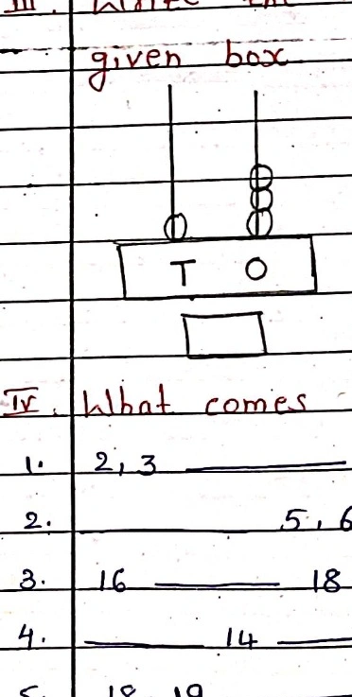  1. | 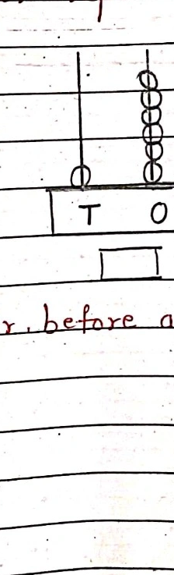  2. | 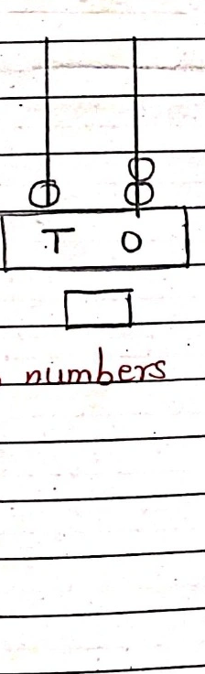  3.

T O | T O | T O
[box] | [box] | [box]

IV What comes after, before and between numbers. | 5x1=5

1. 2, 3 ____________________________________________________
2. 5, 6 ____________________________________________________
3. 16 ________________ 18 _________________________________
4. 14 ______________________________________________________
5. 18, 19 __________________________________________________
V Arrange the following numbers from the smallest to the greatest. | 2x1=2

1. 3, 13, 18, 6 = ___________________________________________
2. 10, 9, 3, 2 = ____________________________________________
mat-I
VI Choose the correct answers for the following. | 3x1=3

1. Identify the greatest number | ( )

a) 8 | b) 4 | c) 6 | d) 10

[[QUESTION_ROW: 2. The numeral for the number name Eight is ( )]]
a) 6 | b) 4 | c) 5 | d) 8.

3. The number that less than 5 is is | ( )

a) 8 | b) 4 | c) 1 | d) 9

VII. count and write the number of objects | 3x1=3

[[SOURCE_FIGURE_ROW: source-15|1.|box | source-16|2.|box | source-17|3.|box]]

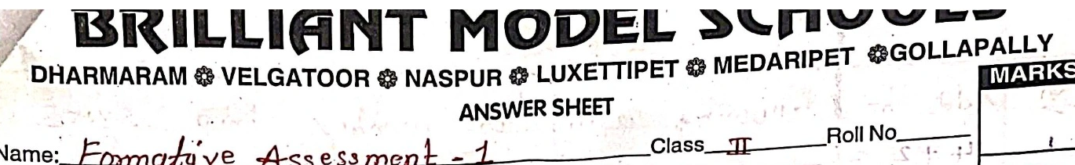
Name: Formative Assessment - 1 Class: II Roll No. ________
Sub. Maths Name of the Examination: ____________________ 25m.
I. Circle the correct number for the following. | 3x1=3

number names
1. Fourteen 44 41 40 14
2. Forty four 40 14 26 44
3. seventeen 71 51 91

II. Unscramble the letters in column A to make number | 4x1=4

names. Then match them with the numbers in column B
A | ( ) | B

1. ent || ( ) || 90
2. inenyt || ( ) || 40
3. venseyt || ( ) || 10
4. Foryt || ( ) || 70

III. Fill in the missing numbers | 3x1=3

1. 10 ____ 12
2. 23, 24 ____ 26, 27, 28.
3. ____ ____ ____

IV. Arrange the numbers in Ascending and Descending order | 2x3=6

1. 38, 99, 83, 61, 50, 12
A.D = ____________________
D.D = ____________________

2. 3, 32, 73, 93, 23, 37
A.D = ____________________
D.D = ____________________

V. Add the following | 3x2=6

1. T O  7 0  1 2 | 2. T O  4 4  + 3 | 3. T O  2 4  + 2 3

mat - II
VI Add the following using the number strip | 3x1=3

1. 14 + 2 =
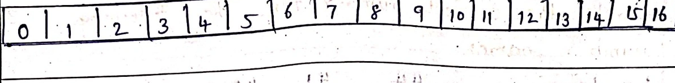
0

2. 12 + 6 =
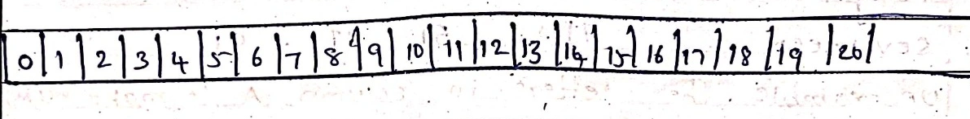
0

3. 13 + 4 =
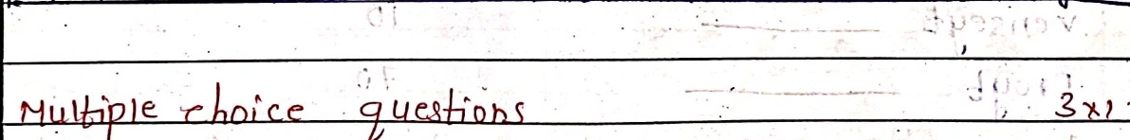
0

VII Multiple choice questions | 3x1 23

1. 14 + 12 = +14 ( )
a) 11 | b) 14 | c) 15 | d) 12

2. Jatin got 10 apples. Her brother got 9. How many apples they got in all ( )
a) 15 | b) 20 | c) 19 | d) 14

3. Which of the following is the numeral for seventy two ( )
a) 65 | b) 98 | c) 23 | d) 72.

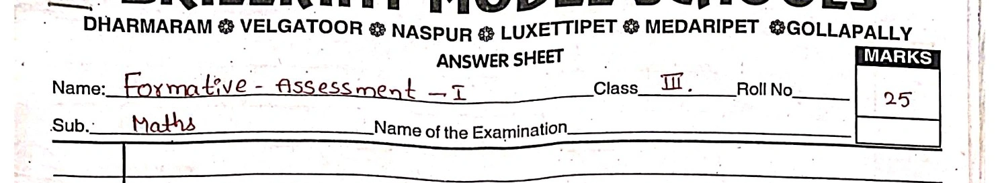
Name: Formative - Assessment - I Class: III Roll No: 25
Sub: Maths Name of the Examination: ____________________
MARKS
25
____________________________
I. Write the given numerals in words. | 5x1=5

1. 4205 = ____________________________
2. 1199 = ____________________________
3. 6500 = ____________________________
4. 4008 = ____________________________
5. 3112 = ____________________________
II. compare the following using >, < or (=) sign | 4x1=4

1. 209 ________________ 3819
2. 3901 ________________ 1450
3. 1201 ________________ 1201
4. 7710 ________________ 7727
III. Write the successor and Predecessor of the following | 4x1=4

1. 2986, ____________________________
2. 5129, ____________________________
3. ________________ 1046
4. ________________ 7302
IV. Do the following additions. | 4x1.5=6

1. H T O
5 6 3
2 1 4
2. H T O
4 5 6 7
+ 2 5 5 4
3. H T O
3 4 7 8
+ 1 6 7 8
4. H T O
5 6 4 5
+ 3 6 6 7

V. Fill in the blanks. | 6x1=6

1. 2456 + 9876 = ________________ + 2456
2. 6543 + 0 = ____________________________
3. 4567 + ________________ = 8765 + ________________
4. 5555 + 1 = ____________________________
5. 0 + ________________ = 4321
6. 6342 + ________________ = 6343

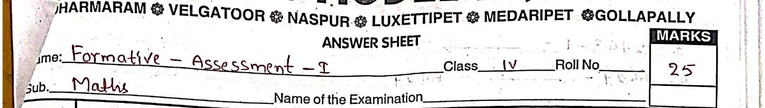
Name: Formative - Assessment - I Class IV Roll No. 25
Sub. Maths Name of the Examination _________________________________
MARKS 25
I. Write numbers for the given number names. | 4x1=4

1. Sixty nine thousand eight hundred seventy four _________________________________
2. Four lakh sixteen thousand three hundred nine _________________________________
3. Two lakh six hundred one _________________________________
4. Eighteen thousand seven hundred five _________________________________
II. compare the following numbers by putting >, < (or =) | 4x1=4

1. 4,87,201 _________________ 6,78,214
2. 5,61,289 _________________ 47,281
3. 6,87,651 _________________ 6,87,651
4. 38,541 _________________ 89,251
III. Write these Hindu-Arabic numbers as Roman numerals | 3x1=3

1. 35 _________________________________
2. 22 _________________________________
3. 61 _________________________________
IV. Do the following problems. | 4x1½=6

Add
a. L | T.Th | Th | H | T | O
2 | 7 | 6 | 5 | 4 | 5
2 | 2 | 4 | 5 | 3 | 4

+ 3 | 1 | 6 | 5 | 4 | 5

b. L | T.Th | Th | H | T | O
5 | 1 | 2 | 3 | 4 | 5
1 | 5 | 4 | 3 | 2 | 1

+ 1 | 1 | 7 | 6 | 8 | 7

Subtract
a. L | T.Th | Th | H | T | O
5 | 7 | 8 | 3 | 5

- 1 | 8 | 0 | 7 | 6

b. L | T.Th | Th | H | T | O
7 | 8 | 4 | 0 | 2 | 1

- 4 | 1 | 5 | 4 | 8 | 7

V. Fill in the blanks | 6x1=6

1. 07+2728 = _________________________________
2. 6273+1120 = _________________ + 6273
mat - IV
3. 2748 - 1 = ________
4. 6427 - ________ = 6427
5. 7382 - 7382 = ________
6. ________ + 6271 = 6272
VI. Draw an Indian place value chart. | 1x2 = 2M

MARKS
Name: Formative - Assessment - I Class V Roll No 25
Sub. Maths Name of the Examination
____________________________
I. Write the following numbers in words. | 4x1=4

1. 1,72,89,103 =

2. 56,17,28,910 =

3. 39,99,20,102 =

4. 67,28,91,903 =

II. Write the place value of the digit 7 in the following numbers | 4x1=4

1. 20398765

2. 765589023'

3. 378906541

4. 526872910

III. Compare and insert >, < (or) = sign in each of the circles below | 3x1=3

1. XCIII CXIII

2. CCX CCLIX

3. CD CCCXC

IV. Do the following Problems. | 4x1.5=6

1. Add 4,01,89,856 + 8,54,45,971

2. Subtract 5,33,03,543 - 2,34,67,343

3. Multiply 14,103 x 7

4. Solve the following and find the quotient and remainder.
68,746 ÷ 4

V. Fill in the blanks | 6x1=6

1. 12,785 + 6,124 = ________ + 12,785

2. 56,723 - 56,723 =

3. 81,567 x 0 =

4. 0 ÷ 34,566 =

5. 5,678 + 0 =

6. 762 x ________ = 762.
VI. Write the following table | 1x2=2

1. 12 table

