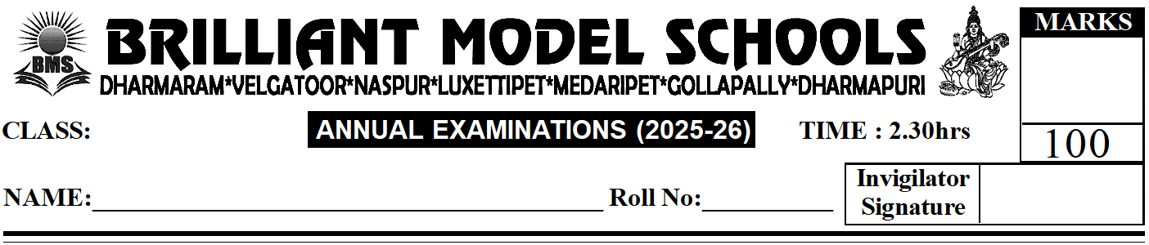
I. Answer Any Ten of the Following. (10 x 4 = 40)

NUR - ENG(W)
I -Secience
1) Name two things we can see in the sky at night.
2) What kind of clothes do we wear in the summer season?
3) Name any three things in which water is stored.
4) What do we do in the kitchen?
5) Why is a storm dangerous?
6) Name our sense organs.
7) What is healthy food? Name any two healthy foods.
8) Why do animals need homes?
9) What is the difference between trees and shrubs?
10) Name any two plants that give us:
a) Oil: ______________
b) Fruits: ______________
11) How do plants help us?
12) What are wild animals?
II. Give two examples for each of the following. (5x2=10)
1) Cereals ______________________ ______________________
2) Flowers eaten as vegetables ______________________ ______________________
3) Animals that live on land ______________________ ______________________
4) Animals that eat only the flesh of other animals _____________ __________
5) Animals that eat only plants ______________________ ______________________
III. Write the names of the babies of these animals. (6 x 2 = 12)
a) Duck ___________
b) Sheep ___________
c) Cat ___________
d) Lion ___________
e) Dog ___________
f) Hen ___________
IV. Name the following. (4 x 2 = 8)
1) The wettest season: _______________
2) The coldest season: _______________
3) The hottest season: _______________
4) The season in which we see flowers all around: _______________

V. Fill in the blanks with the correct words. (8 x 1 = 8)
1) _______________ (Neighbours / Families) can be big or small.
2) Clouds are _______________ (made by humans / found in nature).
3) _______________ (Ants / Dogs) make their own homes.
4) We should _______________ (cover / close) our mouth while sneezing.
5) Smoke makes the air _______________ (fresh / dirty).
6) We need a raincoat on a _______________ (sunny / rainy) day.
7) The Moon is _______________ (round / flat).
8) We should keep our house _______________ (clean / empty).

VI. Write T for True. Write F for False. (6 x 1 = 6)
1) There are many Moons in the sky. ( )
2) Living things need water to live. ( )
3) We keep buckets in the living room. ( )
4) Air fills up things. ( )
5) Eating sweets daily is healthy. ( )
6) We eat only the fruits of plants. ( )

VII. Choose the correct answer. (6 x 1 = 6)
1) People living near our house are called this. ( )
A) Family B) Classmates C) Neighbours
2) Humans cannot make these things. ( )
A) Cars B) Buildings C) Stones
3) Spiders make this home. ( )
A) Nests B) Hives C) Webs
4) We wear shoes on these parts of our body. ( )
A) Arms B) Hands C) Feet
5) This thing is not found in a bedroom. ( )
A) Bed B) Pillows C) Gas Stove
6) A bicycle tyre is filled with this. ( )
A) Water B) Air C) Sand

VIII. Match the following. (5 x 2 = 10)
1) Coconut plant ( ) a) Herb
2) Mint plant ( ) b) Shrub
3) Pomegranate fruit ( ) c) Tree
4) Rose plant ( ) d) Has a few seeds
5) Orange fruit ( ) e) Has many seeds

