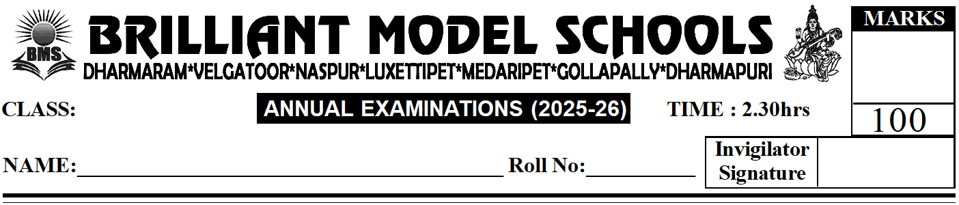
I. Answer Any Ten of the Following. (10 x 4 = 40)

NUR - ENG(W)
II -Secience
1) Name the three forms of water.
2) List any three things air contains.
3) Name the four phases of the Moon.
4) What is a shadow?
5) Write any two things you have learnt about rocks.
6) What types of clothes do we wear in summer and winter?
7) What is the meaning of safety rules?
8) Why do we need protective food?
9) What are joints?
10) What are insects? Name an insect you have seen in your house.
11) Name four milk products.
12) Name four types of small plants.
II. Name the body parts that do these things. (5 x 2 = 10)
1) Helps us think: _______________
2) Sends blood to all parts of the body: _______________
3) Helps us breathe: _______________
4) Helps us see ourselves in the mirror: _______________
5) Helps us feel that a stone is hard: _______________
III. Give two examples for each of the following. (4 x 2 = 8)
1) Stems of plants we eat: _______________ _______________
2) Beverages: _______________ _______________
3) Flowers from which we make perfume: _______________ _______________
4) Oils: _______________ _______________
IV. Fill in the blanks with the correct words. (8 x 1 = 8)
1) _______________ (Elephants / Dogs) help us carry things.
2) Rabbits live _______________ (on land / in water).
3) Bones and muscles are covered with _______________ (skin / joints).
4) Rice and _______________ (sugar / fish) are energy-giving food.
5) People living in hills make houses with _______________ (sloping / flat) roofs.
6) We write on the blackboard using a soft rock called _______________ (chalk / talc).
7) The Sun is a _______________ (natural / human-made) source of light.
8) Dirty water contains _______________ (germs / ice).
V. Write T for True. Write F for False. (5 x 1 = 5)
1) The pumpkin plant is a tree. ( )
2) Ginger and potato are roots of plants. ( )
3) Ears are the sense organ for sight. ( )
4) We should always walk in the middle of the road. ( )
5) Boiling makes water safe to drink. ( )

VI. Choose the correct answer. (6 x 1 = 6)
1) These make the air dirty. ( )
A) Germs B) Smoke C) Dust D) All of these
2) Shadows are short at this time of the day. ( )
A) In the morning B) In the evening C) At noon D) None of these
3) This is used for cooking things. ( )
A) Marble B) Sandstone C) Slate D) Coal
4) We should drink this to keep healthy. ( )
A) Soft drink B) Tea C) Coffee D) Water
5) This animal has webbed feet. ( )
A) Frog B) Fish C) Lion D) Giraffe
6) These animals help us guard our homes. ( )
A) Cows B) Dogs C) Cats D) Hens

VII. Circle the odd one out. (4 x 2 = 8)
1) Cow Horse Buffalo
2) Hen Duck Sheep
3) Wool Honey Silk
4) Honey Beeswax Milk
VIII. Match the following. (5 x 2 = 10)
1) Air ( ) a) Makes the air dirty
2) Wind ( ) b) Make us ill
3) Storm ( ) c) Helps a kite fly
4) Burning leaves ( ) d) Can damage houses
5) Germs ( ) e) Present all around us

IX. Observe and Answer. (1 x 5 = 5)
Look at the picture given: A child is playing football on the road.
i) What is the child doing?
ii) Is this a safe action?
