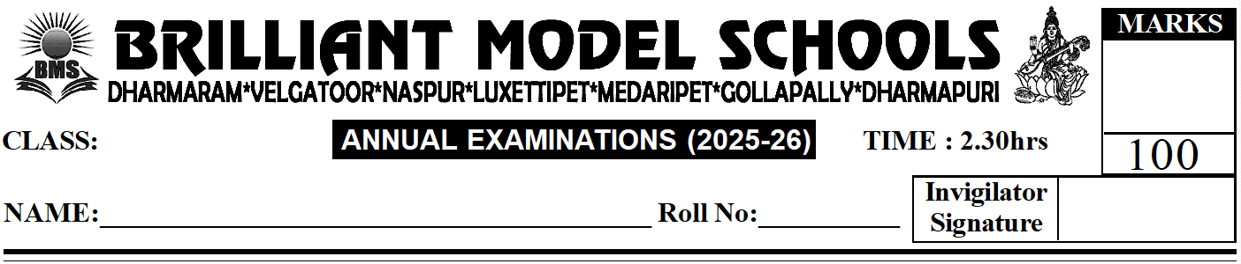
PART - A

NUR - ENG(W)
III -Secience
I. Answer any ten of the following. (10 x 3 = 30)
1) How do human beings feel changes around them?
2) List the things plants require to make food.
3) Why do eagles have sharp and hooked beaks?
4) What is first aid?
5) Why do we wear woollen clothes in winter?
6) Why do we say that air is a gas?
7) List any three things that soil contains.
8) What is force?
9) What is weather?
10) What are stars?
11) What is the meaning of measurement?

II. Answer any five of the following. (5 x 4 = 20)
1) How do plants get food?
2) Write any two differences between root and shoot.
3) What are plant fibres? Give two examples of plant fibres.
4) Write any two differences between solids and liquids.
5) How are these units written: i) Metre ii) Millilitre iii) Gram?
6) What are inner planets and outer planets? Name them.

III. Fill in the blanks. (10 x 1 = 10)
1) Animals feel changes around them using their _______________ (new / sense) organs.
2) _______________ beak helps sparrows to crack seeds.
3) Always cross the road _______________ (with a grown-up / alone).
4) Do not run or play _______________ (in the park / on the road).
5) Wool is a/an _______________ fibre.
6) The _______________ is called the farmer's friend.
7) _______________ is the measure of how long something is.
8) The surface of the Moon has huge holes called _______________.
9) The Sun and the objects that move around the Sun are called the _______________.
10) This is produced by silkworms: _______________.
IV. Answer in one word. (5 x 2 = 10)
1) Animals that eat only plants and parts of plants: _______________
2) A kind of house made of bricks, wood, glass and stone: _______________
3) The process of bringing back food to chew again: _______________
4) Humans who choose to eat plants as well as flesh of animals: _______________
5) These clothes do not allow water to go through them: _______________
V. Write T for True. F for False. (9 x 1 = 9)
1) We should not fight with our friends. ( )
2) We should use a blade to sharpen our pencils. ( )
3) Bananas and oranges are examples of liquids. ( )
4) Steam is an example of gases. ( )
5) Earthworms live on trees. ( )
6) We must protect soil by cutting trees. ( )
7) Autumn is the hottest time of the year. ( )
8) We wear woollen clothes in winter. ( )
9) The surface of the Earth is mostly covered with land. ( )
VI. Match the following. (5 x 1 = 5)
1) Venus ( ) i) Coldest planet
2) Neptune ( ) ii) Planet on which we live
3) Jupiter ( ) iii) Smallest planet
4) Earth ( ) iv) Hottest planet
5) Mercury ( ) v) Largest planet

VII. Choose the correct answer. (10 x 1 = 10)
1) This is a flower we eat. ( )
i) Potato ii) Sugar cane iii) Broccoli iv) Watermelon
2) This fruit has more than one seed. ( )
i) Mango ii) Coconut iii) Papaya iv) Peach
3) The process of water vapour changing into water on cooling is called this. ( )
i) Melting ii) Condensation iii) Evaporation iv) Freezing
4) This is not a luminous object. ( )
i) Table ii) Sun iii) Torch light iv) Candle
5) This is an example of noise. ( )
i) Sound of a loud speaker ii) Children whispering iii) Chirping of a sparrow iv) Playing of flute
6) Air does not contain this. ( )
i) Germs ii) Dust iii) Gases iv) Medicines
7) This is the hottest time of the year. ( )
i) Winter ii) Autumn iii) Summer iv) Spring
8) It takes the Earth this much time to make one revolution around the Sun. ( )
i) 24 hours ii) 24½ days iii) 365¼ days iv) 12½ days
9) This is the only planet known to support life. ( )
i) Mercury ii) Venus iii) Earth iv) Jupiter
10) This process takes place due to the heat of the Sun. ( )
i) Condensation ii) Evaporation iii) Snow iv) None of these

VIII. Write two examples of each. (3 x 2 = 6)
1) Herbivores: _______________, _______________
2) Carnivores: _______________, _______________
3) Omnivores: _______________, _______________

