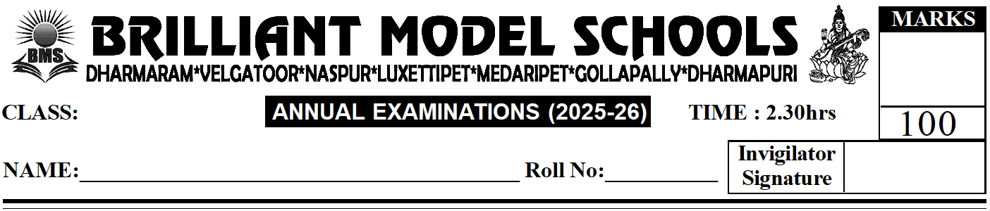
PART - A

NUR - ENG(W)
V -Science
I. Answer any ten of the following. (10 x 3 = 30)
1) What is agriculture?
2) What is spiracles?
3) What is a deficiency disease?
4) What is ligament?
5) What is the first aid for a cut or wound?
6) What is melting?
7) What are minerals?
8) Name the two types of eclipses that can be seen from the Earth.
9) What is pollution?
10) Name the three layers of the Earth.
11) List any three types of force.
II. Answer any five of the following. (5 x 4 = 20)
1) Write a few sentences describing the three R's of waste management.
2) What is the difference between floods and droughts?
3) Give two examples of how air pressure is useful to us in daily life.
4) What do you think would happen if there was no gravitational force?
5) What is the difference between voluntary and involuntary muscles?
6) Write any three ways in which disease spreads.
PART- B
III. Fill in the blanks with the correct words. (10 x 1 = 10)
1) Crops grown in winter are called _______________ (Kharif / Rabi) crops.
2) Diseases that are not passed on from one person to another are called _______________ diseases.
3) _______________ organs help us to sense our surroundings.
4) The change of state of a solid into a liquid on heating, is called _______________.
5) Iron is a _______________ mineral.
6) Our planet has _______________ natural satellite.
7) _______________ are holes found on the surface of the Moon.
8) A push or pull on an object is called _______________.
9) The layer of molten rock inside the Earth is called _______________.
10) We have two _______________, one on each side of the chest area.
11) Monsoon crops are also called _______________ (Kharif / Rabi) crops.

IV. Answer in one word. (6 x 2 = 10)
1) Crops that are grown from June to October: _______________
2) A rock used to lay roads: _______________
3) The force required to move a lever: _______________
4) An inclined plane that is wrapped around a central rod: _______________
5) Magma that comes out of volcanoes: _______________
6) In a lever, the point about which a rod turns: _______________

V. Choose the correct answer. (10 x 1 = 10)
1) This stores food for the baby plant. ( )
i) Cotyledon ii) Seed coat iii) Embryo iv) None of these
2) This is a voluntary muscle. ( )
i) Cardiac muscle ii) Skeletal muscle iii) None of these iv) Both i and ii
3) A paste of baking soda with water is used for this. ( )
i) Wasp sting ii) Monkey bite iii) Bee sting iv) Dog bite
4) The state of matter depends on this of molecules. ( )
i) Size ii) Arrangement iii) Shape iv) Weight
5) We can see clearly through such objects. ( )
i) Transparent ii) Opaque iii) Translucent iv) All of these
6) Weather changes take place in this layer. ( )
i) Mesosphere ii) Atmosphere iii) Troposphere iv) Exosphere
7) About 21 percent of air is made of this gas. ( )
i) Nitrogen ii) Ozone iii) Carbon dioxide iv) Oxygen
8) This device measures seismic waves. ( )
i) Seismogram ii) Microscope iii) Seismograph iv) Stethoscope
9) Very low rainfall over a long period of time causes this. ( )
i) Drought ii) Flood iii) Forest fire iv) Tsunami
10) This is a renewable resource. ( )
i) Plastic ii) Air iii) Coal iv) Petroleum

VI. Write T for True. Write F for False. (7 x 1 = 7)
1) Never use water to put out an electrical fire. ( )
2) We should wear cotton clothes while working in the kitchen. ( )
3) If a person's clothes catch fire, the person must run around in panic. ( )
4) We should prick a burn blister so that it can heal faster. ( )
5) Muscular force causes damage to bicycle tyres. ( )
6) Potential energy is the stored energy of a body at rest. ( )
7) The Sun is an example of sound energy in nature. ( )
VII. Match the following. (6 x 1 = 6)
1) Air Pollution ( ) i) Typhoid
2) Water Pollution ( ) ii) Coal
3) Land Pollution ( ) iii) Asthma
4) Noise Pollution ( ) iv) Eggshells
5) Non-renewable resource ( ) v) Soil losing its fertility
6) Biodegradable waste ( ) vi) Deafness
IX. Match the following. (4 x 1 = 4)
a) Inclined plane ( ) i) A fork
b) Pulley ( ) ii) Ramp in a hospital
c) Screw ( ) iii) Roller blinds
d) Wedge ( ) iv) A spiral staircase

