PART - ANUR - ENG(W)IV -Secience
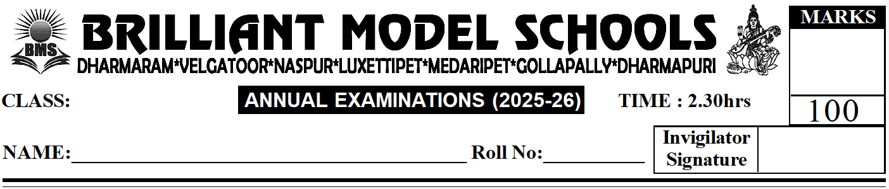 | 

I. Answer any ten of the following. (10 x 3 = 30)
1) Define photosynthesis.
2) Name two animals that undergo metamorphosis.
3) What is migration?
4) How is calcium helpful to the body?
5) Name the three types of blood vessels.
6) What are clothes made of?
7) Name the force exerted by the Earth.
8) What is precipitation?
9) What are constellations? Give two examples.
10) What is humus?
11) Name any two foods that are bad for our teeth.
II. Answer any five of the following. (5 x 4 = 20)
1) What adaptations help a bird fly in air?
2) Give reasons why proteins are said to be body-building food.
3) Write any three ways by which we can take care of our teeth.
4) Differentiate between an artery and a vein.
5) Explain the uses of air and water for humans.
6) What are human-made fibres? Give three examples of human-made fibres.
III. Answer in one word. (10 x 2 = 20)
1) The substance present in leaves that makes leaves appear green: _______________
2) A method of food preservation that removes water from food: _______________
3) Blood vessels that take blood away from the heart: _______________
4) Blood vessels that bring blood back to the heart: _______________
5) The amount of space matter takes up: _______________
6) The liquid in which a substance gets dissolved: _______________
7) This is formed when water vapour freezes on objects on cold nights: _______________
8) Dead and decayed plant and animal matter in the soil: _______________
9) Cutting down of trees in a forest in large numbers: _______________
10) Growing of trees in large numbers: _______________
IV. Fill in the blanks. (10 x 1 = 10)
1) Plants that grow under water are called _______________.
2) The female frog lays eggs in bunches called _______________.
3) Sugar and starch are types of _______________.
4) Iodised salt is a source of _______________.
5) The _______________ system is the transport system of our body.
6) _______________ carries nutrients, oxygen and carbon dioxide.
7) _______________ are materials that have a definite shape and volume.
8) The process of water from water bodies changing to water vapour is called _______________.
9) _______________ are minerals used to make jewellery.
10) The bottom layer of soil is called the _______________.
V. Choose the correct answer. (10 x 1 = 10)
1) These are areas of land that are very cold most of the layers. ( )
i) Plains ii) Mountains iii) Swamps iv) Coastal areas
2) A whale lives in this habitat. ( )
i) Terrestrial ii) Aerial iii) Arboreal iv) Aquatic
3) Animals that spend a lot of time in the air are called this. ( )
i) Terrestrial ii) Aerial iii) Arboreal iv) Aquatic
4) These are teeth used to bite and cut food. ( )
i) Incissors ii) Canines iii) Premolars iv) Molars
5) This is an animal fibre. ( )
i) Cotton ii) Jute iii) Coir iv) Silk
6) This is a pulling force. ( )
i) Work ii) Gravity iii) Friction iv) Energy
7) This is the hottest planet. ( )
i) Mercury ii) Venus iii) Earth iv) Jupiter
8) Seasons are caused by this. ( )
i) Rotation of the Earth ii) Revolution of the Earth iii) Both of these iv) None of these
9) This energy comes from the Sun. ( )
i) Muscular ii) Solar iii) Electricity iv) Wind
10) This is a human-made fibre. ( )
i) Acrylic ii) Jute iii) Wool iv) Silk
VI. Write T for True. F for False. (10 x 1 = 10)
1) The food made by green plants is called starch. ( )
2) The eggs of a butterfly hatch to form a pupa. ( )
3) The Arctic tern is a migratory bird. ( )
4) Digestion of carbohydrates begins in the stomach. ( )
5) Cotton clothes keep us warm. ( )
6) Waterproof clothes allow water to pass through them. ( )
7) A playground slide is an example of a lever. ( )
8) Solar energy is the energy obtained from wind. ( )
9) The Sun moves around the Earth. ( )
10) Subsoil is rich in humus. ( )
PART - ANUR - ENG(W)IV -SeciencePAGE NO: 1
PART - ANUR - ENG(W)IV -SeciencePAGE NO: 1
PART - ANUR - ENG(W)IV -SeciencePAGE NO: 1
PART - ANUR - ENG(W)IV -SeciencePAGE NO: 1
PART - ANUR - ENG(W)IV -SeciencePAGE NO: 1
PART - ANUR - ENG(W)IV -SeciencePAGE NO: 1
PART - ANUR - ENG(W)IV -SeciencePAGE NO: 1
PART - ANUR - ENG(W)IV -SeciencePAGE NO: 1
PART - ANUR - ENG(W)IV -SeciencePAGE NO: 1
PART - ANUR - ENG(W)IV -SeciencePAGE NO: 1

PART - ANUR - ENG(W)IV -SeciencePAGE NO: 1

