Class 5 Science Annual Examination
PART - A
I. Answer the following questions (10 x 3 = 30)
1) Define photosynthesis.
2) Name the three types of blood vessels.
3) What is migration?
II. Fill in the blanks (5 x 2 = 10)
1) Plants that grow under water are called ______.
2) Sugar and starch are types of ______.
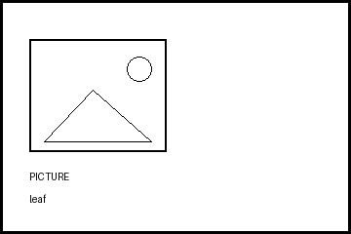 leaf | 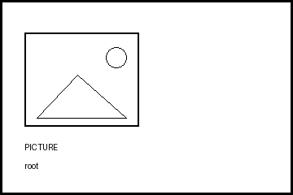 root | 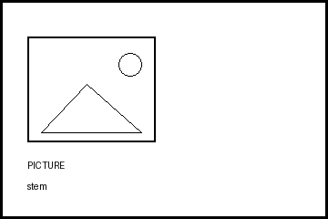 stem
III. Choose the correct answer (5 x 1 = 5)
1) This is a pulling force.
Work | Gravity | Friction | Energy
2) This is an animal fibre.
Cotton | Jute | Coir | Silk
IV. Match the following (5 x 1 = 5)
Photosynthesis | Makes food
Heart | Pumps blood
Lungs | Breathing
V. Look at the picture and tick the correct box (3 x 1 = 3)

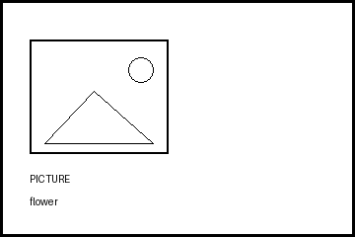 flower
VI. Complete the tree (2 x 1 = 2)
Plant | →
Root | Absorbs water
Stem | Transports food
MAX. MARKS: 55

