Recursion Problem

1. M Apples are placed in N Plates.
We want M apples to be placed in N plates. It allows empty plates. How many choices to distribute apples to plates? And it allows repeatable combinations. For example, M=4, N=3, (1, 1, 2), (1, 2, 1) and (2, 1, 1) are repeatable combinations, they are regarded as three choices.
int fun(int m, int n){
if(m <= 0)
return 1;
if(n <= 0)
return 0;
int num=0;
for(int i=0;i<=m; ++i){
num += fun(m-i, n-1);
}
return num;
}

2. 4 0~9 Numbers form 24 points with +-*/
We want 4 decimal numbers which ranges from 0~9 to form 24 point with operations +-*/. For example, 4 numbers: 7, 3, 2, 4. Then (7+3)*2+4=24.
The issue can be divided into two parts:
1) Four numbers in various orders, totally 4*3*2*1 = 24 choices.
2) For each order, justify whether it can form 24 or not.
For 1),
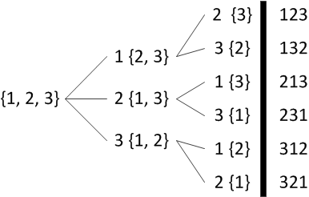

SET_COMB[MAX][4];
Set_cnt=0;
Permute(set, start, end){
If (start==end){
Memcpy(SET_COMB[set_cnt], set, 4 * sizeof(int)); // save the final result
Set_cnt++;
}
For (i=start;i<end;i++){
Swap(set, start, i); // exchange set[start] and set[i]
Permute(set, start+1, end);
Swap(set, start, i); // recover the set
}
}
比如说，有{1，2，3，4}, 先固定1， 然后用1， 2， 3，4去替换1， 得到4个并行的集合
{1, x, x, x},
{2, 1, x, x},
{3, x, 1, x},
{4, x, x, 1}
然后分别对单个集合做第二层的处理，第一个元素不用管了，因为数值不同，所以后面不会产生重复的组合。
{1, x, x, x} = {1, 2, 3, 4} => {2, 3, 4}, 固定2， 用后面的元素替换(包括自己)， 得到以下集合
{2, x, x},
{3, 2, x},
{4, x, 2}
接着又可以延申到第三层。。。

For 2)
int func(int result, int* nums, int len){
int i;
int success;
int temp_result;

if ((len == 1) && (result == nums[0]))
{
return 1;
}

if(len == 1){
return 0;
}

success = 0;
for (i=0;i<4;i++){
switch (i){
case 0: temp_result = result - nums[len-1]; break;
case 1: temp_result = result + nums[len-1]; break;
case 2: temp_result = result * nums[len-1]; break;
case 3:
if ((result%nums[len-1])==0){
temp_result = result / nums[len-1];
}else{
return success;
}
break;
}

success += func(temp_result, nums, len-1);
}

return success;
}

