Method

This study investigated 6-year (2015 - 2021) changes in UBC Vancouver's campus buildings, canopy height and cover, and its impact on coyote activity, by leveraging building, LiDAR, and coyote sighting public data. This was achieved through three core steps: (A) processed building shapefiles to visualize historical campus construction, (B) analyzed LiDAR data to create canopy height models and plot canopy cover with tree height thresholds as variables for tracking height- and area-based vegetation changes, and (C) interpreted maps to examine the relationship between building development, trees growing, greenspace connectivity, and coyote sightings. These steps were summarized in a workflow diagram (Figure 1) and further described below.
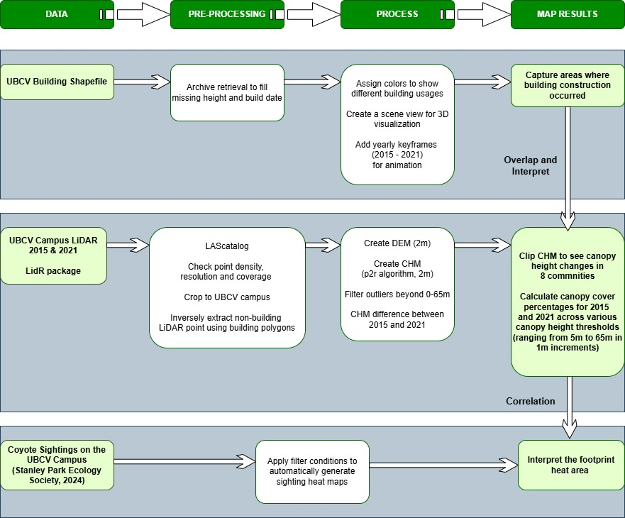
Figure 1 An overview of methods and processes for manipulating UBCV Building shapefile, UBCV Campus LiDAR data, and annual coyote footprint heat maps downloaded from the citizen science web platform (Stanley Park Ecology Society, 2024).

- UBCV Building Shapefile Processing
ArcGIS Pro (3.3.0), developed by Esri, offers robust capabilities in map production, spatial data management, in-depth spatial analysis, integration of datasets, and efficient sharing of geospatial information (Zhu et al., 2016). The building polygons were used in ArcGIS Pro to create an animation with yearly intervals from 2015 to 2021 as keyframes, illustrating historical changes in campus buildings. The process started with a pre-processing step to eliminate redundancies and address missing data related to building height and build date referencing the chronological index of university buildings and facilities. The subsequent phases included data visualization enrichment, where colors were systematically assigned to buildings of different types of use. A transition to a 3D scene view for spatial visualization was realized through extrusion, a process of stretching flat, 2D building polygons vertically to create 3D objects in a scene (ArcGIS Blog, n.d.a). The animation timed each building's appearance by its establishment date, with keyframes presenting temporal shifts in campus construction and new building service types. The final output of this section is a visually engaging representation, in the form of a video. Changes were also mapped to enhance clarity and support their description in written form.
- UBCV Campus LiDAR Data Processing
The lidR package is a toolkit for handling airborne LiDAR data in forestry. It is compatible with .las and .laz file formats, including algorithms for generating the Digital Elevation Model (DEM), Digital Surface Model (DSM), and Canopy Height Model (CHM). Users can perform tasks like normalization, tree detection, segmentation, delineation, and validation. The package also contains a processing engine to work with large LiDAR datasets split into multiple files (Roussel et al., 2022).
This study worked with multiple lidar files (.las) from the UBC study area, loading them into a LAScatalog object to streamline the management and processing of the dataset. We utilized the lidR package to begin data processing by performing an initial check on density, resolution, coverage, and datum to ensure the datasets from 2015 and 2021 were accurate, complete, and consistent. Afterward, the data was cropped to focus on the UBC campus. As the point cloud data only distinguished ground and non-ground points, further processing was required. Building polygons from 2015 and 2021 were used to clip the point clouds corresponding to the buildings, with the inverse selection of areas serving as the focus of interest (ArcGIS Blog, n.d.b).
Next, we normalized the lidar data. Raw .las data generally includes the topographic elevation and surface material height, which makes it difficult to analyze vegetation characteristics like tree heights. To solve the issues, we created a DEM with a 2m resolution using the rasterize_terrain function. Once the DEM was generated, we applied the normalize_height function to the LAScatalog to adjust the lidar points to a normalized ground level.
After normalizing the data, we generated a CHM using the rasterize_canopy function. The CHM provides an essential representation of the height of objects above ground level, such as trees (Wasser, 2020). We created the CHM using the p2r algorithm for efficient processing, ensuring that all points are correctly placed in the raster. After inspecting the initial CHM, we identified and filtered out any outliers by limiting the height range to between 0m and 65m. Finally, we produced CHMs and CHM difference between 2015 and 2021 for the entire study area, which provides a clear visualization of canopy height changes of the UBC Vancouver campus.
Following the visualization of CHMs across the entire campus, we concentrated our analysis on eight communities on campus. We started with loading shapefiles for each neighborhood using the sf package in R. These shapefiles represent the area of interest (AOI) for each community. The shapefiles were then transformed into SpatVector objects using the terra package for compatibility with raster data. We applied a clipping operation to the CHM rasters by using the neighborhood boundaries. This isolated the relevant area to focus the analysis on the canopy changes specific to the community region. The clipped CHM was then visualized with a color palette, where canopy loss was represented in red, and canopy growth was shown in blue. Building footprints were also plotted over the clipped CHM to visualize their impact on the canopy height.
To assess changes in canopy cover, we calculated canopy cover percentages for 2015 and 2021 across various canopy height thresholds (ranging from 5m to 65m in 1m increments). Binary rasters were created for each threshold, where cells with canopy heights above the threshold were marked as true (indicating tree cover), and cells below the threshold are marked as false. The total number of tree-covered cells was counted for both years, and the percentage of canopy cover was calculated by comparing the number of tree cells (times cell size) to the total area of the neighborhood. The canopy cover percentages for 2015 and 2021 were compared across different height thresholds. A line plot was created to visualize the trends in canopy cover changes, with separate lines for each year. By using the plot, we could examine how canopy cover fluctuates with different thresholds, and we applied this approach to all eight communities. The final output included visualizations and quantitative comparisons of canopy loss and growth across the study period.
(Most of my LiDAR data processing was based on the GEM521 lab instructions, so how can I refer to it?)
- Maps Interpretation and Correlation Analysis
Maps showing changes were compared and analyzed. They are 1) changes in campus buildings; 2) changes in canopy height; and 3) changes in coyote sighting locations and frequency hotspot areas obtained from the Citizen Science Web Platform (Stanley Park Ecology Society). In this study, ArcGIS Pro was employed to produce overlay maps that assess how changes in building structures relate to green space changes, identifying areas where development might threaten tree height growth, canopy expansion, and wildlife habitats. The visual integration of green spaces with coyote footprints assisted in evaluating clustering tendencies in coyotes and identifying their habitat preferences. (Within my research year, I was only able to find coyote track maps visualized directly through the website. Since the map was not created by me and the data is not public, I will analyze it with my research in the discussion section.)

Results

This study visualizes the new construction of buildings and changes in the proportion of buildings usage on the UBC Vancouver campus between 2015 and 2021. The majority of new campus buildings were developed for housing, with a denser cluster in the southern region. Additionally, the study analyzed the impact of construction on tree height and canopy cover in eight different campus neighborhoods. The analysis shows that Wesbrook Place, a heavily developed neighborhood, underwent a decrease in tree height and canopy cover, pointing to the conversion of vegetated areas into built spaces. Even in areas where no new buildings were constructed, the density of existing structures affected tree height and canopy cover. With lower building densities, East Campus and Hawthorn Place offer more space for taller tree growth and expanded canopy cover.

Table 1 UBCV campus building statistics for 2015 and 2021.
Total Area | 401.72 ha
Year | Building Count | Building Area
2015 | 367 | 66.77 ha
2021 | 413 | 73.88 ha

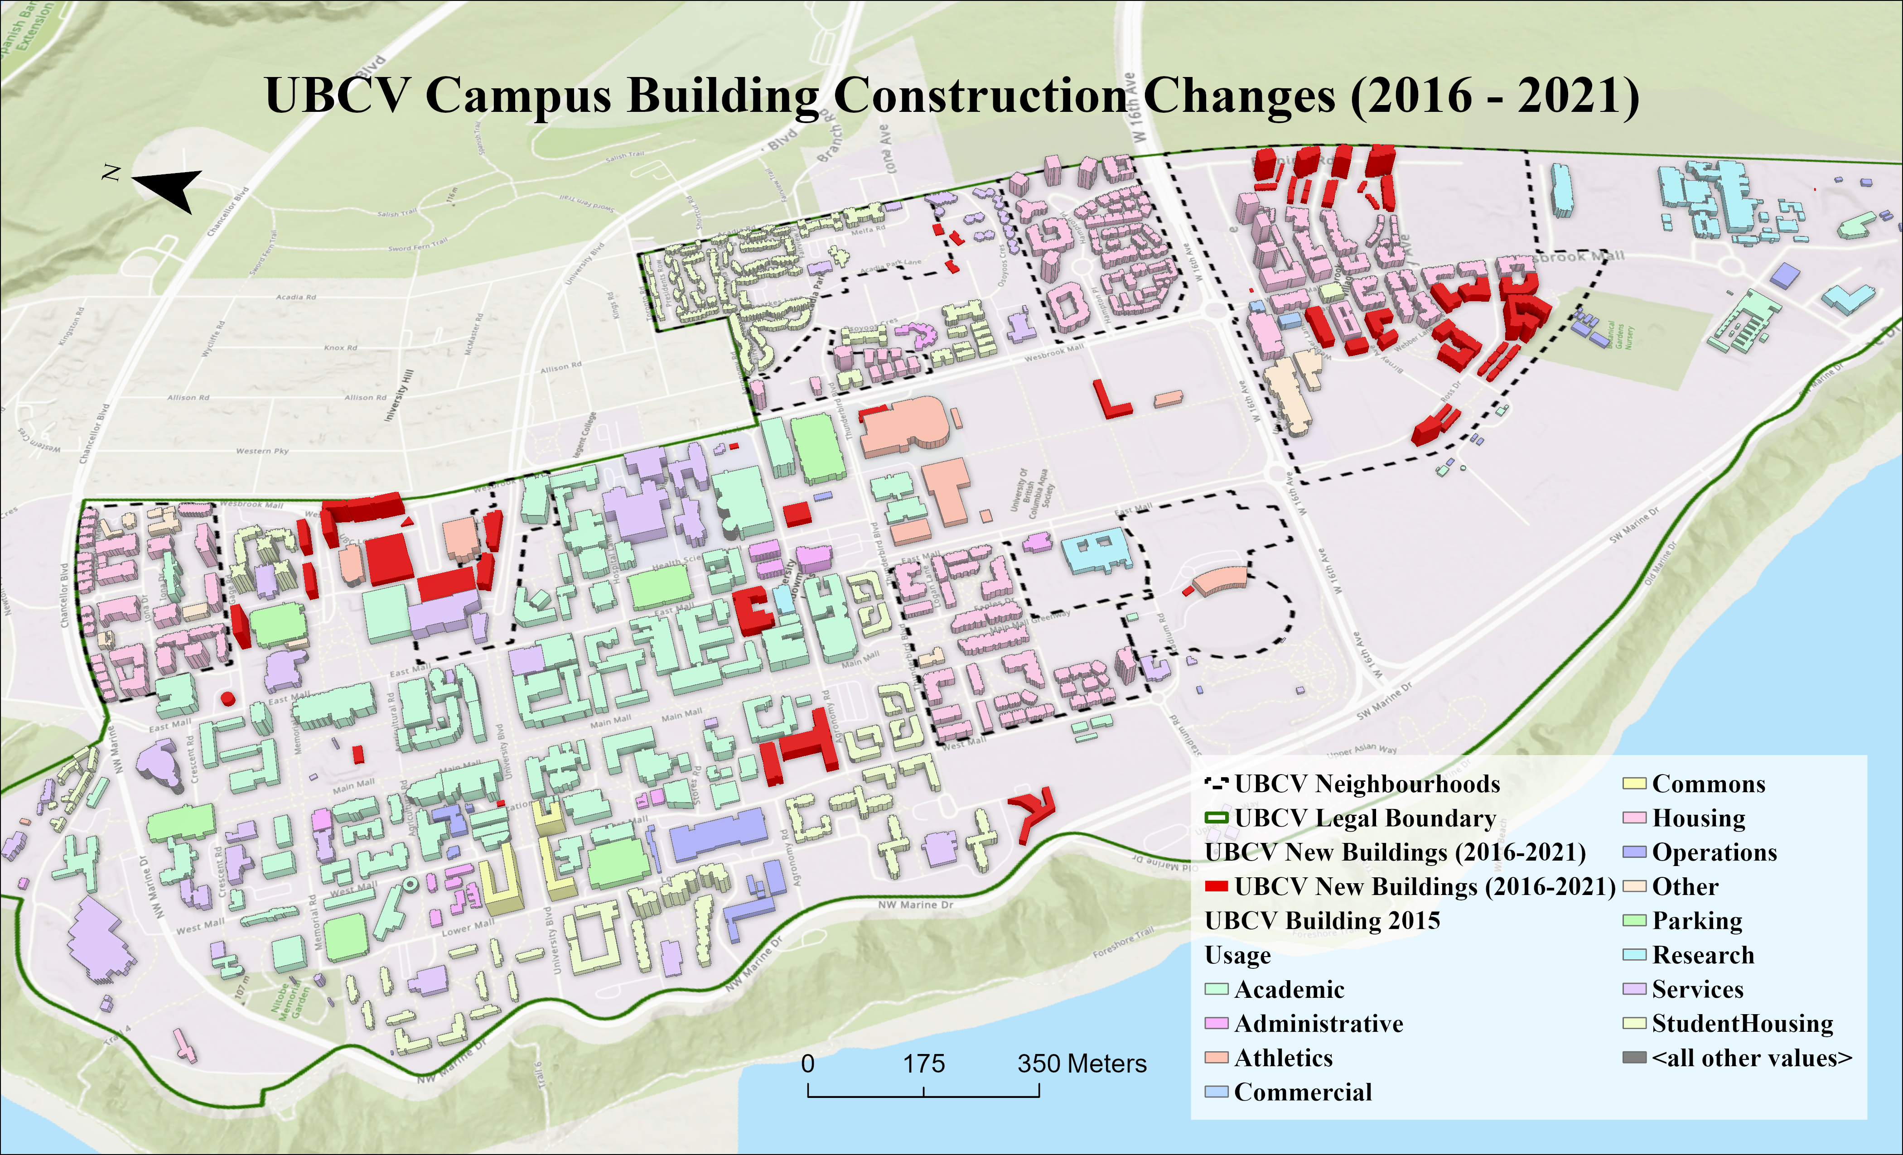

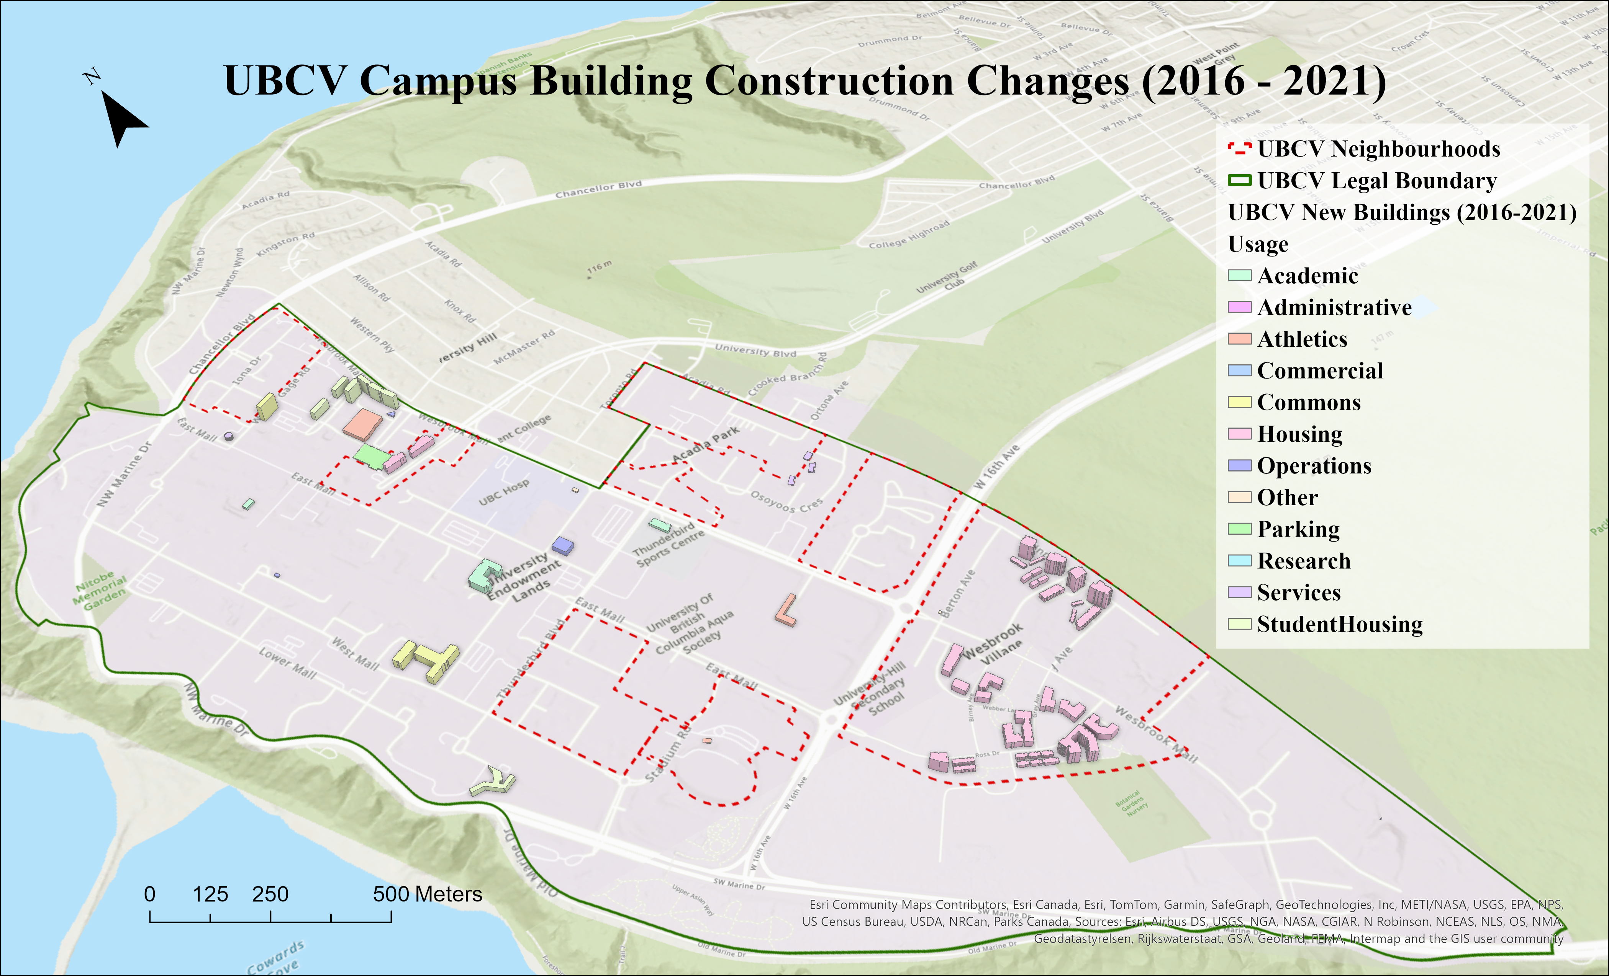
Figure 2 Visualization of campus buildings built between 2015 and 2021, categorized by service function. Dashed lines outline the eight UBCV neighborhoods selected for further analysis.

As shown in Figure 2, the majority of campus buildings from 2015, as well as those constructed between 2016 and 2021, serve academic and housing functions. Wesbrook Place, situated south of campus, has experienced the highest concentration of new buildings and densification among all eight neighborhoods. Table 1 gives an overall comparison of the campus building data for 2015 and 2021. With a campus area of 401.72 hectares, the 2015 building density stood at 0.91 buildings per hectare, accounting for 16.62% of the total land. As of 2021, buildings covered 18.39% of the campus, with a density increase to 1.03 buildings per hectare.

Figure 3 illustrates the changes in the number and proportion of each newly built building type. The overall building count and their usage distribution highlight the campus’s physical expansion and development trends. Academic, housing, student housing, and service buildings all showed an increase over the six-year period, with housing seeing the most significant growth. The shifting proportions of building types reflect changes in how campus spaces have been allocated, with academic buildings decreasing in dominance and housing taking the lead by 2021.

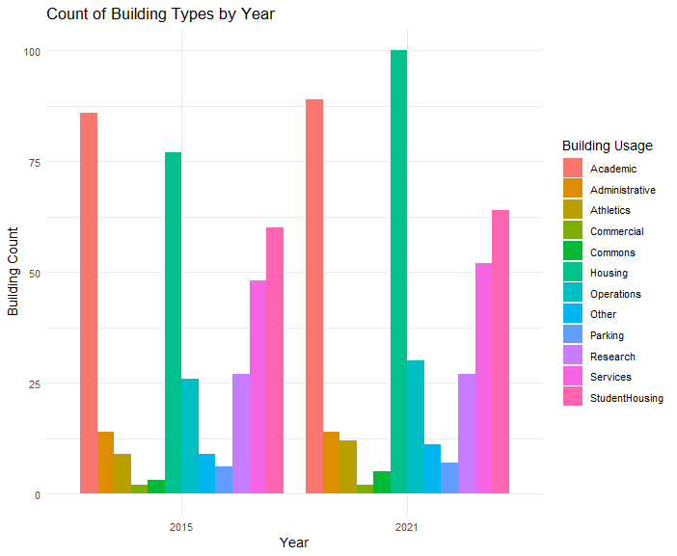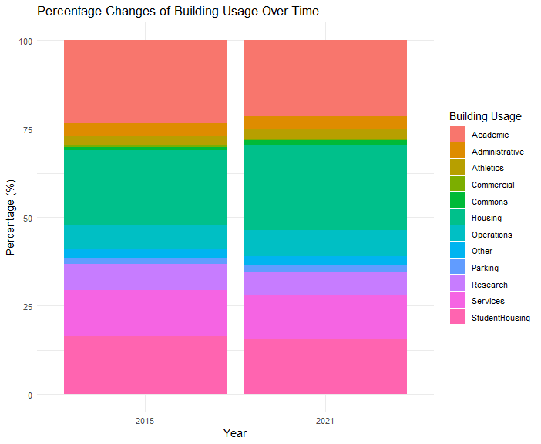
Figure 3 The grouped bar chart displays the count of buildings categorized by usage types on the UBC Vancouver campus in 2015 and 2021. The stacked bar chart shows the percentage distribution of different building usage types on the UBC Vancouver campus in 2015, and 2021.
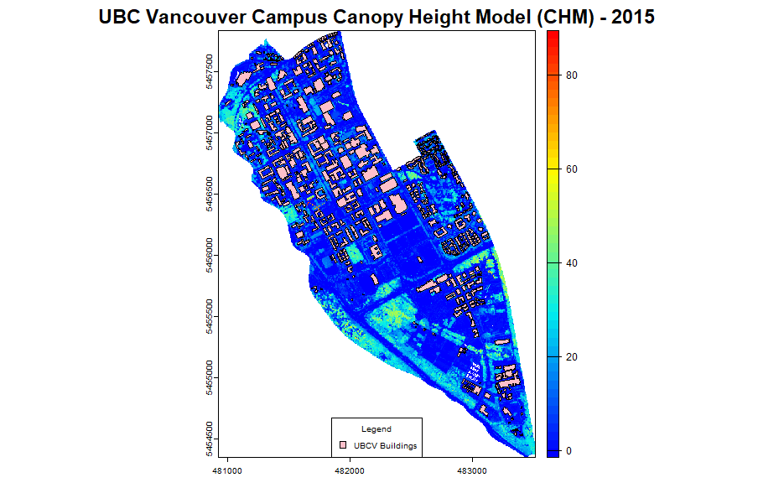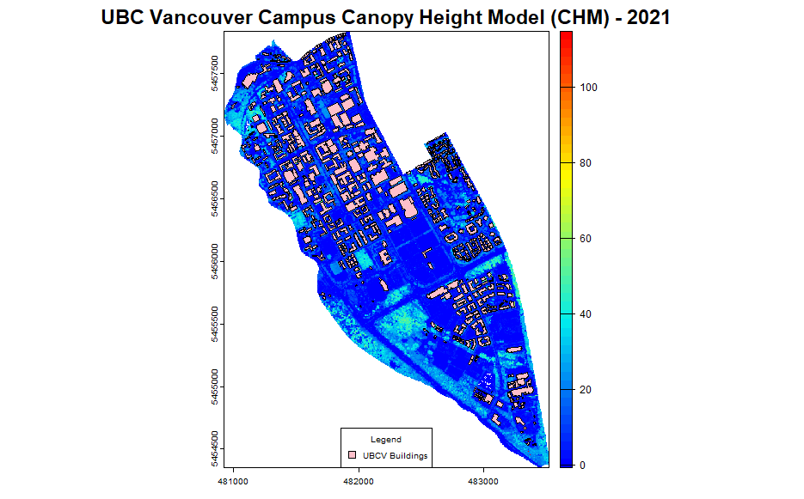
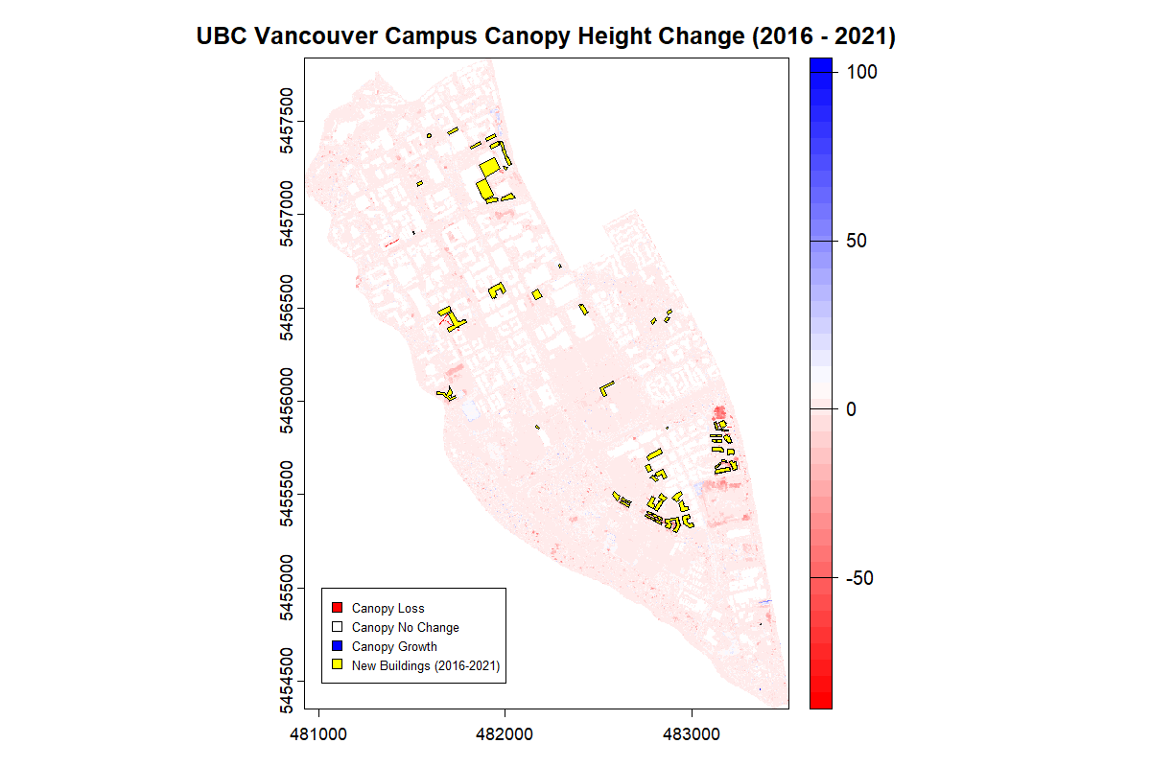
Figure 4 Canopy Height Model (CHM, derived from normalized LAS tiles, using a point-to-raster algorithm (p2r)) of the UBC Vancouver campus are visualized in 2D with a spatial resolution of 2 meters.
The large, empty locations in the CHM represent areas where there is no vegetation (buildings) or where vegetation height is below the spatial resolution of the CHM. In general, the noticeable change in tree height visually aligns with the introduction of new buildings (Figure 2).

Neighbourhoods with new buildings construction between 2016 – 2021
- Wesbrook Place
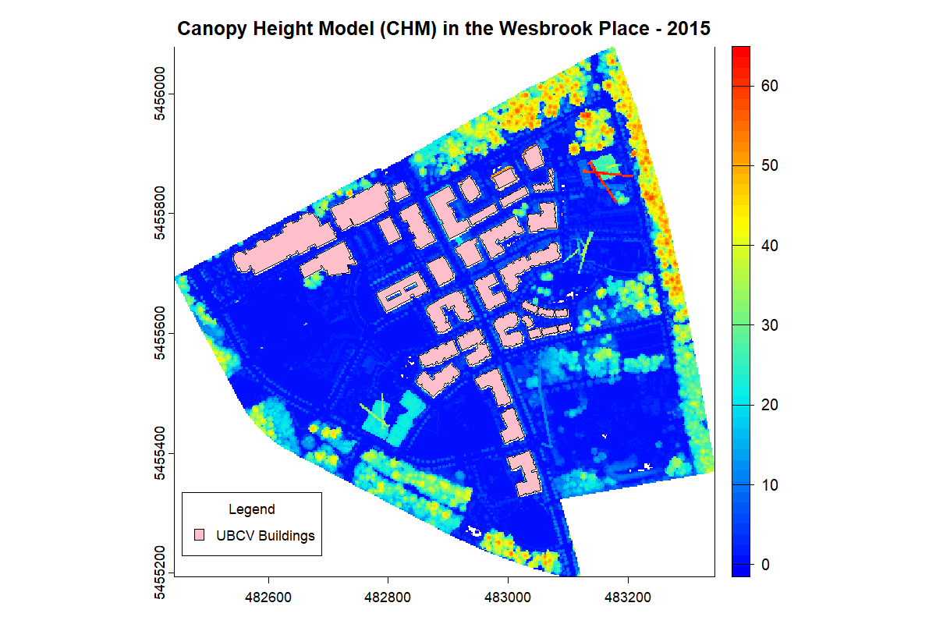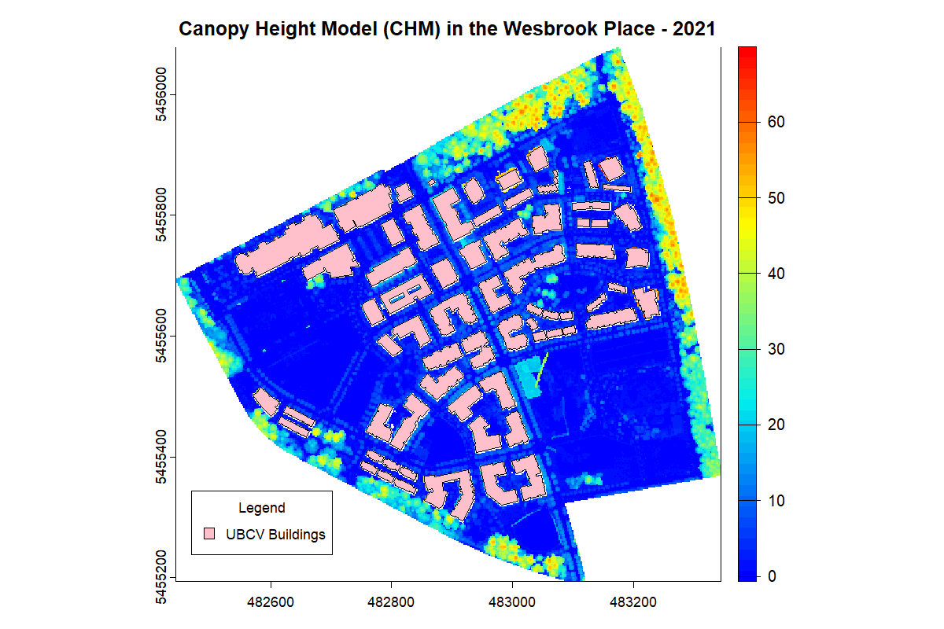
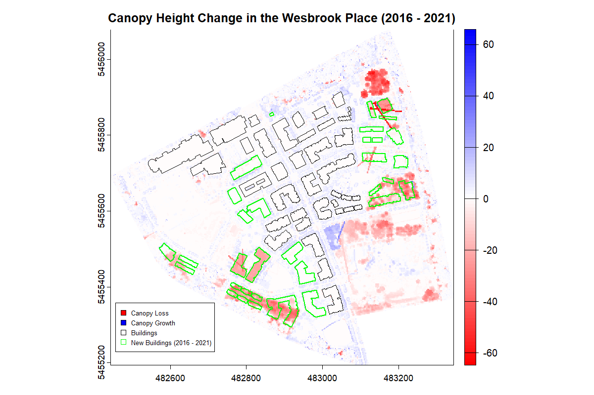
Figure 5 The comparison of CHMs for Wesbrook Place, created from UBC campus LiDAR data in 2015 and 2021 using the point-to-raster (p2r) algorithm with a spatial resolution of 2 meters, highlights changes in tree height and canopy structure.
We can observe the completion of 22 new buildings in Wesbrook Place. All of them were classified as “housing,” except for one, which was categorized as “other”. Natural tree height growth was observed in some undisturbed areas along the community’s edges. The high overlap between new construction and areas with reduced canopy height indicates the common replacement of vegetation with buildings in Wesbrook Place. The canopy height increase recorded in the central area of the community was an error. The area was artificially identified as a building under construction by viewing the initial point cloud data. The error arose from the use of building polygons to clip the original point cloud data, where the under-construction project was excluded from the 2021 building polygons.
- Acadia East
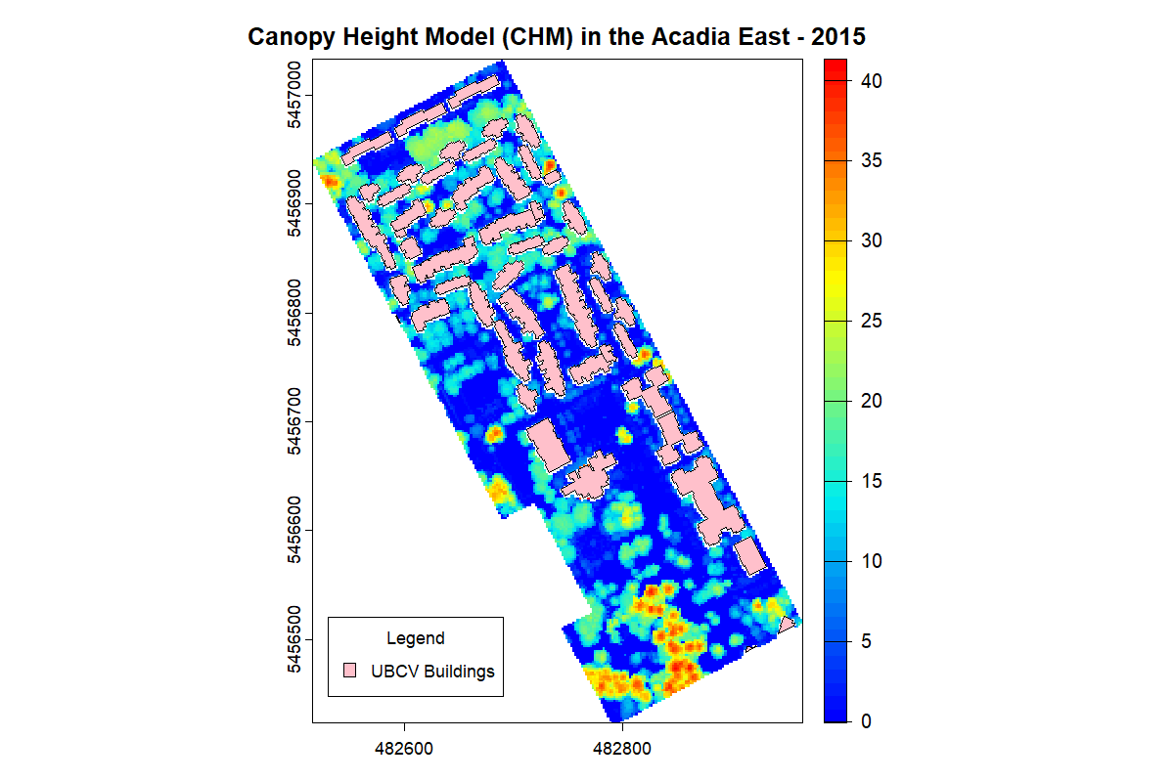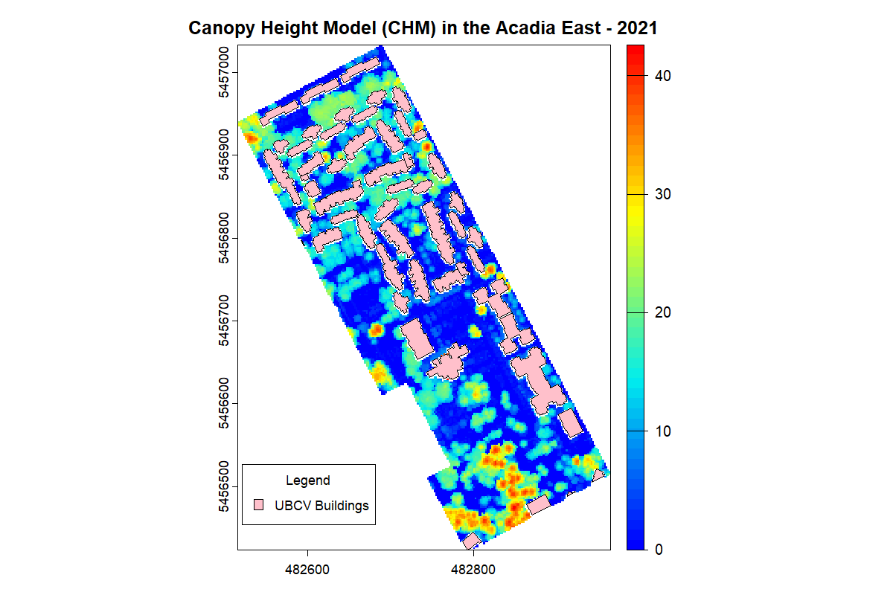
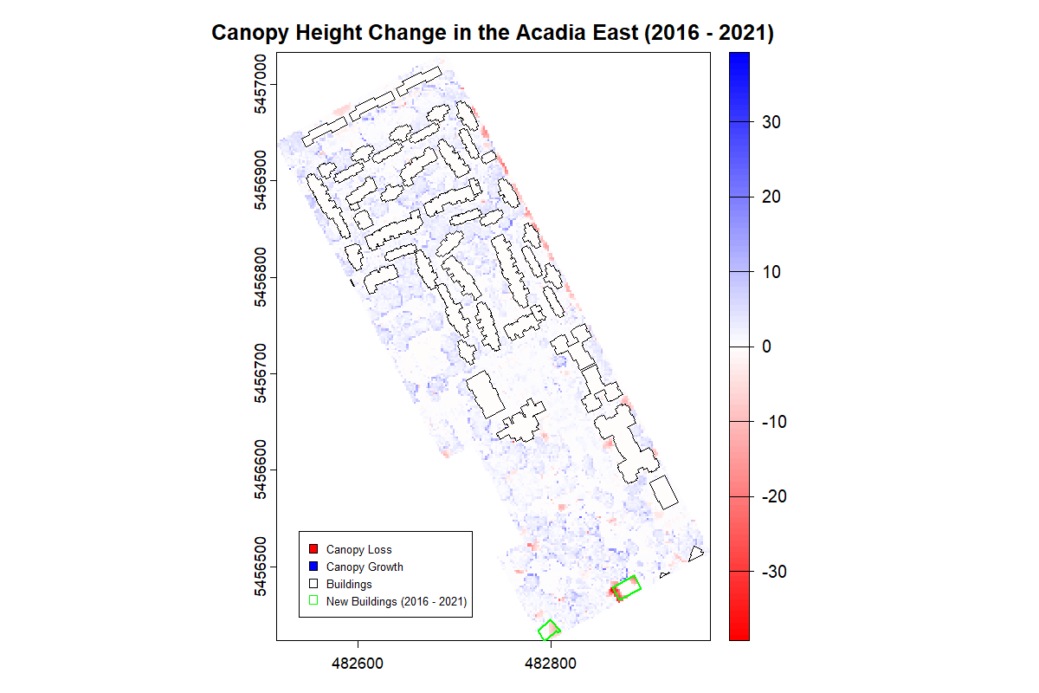
Figure 6 The comparison of CHMs for Acadia East, created from UBC campus LiDAR data in 2015 and 2021 using the point-to-raster (p2r) algorithm with a spatial resolution of 2 meters, highlights changes in tree height and canopy structure.
For Acadia East, only two new buildings on the edge of the neighborhood were recorded, and both were classified as “academic”. Similarly, new construction overlapped with the reduction in canopy height. In contrast to Wesbrook Place, the new buildings were smaller in size relative to the overall neighborhood and brought less disturbance. Canopy heights generally maintained their natural growth across the Acadia East.

- Stadium
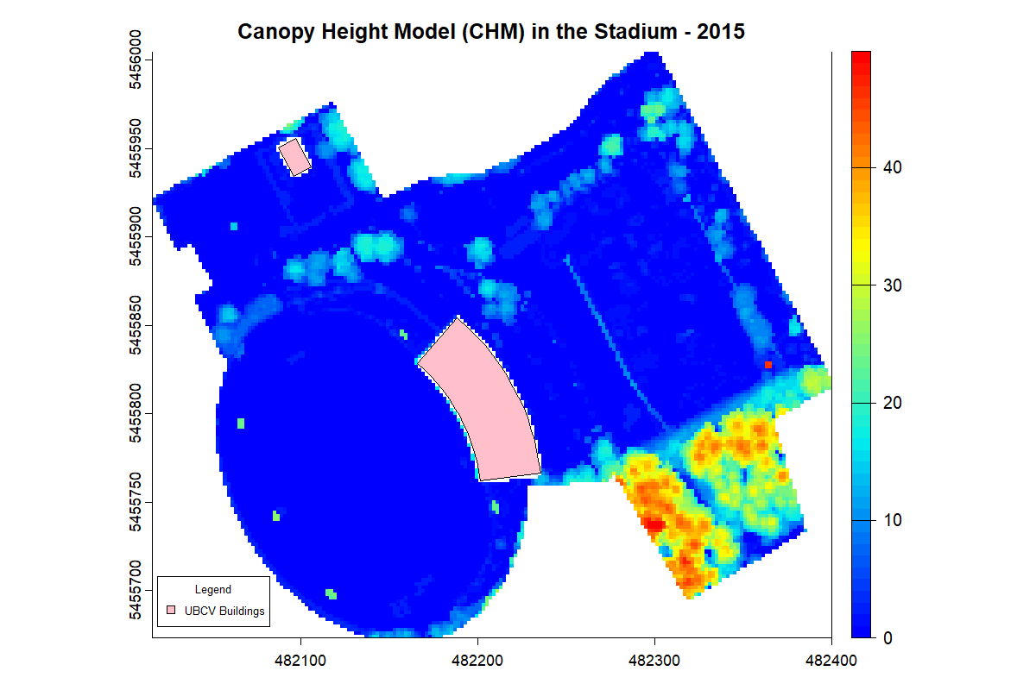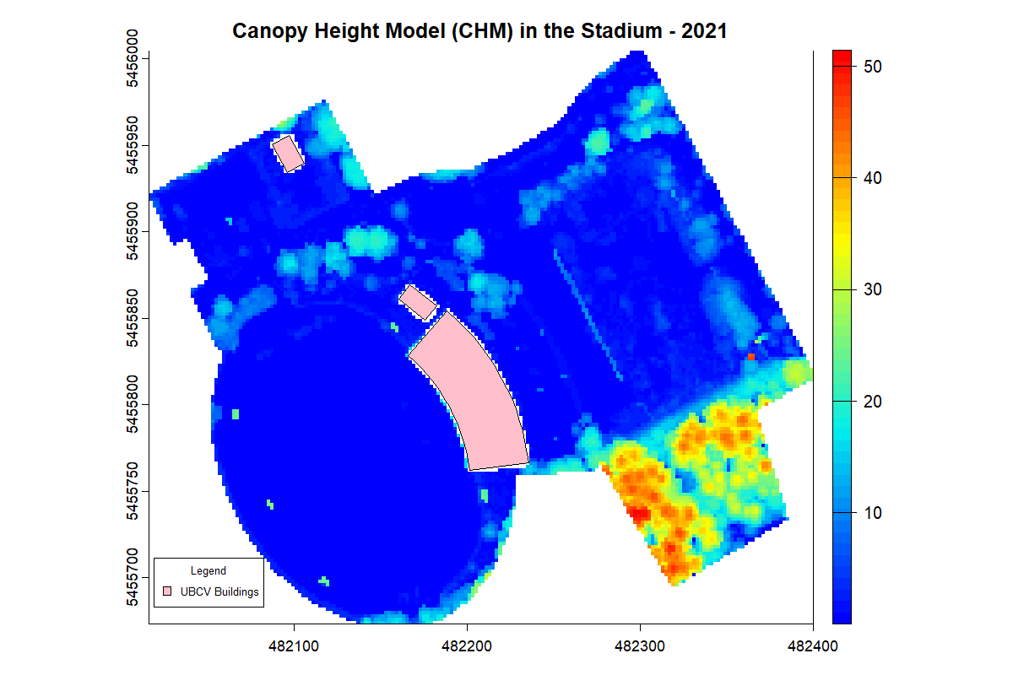
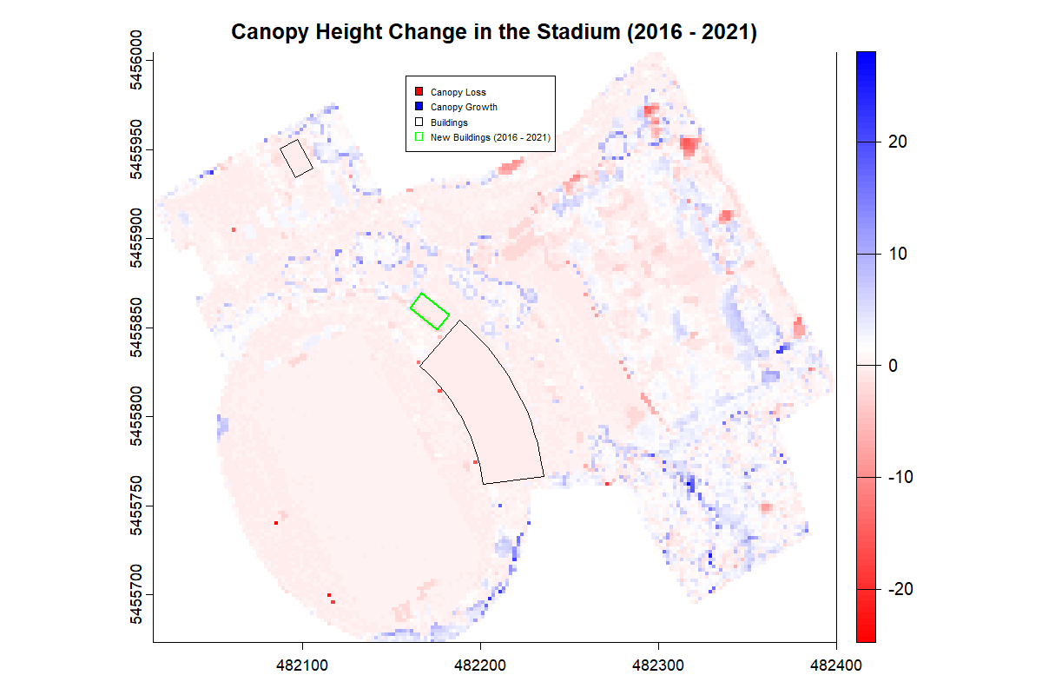
Figure 7 The comparison of CHMs for Stadium, created from UBC campus LiDAR data in 2015 and 2021 using the point-to-raster (p2r) algorithm with a spatial resolution of 2 meters, highlights changes in tree height and canopy structure.
The Stadium neighborhood saw the addition of just one new “Athletics” building during the study period. It consists primarily of Thunderbird Stadium. The vicinity of the stadium did not experience any large developments recently. Natural tree growth was observed throughout the community, only certain areas at the edge of the neighborhood, near East Mall, the primary campus route, showed a reduction in canopy height.
- University Blvd
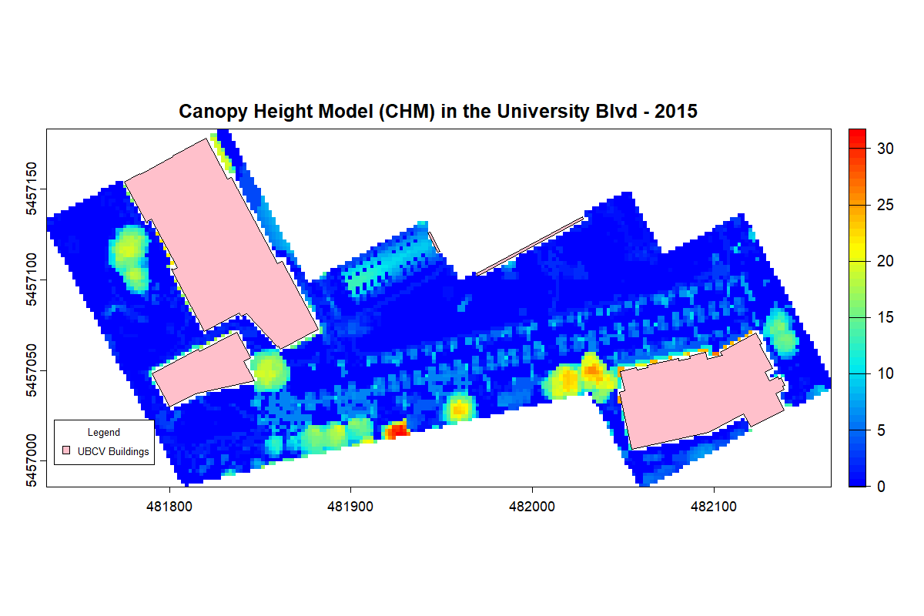
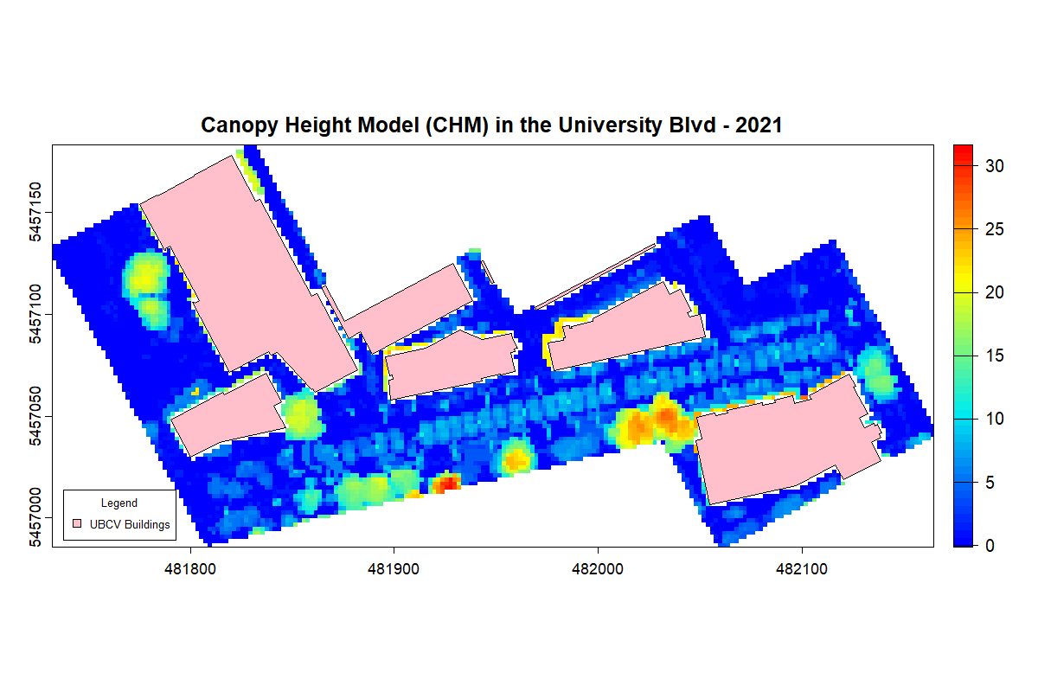
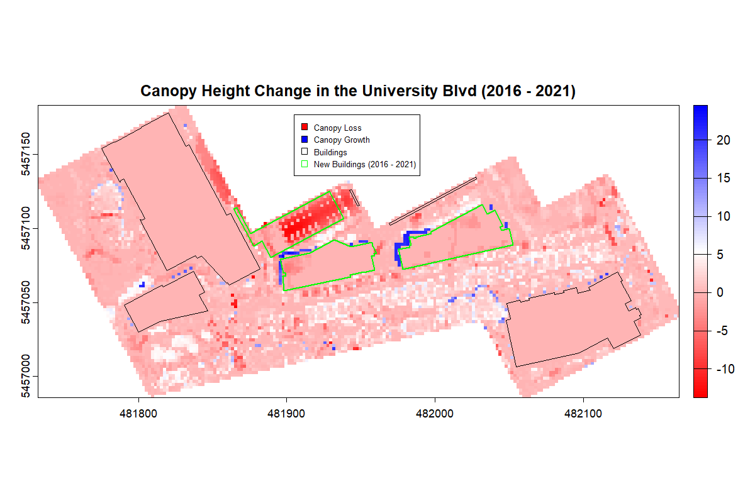
Figure 8 The comparison of CHMs for University Blvd, created from UBC campus LiDAR data in 2015 and 2021 using the point-to-raster (p2r) algorithm with a spatial resolution of 2 meters, highlights changes in tree height and canopy structure.
Three newly constructed buildings emerged in the University Blvd neighborhood, with one serving as a parking structure and the other two as housing. Figure 8 highlights the noticeable loss of trees caused by the construction of the parking lot. The canopy height difference indicates that the lost trees were not old-growth. In 2015, no trees were observed at the future construction sites of the two residences in the neighborhood’s central area. This could be attributed to ground clearing preparations that were completed before 2015. Consequently, the impacts of residential construction in the University Blvd neighborhood were not detected in the 2015 to 2021 year range. Inaccuracies remained in the polygon-based clipping of the raw point cloud, leading to incorrect canopy height increases near the two new residences. University Blvd, the primary road of the university, runs through the neighborhood’s center, where canopy height changes reflected the natural growth of street trees along both sides.

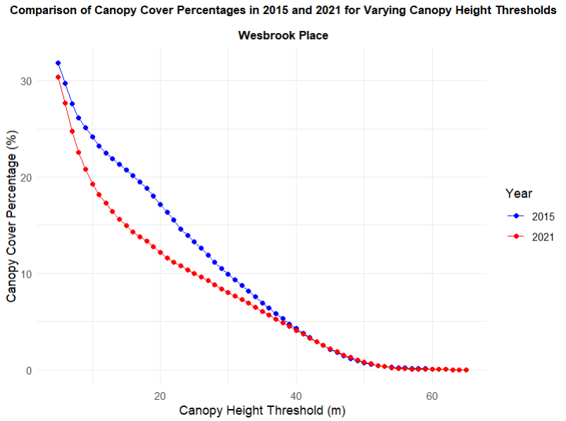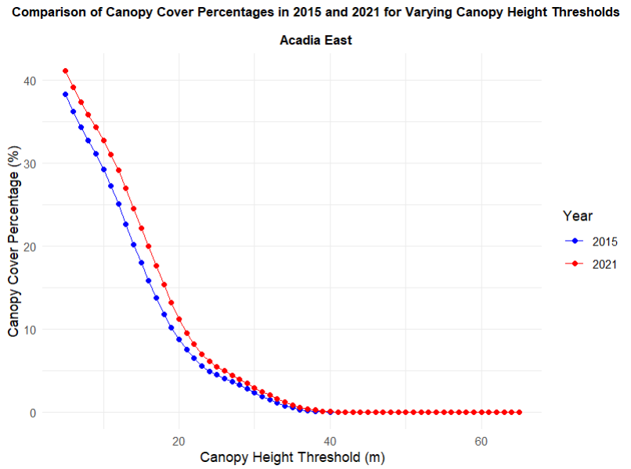
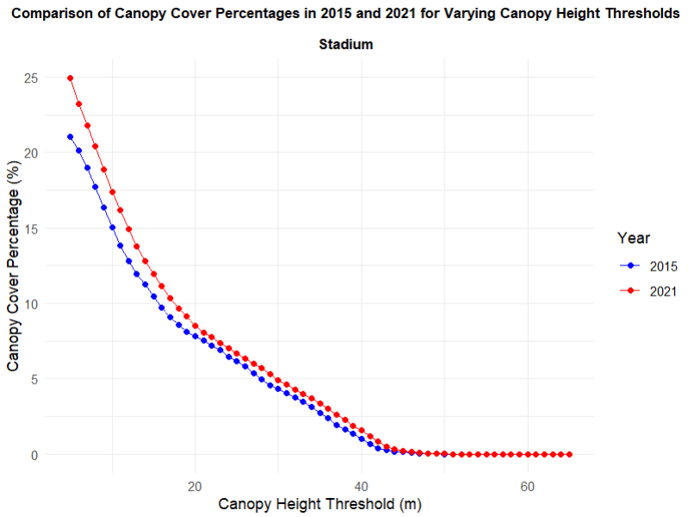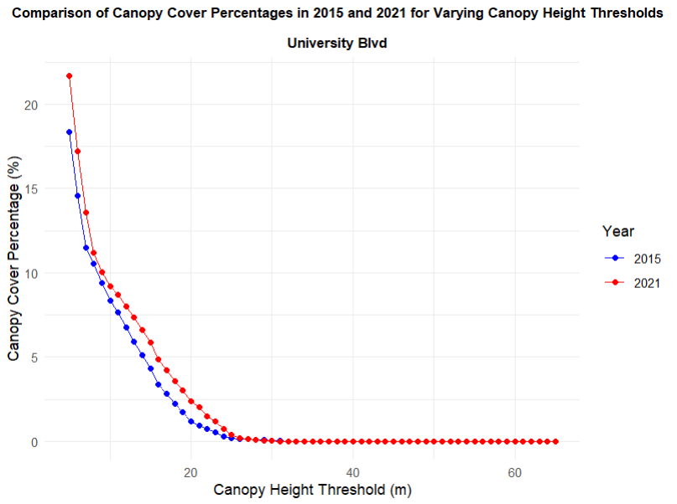
Figure 9 Comparison of canopy cover percentages for neighborhoods with new building construction between 2015 and 2021, examined through different canopy height thresholds (ranging from 5 to 65 meters).
All pixels with a height greater than thresholds are classified as the canopy. Figure 9 visualizes the variation in canopy pixel proportions in four neighborhoods with new building development from 2015 to 2021 as threshold values increase from 5 to 65 meters.
A gradual decrease in canopy cover is evident in all four communities as threshold values increased. When using lower thresholds (e.g., 5m), the canopy cover percentage remains high due to the inclusion of shorter vegetation like shrubs and young trees. As the threshold increases (e.g., 30m, 40m), only taller trees are classified as canopy, reducing the overall canopy cover percentage. Canopy cover in Wesbrook Place drops to 0 at a threshold of approximately 50m, while in other neighborhoods (Acadia East, Stadium, and University Blvd), the canopy cover reaches 0 at lower thresholds (around 40m for Acadia East and Stadium, and about 25m for University Blvd), indicating variations in canopy structure and tree types across these areas. Old-growth trees in Wesbrook Place were largely spared from the effects of construction removal. Acadia East and Stadium neighborhoods were home to medium-growth trees, while University Blvd featured newly planted young trees.
At most thresholds, Wesbrook Place’s canopy cover is lower in 2021, indicating that tree loss occurred as a result of development-related tree removal. The widening gap between the two years at the 10 to 20m range suggests that construction activities, including physical damage to roots, soil compaction, or vegetation removal, may have hindered the growth of young trees that would have contributed to the higher canopy.
In Acadia East and Stadium neighborhoods, where building construction had little disturbance, canopy cover in 2021 is close to or slightly higher than in 2015, showing tree growth or new plantings offsetting the loss of trees. For University Blvd, the increase in canopy height between 2015 and 2021 is very small across most of the thresholds, except for the 10-25m threshold. Minimal change in canopy at low to medium heights reveals growth and tree removal were balanced at lower height ranges. In areas where trees may have been removed earlier for construction or development, new trees or saplings might have grown into the 10-25m range, contributing to an increase in canopy height at 10-25m threshold.

Neighbourhoods without new buildings construction between 2015 - 2021
- Chancellor Place
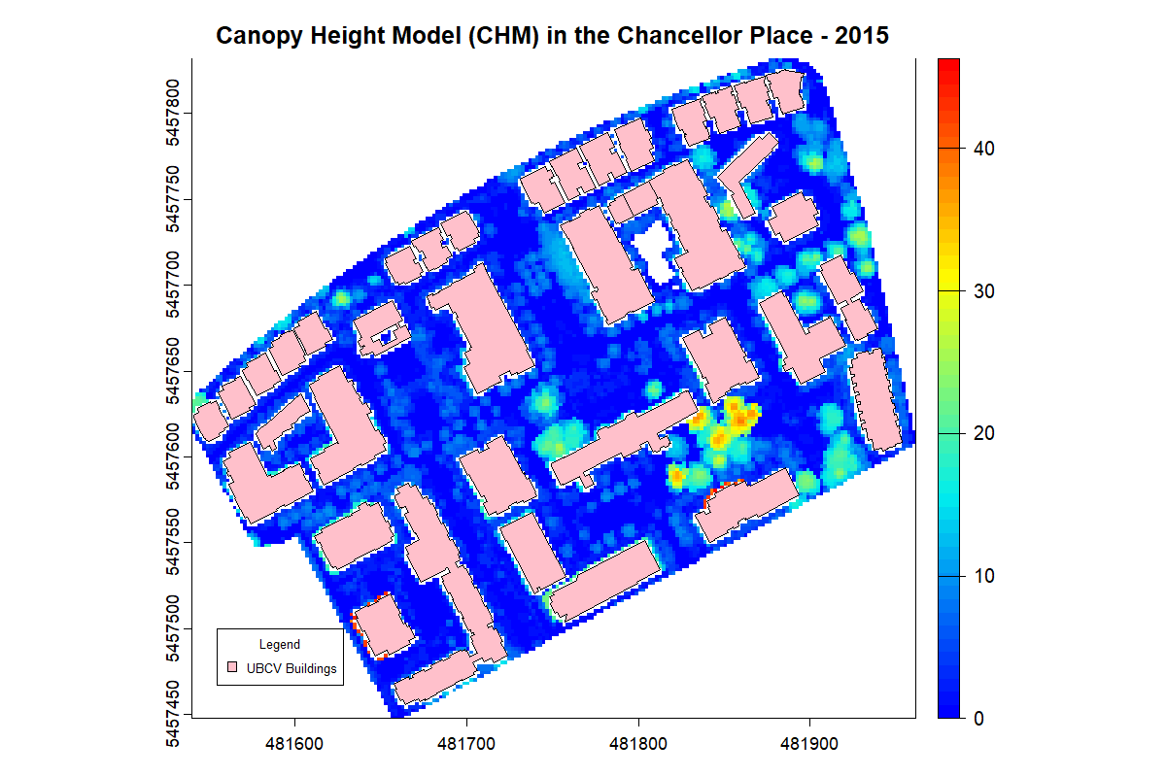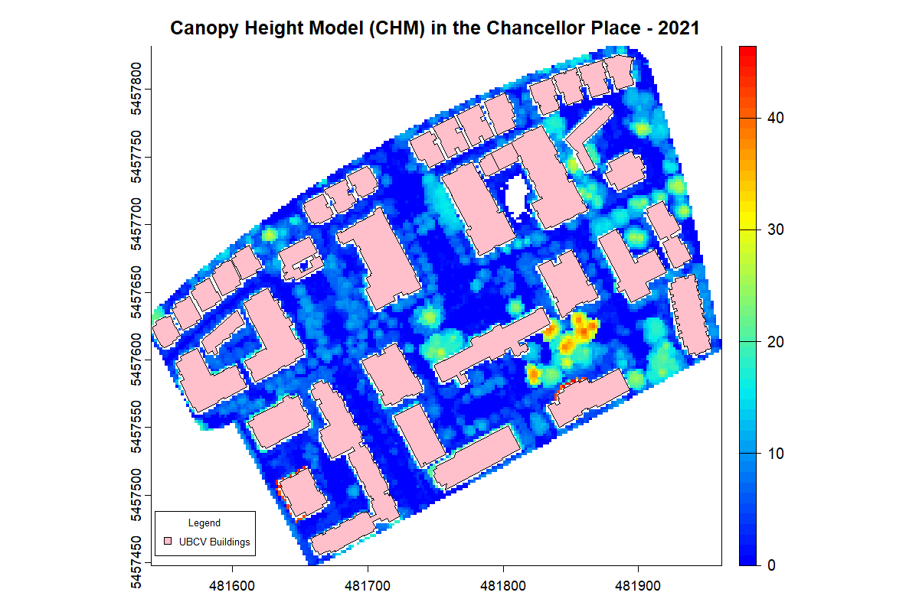
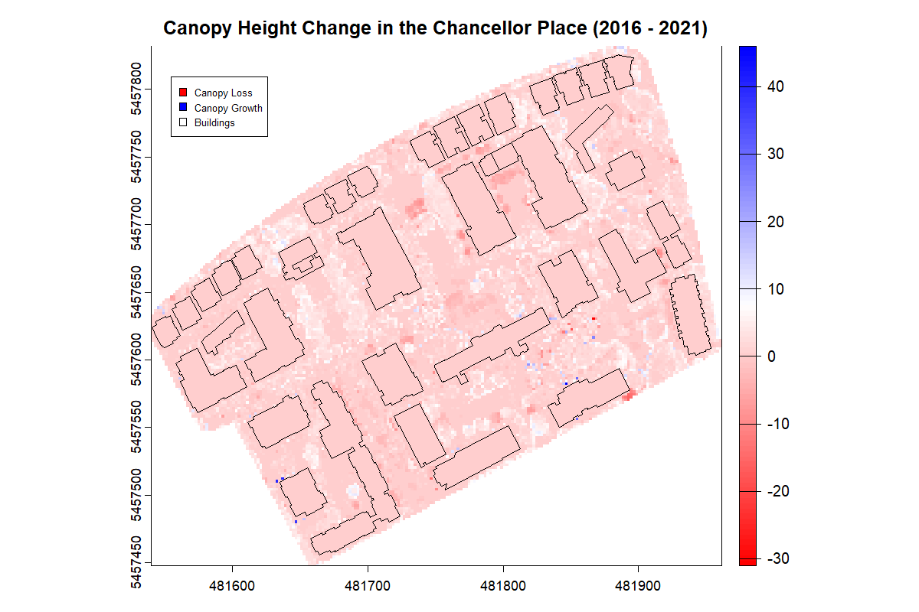
Figure 10 The comparison of CHMs for Chancellor Place, created from UBC campus LiDAR data in 2015 and 2021 using the point-to-raster (p2r) algorithm with a spatial resolution of 2 meters, highlights changes in tree height and canopy structure.
Most of the young street trees in Chancellor Place exhibit normal canopy growth, as there were no strong disturbances from construction, except for a few instances of tree removal along the roadway. The saturated development of buildings and roadways left low opportunity for well-connected spaces capable of supporting large canopy cover expansion in the community.
- East Campus
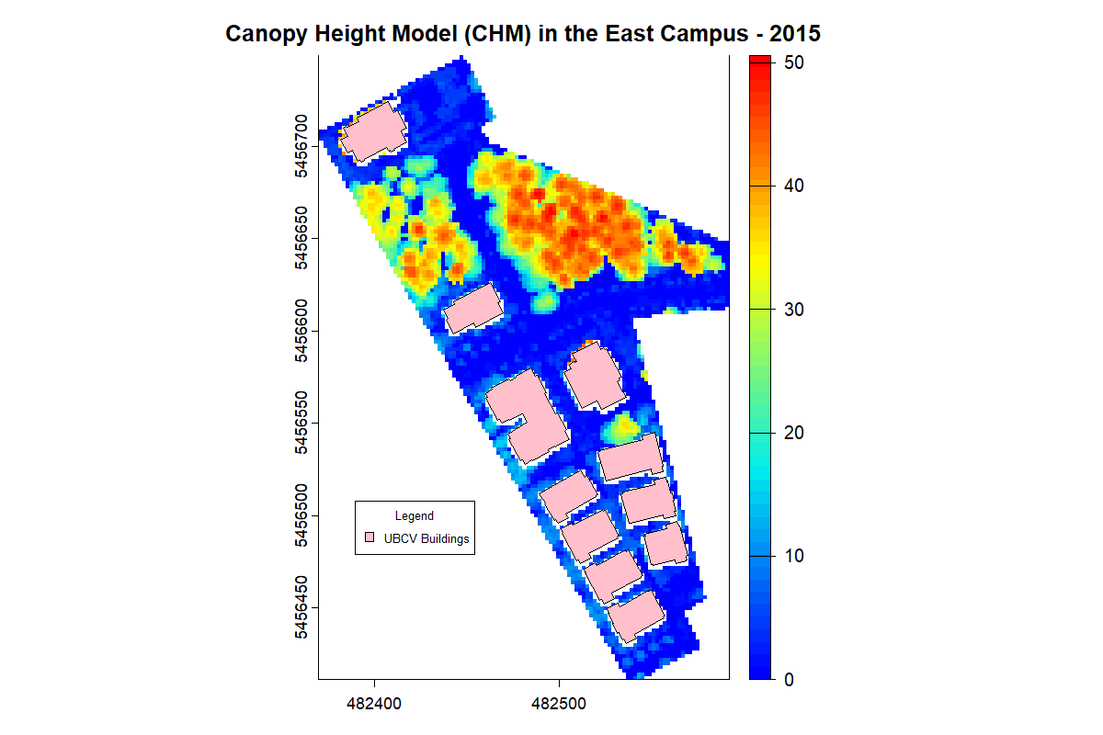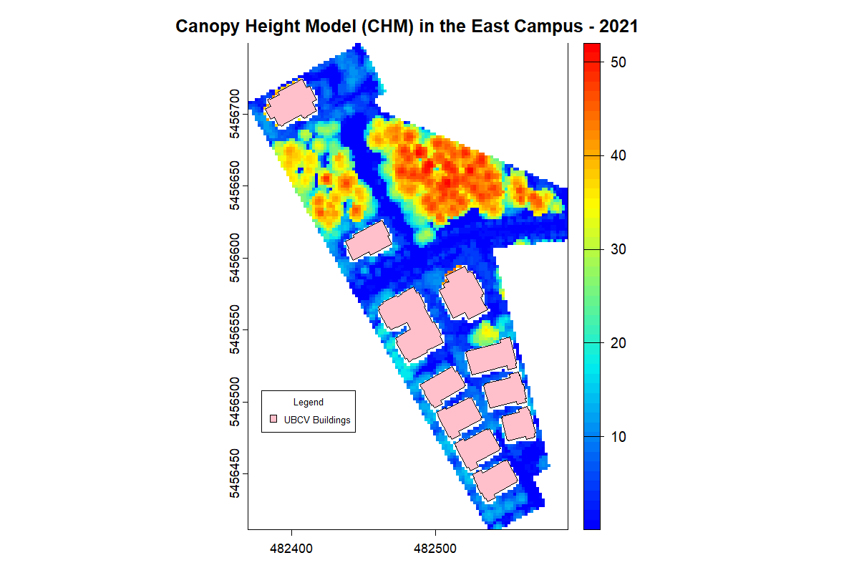
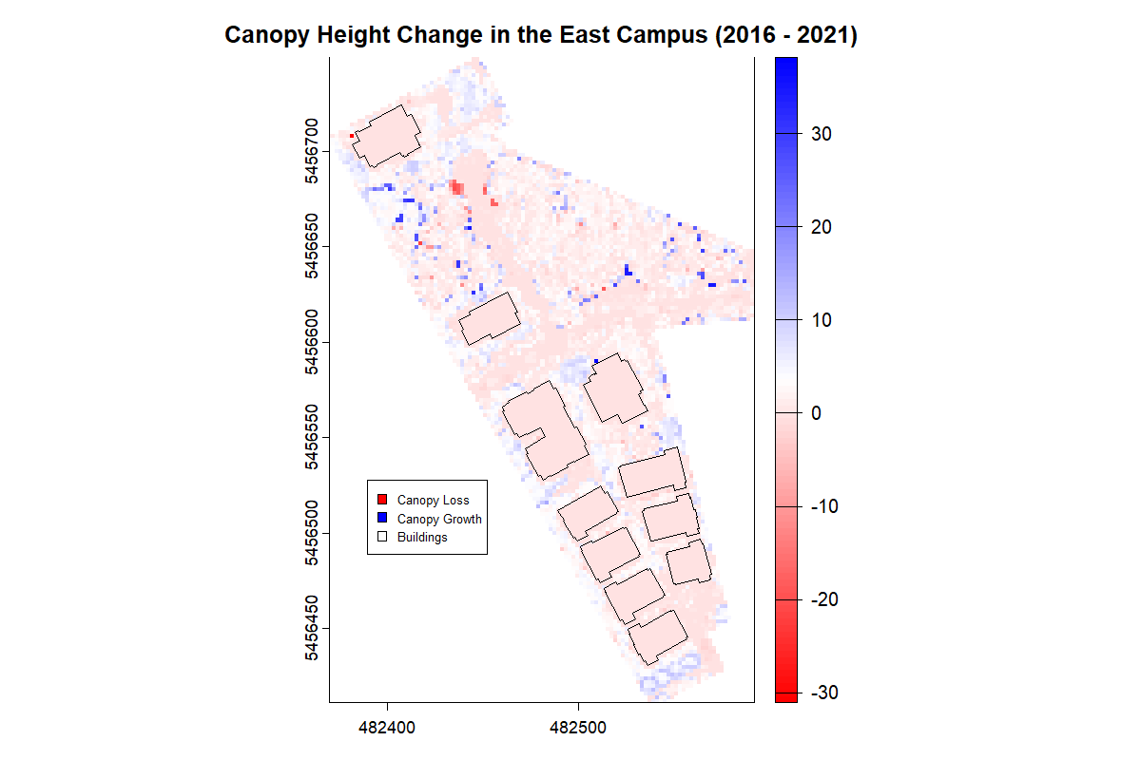
Figure 11 The comparison of CHMs for East Campus, created from UBC campus LiDAR data in 2015 and 2021 using the point-to-raster (p2r) algorithm with a spatial resolution of 2 meters, highlights changes in tree height and canopy structure.
In East Campus, new buildings did not replace trees, leaving larger and more coherent spaces for tree growth, allowing them to grow taller and expand their canopy. Increased canopy height occurred throughout the community.

- Hampton Place
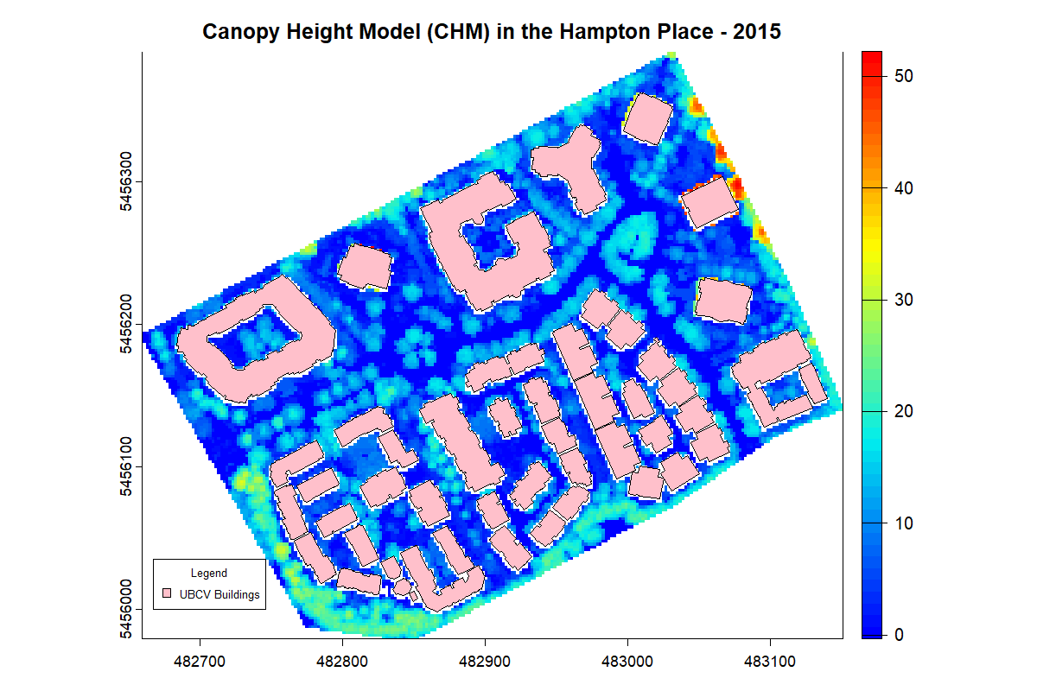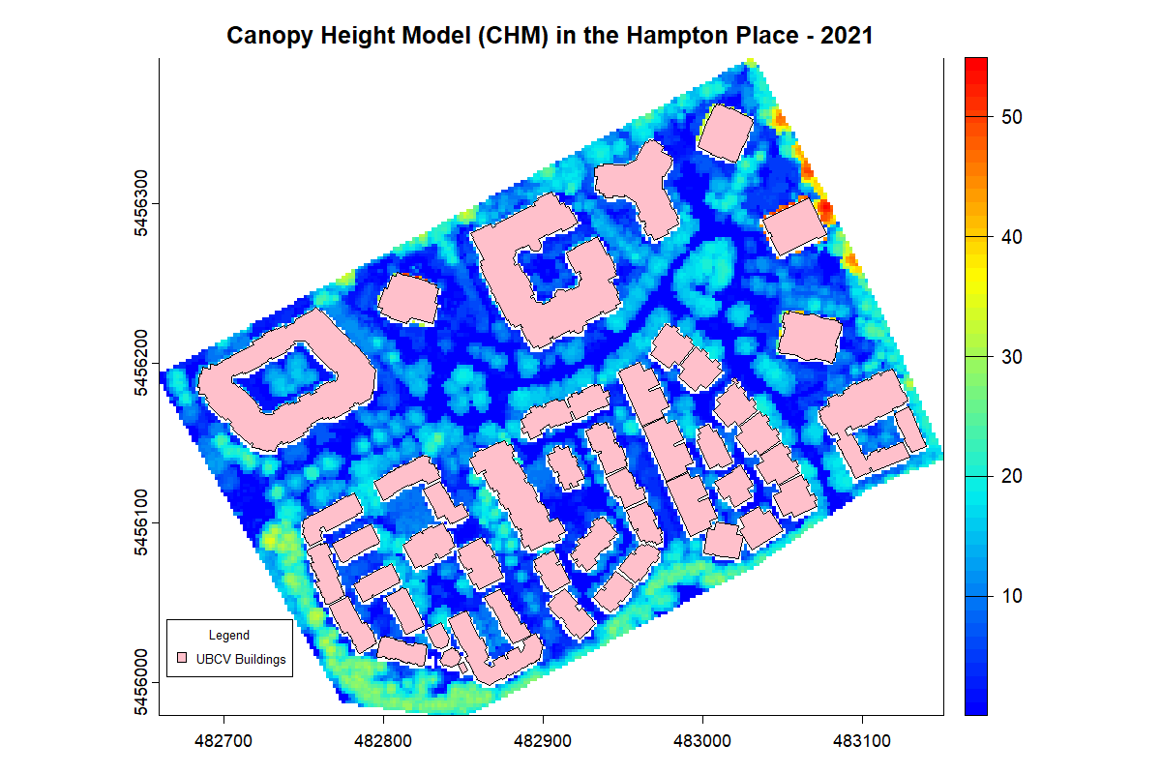
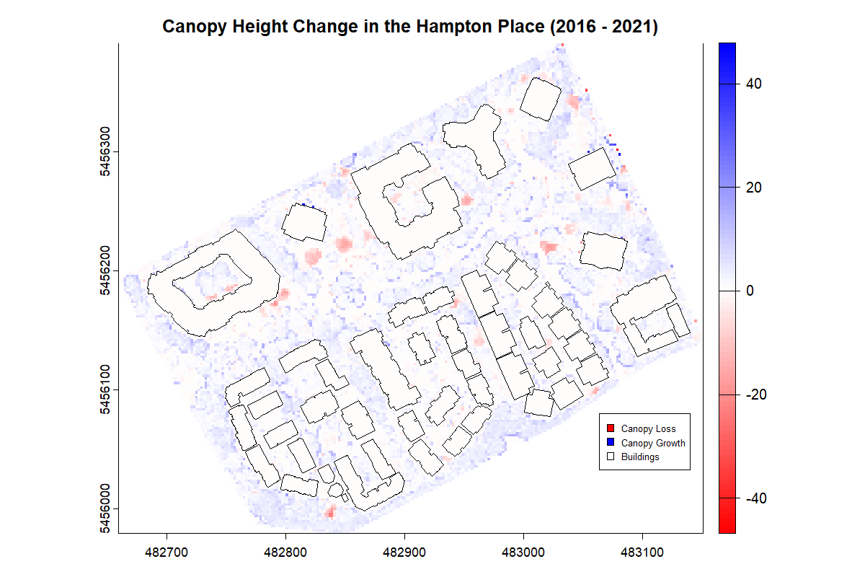
Figure 12 The comparison of CHMs for Hampton Place, created from UBC campus LiDAR data in 2015 and 2021 using the point-to-raster (p2r) algorithm with a spatial resolution of 2 meters, highlights changes in tree height and canopy structure.
Trees around residential buildings generally exhibited an increase in canopy height, though some roadside and selective tree cutting occurred between 2015 and 2021.
- Hawthorn Place
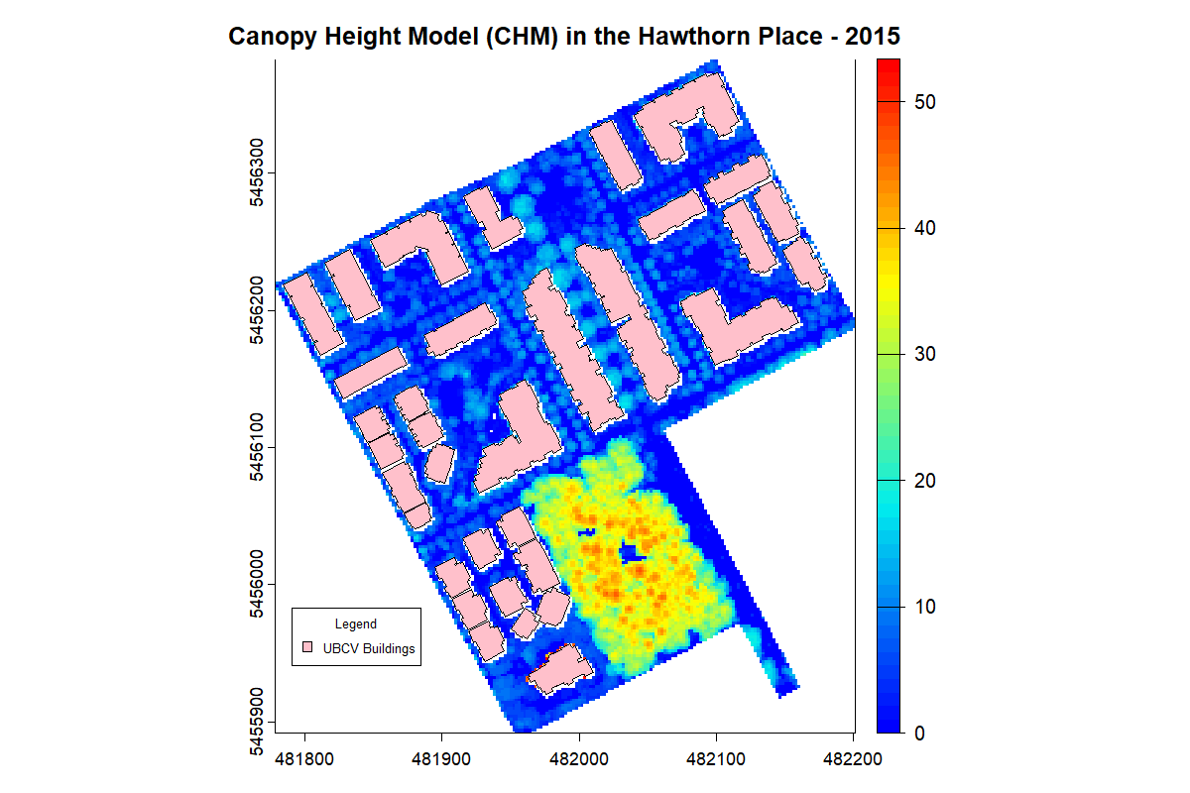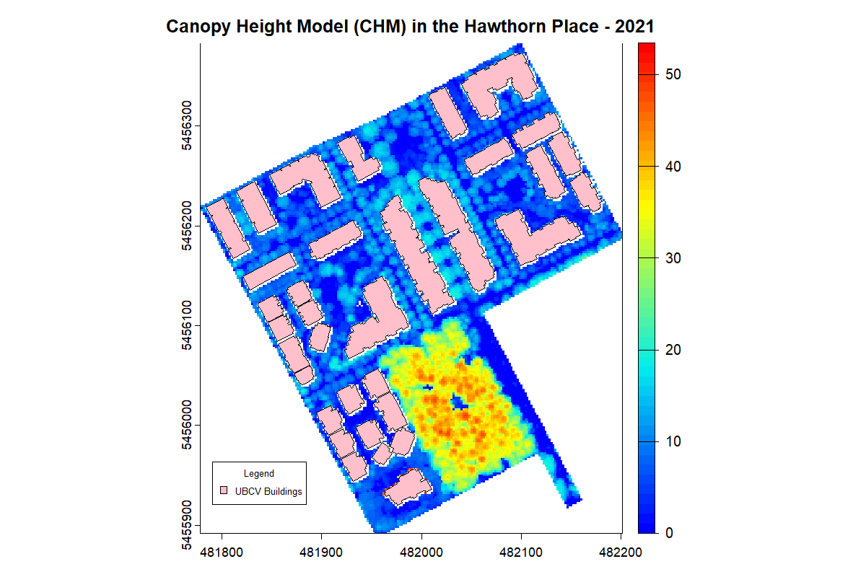
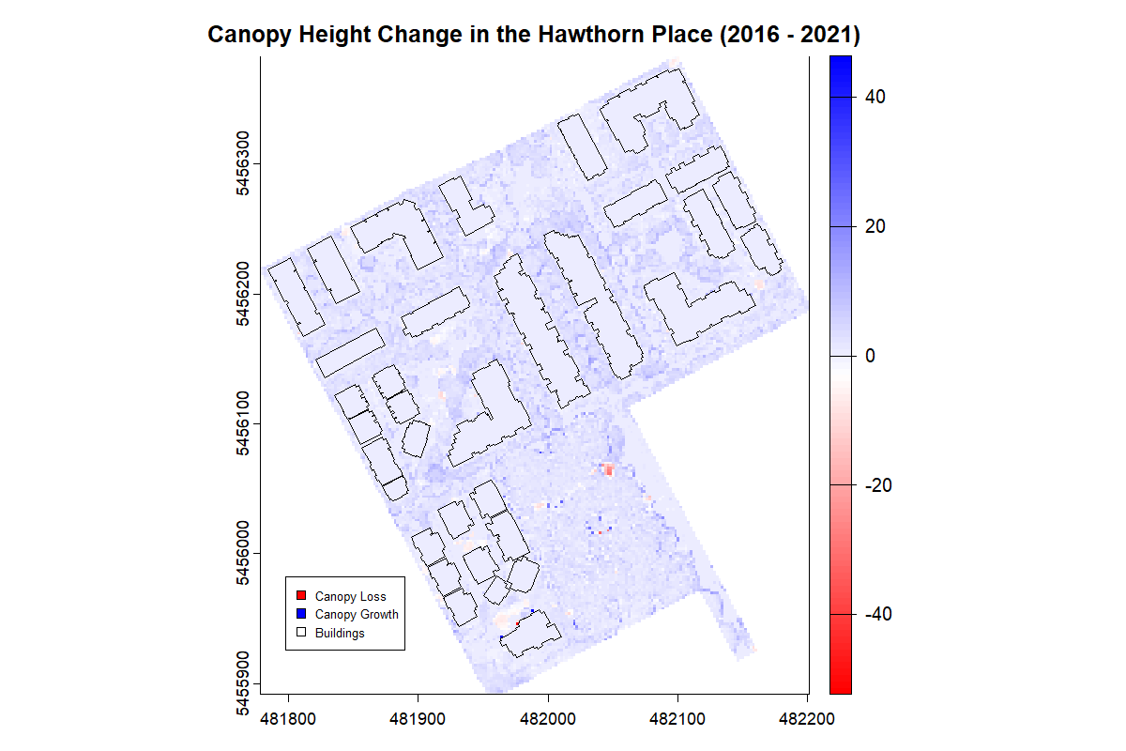
Figure 13 The comparison of CHMs for the Hawthorn Place, created from UBC campus LiDAR data in 2015 and 2021 using the point-to-raster (p2r) algorithm with a spatial resolution of 2 meters, highlights changes in tree height and canopy structure.
Tree canopy heights in the community were progressing at a healthy pace, with large clusters of undeveloped areas holding the potential for future development of old-growth trees.

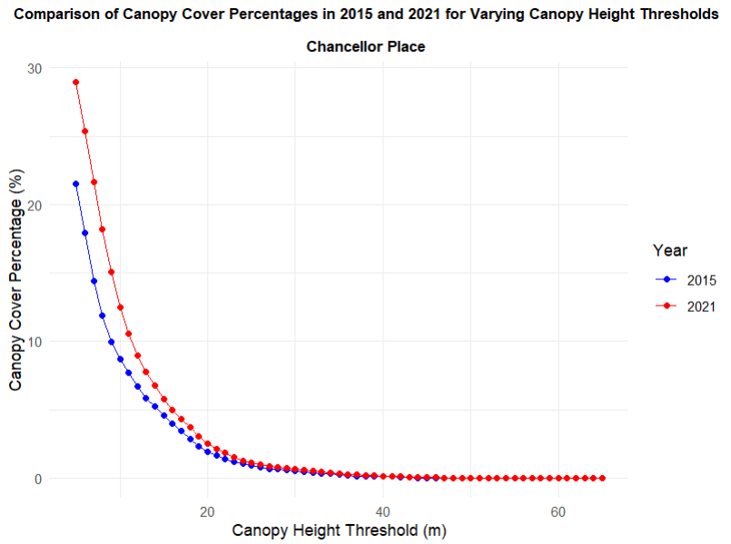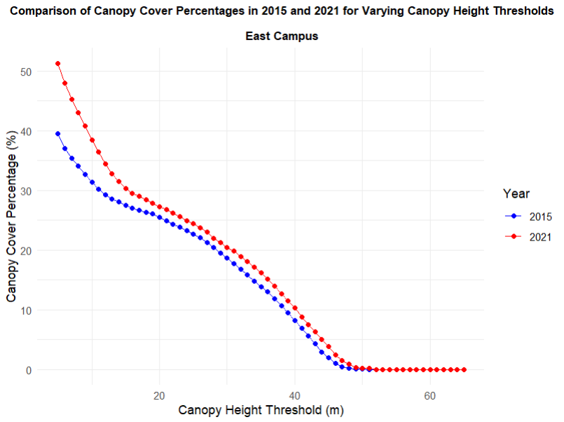
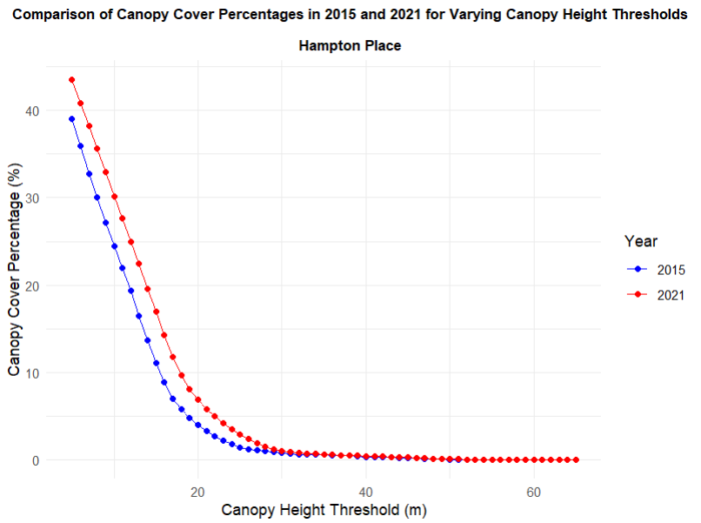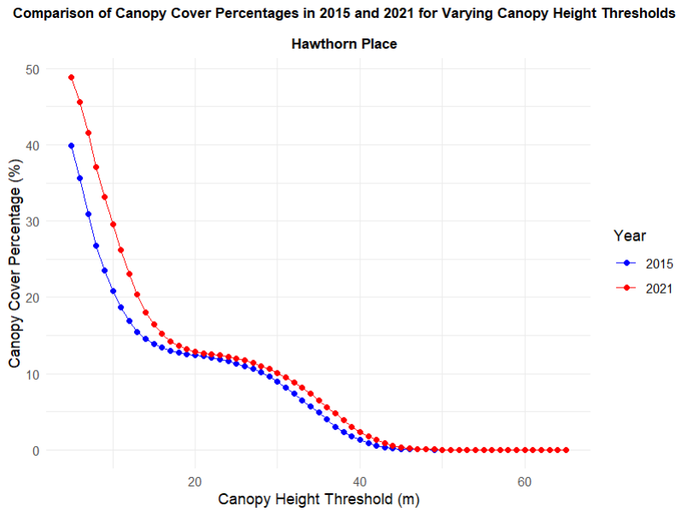
Figure 14 Comparison of canopy cover percentages for neighborhoods without new building construction between 2015 and 2021, examined through different canopy height thresholds (ranging from 5 to 65 meters).
Neighborhoods unaffected by building construction generally had higher canopy cover and showed tree growth between 2015 and 2021, particularly at lower canopy heights. This could be due to the existing young trees natural growth or maturing. All neighborhoods except Hampton Place achieved 10% canopy cover growth between 2015 and 2021 at the 5m canopy height threshold. The relatively lower growth in Hampton Place may stem from fewer available spaces for trees, as the area has denser building development and smaller green spaces compared to other neighborhoods.
Although no new construction took place, the density of the building distribution and available growing space also influenced the canopy cover and age composition of the neighborhood trees. Overall, East Campus and Hawthorn Place, with lower densities of existing buildings had higher canopy coverage. Also, they had trees reaching around 45m in height, while Chancellor Place and Hampton Place had maximum tree heights of 30m and 25m, respectively. With more space for root expansion and growth, young trees in East Campus and Hawthorn Place in 2015 likely benefited from greater access to water, nutrients, and sunlight, allowing them to continue growing without the constraints of nearby buildings or infrastructure. This aligns with the higher canopy cover observed in trees reaching 10-25m in height within East Campus and Hawthorn Place.

References
ArcGIS Blog. (n.d.a). Transform 2D building footprint polygons into 3D buildings using 3D Object Feature Layer. Retrieved November 2, 2024, from https://www.esri.com/arcgis-blog/products/arcgis-pro/3d-gis/transform-2d-building-footprint-polygons-into-3d-buildings-using-3d-object-feature-layer/
ArcGIS Blog. (n.d.b). Extract LAS (3D Analyst). Retrieved March 2, 2025, from https://pro.arcgis.com/en/pro-app/latest/tool-reference/3d-analyst/extract-las.htm
Roussel, J., Goodbody, T. R. H., & Tompalski, P. (2022). The lidR package. Retrieved from https://r-lidar.github.io/lidRbook/
Stanley Park Ecology Society. (2024). Co-Existing with Coyotes Report Map. Retrieved November 2, 2024, from https://stanleyparkecology.shinyapps.io/coyote_sightings_map/
Zhu, W., Wang, D., Eynard, B., Bricogne, M., & Remy, S. (2016). Procedural Approach for 3D Modeling of City Buildings. In A. Bouras, B. Eynard, S. Foufou, & K.-D. Thoben (Eds.), IFIP advances in information and communication technology (Vol. 1–Book, Section, pp. 137–148). Springer International Publishing. https://doi.org/10.1007/978-3-319-33111-9_13

