No registration of other courses not displayed by the program. The program then outputs the current list of registered classes and asks the user if they want to register for another course.

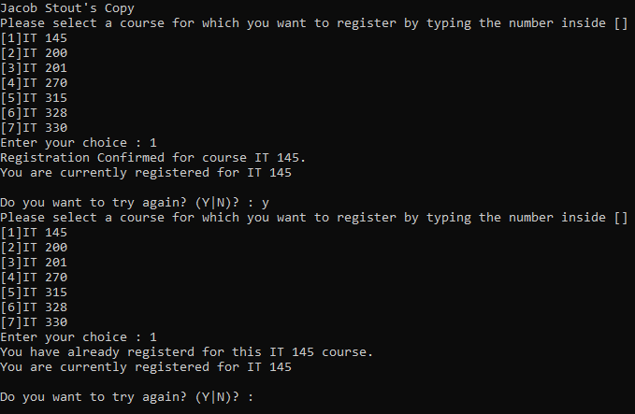

The program validates the user integer menu selection. If the selection is valid, the program registers the student for the selected course. Then there is no registration more than once for the same course.

No registration for more than nine credit hours

using System;

using System.Collections.Generic;

using System.Linq;

using System.Text;

using System.Threading.Tasks;

namespace ConsoleRegisterStudent

{

class Program

{

static void Main(string[] args)

{

(new Program()).run();

}

void run()

{

int choice;

int firstChoice = 0, secondChoice = 0, thirdChoice = 0;

int totalCredit = 0;

string yesOrNo = "";

System.Console.WriteLine("Jacob Stout's Copy");

do

{

WritePrompt();

choice = Convert.ToInt32(Console.ReadLine());

switch (ValidateChoice(choice, firstChoice, secondChoice, thirdChoice, totalCredit))

{

case -1:

Console.WriteLine("Your entered selection {0} is not a recognized course.", choice);

break;

case -2:

Console.WriteLine("You have already registerd for this {0} course.", ChoiceToCourse(choice));

break;

case -3:

Console.WriteLine("You can not register for more than 9 credit hours.");

break;

case 0:

Console.WriteLine("Registration Confirmed for course {0}.", ChoiceToCourse(choice));

totalCredit += 3;

if (firstChoice == 0)

firstChoice = choice;

else if (secondChoice == 0)

secondChoice = choice;

else if (thirdChoice == 0)

thirdChoice = choice;

break;

}

WriteCurrentRegistration(firstChoice, secondChoice, thirdChoice);

Console.Write("\nDo you want to try again? (Y|N)? : ");

yesOrNo = (Console.ReadLine()).ToUpper();

} while (yesOrNo == "Y");

Console.WriteLine("Thank you for registering with us");

Console.WriteLine("Press any key to continue . . .");

Console.ReadKey();

}

void WritePrompt()

{

Console.WriteLine("Please select a course for which you want to register by typing the number inside []");

Console.WriteLine("[1]IT 145\n[2]IT 200\n[3]IT 201\n[4]IT 270\n[5]IT 315\n[6]IT 328\n[7]IT 330");

Console.Write("Enter your choice : ");

}

int ValidateChoice(int choice, int firstChoice, int secondChoice, int thirdChoice, int totalCredit)

{

if (choice < 1 || choice > 7)

return -1;

else if (choice == firstChoice || choice == secondChoice || choice == thirdChoice)

return -2;

else if (totalCredit >= 9)

return -3;

return 0;

}

void WriteCurrentRegistration(int firstChoice, int secondChoice, int thirdChoice)

{

if (secondChoice == 0)

Console.WriteLine("You are currently registered for {0}", ChoiceToCourse(firstChoice));

else if (thirdChoice == 0)

Console.WriteLine("You are currently registered for {0}, {1}", ChoiceToCourse(firstChoice), ChoiceToCourse(secondChoice));

else

Console.WriteLine("You are currently registered for {0}, {1}, {2}", ChoiceToCourse(firstChoice), ChoiceToCourse(secondChoice), ChoiceToCourse(thirdChoice));

}

string ChoiceToCourse(int choice)

{

string course = "";

switch (choice)

{

case 1:

course = "IT 145";

break;

case 2:

course = "IT 200";

break;

case 3:

course = "IT 201";

break;

case 4:

course = "IT 270";

break;

case 5:

course = "IT 315";

break;

case 6:

course = "IT 328";

break;

case 7:

course = "IT 330";

break;

default:

break;

}

return course;

}

}

}