IT 230 Final Project Part I
ConsoleRegisterStudent
Jacob Balderas
Debugging Process
I started by running the starter program to see what it did before changing anything. The program would run, but a valid course selection was not being added to the registration list. I reviewed the code in the existing methods to find where the logic did not match the requirements.
I kept the original structure and fixed the problems that affected the registration rules. I changed the valid course range so that only choices 1 through 7 are accepted. I changed the duplicate check so a course is rejected when it matches any course that is already registered. I also changed the credit-hour check so a student who already has 9 credit hours cannot add another course. Finally, I changed the return value for a valid selection so the program reaches the registration case and stores the selected course.
The variable types in the starter code were already appropriate for the information being stored, so I kept the course selections and credit total as integers and the yes/no response as a string. The math operation that adds three credit hours for each course was kept, and the comparison around the total was corrected. I also used Boolean OR logic for the duplicate check and kept the existing loop so the program can continue until the student chooses to stop.
I added my last name as the first line of the output so the screenshots meet the project requirement. After making the changes, I built the project and tested different valid and invalid choices in Visual Studio. The screenshots below show the results from those tests.

Screenshot 1: Registration and duplicate-course checking
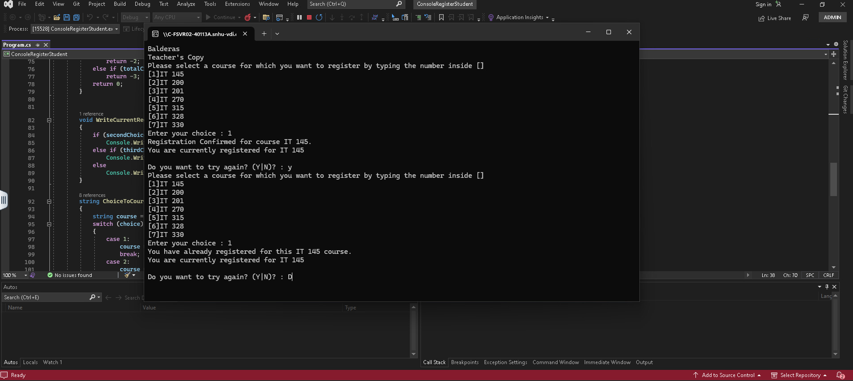
This test shows that I can register for IT 145 by entering 1. I then selected 1 again, and the program correctly said that I had already registered for the course. This shows that the same course cannot be registered more than once.

Screenshot 2: Three-course and nine-credit-hour limit
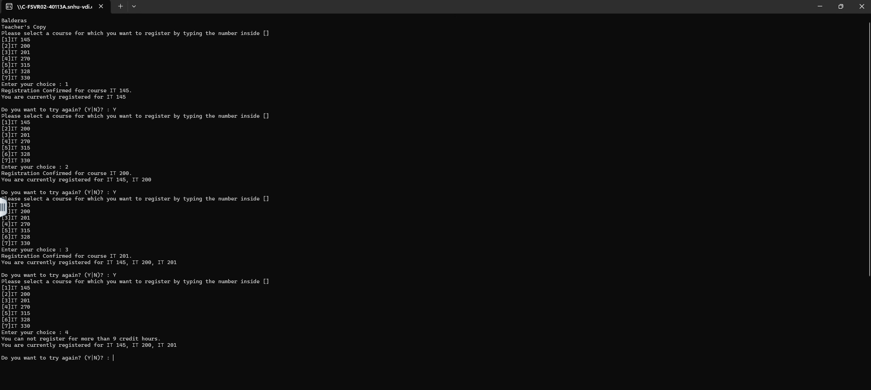
In this test I registered for IT 145, IT 200, and IT 201. The program then rejected IT 270 as a fourth course and said that I could not register for more than 9 credit hours. This verifies the three-course and nine-credit-hour limit.

Screenshot 3: Invalid course selection
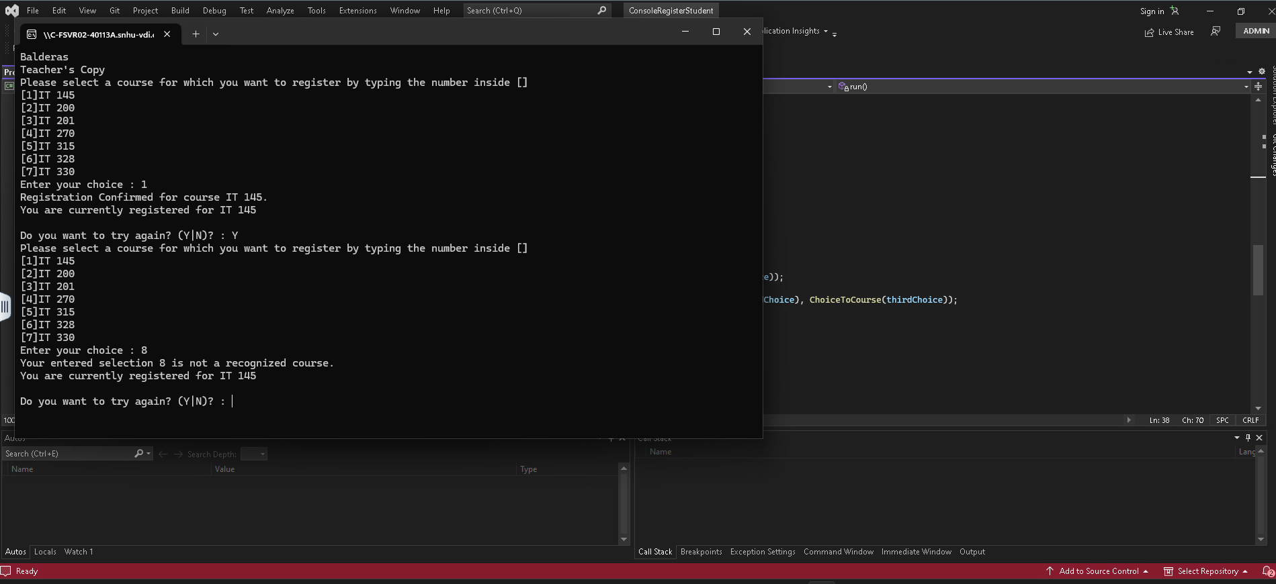
I entered 8 even though the menu only contains choices 1 through 7. The program rejected the selection as an unrecognized course and kept the current registration unchanged. This shows that the program does not allow courses outside the displayed menu.

Screenshot 4: Ending the registration session
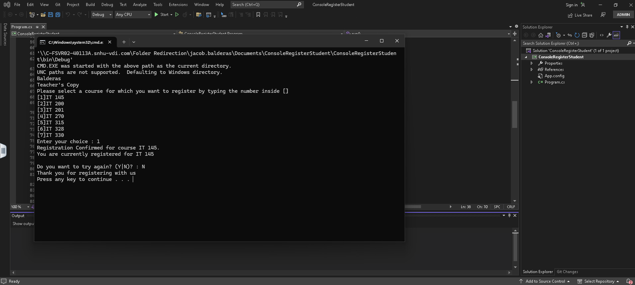
After registering for IT 145, I entered N when the program asked whether I wanted to try again. The program printed the final thank-you message and ended the session. This shows that the user can end the registration process when they choose to stop.

Source Code
The following is the corrected source code from my Program.cs file.
using System;
using System.Collections.Generic;
using System.Linq;
using System.Text;
using System.Threading.Tasks;

namespace ConsoleRegisterStudent
{
class Program
{
static void Main(string[] args)
{
(new Program()).run();
}

void run()
{
int choice;
int firstChoice = 0, secondChoice = 0, thirdChoice = 0;
int totalCredit = 0;
string yesOrNo = "";

System.Console.WriteLine("Balderas");
System.Console.WriteLine("Teacher's Copy");

do
{
WritePrompt();
choice = Convert.ToInt32(Console.ReadLine());

switch (ValidateChoice(choice, firstChoice, secondChoice, thirdChoice, totalCredit))
{
case -1:
Console.WriteLine("Your entered selection {0} is not a recognized course.", choice);
break;
case -2:
Console.WriteLine("You have already registered for this {0} course.", ChoiceToCourse(choice));
break;
case -3:
Console.WriteLine("You can not register for more than 9 credit hours.");
break;
case 0:
Console.WriteLine("Registration Confirmed for course {0}.", ChoiceToCourse(choice));
totalCredit += 3;
if (firstChoice == 0)
firstChoice = choice;
else if (secondChoice == 0)
secondChoice = choice;
else if (thirdChoice == 0)
thirdChoice = choice;
break;
}

WriteCurrentRegistration(firstChoice, secondChoice, thirdChoice);
Console.Write("\nDo you want to try again? (Y|N)? : ");
yesOrNo = (Console.ReadLine()).ToUpper();
} while (yesOrNo == "Y");

Console.WriteLine("Thank you for registering with us");
}

void WritePrompt()
{
Console.WriteLine("Please select a course for which you want to register by typing the number inside []");
Console.WriteLine("[1]IT 145\n[2]IT 200\n[3]IT 201\n[4]IT 270\n[5]IT 315\n[6]IT 328\n[7]IT 330");
Console.Write("Enter your choice : ");
}

int ValidateChoice(int choice, int firstChoice, int secondChoice, int thirdChoice, int totalCredit)
{
if (choice < 1 || choice > 7)
return -1;
else if (choice == firstChoice || choice == secondChoice || choice == thirdChoice)
return -2;
else if (totalCredit >= 9)
return -3;
return 0;
}

void WriteCurrentRegistration(int firstChoice, int secondChoice, int thirdChoice)
{
if (secondChoice == 0)
Console.WriteLine("You are currently registered for {0}", ChoiceToCourse(firstChoice));
else if (thirdChoice == 0)
Console.WriteLine("You are currently registered for {0}, {1}", ChoiceToCourse(firstChoice), ChoiceToCourse(secondChoice));
else
Console.WriteLine("You are currently registered for {0}, {1}, {2}", ChoiceToCourse(firstChoice), ChoiceToCourse(secondChoice), ChoiceToCourse(thirdChoice));
}

string ChoiceToCourse(int choice)
{
string course = "";
switch (choice)
{
case 1:
course = "IT 145";
break;
case 2:
course = "IT 200";
break;
case 3:
course = "IT 201";
break;
case 4:
course = "IT 270";
break;
case 5:
course = "IT 315";
break;
case 6:
course = "IT 328";
break;
case 7:
course = "IT 330";
break;
default:
break;
}
return course;
}
}
}

Reflection
This activity helped me get more comfortable reading code that was already written and finding where the logic was not doing what the program requirements called for. The biggest thing I learned was that a program can compile and still have logic problems. Testing different inputs helped me see what each condition was actually doing and made it easier to decide what needed to change.
I also got more practice with Boolean logic, if and else-if statements, variables, loops, and methods. The duplicate check uses OR logic so a course is rejected if it matches any registered course, and the credit total increases by three for each course. Testing the program after each change helped me make sure the final version followed the registration rules instead of assuming the fixes worked.
AI Use Acknowledgment
I used generative AI as a support tool while completing this assignment. I used it to help me understand the existing C# logic, identify possible debugging issues, review the registration requirements, and organize my explanation of the changes. I tested the corrected program myself in Visual Studio and used the results from those tests in this submission.

