Balderas, Jacob

IT 230 — WPF Register Student: Final Project Part II

Program Output Screenshots

Screenshot 1: Successful Course Registration
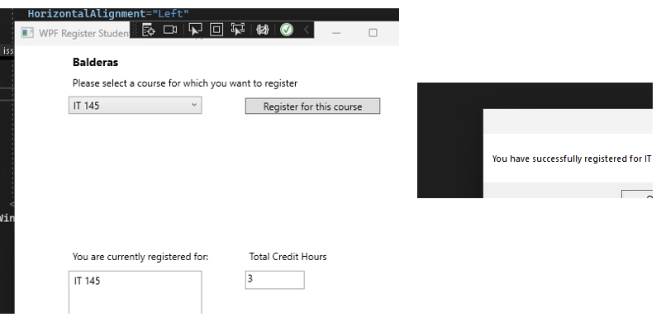
I picked IT 145 and clicked register. It showed the confirmation message, added the class to my list, and changed my total credits to 3.

Screenshot 2: Duplicate Registration Validation
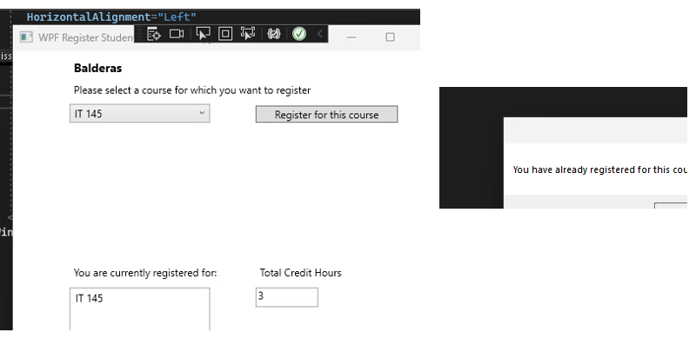
I tried registering for IT 145 a second time to see what would happen. It gave me an error saying I was already registered, and my credits stayed at 3.

Screenshot 3: Maximum Allowed Registration
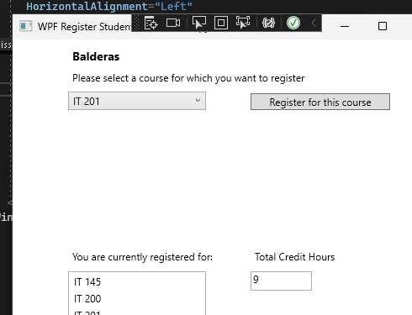
I added IT 145, IT 200, and IT 201. Since they are 3 credits each, the total came out to 9 like it should.

Screenshot 4: Nine-Credit-Hour Limit
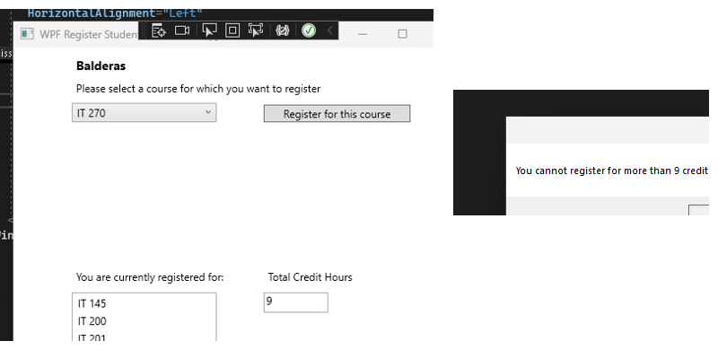
I tried adding IT 270 after I already had 9 credits. The program gave me an error and did not add the class, so the total stayed at 9.

Screenshot 5: No Course Selected
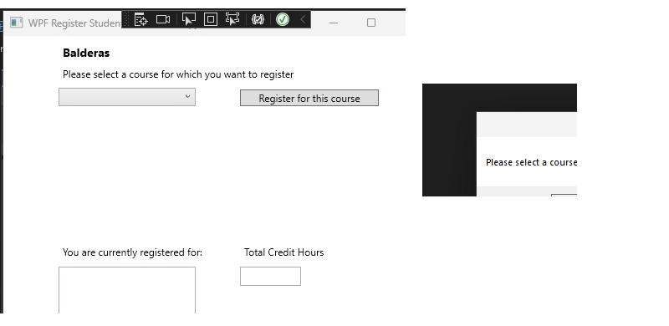
I opened the program again and clicked register without picking a class. It told me to select a course first, which is what I wanted to check.

C# Source Code

Course.cs
using System;
using System.Collections.Generic;
using System.Linq;
using System.Text;
using System.Threading.Tasks;

namespace WPFRegisterStudent
{
class Course
{
private string name = "";
private bool isRegisteredAlready = false;

public Course(string name)
{
this.name = name;
}

public void setName(string name)
{
this.name = name;
}

public string getName()
{
return name;
}

public bool IsRegisteredAlready()
{
return isRegisteredAlready;
}

public void SetToRegistered()
{
isRegisteredAlready = true;
}

public override string ToString()
{
return getName();
}
}
}

MainWindow.xaml.cs
using System;
using System.Collections.Generic;
using System.Linq;
using System.Text;
using System.Threading.Tasks;
using System.Windows;
using System.Windows.Controls;
using System.Windows.Data;
using System.Windows.Documents;
using System.Windows.Input;
using System.Windows.Media;
using System.Windows.Media.Imaging;
using System.Windows.Navigation;
using System.Windows.Shapes;

namespace WPFRegisterStudent
{
/// <summary>
/// Interaction logic for MainWindow.xaml
/// </summary>
public partial class MainWindow : Window
{
Course choice;
int totalCreditHours = 0;

public MainWindow()
{
InitializeComponent();
}

private void Window_Loaded(object sender, RoutedEventArgs e)
{

Course course1 = new Course("IT 145");
Course course2 = new Course("IT 200");
Course course3 = new Course("IT 201");
Course course4 = new Course("IT 270");
Course course5 = new Course("IT 315");
Course course6 = new Course("IT 328");
Course course7 = new Course("IT 330");

this.comboBox.Items.Add(course1);
this.comboBox.Items.Add(course2);
this.comboBox.Items.Add(course3);
this.comboBox.Items.Add(course4);
this.comboBox.Items.Add(course5);
this.comboBox.Items.Add(course6);
this.comboBox.Items.Add(course7);

this.textBox.Text = "";
}

private void button_Click(object sender, RoutedEventArgs e)
{
choice = (Course)(this.comboBox.SelectedItem);

if (choice == null)
{
MessageBox.Show("Please select a course first.");
}
else if (choice.IsRegisteredAlready())
{
MessageBox.Show("You have already registered for this course.");
}
else if (totalCreditHours + 3 > 9)
{
MessageBox.Show("You cannot register for more than 9 credit hours.");
}
else
{
choice.SetToRegistered();
totalCreditHours += 3;

listBox.Items.Add(choice.getName());
textBox.Text = totalCreditHours.ToString();

MessageBox.Show("You have successfully registered for " + choice.getName());
}

}

}
}

AI Use Acknowledgment
I used ChatGPT to help me with this assignment, including figuring out what needed to be fixed in the C# code and suggesting changes. It also helped me double-check my work and go through the different tests. I made the changes in Visual Studio myself, ran the program, and checked that everything worked the way it was supposed to.

