Examples for Testing of the Indirect Estimation Prototype

Deanna Isaman
Jacob Barhak

University of Michigan
Ann Arbor

07-Dec-2009

Copyright (C) 2007, 2009 The Regents of the University of Michigan

This file is part of the Indirect Estimation Prototype. The Indirect Estimation Prototype is free software: you can redistribute it and/or modify it under the terms of the GNU General Public License as published by the Free Software Foundation, either version 3 of the License, or (at your option) any later version.

The Indirect Estimation Prototype is distributed in the hope that it will be useful, but WITHOUT ANY WARRANTY; without even the implied warranty of MERCHANTABILITY or FITNESS FOR A PARTICULAR PURPOSE. See the GNU General Public License for more details.

ADDITIONAL CLARIFICATION

The Indirect Estimation Prototype is distributed in the hope that it will be useful, but "as is" and WITHOUT ANY WARRANTY of any kind, including any warranty that it will not infringe on any property rights of another party or the IMPLIED WARRANTIES OF MERCHANTABILITY or FITNESS FOR A PARTICULAR PURPOSE. THE UNIVERSITY OF MICHIGAN assumes no responsibilities with respect to the use of the Indirect Estimation Prototype.

Introduction

This document contains a set of examples that demonstrates the estimation capabilities of the Indirect Estimation Prototype. These capabilities are demonstrated by a set of examples that are presented in increasing level of complexity.

Each example consists of a visual description of the model to be estimated. The states are numbered and transitions are noted by coefficient names. In case the model uses a coefficient table depending on a covariate, the table is presented after the graphic model. The coefficients are the unknowns to be deduced during estimation.

To estimate the model, each example provides a set of studies that provide sufficient information to estimate the model. Each study is presented graphically in model terminology, i.e. the start and end state of the study is provided using the states declared in the model. The information for each study consists of:
- T - Study length in time units
- Study related information of one of the following forms:
  - Studies that provide data
    - N – Initial population at start state
    - x – Incident count reaching the study end state by the end of study
  - Studies that provide regression information
    - 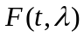 – Regression formula
    - – Regression coefficients provided by the study
    - – The covariance matrix associated with these coefficients
- Population – In some cases, population information is required to interpret the study or to support the system operation. The population is provided per study and may be presented in one of the following ways:
  - Default – theoretically not required, although the software may require some definition for proper functionality.
  - Dummy – Any population that describes one or more covariates to allow proper functionality of the software. Not required theoretically.
  - Distribution – a set of covariates and their marginal distribution function
  - Data – a table that its columns are covariates and each row contains the values for this column for each individual.

The expected outcomes that describe the optimal coefficient values are presented at the end of each example. In some cases, some comments or variations on the example are also provided as well as the expected partial likelihood related to a specific study.

For further information about the project, please visit the project web site:
http://www.med.umich.edu/mdrtc/cores/DiseaseModel/

Example 1: Simple Example with Trivial Outcome:

Model
0
1
P₀₁

Study 1
0
1
Data: N=100 x=20 T=3
Population: Default - Theoretically none needed
Partial Likelihood:
[1-(1-p01)^T]^x [(1-p01)^T]^(N-x) [1-(1-p01)^3]^20 [(1-p01)^3]^(80)

Expected Outcome:
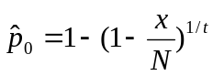=0.0717

Example 2: Theoretical Example with previous Algorithms (based on Isaman, 2006, Table 1, model 1:1:3)

Model
0
1
P₀₁
2
P₁₂

Study 1
0
1
Data: N=500 x= 204.755 T=5
Population: Default - Theoretically none needed
Partial Likelihood: [1-(1-P0)^T]^x [(1-P0)^T]^(N-x)

Study 2
1
2
Data: N=500 x= 336.16 T=5
Population: Default - Theoretically none needed
Partial Likelihood: [1-(1-P1)^T]^x [(1-P1)^T]^(N-x)

Study 3-5
0
2
Data Study 3: N=500 x= 73.35 T=5
Data Study 4: N=400 x= 58.68 T=5
Data Study 5: N=300 x= 44.01 T=5
Population: Default - Theoretically none needed
Partial Likelihood: [1-(1-P)]^x [(1-P)]^(N-x) where
P = P0*P1+P0*P1*(1-P0)+P0*P1*(1-P1)+P0*P1*(1-P0)^2+P0*P1*(1-P1)^2+P0*P1*(1-P0)*(1-P1)+P0*P1*(1-P0)^3+P0*P1*(1-P1)^3+P0*P1*(1-P0)*(1-P1)^2+P0*P1*(1-P0)^2*(1-P1)

Expected Outcome:
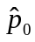=0.1 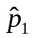=0.2

Example 3: Theoretical Example - Missing Some Data- (based on Isaman, 2006, Table 1, model 0:1:3)

Model
0
1
P₀₁
2
P₁₂

Study 1
1
2
Data: N=500 x=336.16 T=5
Population: Default - Theoretically none needed
Partial Likelihood: Not given

Study 2-4
0
2
Data Study 3: N=500 x=73.35 T=5
Data Study 4: N=400 x=58.68 T=5
Data Study 5: N=300 x=44.01 T=5
Population: Default - Theoretically none needed
Partial Likelihood: Not given

Expected Outcome:
=0.1 =0.2

Example 4: Funny Loop Example – No Direct Data – (from Isaman, 2006, Table 2, model C)

Model
0
1
P₀₁
2
P₁₂
P₂₀

Study 1-3
0
2
Data Study 1: N=500 x=73.35 T=5
Data Study 2: N=400 x=58.68 T=5
Data Study 3: N=300 x=44.01 T=5
Population: Default - Theoretically none needed
Partial Likelihood: [1-(1-P)]^x [(1-P)]^(N-x) where
P = P0*P1+P0*P1*(1-P0)+P0*P1*(1-P1)+P0*P1*(1-P0)^2+P0*P1*(1-P1)^2+P0*P1*(1-P0)*(1-P1)+P0*P1*(1-P0)^3+P0*P1*(1-P1)^3+P0*P1*(1-P0)*(1-P1)^2+P0*P1*(1-P0)^2*(1-P1)

Study 4-6
1
0
Data Study 4: N=500 x=176.55 T=5
Data Study 5: N=400 x=141.24 T=5
Data Study 6: N=300 x=105.93 T=5
Population: Default - Theoretically none needed
Partial Likelihood: [1-(1-P)]^x [(1-P)]^(N-x) where
P = P2*P1+P2*P1*(1-P2)+P2*P1*(1-P1)+P2*P1*(1-P2)^2+P2*P1*(1-P1)^2+P2*P1*(1-P2)*(1-P1)+P2*P1*(1-P2)^3+P2*P1*(1-P1)^3+P2*P1*(1-P2)*(1-P1)^2+P2*P1*(1-P2)^2*(1-P1)
Study 7-9
2
1
Data Study 7: N=500 x=99.15 T=5
Data Study 8: N=400 x=79.32 T=5
Data Study 9: N=300 x=59.49 T=5
Population: Default - Theoretically none needed
Partial Likelihood: [1-(1-P)]^x [(1-P)]^(N-x) where
P = P0*P2+P0*P2*(1-P0)+P0*P2*(1-P2)+P0*P2*(1-P0)^2+P0*P2*(1-P2)^2+P0*P2*(1-P0)*(1-P2)+P0*P2*(1-P0)^3+P0*P2*(1-P2)^3+P0*P2*(1-P0)*(1-P2)^2+P0*P2*(1-P0)^2*(1-P2)

Expected Outcome:
=0.1 =0.2 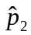=0.3

Example 5: Example with a Pooled State

Model
0
P₀₁
4
P₁₂
5
P₀₂
P₂₃
P₄₅
P₃₄
P₃₅
1
2
3
Study 1-2
0
1
Data Study 1: N=79 x=12.871600960512 T=6
Data Study 2: N=90 x=20.7539552818476 T=9
Population: Default - Theoretically none needed
Partial Likelihood: Not given

Study 3
Pooled 0-1
2
Data: N=398 x=79.18810184 T=4, Prevalence = 50% State 0
Population: Default - Theoretically none needed
Partial Likelihood: Not given

Study 4
0
2
Data: N=176 x=16.118751520256 T=6
Population: Default - Theoretically none needed
Partial Likelihood: Not given

Study 5-6
1
2
Data Study 5: N=49 x=22.959391 T=6
Data Study 6: N=45 x=18.42795 T=5
Population: Default - Theoretically none needed
Partial Likelihood: Not given
Study 7
2
3
Data: N=202 x=19.4079990464 T=5
Population: Default - Theoretically none needed
Partial Likelihood: Not given

Study 8
3
4
Data: N=1000 x=40 T=1
Population: Default - Theoretically none needed
Partial Likelihood: Not given

Study 9-10
3
5
Data: N=231 x=109.24914 T=3
Data: N=11929 x=7597.886603726 T=5
Population: Default - Theoretically none needed
Partial Likelihood: Not given

Study 11
4
5
Data: N=23 x=5.2030384375 T=5
Population: Default - Theoretically none needed
Partial Likelihood: Not given

Expected Outcome:
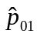=0.03, 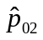=0.01, 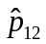=0.1, 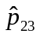=0.02, 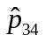=0.04, 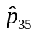=0.2, 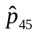=0.05

Example 6: Simple Example with Covariates:

Model
0
1
P₀₁

Study 1
0
1
Data: According to the following table
Time | Gender = 0 | Gender = 1
Initial count N | 90 | 100
T= 3 | 30 | 20
Population: Any population defining Gender in the range [0,1]
Partial Likelihood: [1-(1-P01)^T]^xmale * [(1-P01)^T]^(Nmale-xmale)
[1-(1-P01)^T]^xfemale*[(1-P01)^T]^(Nfemale-xfemale)
=[1-(1-P01)^3]^20 [(1-P01)^3]^80 [1-(1-P01)^3]^30 [(1-P01)^3]^60

Expected Outcome:
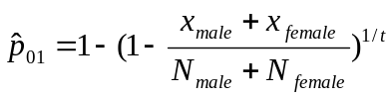=0.09678

Example 7: Non Unique Solution - Example with Covariates #2:

Model
0
1
P_{01m} P_{01f}

Model coefficient table for the transition from 0 to 1:
Gender = 0 | Gender = 1
P01f | P01m

Study 1
0
1
Data: N=100 x= 75.2250 T=3
Population: Gender ~ Bernoulli(0.75)
Partial Likelihood: [Wm*(1-(1- P01m)^T) + (1-Wm)*(1-(1- P01f)^T)]^x +
[Wm*( (1- P01m)^T) + (1-Wm)*( (1- P01f)^T)]^(N-x)
Where Wm is the prevalence of male, i.e. Wm = 0.75

Study 2
0
1
Data: N=100 x= 54.2500 T=2
Population: Gender ~ Bernoulli(0.25)
Partial Likelihood: [Wm*(1-(1- P01m)^T) + (1-Wm)*(1-(1- P01f)^T)]^x +
[Wm*( (1- P01m)^T) + (1-Wm)*( (1- P01f)^T)]^(N-x)
Where Wm is the prevalence of male, i.e. Wm = 0.25

Expected Outcome:
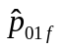=0.3
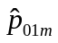=0.4

Simple variation to demonstrate the estimably:
If the same example is run without study 2, then the result is inestimable since the model requires more information than the study supplies. The likelihood graph will show a ridge, rather than a peak, meaning that there are multiple solutions. The system will return one such solution that may vary depending on the initial guess.

Example 8: Simple Example with Covariates #3:

Model
0
1
P_{01m} P_{01f}

Model coefficient table for the transition from 0 to 1:
Gender = 0 | Gender = 1
P01f | P01m

Study 1
0
1
Data: According to the following table
Time | Gender = 0 | Gender = 1
Initial count N | 90 | 100
T=3 | 30 | 20
Population: Any population that includes Gender in the range [0,1]
Partial Likelihood: [1-(1-P01m)^T]^xmale * [(1-P01m)^T]^(Nmale-xmale)
[1-(1-P01f)^T]^xfemale*[(1-P01f)^T]^(Nfemale-xfemale)
=[1-(1-P01m)^3]^20 [(1-P01m)^3]^80 [1-(1-P01f)^3]^30 [(1-P01f)^3]^60

Expected Outcome:
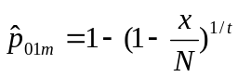= 0.07168
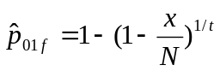=0.12642

Example 9: Simple Example with Regression Outcome:

Model
0
1
P₀₁

Study 1
0
1
Data: 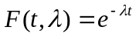,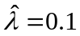, 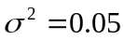, T=5
Population: Default - Theoretically none needed
Partial Likelihood: Not given

Expected Outcome:
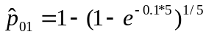=0.17018

Simple variation for authentication:
For the simple example where T=1 the result should be:
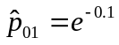=0.90484

Example 10: Simple Example with Regression Outcome and Covariates:

Model
0
1
P_{01m} P_{01f}

Model coefficient table for the transition from 0 to 1:
Gender = 0 | Gender = 1
P01f | P01m

Study 1
0
1
Data: 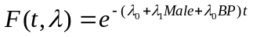, 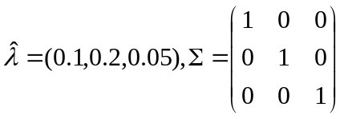, T=1,2,3
Population: 4 individuals (Gender,BP) = (0,125), (0,115), (1,125), (1,115)
Where Gender =1 means male

Partial Likelihood: Not given

Expected Outcome:

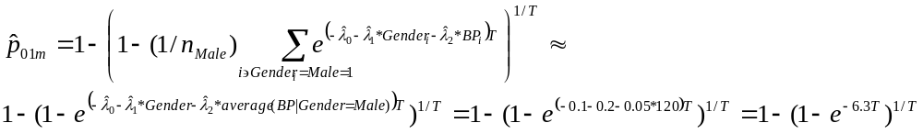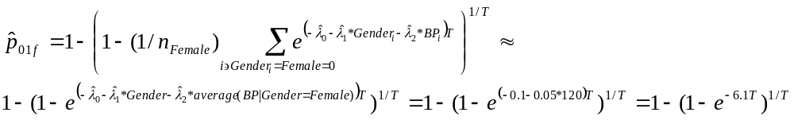

T | P_{01 m} | P_{01 f}
1 | 0.0018939888023991047 | 0.0023133231471746951
2 | 1.9011877737673544e-06 | 2.8362402018089483e-06
3 | 2.672246868229422e-09 | 4.8691513043763734e-09
1 Approx. | 0.00183630477703 | 0.00224286771949
2 Approx. | 1.6860090383818971e-06 | 2.5152309667264561e-06
3 Approx. | 2.0640158471252334e-09 | 3.7608821612522547e-09
Note: The approximation gives an idea for results with similar populations

Example 11: Simple Example with Regression Outcome Consistent with Time:

Model
0
1
P_{01m} P_{01f}

Model coefficient table for the transition from 0 to 1:
Gender = 0 | Gender = 1
P01f | P01m

Study 1
0
1
Data: 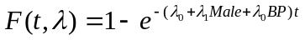, 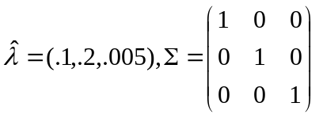, T=1,2,3
Population: 4 individuals (Gender,BP) = (0,125), (0,115), (1,125), (1,115)
Where Gender =1 means male

Partial Likelihood: Not given

Expected Outcome:
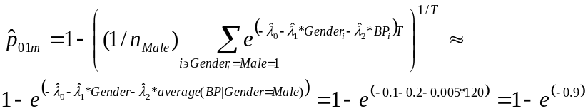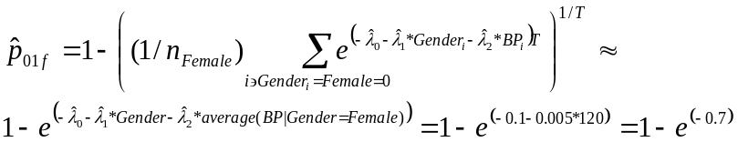

T | P_{01 m} | P_{01 f}
1 | 0.59330328062324944 | 0.50325950521854423
2 | 0.59317626067050078 | 0.5031043626979157
3 | 0.59304935961526495 | 0.50294936539903712
Approx. | 0.59343034025940089 | 0.50341469620859047
Note: The approximation gives an idea for results with similar populations
The Jacobian and the Covariance matrices for T=1 should be:

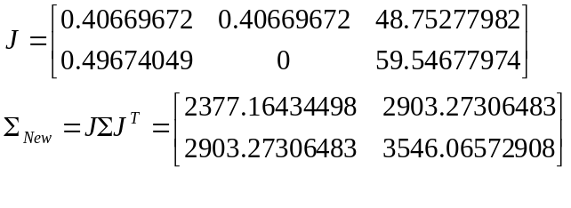
Note that row order in the Jacobian and diagonal elements in the covariance matrix may switch if the output vector is ordered by the program [female, male] rather than [male, female].

Example 12: Regression with UKPDS formula:

Model
0
1
P_{01m} P_{01f}

Model coefficient table for the transition from 0 to 1:
Gender = 0 | Gender = 1
P01f | P01m

Study 1
0
1
Data: 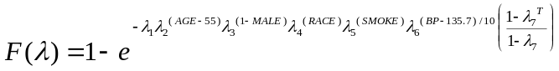
Population: 4 individuals (Age, Gender, Race, Smoke, BP)
54,1,0,0,115
56,1,1,0,125
54,0,0,1,115
56,0,0,0,125
Where Gender =1 means male

Partial Likelihood: Not given

Expected Outcome:
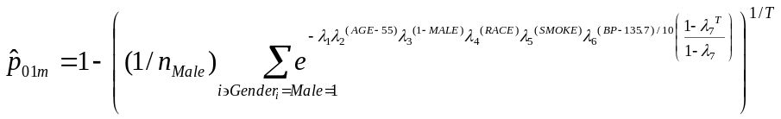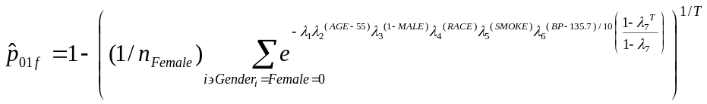

T | P_{01 m} | P_{01 f}
1 | 0.00653004287191838 | 0.00597431015512395
2 | 0.00678083530428653 | 0.00620653272582317
3 | 0.007044275112843 | 0.00645076680543022
Note that for time = 1 the formula is simplified.

Example 13: Event States – Basic Test

Model
0
P₀₁
2
P₁₂
3
1-P₁₂
1

Study 1
0
1
Data: N=1000 x=200 T=1
Population: Default - Theoretically none needed
Partial Likelihood: Not given

Study 2
1
2
Data: N=1000 x=300 T=1
Population: Default - Theoretically none needed
Partial Likelihood: Not given

Expected Outcome:
=0.2 =0.3

Example 14: Event States – Event Bypass Study

Model
0
P₀₁
2
P₁₂
3
1-P₁₂
1

Study 1
0
1
Data: N=1000 x=200 T=1
Population: Default - Theoretically none needed
Partial Likelihood: Not given

Study 2
0
2
Data: N=1000 x=60 T=1
Population: Default - Theoretically none needed
Partial Likelihood: Not given

Expected Outcome:
=0.2 =0.3

Example 15: Event States – Another Event Bypass

Model
0
P₀₁
2
P₁₂
3
1-P₁₂
1

Study 1
1
2
Data: N=1000 x=300 T=1
Population: Default - Theoretically none needed
Partial Likelihood: Not given

Study 2
0
2
Data: N=1000 x=60 T=1
Population: Default - Theoretically none needed
Partial Likelihood: Not given

Expected Outcome:
=0.2 =0.3

Example 16: Event States – Two year study

Model
0
P₀₁
2
P₁₂
3
1-P₁₂
1

Study 1
0
1
Data: N=1000 x=360=(200+160) T=2
Population: Default - Theoretically none needed
Partial Likelihood: Not given

Study 2
0
2
Data: N=1000 x=108=(60+48) T=2
Population: Default - Theoretically none needed
Partial Likelihood: Not given

Expected Outcome:
=0.2 =0.3

Example 17: Event States – Loop Back To Event

Model
0
P₀₁
2
P₁₂
P₂₁
1
3
1-P₁₂
Study 1
0
1
Data: N=1000 x=360 T=2
x= 1000*0.2 +1000*(1-0.2)* 0.2
Population: Default - Theoretically none needed
Partial Likelihood: Not given

Study 2
0
2
Data: N=10000 x=1080 T=2
x= 10000*0.2*0.3 +10000*(1-0.2)* 0.2 *0.3
Population: Default - Theoretically none needed
Partial Likelihood: Not given

Study 3
2
3
Data: N=10000 x=4816 T=2
x= 10000*(0.4*0.7) +10000*(1-0.4*0.7)*(0.4*0.7)
Population: Default - Theoretically none needed
Partial Likelihood: Not given

Expected Outcome:
=0.2 =0.3 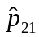=0.4
Simple variation for authentication:
The same results should be reported for the same studies where T=1 and the study outcomes for studies 1-3 are 200, 600, 2800 respectively.

Example 18: Event States – Multiple Event States

Model
0
P₀₁
3
P₁₂
1-P₂₃
1
4
1-P₁₂
2
P₂₃

Study 1
0
2
Data: N=1000 x=108 T=2
x=1000*0.2*0.3+1000*(1-0.2)*0.2*0.3
Population: Default - Theoretically none needed
Partial Likelihood: Not given

Study 2
0
3
Data: N=10000 x=432 T=2
x=10000*0.2*0.3*0.4+10000*(1-0.2)*0.2*0.3*0.4
Population: Default - Theoretically none needed
Partial Likelihood: Not given

Study 3
0
4
Data: N=10000 x=3168 T=2
x=10000*0.2*(0.7+0.3*0.6) +10000*(1-0.2)*0.2*(0.7+0.3*0.6)
Population: Default - Theoretically none needed
Partial Likelihood: Not given

Expected Outcome:
=0.2 =0.3 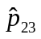=0.4

Simple variation for authentication:
The same results should be reported for the same studies where T=1 and the study outcomes for studies 1-3 are 60, 240, 1760 respectively.
Example 19: Event States – Extended Multiple Event States with a Loop

Model
0
P₀₁
3
P₁₂
1-P₂₃
1
4
1-P₁₂
2
P₂₃
P₃₁
Study 1
0
2
Data: N=10000 x=1080 T=2
x=10000*0.2*0.3+10000*(1-0.2)*0.2*0.3
Population: Default - Theoretically none needed
Partial Likelihood: Not given

Study 2
0
3
Data: N=10000 x=432 T=2
x=10000*0.2*0.3*0.4+10000*(1-0.2)*0.2*0.3*0.4
Population: Default - Theoretically none needed
Partial Likelihood: Not given

Study 3
3
2
Data: N=1000 x=225 T=2
x=1000*0.5*0.3 + 1000 * (1-0.5) *0.5*0.3
Population: Default - Theoretically none needed
Partial Likelihood: Not given

Study 4
0
4
Data: N=10000 x=3273.6 T=2
x=10000*0.2*(0.7+0.3*0.6) +10000*(1-0.2)*0.2*(0.7+0.3*0.6) +10000*0.2*0.3*0.4*0.5*(0.7+0.3*0.6)
Population: Default - Theoretically none needed
Partial Likelihood: Not given

Expected Outcome:
=0.2 =0.3 =0.4 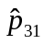=0.5

Simple variation for authentication:
The same results should be reported for the same studies where T=1 and the study outcomes for studies 1-4 are 600, 240, 150, 1760 respectively.

Example 20: Event States – Multiple Event States and a Loop

Model
0
P₀₁
4
P₁₂
1-P₂₃
1
5
1-P₁₂
2
P₂₃
P₄₁
3
1-P₃₄
P₃₄
Study 1
0
2
Data: N=10000 x=1080 T=2
x=10000*0.2*0.3+10000*(1-0.2)*0.2*0.3
Population: Default - Theoretically none needed
Partial Likelihood: Not given

Study 2
0
3
Data: N=10000 x=432 T=2
x=10000*0.2*0.3*0.4+10000*(1-0.2)*0.2*0.3*0.4
Population: Default - Theoretically none needed
Partial Likelihood: Not given

Study 3
3
2
Data: N=1000 x=126 T=3
x=1000*0.5*0.6*0.3 + 1000*0.5*(1-0.6)*0.6*0.3
Population: Default - Theoretically none needed
Partial Likelihood: Not given

Study 4
4
5
Data: N=10000 x=8099.04 T=2
x=10000*0.6*(0.7+0.3*(0.6+0.4*0.5)) + 10000*(1-0.6)* 0.6*(0.7+0.3*(0.6+0.4*0.5)) + 10000*0.6*0.3*0.4*0.5*0.6*(0.7+0.3*(0.6+0.4*0.5))
Population: Default - Theoretically none needed
Partial Likelihood: Not given

Study 5
0
5
Data: N=10000 x=3451.68 T=2
x=10000*0.2*(0.7+0.3*(0.6+0.4*0.5)) + 10000*(1-0.2)*0.2*(0.7+0.3*(0.6+0.4*0.5)) +10000*0.2*0.3*0.4*0.5*0.6*(0.7+0.3*(0.6+0.4*0.5))
Population: Default - Theoretically none needed
Partial Likelihood: Not given

Expected Outcome:
=0.2 =0.3 =0.4 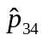=0.5 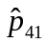=0.6

Simple variation for authentication:
The same results should be reported for the same studies where T=1 and the study outcomes for studies 1-5 are 600, 240, 90, 5640, 1880 respectively.

Example 21: Example with study with multiple time outcomes

Model
0
1
P₀₁

Study 1
0
1
Data: According to the following table
Time | Count
Initial count N | 10000
T=1 | 1000
T=2 | 1900
T=5 | 4095.1

Population: Default - Theoretically none needed
Partial Likelihood: Not given

Expected Outcome:
=0.1

Example 22: Information with Different table Dimensions

Model
0
1
2
P_{12L}
P_{12H}
P_{01f}
P_{01m}

Model coefficient table for the transition from 0 to 1:
Gender = 0 | Gender = 1
P01f | P01m
Model coefficient table for the transition from 1 to 2:
BMI<=25 | BMI>25
P12L | P12H

Study 1:
0
1
Data: According to the following table
Time | Gender = 0 | Gender = 1
Initial count N | 50 | 100
T=2 | 9.5 | 36
Population: Any population defining:
Gender in the range [0,1]
BMI so that 25 is in the range. One option is [-inf, inf]
Partial Likelihood: Not given

Study 2:
0
2
Data: According to the following table
Time | BMI<=30 | BMI>30
Initial count N | 400 | 200
T=3 | 52 | 29.2
Population: 600 individuals = 100 times x 6 individuals (Gender, BMI)
0,31
0,26
0,19
1,31
1,26
1,19
Partial Likelihood: Not given

Expected Outcome:
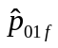= 0.1 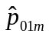=0.2 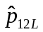= 0.3 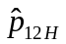=0.4

Example 23: Complex example with an event state

Model
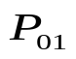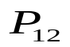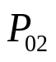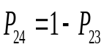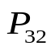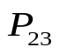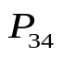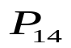
0
1
3
4
2

Study 1
0
1
Data: N=1138 x=48.7255388591079 T=10
Population: Default - Theoretically none needed
Partial Likelihood: Not given

Study 2
0
2
Data: N=890 x=172.110040233588 T=7
Population: Default - Theoretically none needed
Partial Likelihood: Not given

Study 3
0
3
Data: N=4540 x=901.596644864313 T=10
Population: Default - Theoretically none needed
Partial Likelihood: Not given

Study 4
1
2
Data: N=569 x=54.055 T=2
Population: Default - Theoretically none needed
Partial Likelihood: Not given

Study 5
1
4
Data: N=569 x=68.1021875 T=2
Population: Default - Theoretically none needed
Partial Likelihood: Not given

Study 6
2
4
Data: N=475 x=118.75 T=1
Population: Default - Theoretically none needed
Partial Likelihood: Not given

Study 7
3
2
Data: N=73 x=6.7388965376 T=5
Population: Default - Theoretically none needed
Partial Likelihood: Not given

Study 8
3
2
Data: N=169 x=21.0026880998605 T=7
Population: Default - Theoretically none needed
Partial Likelihood: Not given

Study 9
3
2
Data: N=78 x=7.2004647936 T=5
Population: none needed
Partial Likelihood: Not given

Study 10
3
4
Data: N=468 x=55.6472155078125 T=5
Population: Default - Theoretically none needed
Partial Likelihood: Not given

Expected Outcome:
= 0.005 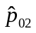=0.03 =0.05 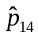=0.05 =0.75 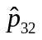=0.02 =0.02

Example 24: Complex example with an event state and studies with tables and multiple times

Model
0
1
3
4
2

Study 1
0
1
Data: N=1138 x=48.7255388591079 T=10
Population: Default - Theoretically none needed
Partial Likelihood: Not given

Study 2
0
2
Data: N=890 x=172.110040233588 T=7
Population: Default - Theoretically none needed
Partial Likelihood: Not given

Study 3
0
3
Data: According to the following table
Time | Gender = 0 | Gender = 1
Initial count N | 1897 | 2643
T=2 | 84.2268 | 117.3492
T=4 | 163.92128048625 | 228.38373448875
T=6 | 239.155679788621 | 333.204249700224
T=8 | 310.042767715336 | 431.9678624521
T=10 | 376.724413063348 | 524.872231800965

Population: Any population defining Gender in the range [0,1]
Partial Likelihood: Not given

Study 4
1
2
Data: N=569 x=54.055 T=2
Population: Default - Theoretically none needed
Partial Likelihood: Not given

Study 5
1
4
Data: N=569 x=68.1021875 T=2
Population: Default - Theoretically none needed
Partial Likelihood: Not given

Study 6
2
4
Data: According to the following table
Time | Gender = 0 | Gender = 1
Initial count N | 163 | 312
T=1 | 40.75 | 78

Population: Any population defining Gender in the range [0,1]
Partial Likelihood: Not given

Study 7
3
2
Data: According to the following table
Time
Initial count N | 73
T=1 | 1.46
T=2 | 2.8616
T=5 | 6.7388965376

Population: Default - Theoretically none needed
Partial Likelihood: Not given

Study 8
3
2
Data: N=169 x=21.0026880998605 T=7
Population: Default - Theoretically none needed
Partial Likelihood: Not given

Study 9
3
2
Data: N=78 x=7.2004647936 T=5
Population: Default - Theoretically none needed
Partial Likelihood: Not given

Study 10
3
4
Data: According to the following table
Time | Gender = 0 | Gender = 1
Initial count N | 181 | 287
T=5 | 21.5216795019531 | 34.1255360058594

Population: Any population defining Gender in the range [0,1]
Partial Likelihood: Not given

Expected Outcome:
= 0.005 =0.03 =0.05 =0.05 =0.75 =0.02 =0.02

Example 25: Complex example with an event state, multiple outcomes and regression data using UKPDS form

Model
0
1
3
4
2
Study 1
0
1
Data: N=1138 x=48.7255388591079 T=10
Population: Default - Theoretically none needed
Partial Likelihood: Not given

Study 2
0
2
Data: N=890 x=172.110040233588 T=7
Population: Default - Theoretically none needed
Partial Likelihood: Not given

Study 3
0
3
Data: 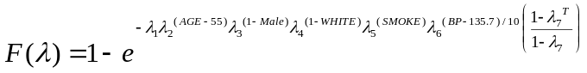
Population: 4 individuals (Age, Gender, Race, Smoke, BP)
54,1,0,0,115
56,1,1,0,125
54,0,0,1,115
56,0,0,0,125
Where Gender =1 means male
Partial Likelihood: Not given
Study 4
1
2
Data: N=569 x=54.055 T=2
Population: Default - Theoretically none needed
Partial Likelihood: Not given

Study 5
1
4
Data: N=569 x=68.1021875 T=2
Population: Default - Theoretically none needed
Partial Likelihood: Not given

Study 6
2
4
Data: According to the following table
Time | Gender = 0 | Gender = 1
Initial count N | 163 | 312
T=1 | 40.75 | 78

Population: Any population defining Gender in the range [0,1]
Partial Likelihood: Not given

Study 7
3
2
Data: According to the following table
Time
Initial count N | 73
T=1 | 1.46
T=2 | 2.8616
T=5 | 6.7388965376

Population: Default - Theoretically none needed
Partial Likelihood: Not given

Study 8
3
2
Data: N=169 x=21.0026880998605 T=7
Population: Default - Theoretically none needed
Partial Likelihood: Not given

Study 9
3
2
Data: N=78 x=7.2004647936 T=5
Population: Default - Theoretically none needed
Partial Likelihood: Not given

Study 10
3
4
Data: According to the following table
Time | Gender = 0 | Gender = 1
Initial count N | 181 | 287
T=5 | 21.5216795019531 | 34.1255360058594

Population: Any population defining Gender in the range [0,1]
Partial Likelihood: Not given

Expected Outcome:
= 0.005 =0.03 =0.05 =0.05 =0.75 =0.02 =0.02

Example 26: Complex example with an event state, multiple outcomes and model coefficients table for one transition

Model
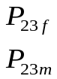
0
1
3
4
2
Model coefficient table for the transition from 2 to 3:
Gender = 0 | Gender = 1
P23f | P23m
Study 1
0
1
Data: N=1138 x=48.7255388591079 T=10
Population: Gender~Bernoulli(0.5)
Partial Likelihood: Not given

Study 2
0
2
Data: N=890 x=172.110040233589 T=7
Population: Gender~Bernoulli(0.5)
Partial Likelihood: Not given

Study 3
0
3
Data: According to the following table
Time | Gender = 0 | Gender = 1
Initial count N | 1897 | 2643
T=2 | 78.61168 | 125.17248
T=4 | 152.9931951205 | 243.609316788
T=6 | 223.211967802713 | 355.417866346905
T=8 | 289.373249867647 | 460.765719948907
T=10 | 351.609452192458 | 559.863713921029
Population: Any population defining Gender in the range [0,1]
Partial Likelihood: Not given

Study 4
1
2
Data: N=569 x=54.055 T=2
Population: Gender~Bernoulli(0.5)
Partial Likelihood: Not given

Study 5
1
4
Data: N=569 x=68.100765 T=2
Population: Gender~Bernoulli(0.5)
Partial Likelihood: Not given

Study 6
2
4
Data: According to the following table
Time | Gender = 0 | Gender = 1
Initial count N | 163 | 312
T=1 | 48.9 | 62.4
Population: Any population defining Gender in the range [0,1]
Partial Likelihood: Not given

Study 7
3
2
Data: According to the following table
Time
Initial count N | 73
T=1 | 1.46
T=2 | 2.8616
T=5 | 6.7388965376
Population: Default - Theoretically none needed
Partial Likelihood: Not given

Study 8
3
2
Data: N=169 x=21.0026880998605 T=7
Population: Default - Theoretically none needed
Partial Likelihood: Not given

Study 9
3
2
Data: N=78 x=7.2004647936 T=5
Population: Default - Theoretically none needed
Partial Likelihood: Not given

Study 10
3
4
Data: According to the following table
Time | Gender = 0 | Gender = 1
Initial count N | 181 | 287
T=5 | 22.3378411472491 | 32.8260810667131

Population: Any population defining Gender in the range [0,1]
Partial Likelihood: Not given

Expected Outcome:
= 0.005 =0.03 =0.05 =0.05 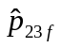=0.7 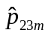=0.8 =0.02 =0.02

Example 27: Complex example with an event state, multiple outcomes and model coefficients table for several transitions

Model
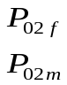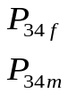
0
1
3
4
2
Model coefficient table for the transition from 0 to 2:
Gender = 0 | Gender = 1
P02f | P02m
Model coefficient table for the transition from 2 to 3:
Gender = 0 | Gender = 1
P23f | P23m
Model coefficient table for the transition from 3 to 4:
Gender = 0 | Gender = 1
P34f | P34m

Study 1
0
1
Data: N=1138 x=48.7397240645688 T=10
Population: Gender~Bernoulli(0.5)
Partial Likelihood: Not given

Study 2
0
2
Data: N=890 x=171.715684534946 T=7
Population: Gender~Bernoulli(0.5)
Partial Likelihood: Not given

Study 3
0
3
Data: According to the following table
Time | Gender = 0 | Gender = 1
Initial count N | 1897 | 2643
T=2 | 65.73105 | 145.57644
T=4 | 128.75690212 | 281.607759504
T=6 | 189.013327191458 | 408.487362202886
T=8 | 246.48247219871 | 526.64524635182
T=10 | 301.182029208623 | 636.532322647806

Population: Any population defining Gender in the range [0,1]
Partial Likelihood: Not given

Study 4
1
2
Data: N=569 x=54.055 T=2
Population: Default - Theoretically none needed
Partial Likelihood: Not given

Study 5
1
4
Data: N=569 x=68.1078775 T=2
Population: Gender~Bernoulli(0.5)
Partial Likelihood: Not given

Study 6
2
4
Data: According to the following table
Time | Gender = 0 | Gender = 1
Initial count N | 163 | 312
T=1 | 48.9 | 62.4

Population: Any population defining Gender in the range [0,1]
Partial Likelihood: Not given

Study 7
3
2
Data: According to the following table
Time
Initial count N | 73
T=1 | 1.46
T=2 | 2.8616
T=5 | 6.7392399889125
Population: Default - Gender~Bernoulli(0.5)
Partial Likelihood: Not given

Study 8
3
2
Data: N=169 x=21.005307401201 T=7
Population: Default - Gender~Bernoulli(0.5)
Partial Likelihood: Not given

Study 9
3
2
Data: N=78 x=7.200831768975 T=5
Population: Default - Gender~Bernoulli(0.5)
Partial Likelihood: Not given

Study 10
3
4
Data: According to the following table
Time | Gender = 0 | Gender = 1
Initial count N | 181 | 287
T=5 | 18.2233771439173 | 39.2703173684648
Population: Any population defining Gender in the range [0,1]
Partial Likelihood: Not given

Expected Outcome:
= 0.005 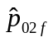=0.025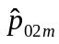=0.035 =0.05 =0.05 =0.7 =0.8 =0.02 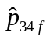=0.015 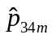=0.025

