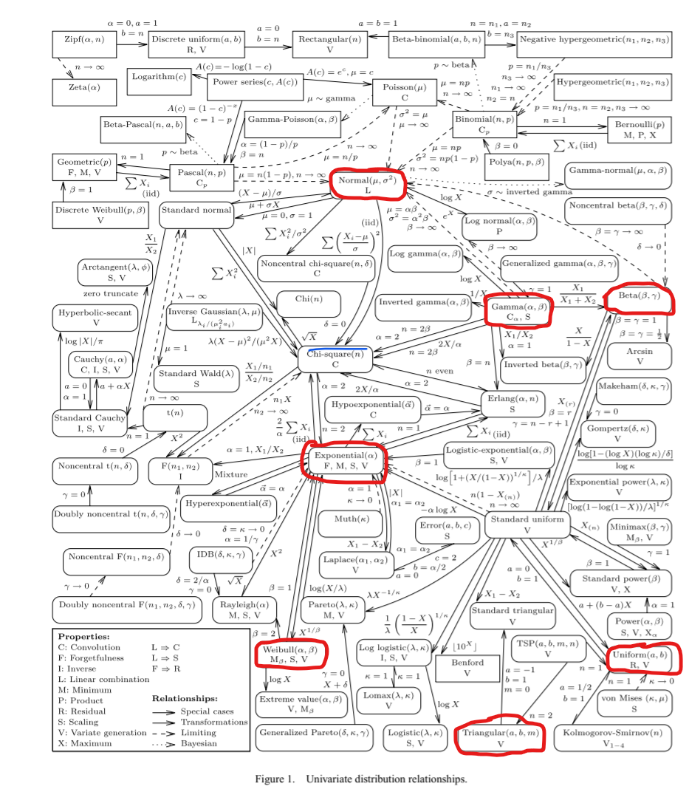

1. Q. Are the distributions you just highlighted discrete or continuous?
2. A. Continuous
3. Q. Write a sentence or two about what you notice about the chosen distributions?
4. A. The chosen distributions tend to be well-connected and have very complex mathematical expressions.
5. Choose **one** of the distributions on the chart (to make it easy on yourself, choose one from the list above). Do online research to find out what the plot of the PDF of the may look like, and draw a sketch.
6. A. Domain is all reals. Because 1=(1/2)*(B-A)*Height; Height=2/(B-A), which works for any values for A and B as long as B > A. The range of possible values for the y-axis (Probability density) would be (0, infinity), since as the difference of B and A shrinks the peak will increase without bound.

