B.

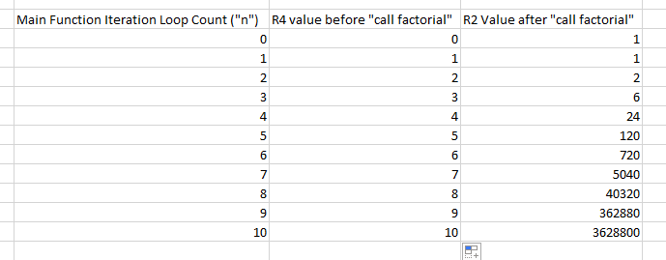

Register 4 is used as the loop counter and Register 2 is used to temporarily store the output of each factorial.

C.

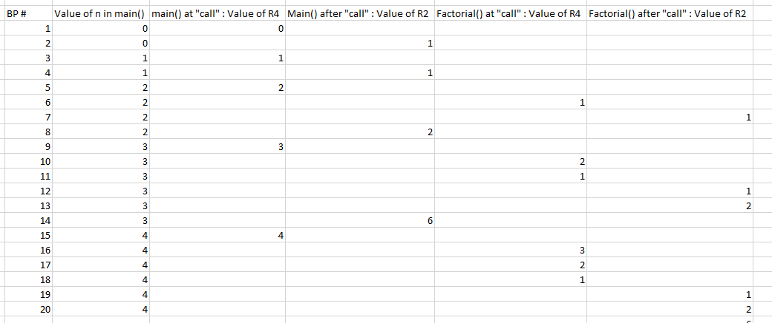

When the factorial function is called, it recursively calls itself with the number given minus 1 if the number is greater than 1. R4 represents the numbers for each factorial call return value in the stack of recursion. R2 is the accumulator that works from the last factorial call called and goes back up the chain, keeping the value of each factorial from 0!, 1!, 2!,…, to (n-1)!. For example, when R4 is 4, R2 is 1,2, and then 6, which is the first three factorials.

Part II

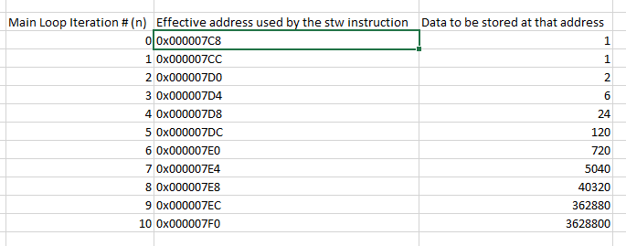

* 1. The memory in the array is found in 0x000007C8
  2. 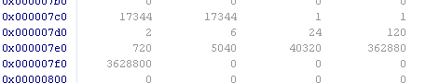

Part III