COIT13229: Applied Distributed Systems

Term 1, 2026

Assessment 2

Name: Jacob Duckworth
ID: 12273526

Due Date: 15/05/2026

Table of Contents
1. Requirements 3
1.1. Scope and Assumptions 3
1.2. Use Case Overview 3
1.3. Functional Requirements 3
1.4. Non-Functional Requirements 4
1.5. Requirement Notes 4
2. Design 5
2.1. System Architecture 5
2.2. Use of Coordination Service (ZooKeeper) 5
2.3. Consistency Model 6
2.4. Class Design 6
2.5. Dynamic Behaviour 7
2.6. Fault Handling Design 8
3. Test plan 9
3.1. Overview 9
3.2. Testing Approach 9
3.3. Normal Operation Test 9
3.4. Lag (Delay) Test 9
3.5. Lost Message Test 10
3.6. Node Crash Test 11
3.7. Consistency Test 12
3.8. Limitations 13
4. Implementation and Test Results 14
4.1. Implementation Overview 14
4.2. Test Environment 14
4.3. Test Results Summary 15
4.4. Startup Test Result 15
4.5. Distributed Test Result 15
4.6. Manual Testing Result 16
4.7. Repository Link 20

Requirements

Scope and Assumptions
The Gold Miner system is a distributed multiplayer game designed for a group of up to 100 participants within the same organisation. The system allows human participants and bot participants to compete by collecting gold within a shared grid environment. Each participant connects from a separate node over the network.
The system maintains a shared game session in which participants can join, move, collect gold, and leave during the gameplay.
It is assumed that:
- Participants are connected via a network.
- The number of participants may scale up to approximately 100 participants.
- The game map is a fixed-size grid.
- Multiple participants may attempt to collect the same gold item at the same time.

Use Case Overview
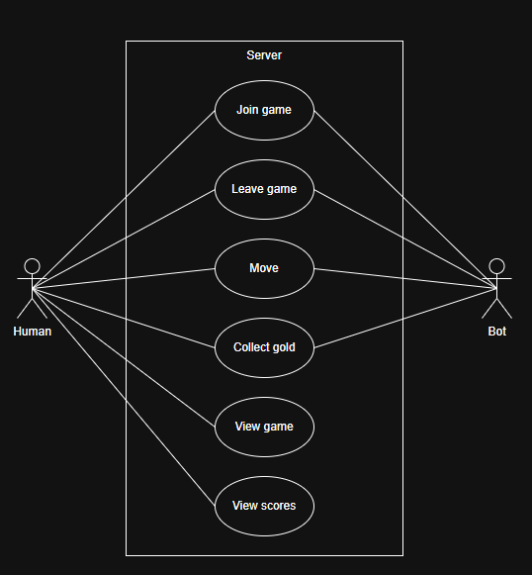

Functional Requirements
FR1. The system shall allow human participants to join a game session.
FR2. The system shall allow automated bot participants to join a game session.
FR3. The system shall allow participants to move within a two-dimensional grid.
FR4. The system shall maintain a shared game world, accessible to all participants on a given network.
FR5. The system shall generate and place gold items within the game world.
FR6. The system shall allow participants to collect gold by moving onto its location.
FR7. The system shall track and update scores for all participants.
FR8. The system shall resolve conflicts when multiple participants attempt to collect the same gold item.
FR9. The system shall distribute updates of the game state to participants during gameplay.
FR10. The system shall allow participants to leave the session without interrupting the game for others.

Non-Functional Requirements
Reliability
- The system shall continue operating when one or more participants disconnect unexpectedly.
- The system shall handle temporary communication delays between participants.
Scalability
- The system shall support an increasing number of participants.
- The system shall support up to approximately 100 human participants in a session.

Requirement Notes
The system focuses on challenges such as maintaining a shared state, handling communication delays, and managing participant disconnections. Immediate consistency is not required at all times; however, the system must ensure that the game state becomes consistent across participants after the updates are exchanged.

Design

System Architecture
The system adopts a centralised distributed architecture consisting of a single game server and multiple client nodes. Client nodes include both human-controlled clients and the automated bot clients. All nodes communicate with the game server over a network.
The game server is responsible for maintaining the game state, including the participants positions, gold locations, and scores. Clients send actions (such as movement) to the server, which processes these actions and distributes the updated game state to all of the participants.
A coordination service is used to manage group membership and detect if a node fails. Each participant registers with the coordination service when joining the system. If a participant disconnects or crashes, it is automatically removed from the active group.
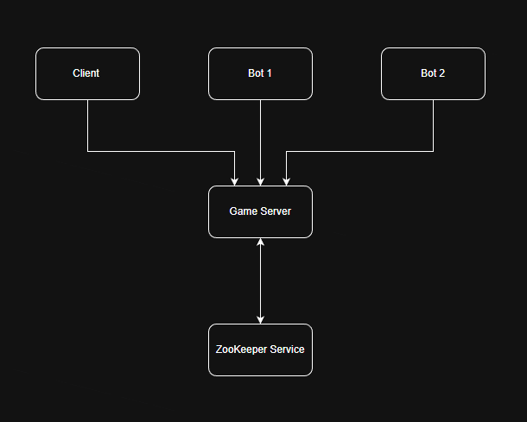
This diagram illustrates the distributed architecture.

Use of Coordination Service (ZooKeeper)
The system uses a coordination service to support distributed system management. This service is responsible for tracking active participants and detecting node failures.
The coordination service is used for:
- Group membership management: Each node registers when joining the system.
- Failure detection: Nodes are automatically removed if they disconnect or crash.
- System coordination: The server monitors active participants through the coordination service.
This is achieved through the use of ephemeral registrations, where each active participant is represented by a temporary entry that is removed automatically when the node fails.

Consistency Model
The system uses an eventual consistency model.
Design Options Considered
Two consistency approaches were considered:
- Strong consistency: Ensures all nodes always have the same state but requires strict coordination and introduces delays.
- Eventual consistency: Allows temporary inconsistencies but ensures all nodes converge to the same state over time.
Chosen Approach and Rationale:
Eventual consistency was chosen because:
- The system must tolerate communication delays and node disconnections.
- It provides better scalability for many participants.
- Temporary inconsistencies are acceptable in a non-real-time game.
How the Model is Achieved
- The game server maintains the state.
- Clients send updates to the server.
- The server processes said updates and distributes them to all the clients.
- Clients may temporarily operate on slightly outdated state.
Properties Used
- All participants will eventually receive the game state.
- The system continues operating despite delays or missing updates.
Issues Arising
- Participants may briefly see outdated positions.
- Bots may act on old information.
- Conflicts may occur when multiple participants attempt to collect the same gold.

Class Design
The system is composed of the following high-level classes:
GameServer
- Maintains game state
  - Processes actions
  - Sends updates to clients
- Player
  - Represents a participant with position and score
- Bot
  - Extends Player with automated decision-making behaviour
- GameState
  - Stores the map, gold positions, and all participants
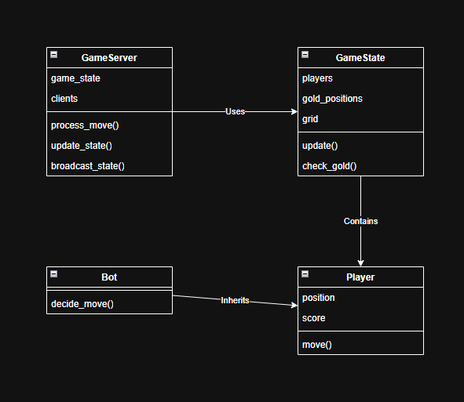
This diagram shows the relationships between the main classes. The GameServer interacts with GameState, while Player and Bot represent different participant types. The Bot extends Player to reuse the common functionality.

Dynamic Behaviour
The most complex interaction in the system occurs when multiple participants attempt to collect the same gold item.
The interaction flow is as follows:
- A client sends a movement request to the server.
- The server updates the participant’s position.
- The server checks for gold collection.
- If multiple participants attempt to collect the same gold, the server resolves the conflict.
- The server updates the game state and distributes it to all clients.
- Clients update their local view of the game.
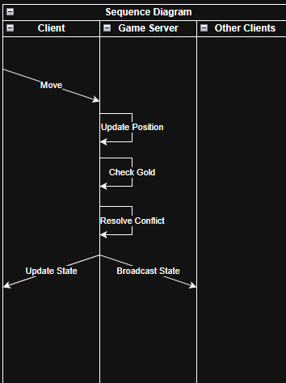
This diagram illustrates the interaction between a client, the server, and other participants during a movement and gold collection event.

Fault Handling Design
The system is designed to tolerate common distributed system faults:
- Node failure
If a client or bot disconnects, it is removed from the system without interrupting gameplay.
- Communication delay (lag)
The system continues operating even when messages are delayed.
- Lost messages
Missing updates are corrected by future updates, ensuring eventual consistency.

Test plan

Overview
This test plan evaluates the behaviour of the distributed Gold Miner system under what are deemed normal operations and distributed system faults. The focus is on testing the system’s ability to handle communication delays, lost messages, and node failures.

Testing Approach
Testing is performed using a combination of:
- Manual testing (running multiple clients and bots)
- Simulated faults within the code (e.g. delays and dropped messages)
The focus of testing is on:
- System behaviour under fault conditions
- Consistency of shared game state
- Ability to continue operating despite said failures

Normal Operation Test
Test Name: Basic Gameplay
Description:
Verify that the system operates correctly without faults.
Steps:
- Start the game server
- Connect one client and multiple bot nodes
- Perform movement actions
- Collect gold
Expected Result:
- Game state updates correctly
- Scores update correctly
- All participants see consistent state

Lag (Delay) Test
Test Name: Communication Delay
Description:
Simulate network lag to test system behaviour under delayed communication.
How the test is implemented:
Artificial delay is added in message sending using the sleep function. As this delay is applied before sending updates between the nodes.
Steps:
- Start the system
- Introduce delay in message sending
- Perform player actions
Expected Result:
- Game continues operating
- Updates are delayed but eventually applied
- Temporary inconsistencies may occur
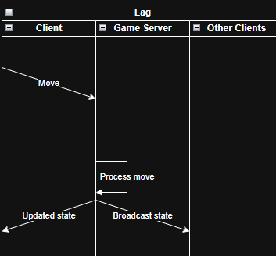
This diagram shows delayed message transmission between client and server.

Lost Message Test
Test Name: Message Loss
Description:
Simulate message loss to test how the system handles the missing updates.
How the test is implemented:
Messages are randomly dropped before sending.
Steps:
- Start the system
- Enable message dropping logic
- Perform player actions
Expected Result:
- Some updates are missed
- Later updates correct the game state
- System remains operational
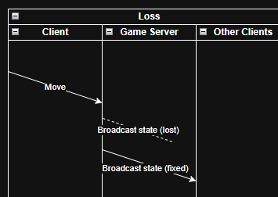
This diagram shows a message being lost and a later update correcting the state.

Node Crash Test
Test Name: Node Failure
Description:
Simulate a participant disconnecting unexpectedly.
How the test is implemented:
A client or bot process is manually terminated during gameplay.
Steps:
- Start the system with multiple participants
- Terminate one client or bot
- Continue gameplay
Expected Result:
- System continues running
- Disconnected node is removed
- Remaining participants continue normally
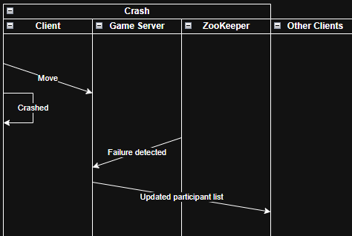
This diagram shows a node disconnecting and the system continuing operation without it.

Consistency Test
Test Name: Eventual Consistency
Description:
Verify that all participants eventually reach the same game state after updates.
How the test is implemented:
Introduce delays and message loss while monitoring game state across clients.
Steps:
- Start system with multiple clients
- Introduce lag and message loss
- Observe game state over time
Expected Result:
- Clients may temporarily disagree
- All clients eventually converge to the same state
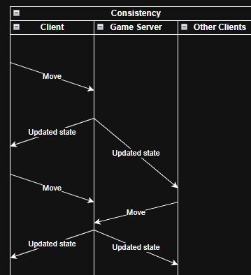
This diagram shows temporary inconsistencies followed by convergence to a consistent state.

Limitations
Due to the prototype nature of the system:
- Some fault scenarios may not be fully handled
- Message loss may result in temporary incorrect states
- Node recovery after failure is not implemented

Implementation and Test Results

Implementation Overview
The implemented system is a Python prototype of said distributed Gold Miner game. The implementation uses a central game server, a shared game state model, a player client, and ZooKeeper to handle the coordination/state sharing.
The implementation is organised into the following files:
File | Purpose
game_server.py | Runs the server and manages game updates.
game_state.py | Stores the game state, including player position, bot positions, gold locations, and scores.
player_client.py | Runs the player client and allows interaction with the game.
bot_client.py | Runs an automated bot participant as a separate process/node.
test_startup.py | Tests whether the server and client can start and communicate.
test_distributed_game.py | Contains tests for game state, ZooKeeper integration, lag, lost messages, node crashes, and consistency.
requirements.txt | Lists the required Python packages.
start.bat | Starts the server and client files
test.bat | Starts the 2 test files
The implementation uses a turn-based system. The player submits a movement request, the server applies the player move, bot clients are then allowed to submit one movement request each, and the server sends the completed turn state to ZooKeeper.
The implementation is mostly consistent with the original design. Although, the implementation does have a few small differences:
- The prototype uses a turn-based movement cycle to avoid bots moving continuously while the player is deciding.
- Byzantine fault tolerance is not implemented as it’s not required for this prototype.

Test Environment
Testing was performed on a local machine using multiple Python processes to simulate distributed nodes. ZooKeeper was run locally using the address: 127.0.0.1:2181 via a docker container.
The test files were executed from the provided bash file called test.bat

Test Results Summary
Test File | What Was Tested | Result
test_startup.py | Server startup, client connection, and movement command | Pass
test_distributed_game.py | Game state logic, ZooKeeper connection, state persistence, lag simulation, lost message simulation, node crash simulation, and eventual consistency | Pass
Manual Testing | Gameplay, gold collection, bot disconnection, and board reset | Pass

Startup Test Result
The startup test confirmed that the game server could start and that the player client could connect, retrieve game state, send a movement command, and receive updated state.
Result: Pass
Evidence:
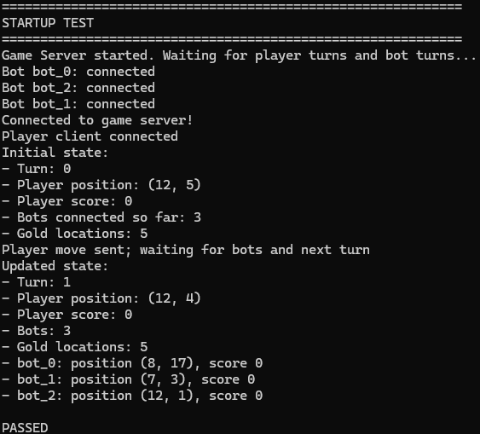

Distributed Test Result

This set of tests includes game state persistence, simulated lag, simulated lost messages, simulated node crash using ZooKeeper ephemeral nodes, and eventual consistency checks.
Result: Pass
Evidence:
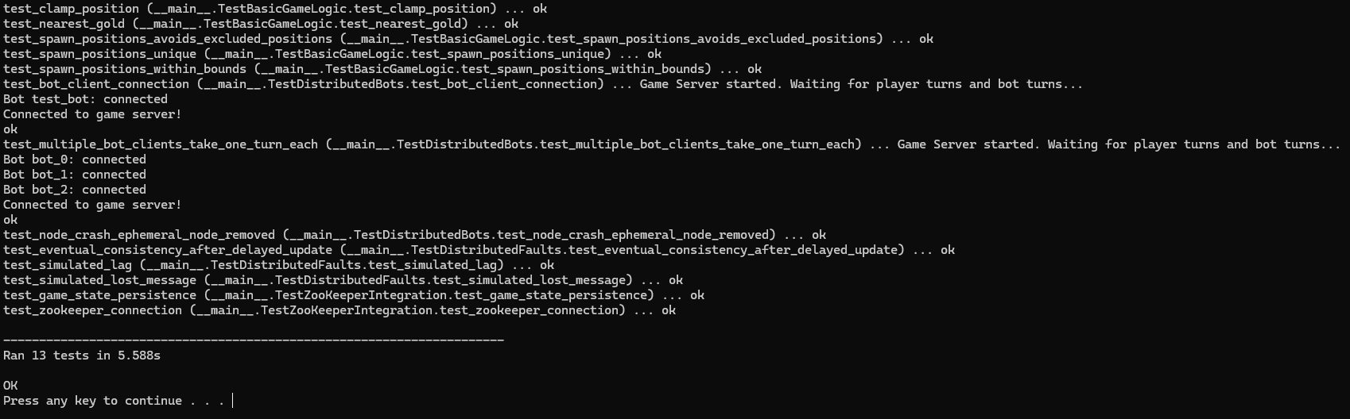

Manual Testing Result
Manual testing was also performed as followed.

- Basic Gameplay
Steps:
1. Start ZooKeeper.
2. Run start.bat.
3. Move the player using W, A, S, and D.
Expected Result:
The server, player client, and bot clients start successfully. The player can move around the grid, bots take turns moving, and the game state updates after each turn.
Results:
Pass. The game started successfully and the player was able to move. Bot clients also connected and participated in the game.
Evidence:
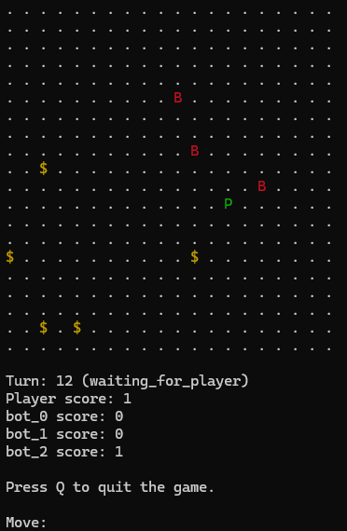
- Gold Collection
Steps:
1. Start the game.
2. Move the player towards gold.
3. Collect the gold.
4. Check the score and gold list after the turn is processed.
Expected Result:
When a player or bot moves onto a gold location, the score increases and a new gold item appears on the board.
Actual Result:
Pass. Gold collection updated the score.
Evidence:
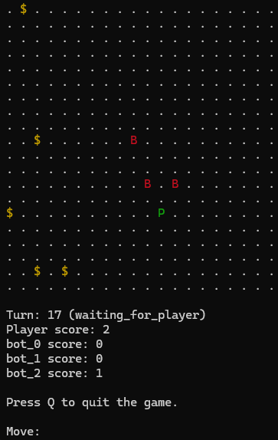
- Bot Client Disconnect
Steps:
1. Start the game with the server, player client, and bot clients.
2. Close one bot client window during gameplay.
3. Continue playing using the player client.
Expected Result:
The game should continue operating even if one bot client disconnects. Remaining participants should still be able to continue.
Actual Result:
Pass. The game continued running after a bot client was closed.
Evidence:
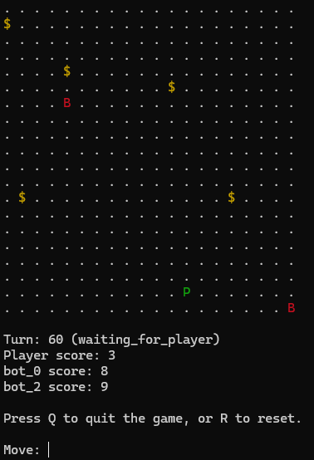
- Player Reset
Steps:
1. Start the game.
2. Move the player and allow bots to move.
3. Press R in the player client to request a reset.
4. Check the updated board and scores.
Expected Result:
The game state should reset and the game should continue operating.
Actual Result:
Pass. The reset request was processed and the game continued.
Evidence:
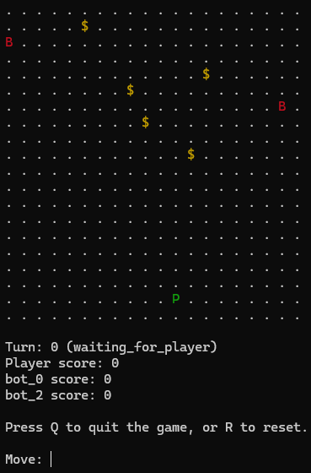

Repository Link
GitHub repository:
https://github.com/Jacob-Jasch/COIT13229-AppliedDistributedSystemsAT2

