**Lab3_report**

**Threshold and color space**

***Question of part c:***

QUS 1: How did you create the filter? Did you get a good result, i.e. similar to the

middle image of Figure 1? Why/why not? (Possibly there are a lot of white

pixels – do not worry).

ANS 1:

We created the filter by converting the image to a hsv image. Then by using the hue data and applying binary mask with the limitation set to the hue range of the green color, as shown in Figure 1 and Figure 2.

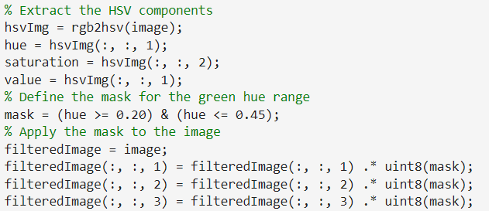Figure 1

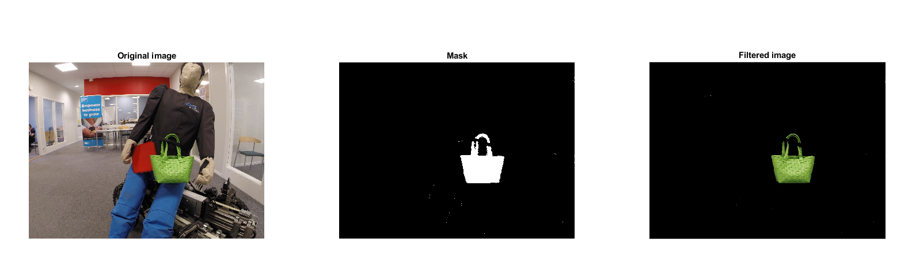Figure 2

QUS2: Suggest how to improve the result

ANS 2: Using other filters such as Color Range Filtering or implementing object detection for masking the green bag.

We could suggest some other solutions, but the ones above should work.

***Question of part d:***

QUS3: How do you create the green filter in this color space? Which parameter

was the most important?

ANS3: The filter was created by modifying the maskedRGBImage that was made using the HSV in the Color Threshold App in MatLab.

The most important parameter is Hue as it decides which colors are shown.   
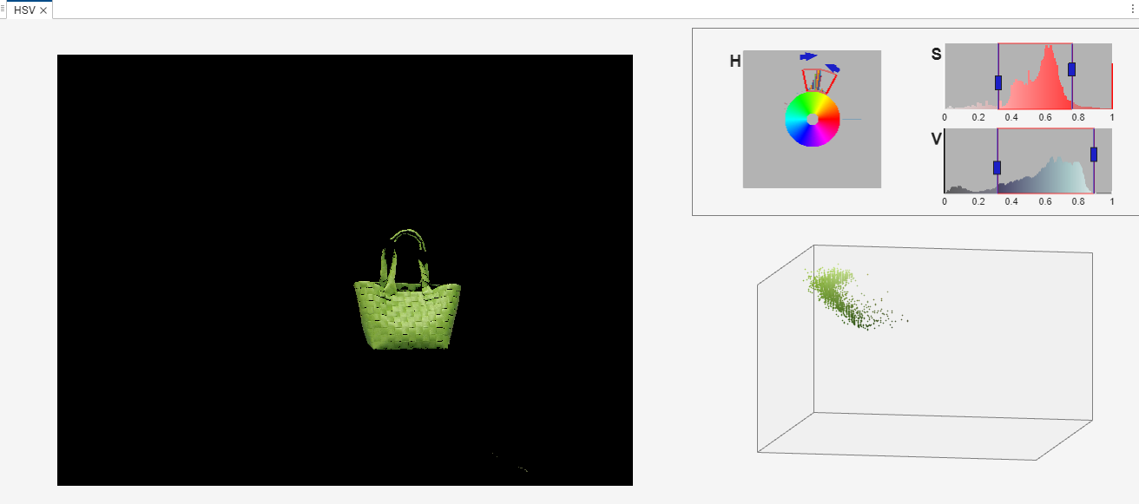 Figure 3

QUS4: How does your filtered image compare to the previous RGB-based result?

ANS4: The result is much better(see Figure 3 above) as we could obtain a very similar result to Figure 1 in lab specification.

***Question of part e:***

QUS 5: How did you do this?

ANS 5: We obtained our result by first changing the RGB image to a grayscale image using rgb2gray(); the brighter pixels represent areas with more green in the original RGB image. This is followed by a for-loop to iterate through each pixel of the image and check if the green mask is not black (if it contains green information). Once the condition is TRUE, the blue channel sets the intensity of green from the corresponding pixel in the green mask. The intensity of the green channel is set to 60% intensity(it gave the best result after testing) and lastly the intensity of the red channel is set to zero.

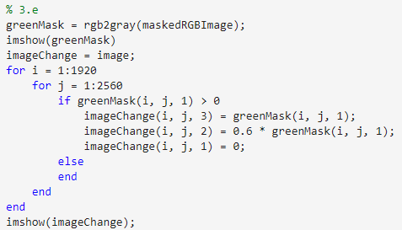Figure 4

QUS 6: Show the resulting image

ANS6: See Figure 5 below

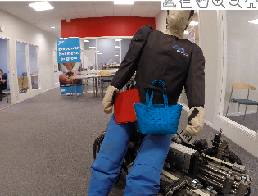Figure 5

**4. Spatial operator and convolution**

***Question of part d:***

QUS 7: Do they produce the same result?

ANS 7: No, they do not produce the same result.

QUS 8: Which one is quicker and why?

ANS 8: Both have approximately the same performance, as shown in Figure 6 below.

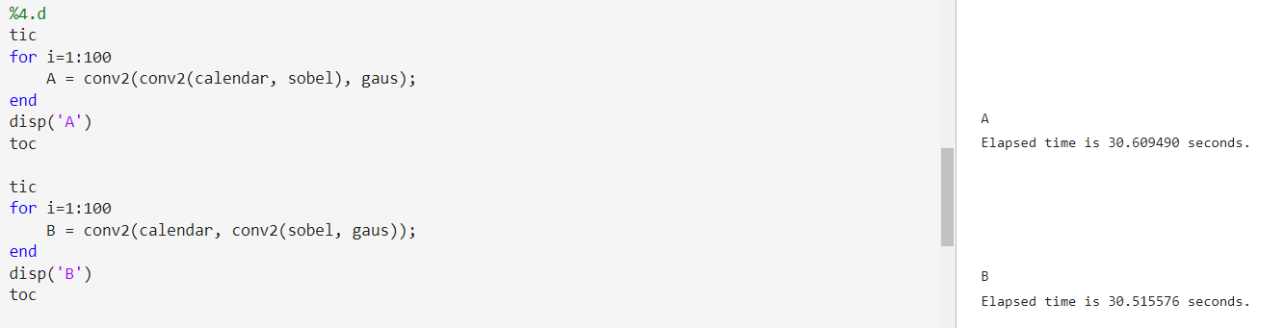Figure 6

**5. Calibration and measurement**

***Question of part e:***

QUS 9: What was the result of your 4 depth estimations? What do you conclude from these with respect to measurement and distortion?

ANS 9: See Figure 7 & 8 for the result of my 4 depth estimations.

Pens have almost the same distance as we see in Figure 8 without distortion. In case we have distortion, we can see a difference in the distances(see Figure 7 below) so we can conclude that distortion affects the measurement of our distances .

 Figure 7

******Figure 8