Final

2025-07-02

library(dplyr)

##   
## Attaching package: 'dplyr'

## The following objects are masked from 'package:stats':  
##   
## filter, lag

## The following objects are masked from 'package:base':  
##   
## intersect, setdiff, setequal, union

library(tidyr)  
library(cluster)  
library(factoextra)

## Loading required package: ggplot2

## Welcome! Want to learn more? See two factoextra-related books at https://goo.gl/ve3WBa

library(ggplot2)  
  
# Loading the data  
file_path <- "EIA923_Schedules_2_3_4_5_M_12_2023_Final_5.csv" # Update with your actual file name  
raw_data <- read.csv(file_path, stringsAsFactors = FALSE, check.names = FALSE)  
  
# Cleaning and selecting data  
ytd_data <- raw_data %>%  
 select(  
 Total_Fuel_Consumption_Quantity = `Total_Fuel_Consumption_Quantity`,  
 Electric_Fuel_Consumption_Quantity = `Electric_Fuel_Consumption_Quantity`,  
 Total_Fuel_Consumption_MMBtu = `Total_Fuel_Consumption_MMBtu`,  
 Elec_Fuel_Consumption_MMBtu = `Elec_Fuel_Consumption_MMBtu`,  
 Net_Generation = `Net_Generation`,  
 YEAR = `YEAR`  
 )  
  
ytd_data <- ytd_data %>%  
 mutate(  
 across(  
 c(  
 Total_Fuel_Consumption_Quantity,  
 Electric_Fuel_Consumption_Quantity,  
 Total_Fuel_Consumption_MMBtu,  
 Elec_Fuel_Consumption_MMBtu,  
 Net_Generation  
 ),  
 ~ as.numeric(gsub(",", "", .))  
 )  
 )  
  
ytd_data <- ytd_data %>%  
 drop_na() %>%  
 filter(Net_Generation > 0, Total_Fuel_Consumption_MMBtu > 0)  
  
# Creating variables  
ytd_data <- ytd_data %>%  
 mutate(  
 Fuel_Efficiency_MMBtu_per_MWh = Total_Fuel_Consumption_MMBtu / Net_Generation,  
 Elec_Fuel_Share = Elec_Fuel_Consumption_MMBtu / Total_Fuel_Consumption_MMBtu  
 ) %>%  
 filter_all(all_vars(!is.infinite(.)))  
  
# clustering  
clustering_vars <- ytd_data %>%  
 select(  
 Total_Fuel_Consumption_MMBtu,  
 Net_Generation,  
 Fuel_Efficiency_MMBtu_per_MWh,  
 Elec_Fuel_Share  
 )  
  
# scaling data  
clustering_scaled <- scale(clustering_vars)  
  
# determining K  
fviz_nbclust(clustering_scaled, FUN = hcut, method = "wss") +  
 ggtitle("Elbow Method for Optimal Clusters")

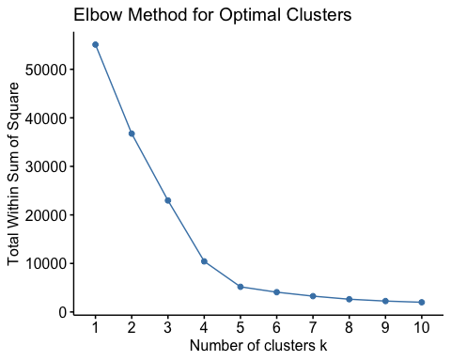

distance_matrix <- dist(clustering_scaled)  
hc_ward <- hclust(distance_matrix, method = "ward.D2")  
plot(hc_ward, labels = FALSE, hang = -1, main = "Dendrogram - Ward’s Method")

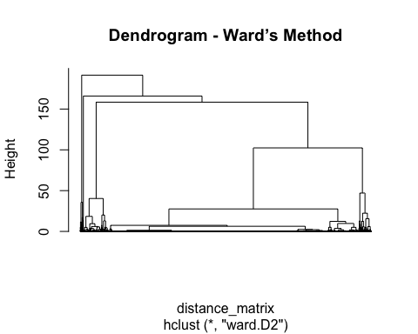

# clustering  
k <- 3 # Adjust as needed based on elbow plot  
clusters <- cutree(hc_ward, k = k)  
  
  
clustered_data <- ytd_data %>%  
 mutate(Cluster = as.factor(clusters))  
  
# Viewing the clusters  
fviz_cluster(list(data = clustering_scaled, cluster = clusters)) +  
 ggtitle("Cluster Visualization")

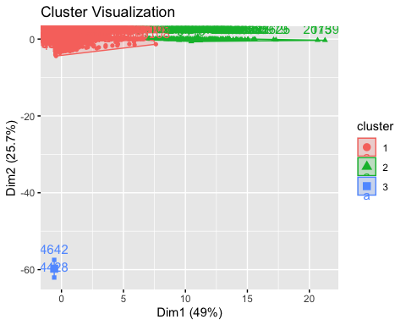

# Cluster summary  
cluster_summary <- clustered_data %>%  
 group_by(Cluster) %>%  
 summarise(  
 Avg_Total_MMBtu = mean(Total_Fuel_Consumption_MMBtu),  
 Avg_Net_Generation = mean(Net_Generation),  
 Avg_Efficiency = mean(Fuel_Efficiency_MMBtu_per_MWh),  
 Avg_Elec_Share = mean(Elec_Fuel_Share),  
 Count = n()  
 )  
  
print(cluster_summary)

## # A tibble: 3 × 6  
## Cluster Avg_Total_MMBtu Avg_Net_Generation Avg_Efficiency Avg_Elec_Share Count  
## <fct> <dbl> <dbl> <dbl> <dbl> <int>  
## 1 1 1633546. 202619. 13.8 0.936 13622  
## 2 2 87043455. 8555703. 10.3 0.998 150  
## 3 3 2248606. 4 559364. 0.500 2