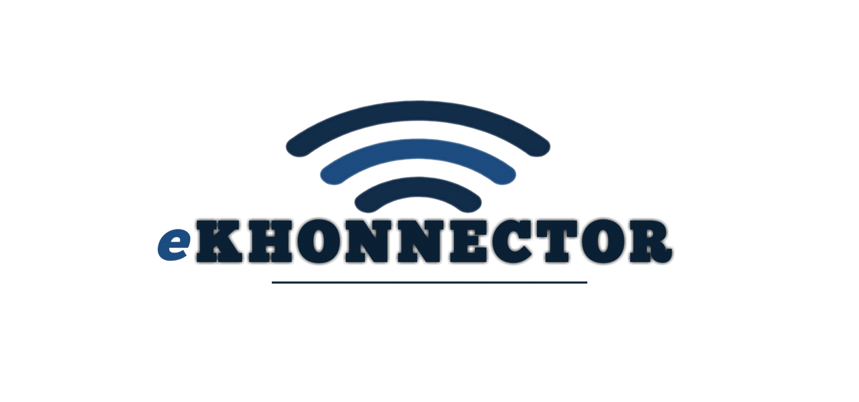**Office 02**

**Elukwatini A Complex**

**Mpumalanga**

**1192**

**Reports@eKhonnector.co.za | www.eKhonnector.co.za | 0130011921 | 0678293770**

**DAILY REPORT**

**30 Thursday March 2023**

**ELELWANI AND MAPHARI**

TESTING UI’s

UI(New Client registration)

**Mistakes**

* Category single and family option reputing
* Policy number text box not working
* Product button reputation of options
* Preferred payment date no calendar option

MAIN MEMBER

* ID has scroll down option

EXTENDED MEMBER

* 1 of 1 on top right
* Contact has scroll down option
* Add member button deletes the information entered , but there’s a pop up message
* Clear all button not working

PRODUCT ADITIONAL MESSAGE

* 1 of 1 on top right
* Add button not working but there’s a pop up message
* Clear all button not working and pop up message
* View Record button not working and pop up message
* button not working and pop up message

**UI POLICIES/ PROCDUCTS**

* category has no option when you scroll down
* Policy category has different options(female and male)
* Policy name has one option
* Underwritten By – replace avbob by select

**Working on proposal**

-OKHAHLAMBA LOCAL MUNICIPALITY

## **Introduction**

The purpose of this technical proposal is to provide a comprehensive plan for the development of a website for OKHAHLAMBA LOCAL MUNICIPALITY. The proposed website OKHAHLAMBA LOCAL MUNICIPALITY will be designed and developed using the latest technologies and will be deployed on a reliable platform. As ekhonnector we propose to develop an existing website of OKHAHLAMBA LOCAL MUNICIPALITY which will be user friendly, responsive, and provide intuitive interface that is not only aesthetically pleasing but its also functional, efficient, reliable, secured and delivers a high quality user experience.

## **Scope**

The scope of this project includes the following task:

* Gathering project Requirements: Our team will collaborate with OKHAHLAMBA LOCAL MUNICIPALITY to gather the project requirements for the website including the scope of hosting and technical support.
* Design and development: Our team will design and develop the website using the latest technologies, adhering to best practices and standards.
* Website implementation and Testing: We shall test the website thoroughly to ensure it meets the user expectations, performs well and is bug-free. We will deploy the website on a secure and reliable platform.
* Content Creation and Management: Our team will assist the client in creating high quality content that is SEO-friendly and follows web content best practices. We shall also manage the website, update content and perform regular maintenance.
* enhancing user experience: By improving the user interface, making it more intuitive and user-friendly, the website can be made easier to use, which can increase adoption and user satisfaction.