Installation Guide for COD3BR3AKR

Encryption/Decryption System

***Version 1***

***December 17, 2018***

***Diverse Engineers***

***Course: CS524***

***Professor: Dimitoglou, George***

***Computer Science Department***

***Hood College of Frederick, Maryland 21701***

**Revision History**

|  |  |  |  |
| --- | --- | --- | --- |
| **Revision** | **Date** | **Description** | **By** |
| 1 | 12/17/2018 | Initial Installation Guide for COD3BR3AKR System | Diverse Engineers |

1 – Download the installer from the GitHub Repository at following link;

<https://github.com/Jacob13209/CS524_COD3BR3AKR/tree/master/Installation>

2 – Double click on the [COD3BR3AKR_Installer.msi](https://github.com/Jacob13209/CS524_COD3BR3AKR/blob/master/Installation/COD3BR3AKR_Installer.msi) to start the installation process.

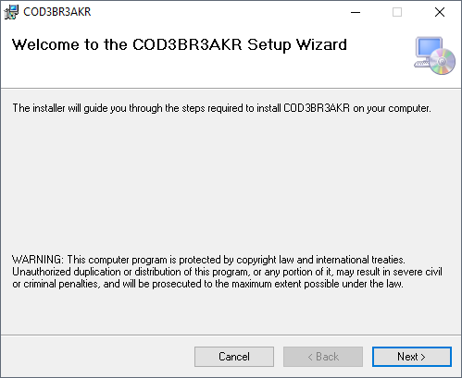

3- Click on Next to continue. The default installation folder is “C:\CS524_HoodCollege\COD3BR3AKR\”. See following screenshot for details, you can also browse a different folder for installation by clicking on the ‘Browse’ button. Click on Next to continue.

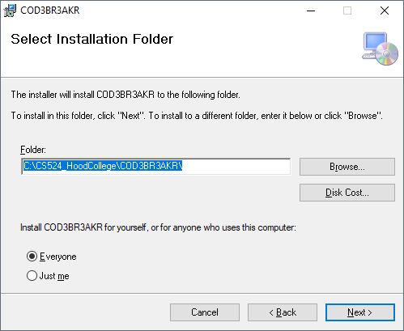

4- Once installation complete, you will see the notice as following screenshots.

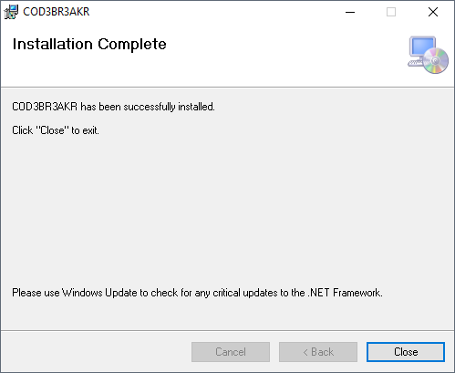

5- Click on Close to finish the installation. There would be a short cut generated on the Desktop that you can access the system by double click on the shortcut.

