User’s Guide

COD3BR3AKR

**Prepared by** Diverse Engineers

**Hood College**

**Department of CS & IT**

**Frederick Maryland**

**12/18/2018**

Table of Contents

A. Introduction A-3

1 Quick Start Guide A-3

1.1 Authentication A-3

1.2 Graphical user interface A-5

1.3 Navigation Bars A-5

1.4 Encrypt user data and output the result A-6

1.5 Decrypt user data and output the result A-6

1.6 File Input A-7

1.7 Algorithms Option A-11

1.8 Status and Duration A-11

2 Users Management A-12

2.1 Refresh user account information for new register users A-13

2.2 Adding new users A-14

2.3 Update user account A-15

2.4 Delete user accounts A-16

# Introduction

The product named “COD3BR3KR” referred to as “**Code Breaker**” is a stand-alone software encryption-decryption system in which allow a user can either input plaintext data (via string or file input) to be encrypted to ciphertext, or input ciphertext (via string or file input) to be decrypted to plaintext. It can be used as a method to protect user data using cryptographic technologies. The **Code Breaker** is a product that runs on a Windows OS and the main functions of the product are:

1. Provide Authentication mechanisms for logging in to the system

2. Encrypt user data and output the result

3. Decrypt user data and output the result

4. Provide an interface for managing users of the system

5. Provide an interface for viewing logs for user activity and error reporting

# Quick Start Guide

## Authentication

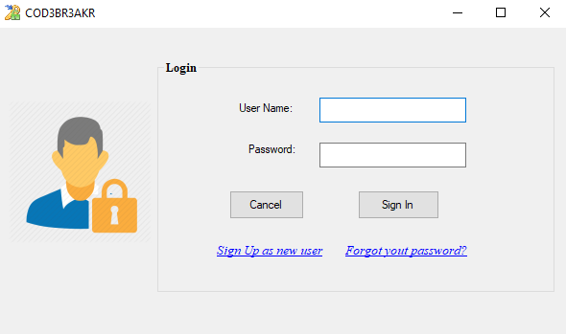

The login screen will be brought up. I will ask you for your authentication in order to access the software. If you already sign up, you can enter your username and password than click sign in. if it is your first time, you should sign up as new users.

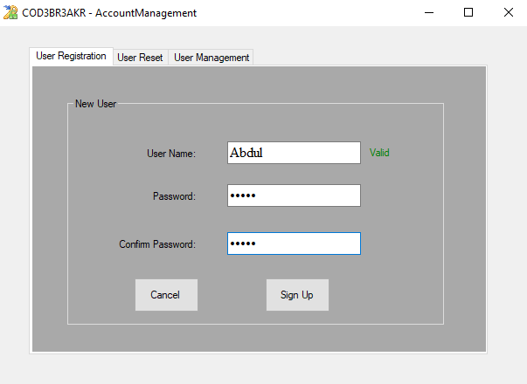

New users must be sign up. In order to sign up you have to have a valid username and passwords as well it will ask you for password conformation. After that click sign up, a pop up will appear “Registration successfully ”than it ask you to login in page again.

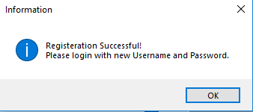

## Graphical user interface

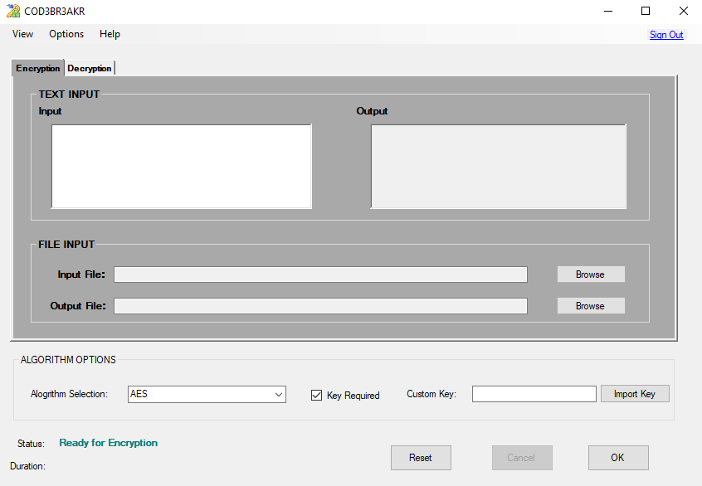

Graphical user interface will have include the following option:

## Navigation Bars

The user will navigate to view the logs and users management as well you can access the help to view the users guides and about the COD3BR3KR. Also , you will have the sign out button that will exit you of the software.





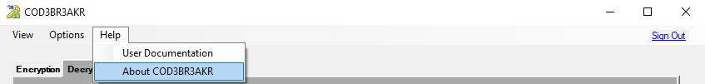

## Encrypt user data and output the result

You can input plaintext data to be encrypted. Once the input is logged, and algorithms selected user shall be able to click on the OK to process the encryption then output the ciphertext to the user.

Note: here is no limit to character combinations, as long as they fall within the symbol set of US-ASCII and are no more than 300 characters in length.

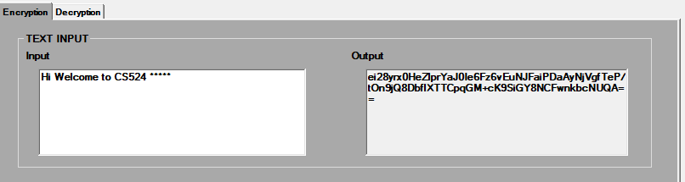

## Decrypt user data and output the result

After decryption is performed, you can copy the output and click on the Decryption tap. Than paste the output and select the algorithm, than add the key that’s associate with algorithm that you choose than click Ok. Notice that is the button OK is highlighted.

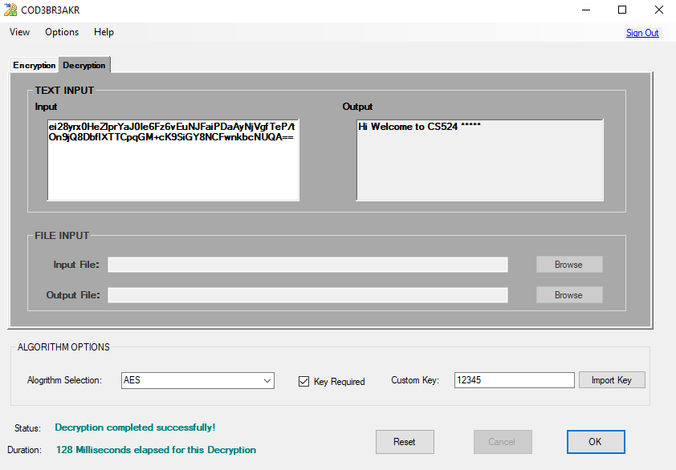

## File Input

You can input plaintext data via a text file to be encrypted and decrypt the. Once the file input is logged with text, you can browse it and select the file. After the file is select, the output file location will be appeared. Select the algorithms and the key than selected click on the OK to process the encryption then output file would be generated.

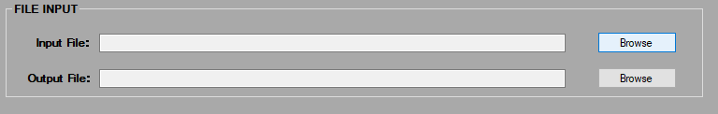

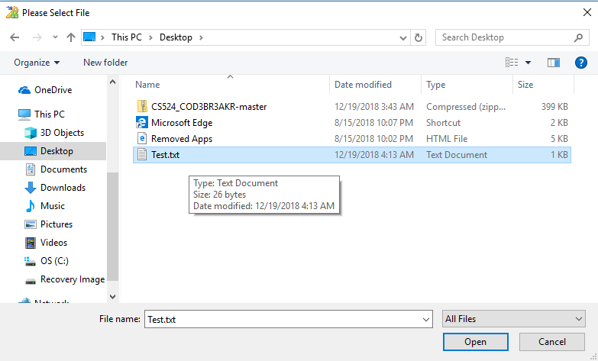

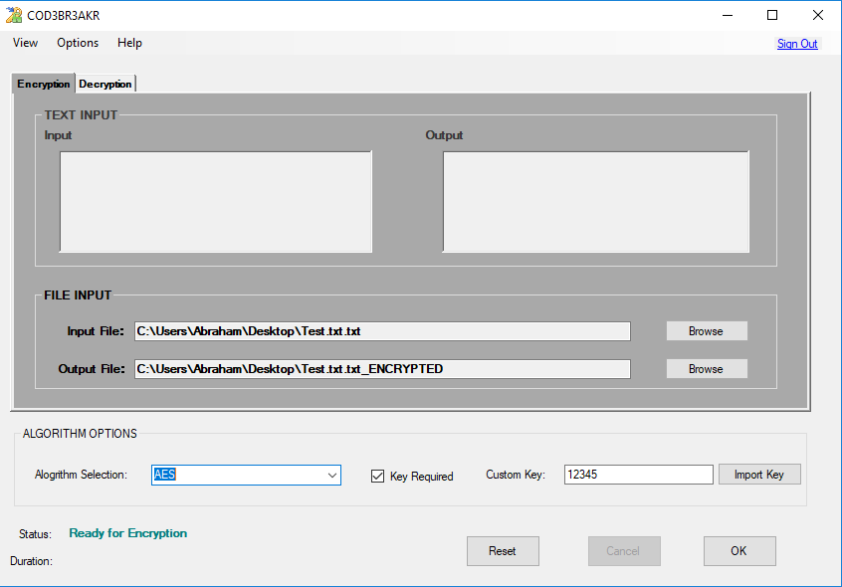

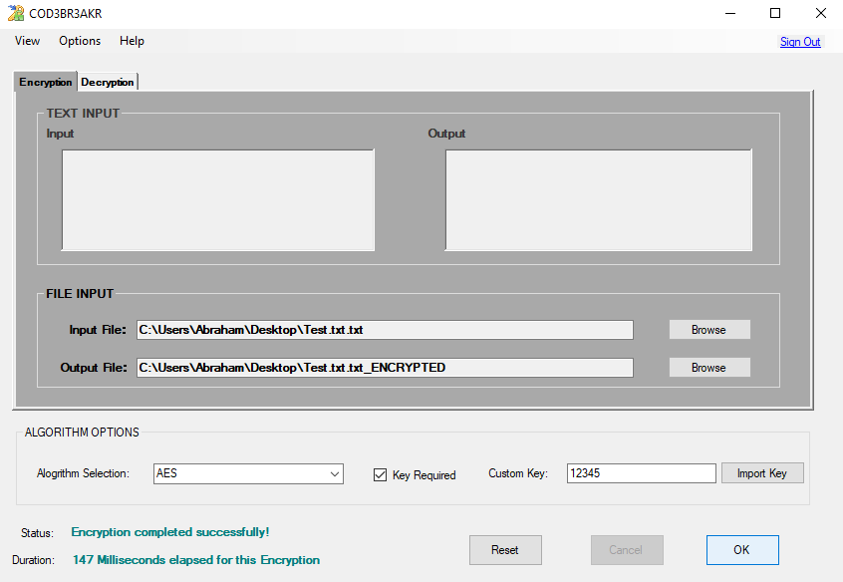

Once the encryption is completed successfully, you can click on the decryption tap. Then browse it and select the file that is encrypted. After the file is select the same algorithms and the key than selected click on the OK to process the decryption.

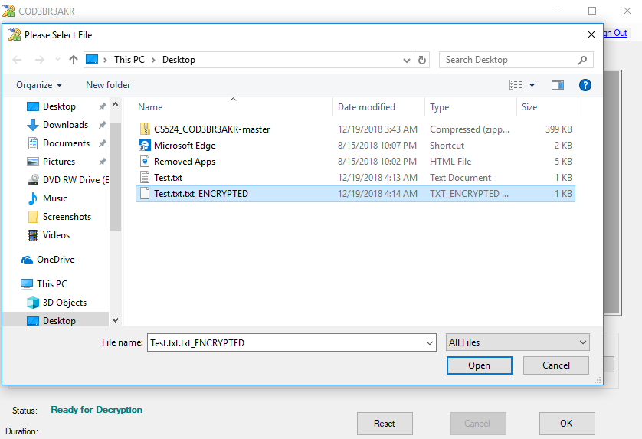

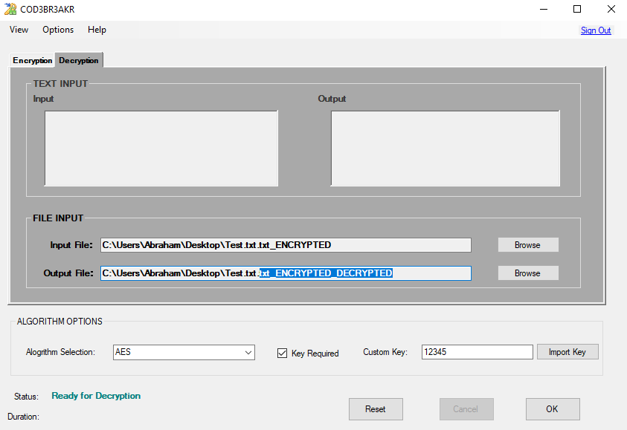

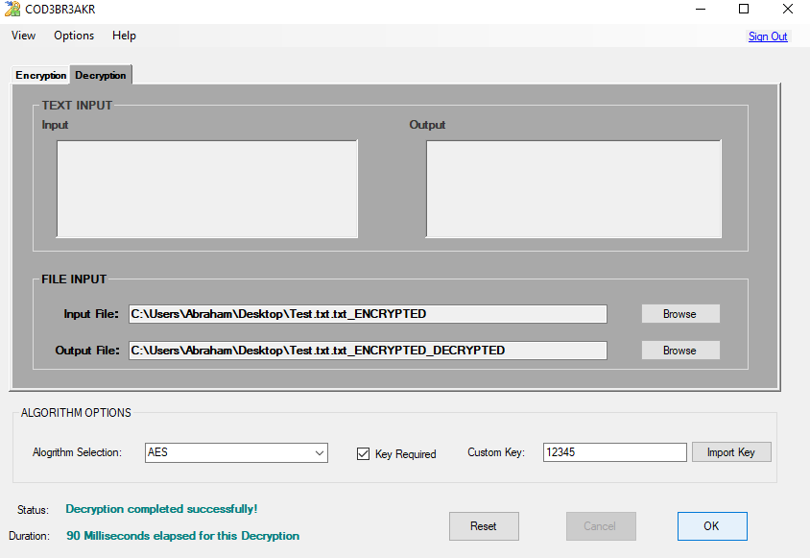

## Algorithms Option

You can select one of the options to choose which encryption algorithm to use for encrypting including AES, RSA, and Triple-DES. Also, you have the option to input or import your encryption key.

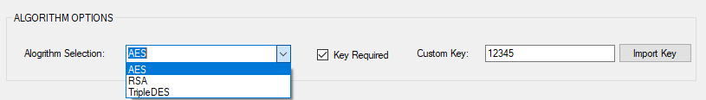

## Status and Duration

Status and duration will keep you track on activates that software is processing for encryption or decryption and the length of the duration of the process.

Ready to encryption

Macintosh HD:Users:ABDUL:Desktop:User Guides:Screenshot (8).png

Encryption Completed successfully

Macintosh HD:Users:ABDUL:Desktop:User Guides:Screenshot (20).png

Decryption Completed successfully



# Users Management

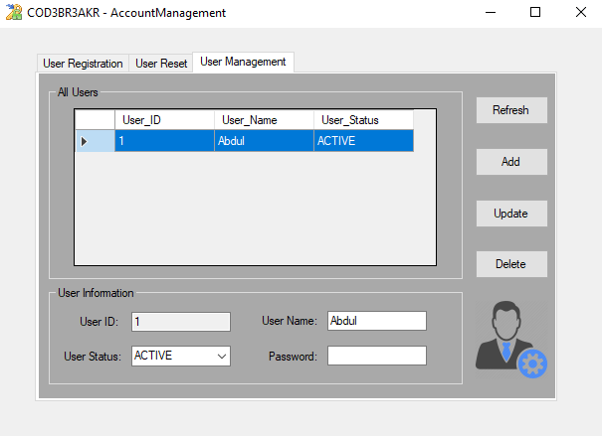

User Management service has several features include user account management. You can create a new user account manually by adding a valid Username, passwords or through user registration in login in windows. Also, you can choose the status for user by activating or inactivating them. We perform full CRUD operations.

## Refresh user account information for new register users

You can active and inactive user, then click refresh to confirm the activation.

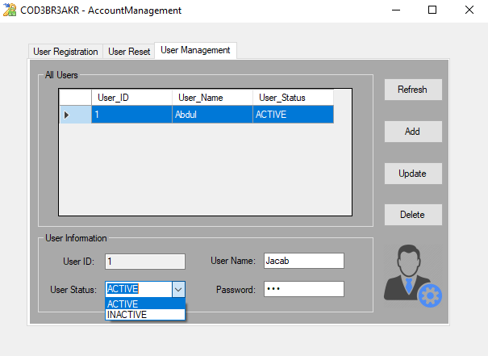

## Adding new users

You can add new user by adding a valid username and passwords, then click the button Add.

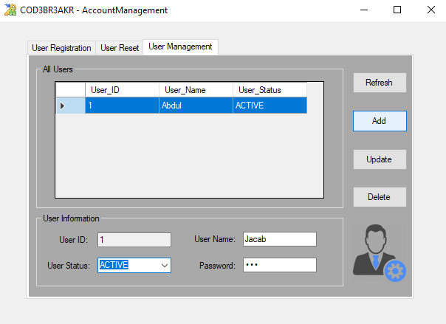

After we refresh the software that we notice that Jacob is added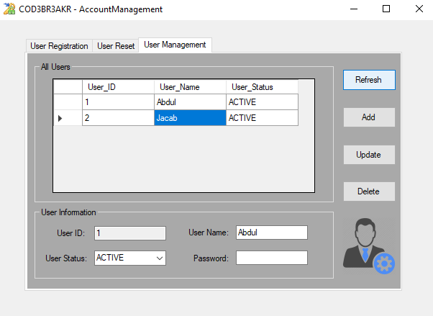

## Update user account

You can update information such as the username or passwords

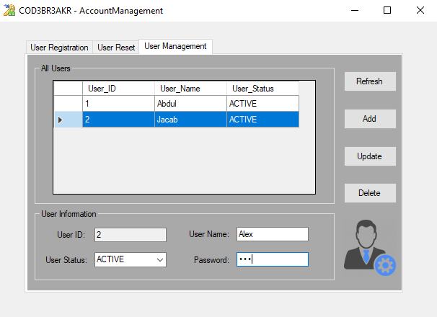

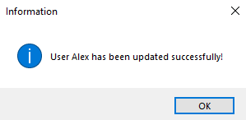

## Delete user accounts

You can delete a user and a confirmation pop up will ask you to confirm that deletion.

