Abstractive Text Summarization with a
Modern Encoder-Decoder Transformer
Jacob Ashoo
CSI-4130/5130: Artificial Intelligence
April 2026

Abstract
This paper presents the design, implementation, and evaluation of a sequence-to-sequence Transformer model built from scratch for abstractive text summarization. The model follows a modern encoder-decoder architecture incorporating Rotary Positional Embeddings (RoPE), SwiGLU feed-forward networks, pre-layer RMSNorm, and Flash Attention, totaling approximately 84 million unique parameters after three-way weight tying. The system was trained on the Newsroom abstractive summarization dataset using a custom 50,000-token BPE tokenizer and distributed data-parallel training across two GPUs with mixed-precision bfloat16 computation. Training was conducted for 35,000 optimizer steps with an effective batch size of 128. The model achieved a best validation cross-entropy loss of 2.895 at step 15,000, after which validation loss began to increase while training loss continued to decline, indicating the onset of overfitting. This report documents the full pipeline from data preprocessing and tokenizer training through model architecture design, training infrastructure, and experimental analysis, and discusses the limitations encountered and potential avenues for future improvement.

1. Introduction
Automatic text summarization is a fundamental challenge in natural language processing that aims to produce concise, faithful condensations of longer documents. Abstractive summarization, in contrast to extractive methods that select and concatenate existing sentences, generates novel phrases and sentences that capture the essential meaning of the source text. This requires the model to develop an internal understanding of the content and to produce fluent natural language output.
The Transformer architecture, introduced by Vaswani et al. (2017), has become the dominant paradigm for sequence-to-sequence tasks including summarization. Since its introduction, numerous architectural refinements have emerged from the large language model research community, including Rotary Positional Embeddings (Su et al., 2021), SwiGLU activation functions (Shazeer, 2020), and RMSNorm (Zhang & Sennrich, 2019). These components have been shown to improve training stability, convergence speed, and generalization in decoder-only language models, but their application in encoder-decoder summarization architectures remains less explored.
This project investigates the design and training of a modern encoder-decoder Transformer for abstractive summarization, incorporating these recent architectural advances. The model is trained from scratch on the Newsroom dataset (Grusky et al., 2018), a large-scale collection of article-summary pairs drawn from major news outlets. The complete system, including data preprocessing, BPE tokenizer training, model implementation, and distributed training infrastructure, was built from the ground up using PyTorch.
The remainder of this paper is organized as follows. Section 2 reviews related work in abstractive summarization and Transformer architectures. Section 3 describes the dataset and preprocessing pipeline. Section 4 details the model architecture and its components. Section 5 covers the training methodology and infrastructure. Section 6 presents experimental results and analysis. Section 7 concludes with a discussion of limitations and future directions.

2. Related Work

2.1 Abstractive Summarization
Neural abstractive summarization has evolved rapidly since the introduction of attention-based sequence-to-sequence models by Rush et al. (2015) and Nallapati et al. (2016). The Transformer architecture (Vaswani et al., 2017) brought significant improvements through its ability to capture long-range dependencies via self-attention. Models such as BART (Lewis et al., 2020) and T5 (Raffel et al., 2020) demonstrated that pretraining encoder-decoder Transformers on large-scale denoising objectives produces strong summarization performance after fine-tuning. More recently, decoder-only large language models have shown competitive summarization abilities through in-context learning, though encoder-decoder architectures remain favored when training from scratch on specific datasets due to their explicit separation of comprehension and generation.

2.2 Modern Transformer Components
Several architectural refinements have been proposed since the original Transformer. Rotary Positional Embeddings (RoPE) encode relative position information directly into the attention computation through rotation matrices, providing better length generalization than absolute sinusoidal embeddings (Su et al., 2021). The SwiGLU activation function, a gated variant of the Swish activation, has been shown to outperform the original ReLU-based feed-forward network in Transformers (Shazeer, 2020). RMSNorm provides a computationally cheaper alternative to LayerNorm by normalizing only by the root mean square of activations, without re-centering (Zhang & Sennrich, 2019). Pre-normalization, applying the normalization before each sub-layer rather than after, has been found to improve training stability (Xiong et al., 2020). This project combines all of these components in an encoder-decoder setting.

2.3 The Newsroom Dataset
The Newsroom dataset (Grusky et al., 2018) contains 1.3 million article-summary pairs from 38 major news publications. Each pair is annotated with extractive and abstractive metrics including compression ratio, coverage, and density, enabling fine-grained filtering. The dataset is notable for its diversity, the summaries are written by the original article authors rather than crowd workers, and its scale. We use the abstractive subset, filtering out extractive examples to focus the model on generating novel text. After filtering, the final dataset contained 87,000 examples.

3. Data

3.1 Preprocessing Pipeline
The raw Newsroom dataset was processed through a multi-stage pipeline designed to produce clean, high-quality training examples suitable for an abstractive summarization model.
Stage 1: Text Cleaning. Each article and summary underwent HTML entity unescaping, removal of URLs and email addresses, emoji stripping, and whitespace normalization. This was applied in a single pass to avoid multiple iterations over the text.
Stage 2: Abstractiveness Filtering. To ensure the dataset contained genuinely abstractive examples, records were filtered to require a compression ratio between 2.0 and 10.0 and a density bin classification other than "extractive." This removed near-extractive summaries that simply copy sentences from the source.
Stage 3: Deduplication. The summaries library (Grusky, 2023) was used to perform deduplication with a test-first strategy, ensuring that no summary in the test set appeared in training. The library also performed additional quality filtering based on compression ratio and content analysis.
Stage 4: Tokenization and Length Filtering. After tokenization with the trained BPE tokenizer, examples were filtered to retain only those where the source text was between 10 and 2,000 tokens and the summary was between 1 and 1,000 tokens. The training split was globally shuffled with a fixed random seed prior to writing to disk.

3.2 BPE Tokenizer
A Byte-Pair Encoding (BPE) tokenizer was trained from scratch on the combined text and summary content of the training set using the HuggingFace Tokenizers library. The vocabulary size was set to 50,000 subword tokens with a minimum frequency threshold of 2. Four special tokens were defined. Training a custom tokenizer rather than reusing an existing one ensured the vocabulary was optimally adapted to the domain and content characteristics of the Newsroom dataset.

4. Methods

4.1 Model Architecture
The model follows a standard encoder-decoder Transformer architecture with several modern modifications. The encoder processes the full source document bidirectionally, producing contextual representations that are consumed by the decoder at every layer via cross-attention. The decoder generates the summary autoregressively, attending causally to its own previous outputs and cross-attending to the encoder output.
Table 1: Model Hyperparameters
Parameter | Value
Model dimension (d_model) | 512
Encoder layers | 8
Decoder layers | 8
Attention heads | 8
Head dimension | 64
FFN hidden dimension | 1,365
Vocabulary size | 50,000
Max source length | 2,002
Max target length | 1,002
Dropout | 0.1
Total unique parameters | ~84M

4.2 Architectural Components
Rotary Positional Embeddings (RoPE). Unlike absolute positional encodings that are added to the input embeddings, RoPE encodes position by rotating the query and key vectors in the attention computation. This allows the model to learn relative position relationships directly within the attention scores. RoPE is applied to self-attention in both the encoder and decoder but is omitted from cross-attention, where queries and keys originate from different sequences with unrelated position indices.
SwiGLU Feed-Forward Network. Each Transformer block uses a SwiGLU FFN consisting of two parallel linear projections (gate and up) from d_model to the hidden dimension, where the gate projection passes through a SiLU activation and is element-wise multiplied with the up projection, followed by a down projection back to d_model. The hidden dimension of 1,365 follows the canonical SwiGLU ratio of approximately 8/3 times d_model. Dropout is applied after the gated activation and before the down projection.
Pre-Layer RMSNorm. RMSNorm is applied before each sub-layer (self-attention, cross-attention, and FFN) rather than after, following the pre-normalization pattern. This improves training stability by ensuring that the inputs to each sub-layer have consistent scale, and simplifies the gradient flow through residual connections.
Flash Attention. Attention is computed using PyTorch’s scaled_dot_product_attention, which dispatches to the FlashAttention kernel when available. This fused implementation avoids materializing the full attention matrix, reducing memory usage from O(n²) to O(n) and providing significant speedups for long sequences.

4.3 Weight Tying
The encoder embedding, decoder embedding, and output projection layer all share a single weight matrix of shape (50,000 × 512). Since the encoder and decoder operate over the same vocabulary, sharing their embeddings ensures consistent token representations. Tying the decoder embedding with the output projection follows the approach of Press and Wolf (2017), exploiting the fact that these two operations are approximate inverses. This three-way tying eliminates approximately 51 million redundant parameters, reducing the unique parameter count from approximately 135 million to 84 million while improving token representation coherence.

5. Training

5.1 Optimization
The model was trained using AdamW (Loshchilov & Hutter, 2019) with β1 = 0.9, β2 = 0.95, and ε = 10⁻⁸. Weight decay of 0.1 was applied only to weight matrices (parameters with ndim ≥ 2); RMSNorm scale parameters were excluded to avoid shrinking their learned scales. The peak learning rate was 1 × 10⁻⁴, reached after 2,000 steps of linear warmup, followed by cosine decay to 50% of the peak rate over the remaining steps. Gradients were clipped to a maximum norm of 1.0.

5.2 Training Configuration
Table 2: Training Configuration
Setting | Value
Per-GPU batch size | 4
Gradient accumulation steps | 16
Number of GPUs | 2
Effective batch size | 128
Maximum optimizer steps | 50,000
Steps completed | 35,000
Peak learning rate | 1 × 10⁻⁴
Warmup steps | 2,000
Weight decay | 0.1
Gradient clipping | 1.0
Label smoothing | 0.1
Precision | bfloat16

5.3 Distributed Training Infrastructure
Training was distributed across two GPUs using PyTorch Distributed Data Parallel (DDP) with the NCCL backend. Gradient accumulation over 16 micro-steps yielded an effective batch size of 128 sequences per optimizer step. To minimize inter-GPU communication overhead, DDP gradient synchronization was suppressed during all micro-steps except the last using model.no_sync(), avoiding 15 unnecessary NCCL all-reduce operations per optimizer step.
The model was compiled with torch.compile() prior to wrapping in DDP, enabling kernel fusion of RMSNorm, SwiGLU, and embedding operations for an estimated 20–30% throughput improvement. Gradient checkpointing was enabled to recompute activations during the backward pass rather than storing them, reducing peak memory usage at the cost of approximately 33% additional compute. Mixed-precision training with bfloat16 was used for forward and backward passes; the GradScaler was omitted since bfloat16 shares the same exponent range as float32 and does not suffer from gradient underflow.

6. Experiments and Results

6.1 Training Dynamics
The model was trained for 35,000 optimizer steps out of a planned 50,000, at which point training was stopped early due to clear signs of overfitting. Figure 1 shows the full training and validation loss curves over the course of training.
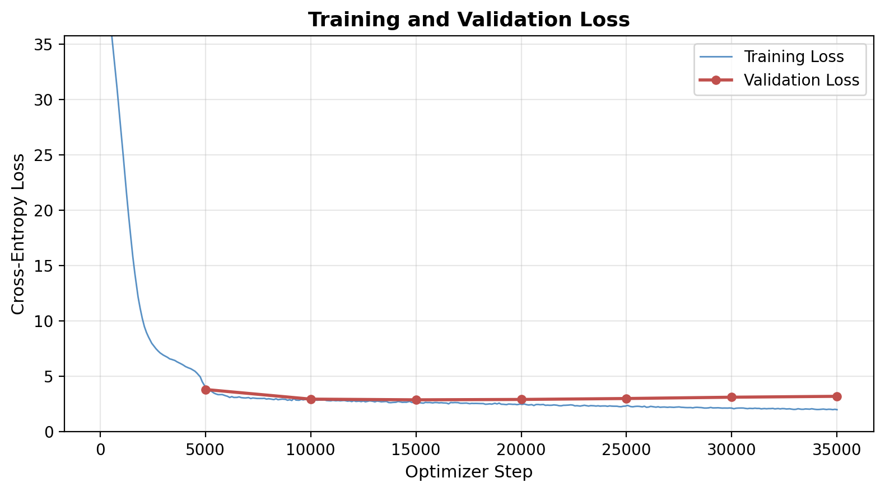
Figure 1: Training and validation loss over 35,000 optimizer steps.
Training loss decreased rapidly during the first several thousand steps, dropping from over 400 to below 10 within the first 2,000 steps (the warmup phase), and continued a steady decline to approximately 2.0 by the end of training. The validation loss, evaluated every 5,000 steps, showed a different trajectory: it decreased from 3.83 at step 5,000 to a minimum of 2.895 at step 15,000, then began to increase steadily through subsequent checkpoints. Figure 2 provides a zoomed view after the warmup period.
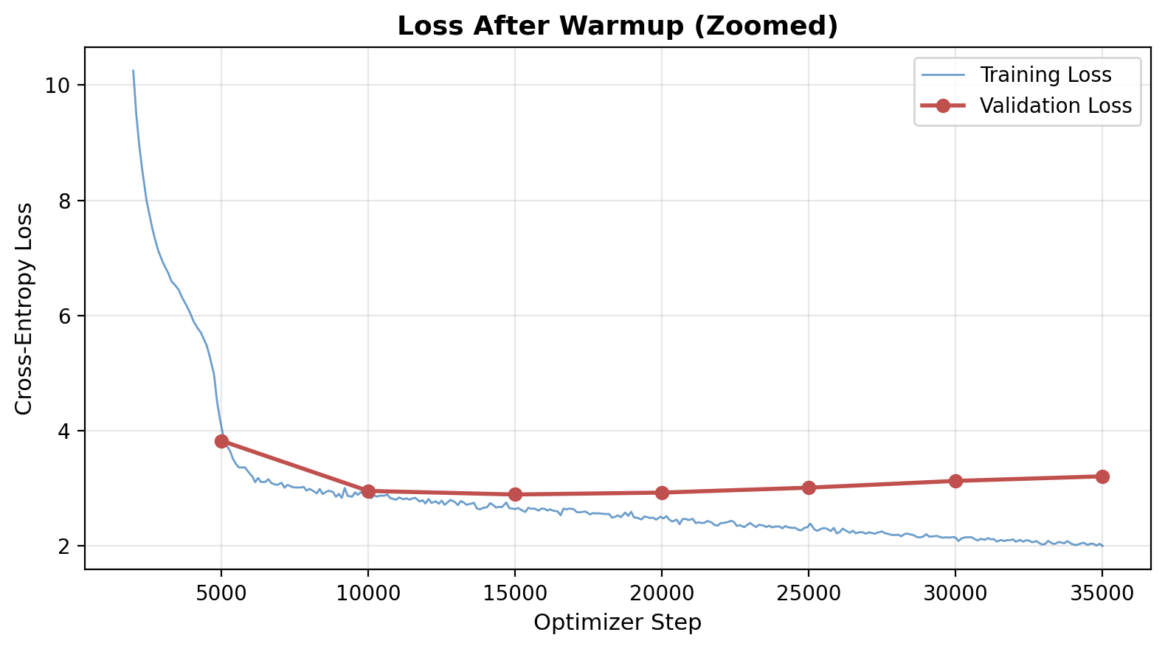
Figure 2: Post-warmup loss curves showing the divergence between training and validation loss.

6.2 Checkpoint Analysis
Table 3 summarizes the validation loss at each checkpoint. The best-performing checkpoint was at step 15,000, after which validation loss increased monotonically, indicating that the model was memorizing training examples rather than learning generalizable patterns.
Table 3: Validation Loss at Each Checkpoint
Step | Validation Loss
5,000 | 3.829
10,000 | 2.957
15,000 | 2.895
20,000 | 2.929
25,000 | 3.014
30,000 | 3.131
35,000 | 3.211

6.3 Analysis of Overfitting
The divergence between training and validation loss after step 15,000 is characteristic of overfitting and can be attributed to several interacting factors. First, the model has 84 million parameters, which provides substantial capacity relative to the size of the training set. While the Newsroom dataset is large, the aggressive filtering for abstractive quality significantly reduced the number of training examples. Second, the label smoothing factor of 0.1, while helpful for preventing overconfident predictions, may not have been sufficient regularization for a model of this scale. Third, dropout of 0.1 was the only other regularization mechanism; additional techniques such as attention dropout, increased weight decay, or data augmentation might have helped.
The best checkpoint at step 15,000 corresponds to approximately the point where the model has seen each training example a sufficient number of times to learn generalizable patterns but has not yet begun to overfit to specific training instances. This early stopping point represents the best trade-off between underfitting and overfitting for this particular configuration.

7. Conclusion
This project demonstrated the end-to-end construction of an abstractive text summarization system, from data preprocessing through model training. The architecture successfully combined modern Transformer components including RoPE, SwiGLU, RMSNorm, and Flash Attention in an encoder-decoder framework, achieving a best validation cross-entropy loss of 2.895 on the Newsroom dataset.
The primary limitation was overfitting, which manifested after 15,000 training steps and prevented the model from fully exploiting its capacity. The validation loss gap of approximately 1.2 at the point of early stopping (training loss ≈ 2.6, validation loss ≈ 2.9 at step 15,000) indicates some generalization ability, but the subsequent divergence suggests the model would benefit from stronger regularization or a larger effective training set.

7.1 Future Work
Several avenues could address the overfitting issue and improve overall performance. Increasing regularization through higher dropout rates, stochastic depth, or R-Drop would directly combat memorization. Data augmentation techniques such as backtranslation, random token replacement, or paraphrase generation could effectively increase the diversity of training examples. Reducing the model size to better match the available data, or conversely, pretraining on a large unsupervised corpus before fine-tuning on Newsroom, would improve the data-to-parameter ratio. Evaluating the model with ROUGE and BERTScore metrics, along with qualitative human evaluation, would provide a more complete picture of summarization quality beyond cross-entropy loss. Finally, implementing beam search decoding with length normalization and repetition penalties would likely improve the quality of generated summaries at inference time.

References
Grusky, M., Naaman, M., & Artzi, Y. (2018). Newsroom: A dataset of 1.3 million summaries with diverse extractive strategies. Proceedings of the 2018 Conference of the North American Chapter of the Association for Computational Linguistics (NAACL).
Lewis, M., Liu, Y., Goyal, N., Ghazvininejad, M., Mohamed, A., Levy, O., Stoyanov, V., & Zettlemoyer, L. (2020). BART: Denoising sequence-to-sequence pre-training for natural language generation, translation, and comprehension. Proceedings of the 58th Annual Meeting of the Association for Computational Linguistics (ACL).
Loshchilov, I. & Hutter, F. (2019). Decoupled weight decay regularization. International Conference on Learning Representations (ICLR).
Nallapati, R., Zhou, B., dos Santos, C., Gulcehre, C., & Xiang, B. (2016). Abstractive text summarization using sequence-to-sequence RNNs and beyond. Proceedings of the 20th SIGNLL Conference on Computational Natural Language Learning (CoNLL).
Press, O. & Wolf, L. (2017). Using the output embedding to improve language models. Proceedings of the 15th Conference of the European Chapter of the Association for Computational Linguistics (EACL).
Raffel, C., Shazeer, N., Roberts, A., Lee, K., Narang, S., Matena, M., Zhou, Y., Li, W., & Liu, P.J. (2020). Exploring the limits of transfer learning with a unified text-to-text transformer. Journal of Machine Learning Research, 21(140), 1–67.
Rush, A.M., Chopra, S., & Weston, J. (2015). A neural attention model for abstractive sentence summarization. Proceedings of the 2015 Conference on Empirical Methods in Natural Language Processing (EMNLP).
Shazeer, N. (2020). GLU variants improve Transformer. arXiv preprint arXiv:2002.05202.
Su, J., Lu, Y., Pan, S., Murtadha, A., Wen, B., & Liu, Y. (2021). RoFormer: Enhanced Transformer with Rotary Position Embedding. arXiv preprint arXiv:2104.09864.
Vaswani, A., Shazeer, N., Parmar, N., Uszkoreit, J., Jones, L., Gomez, A.N., Kaiser, L., & Polosukhin, I. (2017). Attention is all you need. Advances in Neural Information Processing Systems (NeurIPS), 30.
Xiong, R., Yang, Y., He, D., Zheng, K., Zheng, S., Xing, C., Zhang, H., Lan, Y., Wang, L., & Liu, T. (2020). On layer normalization in the Transformer architecture. Proceedings of the 37th International Conference on Machine Learning (ICML).
Zhang, B. & Sennrich, R. (2019). Root mean square layer normalization. Advances in Neural Information Processing Systems (NeurIPS), 32.

