Disease Model Summary

This model was made in the summer of 2020 for the sake of practicing some Python. Since then, some data recording capability was added in order to gain some insight into what goes on during the simulation.

The Model

The model is written in Python using Pygames. Pygames was chosen to use its real-time graphical capabilities. Below are a few snippets during the simulation time. The coding was done such that many parameters can be easily changed, such as population, number of cases at beginning of simulation, movement rate, transmission rate, death rate, and more.

Example Simulation

The following snippets were taken from a simulation ran with a population of 1000, a starting rate of 1 in 1000 (0.1%), a recovery time of 14 days and a transmission rate of 1%. This transmission rate is used to make it so that for every 100 contacts between “people”, only 1 new infection would occur.

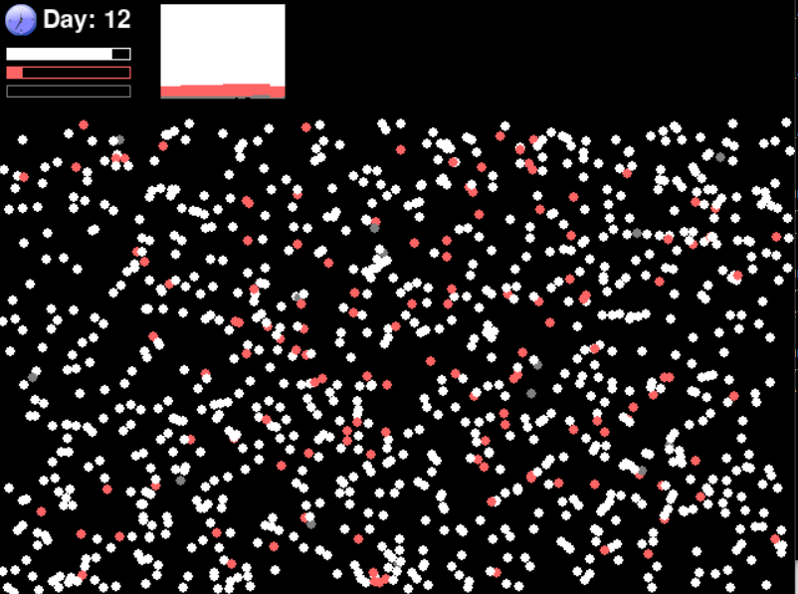

Figure : A snippet from day 12 during the simulation time, with 1000 People Simulated

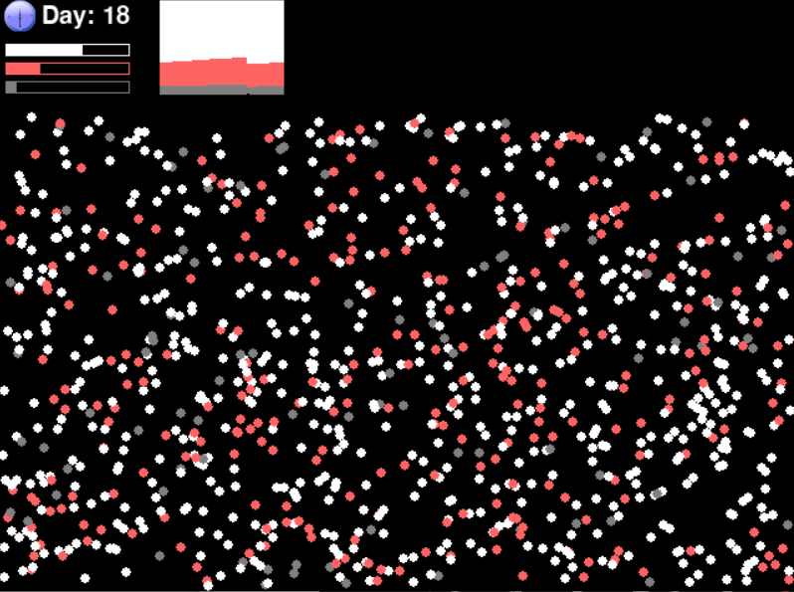

Figure 2: A snippet from day 18 during the simulation time, with 1000 People Simulated. Some people are already recovered at this time

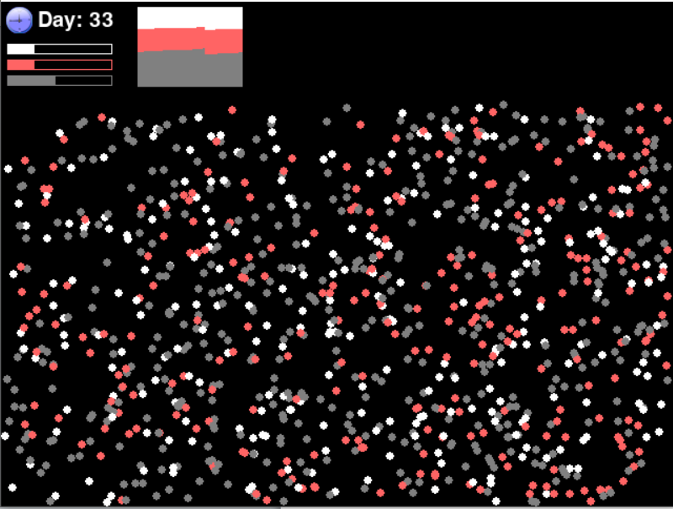

Figure 2: A snippet from day 33 during the simulation time, with 1000 People Simulated. At this point, a lot of people have recovered given the recovery time of 14 days. This is also around the peak of active cases, almost 1 in 3 people are infected.

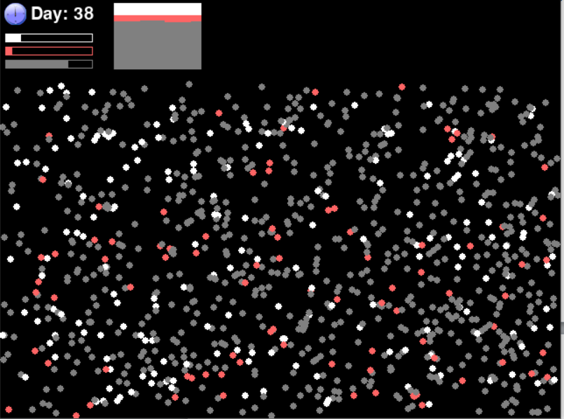

Figure 3: A snippet from day 38 during the simulation time

z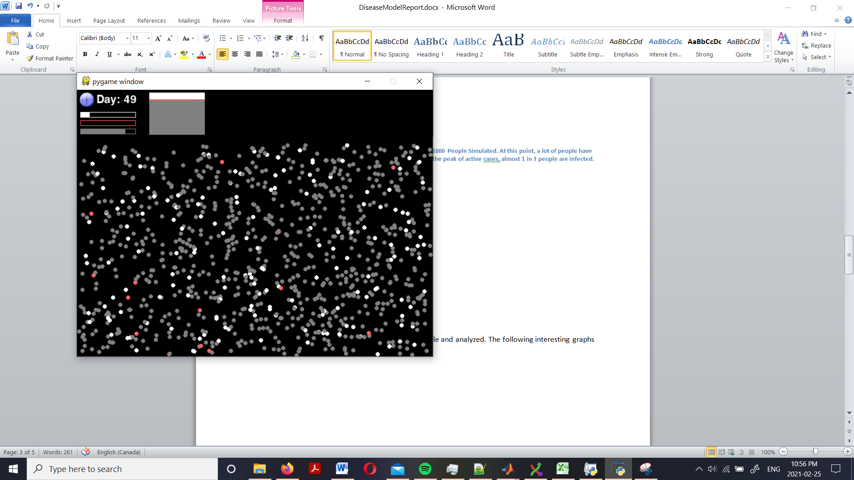

Figure 4: A snippet from day 49 during the simulation time. By this point, heard immunity has taken a toll on the disease and it will soon die out.

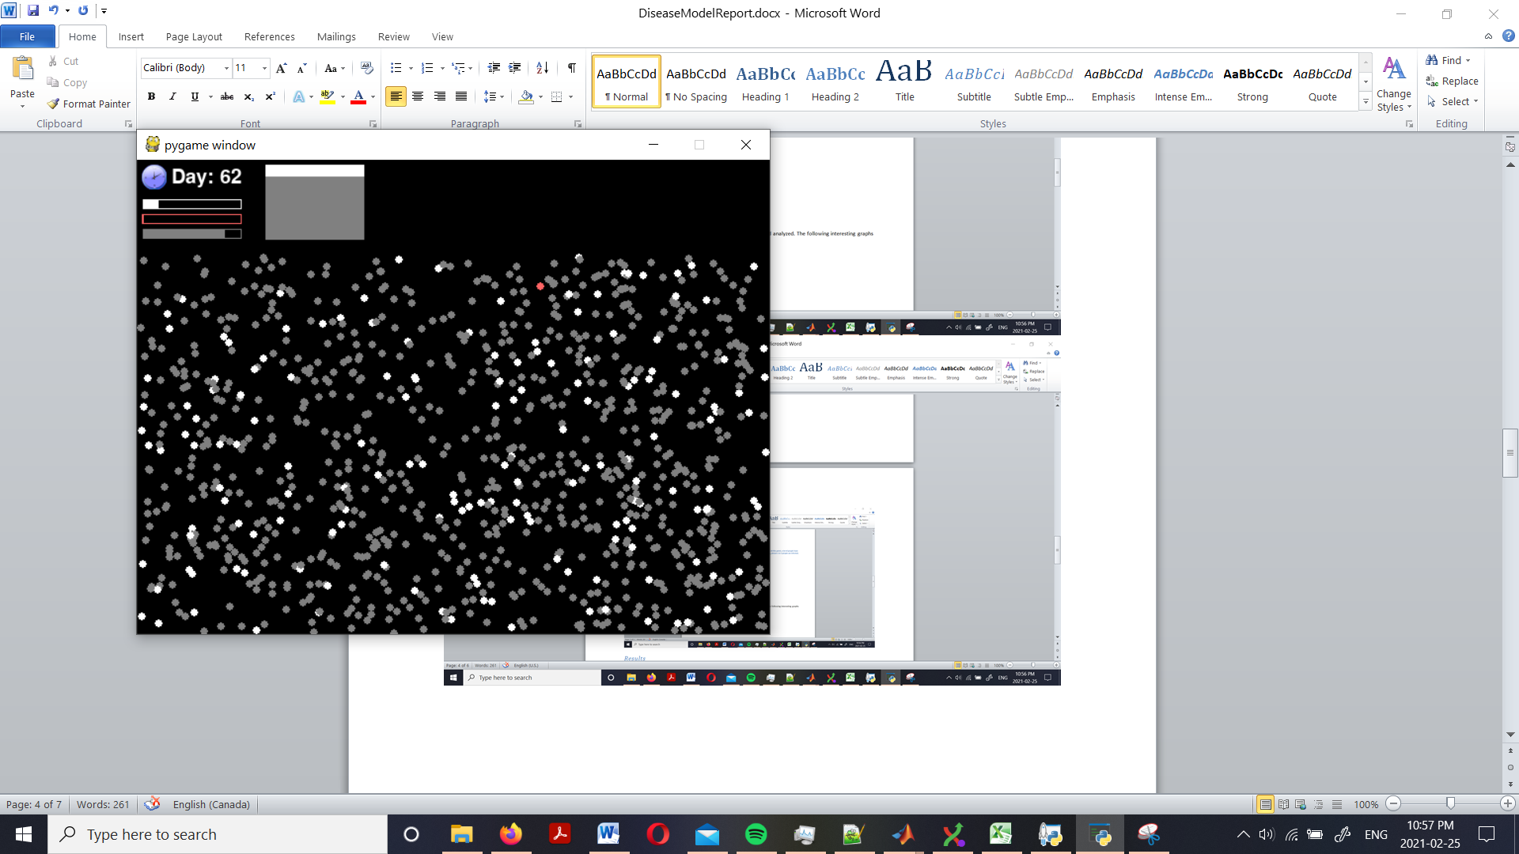

Figure : A snippet from day 63 during the simulation time. Last one!

Results

Data gathered in the simulation was saved in an excel file and analyzed. The following interesting graphs were created. Although this model was quite rudimentary, the data it produced were remarkably similar to those of those tracking the coronavirus pandemic! Note that for “Daily Active Cases”, a bug caused some days to appear as 0. Also note that, no more than 4% of the population were infected on any given day, yet the disease infected nearly 80% of the population.

