|  |  |
| --- | --- |
| Class Code/ Title: | ME975 – Satellite Data Assimilation and Analysis |
| Technical paper title: | Individual Project Report |
| Student Name/ Number: | Jacob Currie – 201718558 |
| Supervisor: | Dr. Annalisa Riccardi |
| Date: | 03/04/2022 |
| Word count: | 2500 |

Abstract

As a result of the COVID-19 lockdown restrictions, public mobility and commercial capacity were severely reduced. As such, the primary emitters of NO2 pollution (vehicles and industrial equipment) were significantly inhibited. This research aims to gather and assimilate satellite-observed NO2 levels across the 12 districts of Scotland, to analyse the trends of pollution levels before, during, and after the lockdown restrictions in the years 2019, 2020, and 2021. The tropospheric NO2 column density was used as the primary parameter in this study, with the population density incorporated to help analyse and draw conclusions from the data. Results are presented both spatially upon maps of the region, and also numerically as annual district averages to allow for comparison. This study found that urban high population density areas exhibited a significant NO2 level reduction, while more remote areas followed a similar trend with variance. Urban areas also showed a return to pre-lockdown NO2 levels, with rural areas much less so, and some very remote areas showing a further decrease in NO2 post-lockdown. In conclusion, while loose general trends of lockdown NO2 decrease are observed, there are complexities involved due to variables outside the scope of this project that are apparent in the results.

Contents

1.0 Introduction 1

1.1 Project Objectives 1

1.2 Background 1

1.3 Scotland’s Districts 1

2.0 Literature review 2

2.1 NO2 Harmful effects 2

2.2 NO2 Sources and Production 2

2.3 Previous Research 2

3.0 Methodology 4

3.1 Data Acquisition 4

3.2 Data Processing 4

3.3 Data Visualisation 4

4.0 Results 5

4.1 Tabulated Results 5

4.2 GEEMAP Visual Results 6

4.3 Visual Results 8

5.0 Discussion 10

6.0 Conclusions 11

6.1 Further Work and Recommendations 11

7.0 References 12

8.0 Appendices 13

8.1 Appendix 1 – Data Acquisition Routine 13

8.2 Appendix 2 – GEEMAP Plotting Routine 15

8.3 Appendix 3 – Traditional Plotting Routine 16

# Introduction

## Project Objectives

The main goal of this project is to assimilate, analyse, and present the NO2 levels before, during, and after the COVID-19 lockdown restrictions across the different districts of Scotland. In addition, the population densities of the districts will also be incorporated to investigate the contribution of this variable to the change in NO2 levels. The results are investigated and discussed, and conclusions drawn.

## Background

It is well established that nitrogen dioxide (NO2) can have a negative effect on the environment and on the human body as a result of contact and exposure. NO2 levels have been both a local and global concern for many decades and have often been a subject of study and analysis, are considered a major component of air pollution and as such, are subject to stringent regulation. Therefore, monitoring NO2 levels around areas with large human population and investigating the effect changes in these levels have on the population as well as the planet and environment, is of great importance.

## Scotland’s Districts

Scotland is split internally into 12 districts that divide the mainland its isles, with each district enclosing a distinct area of the country. The population density and distribution, as well as the geographical and economic nature varies significantly between districts. These districts are visualised below in figure 1, showing each of the district bounds.

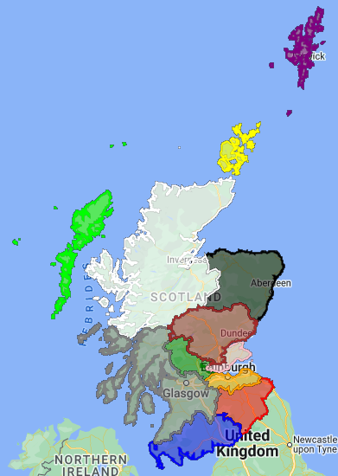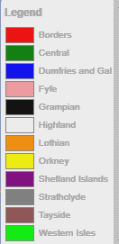

Figure - Scotland's 12 Districts (Colour Coded)

(“Dumfries and Gal” is shorthand for Dumfries and Galloway)

# Literature review

## NO2 Harmful effects

It is well known that exposure and absorption of NO2 is dangerous, harmful, and can lead to health problems, it has also been found that even small variations in the level of NO2 exposure can have a measurable effect on lung and breathing ability[1], and these effects can be observed within hours of exposure[1]. The negative effects have been shown to be lesser for short-term exposure, and subsequently greater for long-term exposure, regardless of the exposure level, which “might be suggestive for a cumulative effect of air pollution exposure”[1].

In addition to causing the above-mentioned issues, NO2 exposure can also exacerbate the negative effects of pre-existing breathing conditions such as asthma, as well as worsen the state of the immune system[2].

Very high levels of exposure, predictably can cause serious and immediate effects, like constriction and inflammation of the airways and lungs. In the long term, high levels of exposure correlates with a risk of pneumonia and bronchitis[3]. External exposure to the skin and body is also dangerous with NO2 exhibiting corrosivity, resulting in chemical burns and irritation[4].

With respect to nature and the environment, NO2 has been shown to be a major contributor the acid rain, as well as limit plant growth[2]. Considering these effects, it is clear that NO2 levels have a direct effect on the health of the environment, and also on the efficiency of agriculture. NO2 is also responsible for reducing visibility in the atmosphere[2].

## NO2 Sources and Production

NO2 is present through natural sources like, volcanic eruptions, and as a product of bacteria. However, NO2 is most prominently produced as a result of internal combustion engines found in vehicles and industrial equipment[2]. It is generally produced through combustion, with notable domestic sources being smoking, and gas cookers. As a result, strict regulations have been placed on NO2 production and exposure. Notably, the introduction and requirement of catalytic converters to the exhaust systems of internal combustion engines, these devices help to limit the amount of NO2 released[5], as part of the vehicle pollution emissions standards. The accumulation of NO2 around centres of population is also subject to regulation with the city of Glasgow, looking to introduce a “Low Emissions Zone” in 2023, allowing only certain vehicles into the city in order to limit pollution and improve air quality[6]. Similar types of schemes have been implemented with success in other cities, such as the well-known “ULEZ” in London.

## Previous Research

Research into studying and tracking the air quality levels in the USA from the mid 2000’s has shown a continuous decrease in NO2 levels among other pollutants, directly correlated to a reduction on emissions[7]. Research similar to this project has also been conducted on a global scale, and found that, during COVID-19 lockdowns, air quality increased and NO2 levels dropped by a significant level[8]. In addition, combustion emissions also decreased by 30% during the initial lockdowns[9].

It has also been observed the both satellite and ground based measurements show similar trends of increased air quality during the lockdown restrictions[8]. Importantly, countries that did not have somewhat strict lockdown protocols, with short lockdown durations and light travel restrictions, did not experience a significant reduction in NO2 and emissions[8].

The source of the COVID-19 outbreak, China, imposed strict lockdowns for an extended period of time, this resulted in a 48% reduction in tropospheric NO2 around the 2020 Chinese new year[8]. On a more global scale, NASA tropospheric NO2 observations, measured via solar radiation backscattering, have indicated a global average reduction of 16.5%[8].

A similar study analysing both the tropospheric NO2 and surface NO2 levels around the affluent and high-density urban, Île-de-France region of France, found that both quantities dropped significantly during lockdown restrictions, and continued to remain at a lower level, before increasing after restrictions were lifted[10]. Figure 2 below from the study shows the NO2 level trends over lockdowns.

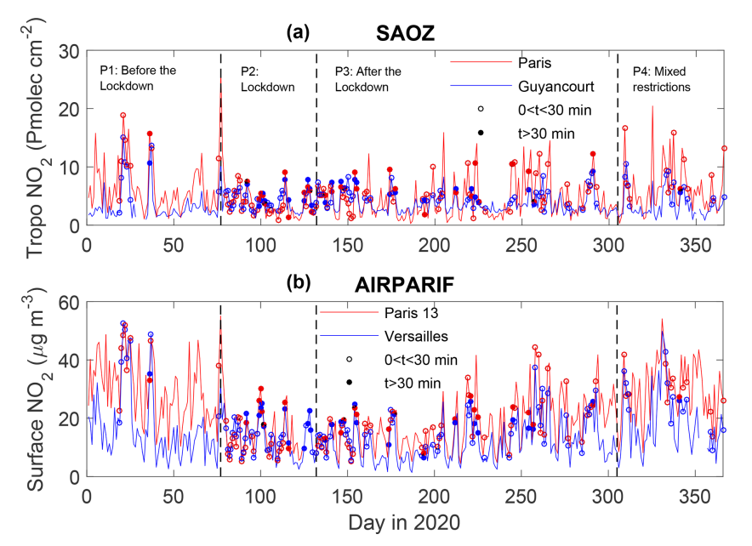

Figure - Parisian Urban Area Tropospheric (a) and Surface (b) NO2 measurements over 2020

The significant spike at the start of lockdown restrictions, around day 75, is attributed to a large number of residents leaving the area. Also of importance, and noted as a cause of the fluctuations in the data, is wind speed and direction. This unaccounted-for variable is thought to add noise to the data, and may be responsible for inaccurate trends.

# Methodology

## Data Acquisition

Google Earth Engine (GEE)[11] was used to gather all the data used in this project, implemented using the GEE API library in Python. The tropospheric NO2 column density data was acquired from the Sentinal-5P mission, part of the Copernicus Earth atmospheric monitoring programme. The population data was acquired from the Global Human Settlement Layers[12] dataset, taking the latest population data from 2015. The information regarding the land area and district bounds of Scotland was also used, and acquired from the Global Administrative Unit Layers 2015, provided by the Food and Agriculture Organisation of the United Nations. All of these datasets were available through GEE.

A per-district approach was adopted for the acquisition of the data presented in this report, after the initial acquisition of the above-mentioned data for the country, each district was considered, with the NO2 data and population density calculated for each. This per-district routine was repeated for each of the three years considered, with the exception of population density.

## Data Processing

To calculate comparable, numerical values from GEE images and features, for NO2, the temporal mean NO2 data for the year was then reduced, taking the spatial mean over the district geometry. The population density was calculated by summing the population of the district area, and dividing by the district area.

The implementation of the data acquisition and processing routine is included in appendix 1.

## Data Visualisation

The visualisation of the gathered data was completed using two methods. Spatial representation of the data was done using “Geemap”, a Google maps style plotting library that integrate with GEE, also implemented in Python. The NO2 and population data were visualised on a country map, in order to analyse the data and gain a deeper understanding of the distribution of the data.

The data was also presented using traditional bar charts and graphs, to analyse the trends in the data and draw conclusions. This was also implemented in Python using the well-known “matplotlib” plotting library.

The Geemap plotting routine as well as the traditional data plotting routine are included in appendices 2 and 3 respectively.

# Results

## Tabulated Results

Below is table 1 presenting the results of the project, containing the tropospheric NO2 column data (mol/m2) for 2019, 2020 and 2021, alongside the population density (million/km2) of each district.

|  |  |  |  |  |
| --- | --- | --- | --- | --- |
| **District** | **2019** | **2020** | **2021** | **Pop Density** |
| Borders | 2.212200855E-05 | 2.071604413E-05 | 2.210136053E-05 | 2.492891778E-05 |
| Central | 2.360914472E-05 | 2.184295374E-05 | 2.207590961E-05 | 1.146326761E-04 |
| Dumfries and Gal | 2.292020575E-05 | 2.083828331E-05 | 2.021583591E-05 | 2.341379914E-05 |
| Fyfe | 2.996572421E-05 | 2.717796303E-05 | 3.007716876E-05 | 2.722375961E-04 |
| Grampian | 1.743806949E-05 | 1.864453226E-05 | 1.932079040E-05 | 6.604844414E-05 |
| Highland | 1.612390919E-05 | 1.539286517E-05 | 1.439016461E-05 | 8.820244062E-06 |
| Lothian | 2.978613520E-05 | 2.552130051E-05 | 3.158178579E-05 | 4.746136197E-04 |
| Orkney | 1.259106590E-05 | 1.227162059E-05 | 1.173165661E-05 | 2.075699127E-05 |
| Shetland Islands | 1.215015471E-05 | 9.723056187E-06 | 1.030521185E-05 | 1.211150336E-05 |
| Strathclyde | 2.203403884E-05 | 2.049074295E-05 | 2.027674558E-05 | 1.582811020E-04 |
| Tayside | 1.916083731E-05 | 1.981541990E-05 | 1.962062230E-05 | 5.212350783E-05 |
| Western Isles | 1.271783014E-05 | 1.071772942E-05 | 1.070616399E-05 | 8.524820131E-06 |

Table - Tropospheric NO2 levels and Population Density across Scotland's Districts

## GEEMAP Visual Results

The population distribution across Scotland is presented below in figure 3, observing the data, it can be seen that the vast majority of the population reside in the central belt, where the largest cities and capital city can be found. As expected, dense hotspots are seen around large towns and cities. The vast uninhabited areas can be attributed to the geography of the land, with a large portion of the unpopulated, white regions of the map home to steep mountains and harsh landscapes, that have little opportunity as urban centres.

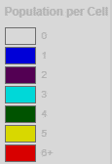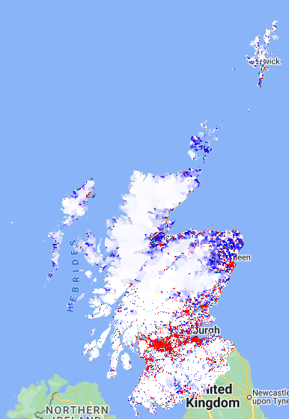

Figure - Scotland Population Distribution (2015)

The NO2 column density maps for 2019, 2020 and 2021 are shown below in figures 4, 5 and 6 respectively.

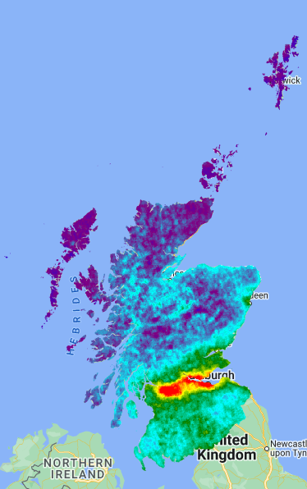 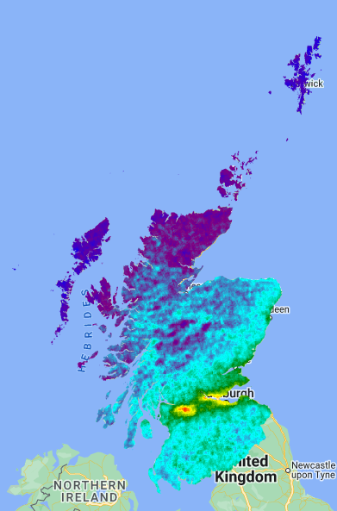

Figure – 2019 tropospheric NO2 Map Figure – 2020 tropospheric NO2 Map

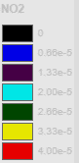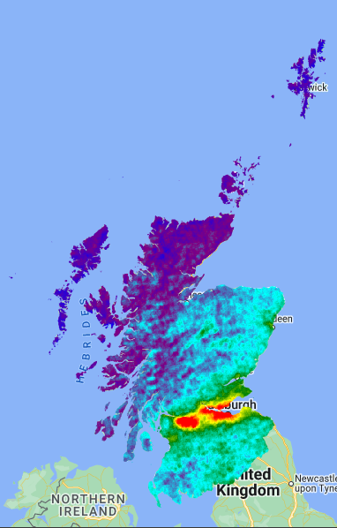

Figure - 2021 tropospheric NO2 Map

## Visual Results

Below, figure 7 presents the numerical annual average NO2 values for each district over the considered years. The districts are also sorted from left to right, in order of ascending population density.

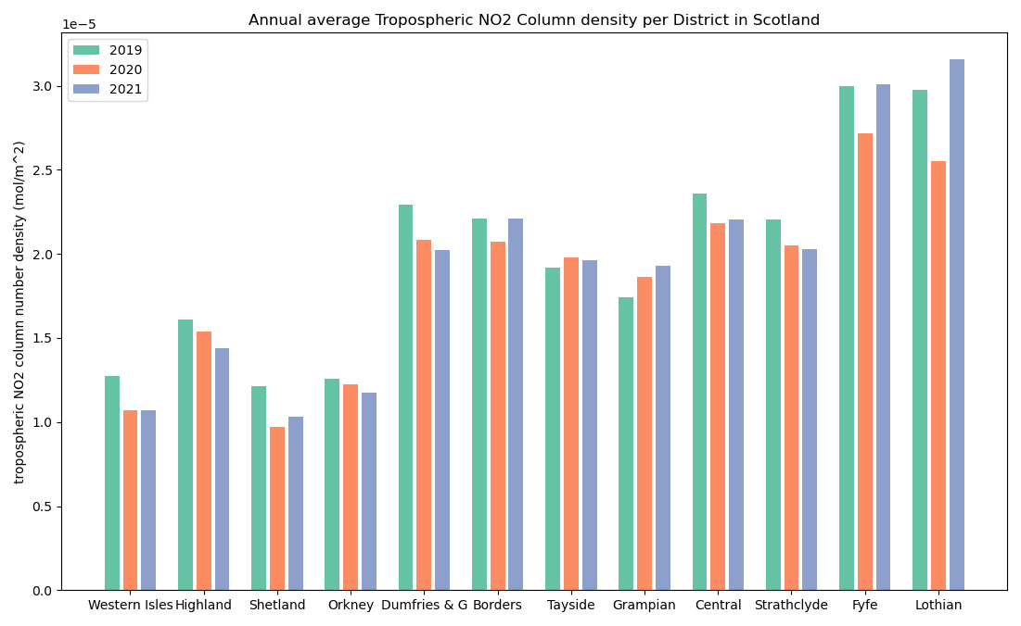

Figure - Annual average NO2 per District in Scotland

Below, figure 8 represents the same data presented in figure 7, in a different format, showing the per-year NO2 levels for each district.

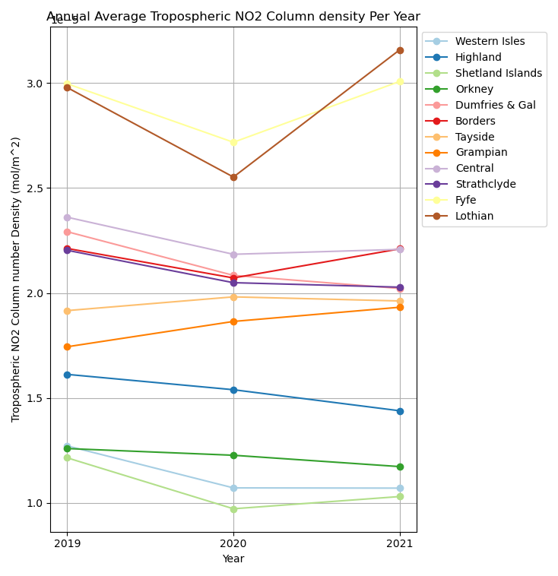

Figure - Annual Average NO2 per Year for each District in Scotland

# Discussion

Observing the 2019 and 2021 map plots (figure 4 and 6), as reference of a time period that can be consider somewhat “normal”, clear hotspots of NO2 are seen around the central areas of Glasgow and Edinburgh, the largest cities in Scotland, in the Strathclyde and Lothian districts respectively. The central belt (Central, Fyfe, Lothian, and Tayside districts) has a general trend of moderate NO2 levels, while the Highland, Grampian, and Island districts show lower levels. All of which correlate well with the population distribution. Observing the 2020 map (figure 5), it is clear that the central belt areas have a significant reduction in NO2, with the whole country also showing this general trend to a lesser extent. This is most likely due to the very high population density of the central districts, as this is by far where the majority of NO2 pollution from vehicles and equipment are emitted, since the lockdown restrictions severely inhibited travel and hindered commercial productivity, there is a clear correlation between the two.

Considering the average changes between 2020 and 2021 (figure 7 and 8), while the majority of low population density districts show a very small change in NO2 level (while some show an increase), The two densest districts (Fyfe and Lothian) show a significant increase in NO2 level, this is most likely due to the public eager to return to normal life, with the use of vehicles and commercial equipment surging as citizens attempt to reintegrate. This may also be attributed to the economical size of the districts, as they possess greater capacity to return to their former economical and industrial output. This trend of “bounce-back” is also observed in figure 6 in the Strathclyde district, however only around the city of Glasgow, which shows a similar increase in NO2 levels. This Grampian district increase is not reflected in the numerical averages in figure 7, this may be due to the large size of the district, as the NO2 increase was mostly around the city.

Observing figure 7, there is a clear proportional trend between population density and NO2. Notably, only two districts (Tayside and Grampian) show an increase in NO2 from 2019 to 2020. Observing the decrease in NO2 levels from 2019 to 2020, there is a loose relationship between population density and NO2 decrease, such that areas with greater density experience a greater decrease. This agrees with the literature, showing that urban areas of high density are home to significantly higher NO2 levels (a trait apparent in figure 4 and 6 also).

Interestingly, the remote, low-density districts (Western Isles, Highlands, Orkney), all show a further decrease in NO2 levels after lockdown restrictions into 2021. This may be due to the fact that the lockdowns severely inhibited tourism and forced many businesses to close, and citizens to relocate. The exception to this is Shetland, which sees a slight increase in NO2 in 2021, although this may possibly be explained by its remote location, as the easing of restrictions would allow for the reopening of shipping routes to and around Scandinavia, owing to an increase in NO2 around the northern region. This is further supported by the fact that Norway is a major oil exporter.

The Grampian district, home to the city of Aberdeen, shows an increase in NO2 levels across both 2020 and 2021, which may be due to affluent citizens relocating to the area, in an attempt to reach areas with fewer and more relaxed restrictions, and also due to Aberdonian citizens returning home from the central belt as their occupation had been disrupted.

# Conclusions

The conclusions of this project are summarised below.

* Overall, districts with the highest population density, showed the biggest reduction in NO2 levels due to lockdown restrictions, with districts that are inherently biased with large dense cities, and small overall size, showing significant decrease in 2020, and subsequent increase in 2021.
* Remote, low-density districts show generally a decrease in NO2 in 2020, and a further decrease in 2021, possible due to the closure of businesses and the relocation of citizens.
* The Grampian district goes against the general trend of lockdown NO2 reduction, showing an increase in NO2 in 2020, possibly due to relocation of citizens into the area.
* Extra urban areas (cities in Strathclyde, Fyfe and Lothian) are show a very significant increase in NO2 levels in 2021, to levels the same or higher than in 2019, most probably due to the immense reintegration of citizens back to a more normal and social lifestyle.
* In terms of the spatial NO2 levels shown on the map plots, an overall significant reduction of NO2 levels is observed country-wide in 2020, due to the lockdown severely limiting mobility and travel using NO2 emitting vehicles. Showing that lockdowns do improve air quality, especially in urban areas.
* There is no clear trend across all districts regarding NO2 level reduction in 2020, or NO2 increase in 2021, inferring that many other variables are contributing to the pollution production.
* Shetland is an exception to the trend of low-density districts showing an increase in NO2 in 2021 post-lockdown, possibly due to the reopening of shipping routes nearby.
* Districts that lie between geographic descriptions of urban and remote, home to towns and small villages (Central, Borders, Dumfries and Galloway) all show decreases in NO2 during 2020, but have no clear trend for NO2 levels in 2021.

## Further Work and Recommendations

While this project has been successful in identifying the trends of NO2 levels across the districts of Scotland in 2019 (pre-COVID-19), 2020 (lockdown restrictions), and 2021 (lockdown easing), there is clearly more research possibilities on the subject.

To improve the accuracy of the results, it would be of great benefit to analyse the data at a much finer scale, taking a closer look at urban and remote areas, as well as areas which do not follow any trend. Also beneficial would be the analysis of data in better defined timescales, for example, during each stage of the lockdown restrictions, or on a monthly interval. Furthermore, the inclusion of more variables such as wind conditions, the movement and mobility of the population during the lockdown restrictions, and sites of significant localised NO2 emission (refineries, factories, areas of high congestion) is recommended. Finally, a comparison between satellite-based, and ground-based NO2 observations would be highly beneficial.

# References

[1] L. Int Panis *et al.*, “Short-term air pollution exposure decreases lung function: a repeated measures study in healthy adults,” *Environ. Health*, vol. 16, no. 1, p. 60, Jun. 2017, doi: 10.1186/s12940-017-0271-z.

[2] Environmental Protection Agency United States, “Nitrogen Dioxide (NO2) Pollution,” *EPA*. https://www.epa.gov/no2-pollution (accessed Apr. 05, 2022).

[3] Environmental Protection Agency United States, “Integrated Science Assessment for Oxides of Nitrogen—Health Criteria,” 2016. doi: 10.1163/9789004313507_012.

[4] PubChem, “PubChem National Library of Medicine - Nitrogen Dioxide.” https://pubchem.ncbi.nlm.nih.gov/compound/nitrogen dioxide.

[5] J. Kašpar, P. Fornasiero, and N. Hickey, “Automotive catalytic converters: Current status and some perspectives,” *Catal. Today*, vol. 77, no. 4, pp. 419–449, 2003, doi: 10.1016/S0920-5861(02)00384-X.

[6] City Council Glasgow, “Glasgow City Council - LEZ.” https://www.glasgow.gov.uk/LEZ.

[7] R. F. Silvern *et al.*, “Using satellite observations of tropospheric NO2 columns to infer long-term trends in US NOx emissions: The importance of accounting for the free tropospheric NO2 background,” *Atmos. Chem. Phys.*, vol. 19, no. 13, pp. 8863–8878, 2019, doi: 10.5194/acp-19-8863-2019.

[8] S. Yoo and S. Managi, “Lockdowns save people from air pollution: Evidence from daily global tropospheric no2 satellite data,” *Sustain.*, vol. 13, no. 21, 2021, doi: 10.3390/su132111777.

[9] P. M. Forster *et al.*, “Current and future global climate impacts resulting from COVID-19,” *Nat. Clim. Chang.*, vol. 10, no. 10, pp. 913–919, 2020, doi: 10.1038/s41558-020-0883-0.

[10] A. Pazmiño *et al.*, “Impact of the COVID-19 pandemic related to lockdown measures on tropospheric NO2 columns over Île-de-France,” *Atmos. Chem. Phys.*, vol. 21, no. 24, pp. 18303–18317, 2021, doi: 10.5194/acp-21-18303-2021.

[11] Google, “Google Earth Engine.” https://earthengine.google.com/.

[12] European Commission, “Global Human Settlement Layer.” https://ghsl.jrc.ec.europa.eu/index.php.

# Appendices

## Appendix 1 – Data Acquisition Routine

GEE initial setup

#Inital Setup

!pip install geemap

!earthengine authenticate

import ee

import geemap.eefolium

import pprint as pp

import matplotlib.pyplot as plt

ee.Initialize()

Main data acquisition routine

#Main Script

DistrictNamesList = ['Borders', 'Central', 'Dumfries and Gal', 'Fyfe', 'Grampian', 'Highland', 'Lothian', 'Orkney', 'Shetland Islands', 'Strathclyde', 'Tayside', 'Western Isles'] #List of the level2 District Names

NO2_2019List = [] #Empty lists for storing per-district data

NO2_2020List = []

NO2_2021List = []

PopDensList = []

Scotland_Bounds = ee.FeatureCollection("FAO/GAUL/2015/level2").filterMetadata('ADM1_NAME', 'equals', 'Scotland') #Getting Scotland District Bounds

Population_Data = ee.Image("JRC/GHSL/P2016/POP_GPW_GLOBE_V1/2015").select('population_count').clip(Scotland_Bounds.geometry()) #Getting Population data

NO2_Data = ee.ImageCollection("COPERNICUS/S5P/OFFL/L3_NO2").filterBounds(Scotland_Bounds.geometry()) #Getting total NO2 data

NO2_2019 = NO2_Data.filterDate('2019-01-01', '2019-12-31').mean().select(['tropospheric_NO2_column_number_density']).clip(Scotland_Bounds.geometry()) #Per-Year mean NO2 column density image clipped to Scotland

NO2_2020 = NO2_Data.filterDate('2020-01-01', '2020-12-31').mean().select(['tropospheric_NO2_column_number_density']).clip(Scotland_Bounds.geometry())

NO2_2021 = NO2_Data.filterDate('2021-01-01', '2021-12-31').mean().select(['tropospheric_NO2_column_number_density']).clip(Scotland_Bounds.geometry())

for District in DistrictNamesList: #For every district - calling .getInfo() inside loop - inefficient but it works

  District_Bounds = Scotland_Bounds.filterMetadata('ADM2_NAME', 'equals', District).geometry() #Getting level2 district data

  NO2_2019List.append(NO2_2019.reduceRegion(**{'geometry': District_Bounds, 'reducer': ee.Reducer.mean(),'scale': 1000,}).getInfo()['tropospheric_NO2_column_number_density']) #NO2 value for each district

  NO2_2020List.append(NO2_2020.reduceRegion(**{'geometry': District_Bounds, 'reducer': ee.Reducer.mean(),'scale': 1000,}).getInfo()['tropospheric_NO2_column_number_density']) #per-year NO2 value (reduce over region)

  NO2_2021List.append(NO2_2021.reduceRegion(**{'geometry': District_Bounds, 'reducer': ee.Reducer.mean(),'scale': 1000,}).getInfo()['tropospheric_NO2_column_number_density'])

  PopSize = Population_Data.reduceRegion(**{'geometry': District_Bounds, 'reducer': ee.Reducer.sum(), 'scale': 250, 'maxPixels':1e9})  #Getting total population size per district (reduce over region)

  PopDensList.append(PopSize.getInfo()['population_count']/ District_Bounds.area().getInfo()) #Calculating population density per district {=total population / district area}

for i in range(len(DistrictNamesList)): #PRINTING RESULTS TO CONSOLE - for each district - printing NO2 and population density

  print('District: '+DistrictNamesList[i])

  print('(mol/m^2) 2019 NO2: '+str(round(NO2_2019List[i],12))+' //2020 NO2: '+str(round(NO2_2020List[i],12))+' //2021 NO2: '+str(round(NO2_2021List[i],12))+' //Population Density: '+str(PopDensList[i]))

  print('---------------------')

## Appendix 2 – GEEMAP Plotting Routine

#Geemap Mapping Script

#Some lines may be commented in and out to view only certain results/legends - Colab wont let Map go fullscreen

#plotting options

NO2_viz = {'min': 0, 'max': 0.00004, 'palette': ['black', 'blue', 'purple', 'cyan', 'green', 'yellow', 'red']}

Pop_viz = {'min': 0, 'max': 6, 'palette': ['white', 'blue', 'purple', 'cyan', 'green', 'yellow', 'red']}

colors = ['red', 'green', 'blue', 'pink', 'black', 'white', 'orange', 'yellow', 'purple', 'gray', 'brown', 'lime']

#Making Geemap + layers

Map = geemap.Map(center=[57.404790, -4.304002], zoom=6) #creating map

Map.addLayer(Population_Data, Pop_viz, 'Population')  #population map

Map.addLayer(NO2_2019, NO2_viz, 'NO2 2019')

Map.addLayer(NO2_2020, NO2_viz, 'NO2 2020') #No2 maps

Map.addLayer(NO2_2021, NO2_viz, 'NO2 2021')

Map.addLayer(Scotland_Bounds, {}, 'Bounds') #district bounds

Map.addLayerControl()

import matplotlib.colors as cl #color to hexadecimal method needed from library for legend dictionaries

boundslegend_dict = {} #Creating district bounds legend with colours

for i in range(len(DistrictNamesList)):

  boundslegend_dict[DistrictNamesList[i]] = cl.to_hex(colors[i])

#creating NO2 legend dictionary with colours

no2legend_dict = {'0':cl.to_hex('black'), '0.66e-5':cl.to_hex('blue'), '1.33e-5':cl.to_hex('purple'), '2.00e-5':cl.to_hex('cyan'), '2.66e-5':cl.to_hex('green'), '3.33e-5':cl.to_hex('yellow'), '4.00e-5':cl.to_hex('red')}

#creating population legend dictionary with colours

poplegend_dict = {'0':cl.to_hex('white'), '1':cl.to_hex('blue'), '2':cl.to_hex('purple'), '3':cl.to_hex('cyan'), '4':cl.to_hex('green'), '5':cl.to_hex('yellow'), '6+':cl.to_hex('red')}

Map.add_legend('Legend', boundslegend_dict) #adding legends to Map

Map.add_legend('Population per Cell', poplegend_dict)

Map.add_legend('NO2', no2legend_dict)

for i in range(len(DistrictNamesList)): #Adding District bounds coloured layers to Map

  District_Bounds = Scotland_Bounds.filterMetadata('ADM2_NAME', 'equals', DistrictNamesList[i])

  Map.addLayer(District_Bounds.geometry(), {'color': colors[i]}, DistrictNamesList[i])

Map #Display Map

## Appendix 3 – Traditional Plotting Routine

#ME975 - Assignment - Jacob Currie - 201718558

#---------------------------------------------

#Plotting/Graphing Script

import matplotlib.pyplot as plt

import numpy as np

#hardcoded arrays of input data taken from google colab variables

DistrictNamesList = ['Borders', 'Central', 'Dumfries & Gal', 'Fyfe', 'Grampian', 'Highland', 'Lothian', 'Orkney', 'Shetland Islands', 'Strathclyde', 'Tayside', 'Western Isles']

Data2019 = [2.2122008554262085e-05,2.3609144718329626e-05,2.2920205749643354e-05,2.996572421056435e-05,1.7438069491396237e-05,1.6123909193907615e-05,

            2.978613519760064e-05,1.2591065901324445e-05,1.2150154708114013e-05,2.2034038841374178e-05,1.916083730769428e-05,1.2717830142645274e-05]

Data2020 = [2.0716044129793837e-05,2.184295374201366e-05,2.0838283314443245e-05,2.7177963032354258e-05,1.8644532261182567e-05,1.5392865174184957e-05,

            2.5521300512970897e-05,1.227162058641417e-05,9.72305618677271e-06,2.04907429503703e-05,1.9815419902427874e-05,1.0717729418158482e-05]

Data2021 = [2.210136053056543e-05,2.207590961163332e-05,2.0215835905095158e-05,3.0077168762210414e-05,1.9320790396829416e-05,1.439016460944674e-05,

            3.158178579266714e-05,1.1731656606566475e-05,1.0305211852537112e-05,2.0276745580832056e-05,1.9620622300899496e-05,1.0706163989725942e-05]

LegendLabels = ['2019', '2020', '2021']

PopDensity = [2.49289177832715e-05,0.00011463267606779667,2.3413799137766673e-05,0.0002722375960673222,6.604844414118531e-05,8.820244062438711e-06,

            0.0004746136196991526,2.0756991266692525e-05,1.2111503364635487e-05,0.00015828110200027238,5.21235078302237e-05,8.524820130842963e-06]

sortIndex = np.argsort(PopDensity)  #Getting sorted list indices for population density

def argSort(data, indices): #sort list with given list or indices

    newList = []

    for i in indices:

        newList.append(data[i])

    return newList

#Creating sorted lists (SORTED BY ASCENDING POPULATION DENSITY)

PopDensitySorted = argSort(PopDensity, sortIndex)

Data2019Sorted = argSort(Data2019, sortIndex)

Data2020Sorted = argSort(Data2020, sortIndex)

Data2021Sorted = argSort(Data2021, sortIndex)

DistrictsSorted = argSort(DistrictNamesList, sortIndex)

#Saving to Excel doc

import xlwt

W = xlwt.Workbook()

Ws = W.add_sheet("Results")

Ws.write(2,1,"District")

Ws.write(3,1,"2019")

Ws.write(4,1,"2020")

Ws.write(5,1,"2021")

Ws.write(6,1,"Pop Density")

for i in range(0, len(DistrictNamesList)):

    Ws.write(2, i + 2, DistrictNamesList[i])

    Ws.write(3, i + 2, Data2019[i])

    Ws.write(4, i + 2, Data2020[i])

    Ws.write(5, i + 2, Data2021[i])

    Ws.write(6, i + 2, PopDensity[i])

Wa = W.add_sheet("Results2")

Wa.write(1,2,"District")

Wa.write(1,3,"2019")

Wa.write(1,4,"2020")

Wa.write(1,5,"2021")

Wa.write(1,6,"Pop Density")

for i in range(0, len(DistrictNamesList)):

    Wa.write(i + 2,2, DistrictNamesList[i])

    Wa.write(i + 2,3, Data2019[i])

    Wa.write(i + 2,4, Data2020[i])

    Wa.write(i + 2,5, Data2021[i])

    Wa.write(i + 2,6, PopDensity[i])

#W.save("Result.xls")

N = len(DistrictNamesList)  #bar chart spacing

xIndex = np.arange(N) * 4

def NO2_Plot(data, labels): #Bar chart plotting function

    f1, ax = plt.subplots()

    c=['#66c2a5', '#fc8d62', '#8da0cb'] #Colours - colourblind safe and pretty

    for j in range(len(data)):

        ax.bar(xIndex + j, data[j], color=c[j])

    ax.set_xticks(xIndex + 1)

    ax.set_xticklabels(labels)

    ax.legend(LegendLabels)

    ax.set_ylabel('tropospheric NO2 column number density (mol/m^2)')

    ax.set_title('Annual average Tropospheric NO2 Column density per District in Scotland')

rawData = [Data2019, Data2020, Data2021] #combine data

NO2_Plot(rawData, DistrictNamesList)    #plot data

rawDataSorted = [Data2019Sorted, Data2020Sorted, Data2021Sorted]  #sorted

NO2_Plot(rawDataSorted, DistrictsSorted)    #sorted plot

def NO2_Line():  #NO2 Line graph Function

    f1, ax = plt.subplots() #colours - not colourblind safe but prettier

    c = ['#a6cee3','#1f78b4','#b2df8a','#33a02c','#fb9a99','#e31a1c','#fdbf6f','#ff7f00','#cab2d6','#6a3d9a','#ffff99','#b15928']

    DistrictData = []

    for i in range(len(Data2019)):

        DistrictData.append([Data2019Sorted[i], Data2020Sorted[i], Data2021Sorted[i]])

    for i in range(len(DistrictsSorted)):

        ax.plot([2019, 2020, 2021], DistrictData[i], '-o', color=c[i])

    ax.set_xticks([2019,2020,2021])

    ax.legend(DistrictsSorted, bbox_to_anchor=(1,1), loc="upper left")

    ax.grid()

    ax.set_xlabel('Year')

    ax.set_ylabel('Tropospheric NO2 Column number Density (mol/m^2)')

    ax.set_title('Annual Average Tropospheric NO2 Column density Per Year')

NO2_Line()  #plotting line graph

plt.show()  #show plots

The Python notebook for this project can be accessed here:

<https://colab.research.google.com/drive/1dWSuVb0RWjbVODfLYaI6vP_aJPNurh_e?usp=sharing>