Fleet fuel efficiency and price variance
  - DA E01 analytical summary
January to June 2025 operations. Revised operational view with separately identified retrospective market context.
The fleet achieves 8.21 MPG over matched measurement intervals. The decision is where evidence supports further investigation: purchased fuel, ECU consumption and tank stock are reconciled separately before efficiency or price differences are interpreted.
Measure | Result | Definition
Scope | 3 tenants / 30 vehicles | 810 vehicle-week rows
Paired distance | 219,385.5 km | Accepted common intervals
Paired ECU fuel | 62,852.7 L | Consumption, not purchases
Fleet efficiency | 8.21 MPG | Ratio of summed distance and fuel
Time coverage | 99.95% | Valid paired / expected seconds
Net fuel purchases | US$76,856.05 | Comparable transaction amount

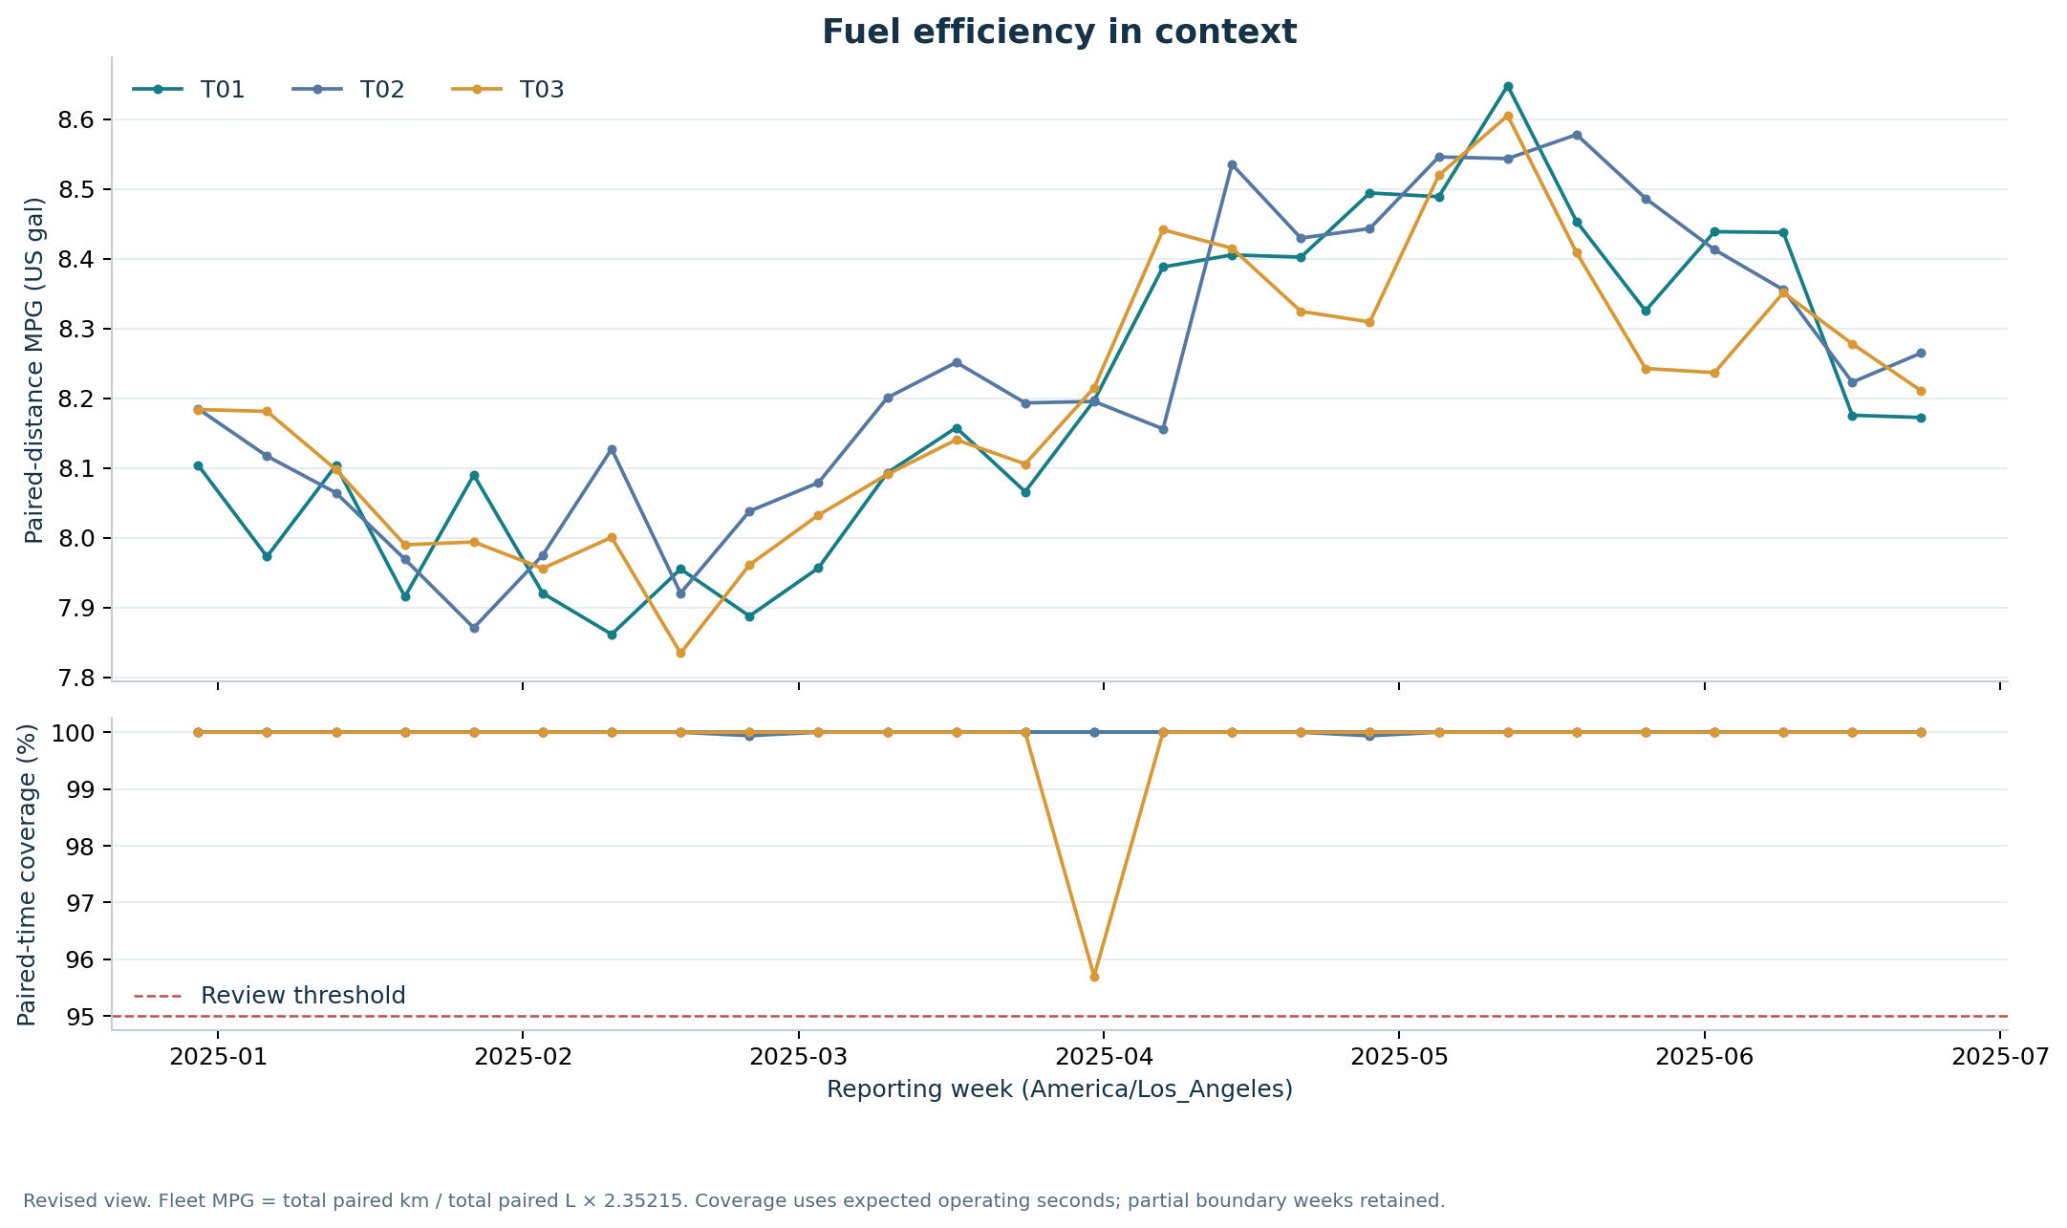
All fleet operations and follow-up cases are synthetic. Actual EIA observations are independent public background. These results demonstrate reproducible scenario analysis, not verified customer savings or production fleet performance.

Separate price effects from operating changes
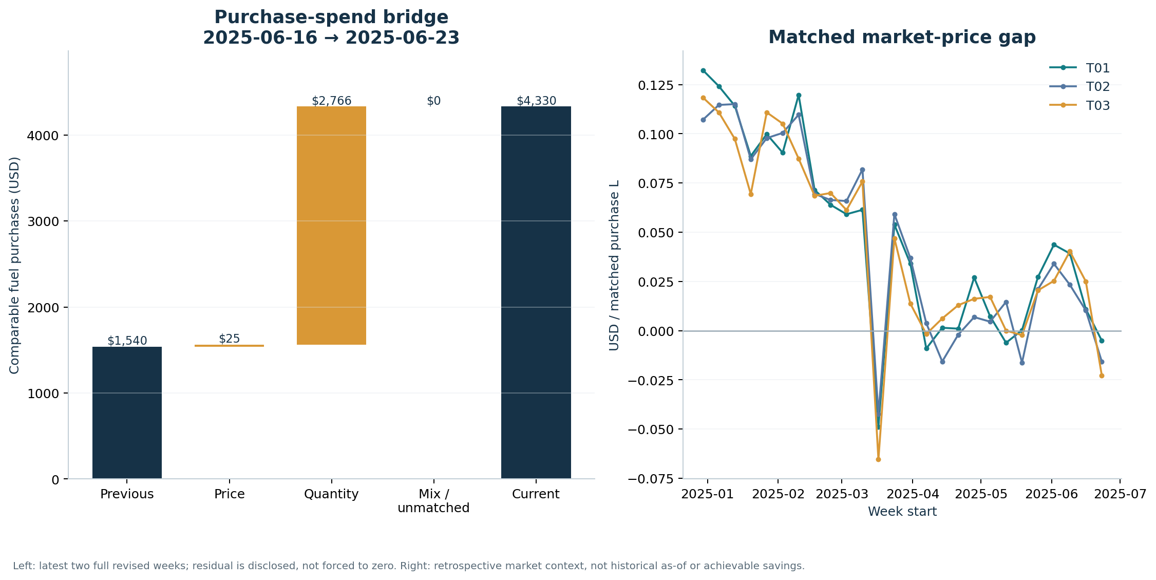
Between the full weeks starting 2025-06-16 and 2025-06-23, comparable purchases change from US$1,539.67 to US$4,330.44. The price effect is US$24.59, the quantity effect is US$2,766.18, and the disclosed residual is US$0.00.
Fuel spending does not establish the cost of fuel consumed during the same week. Retrospective regional market gaps are reference comparisons; they are not executable offers or realizable savings.

Qualify comparisons before selecting cases
The revised view identifies 1 vehicle-week below the coverage threshold and 156 without an eligible peer baseline. Task-specific peer rules flag 1 vehicle-week; price rules flag 17. Reasons may overlap.
Peers share tenant, vehicle class, task and week. Eligible comparisons need at least three other vehicles and 95% coverage. An intensity at least 20% above the eligible peer median calls for load, PTO and route review; it does not prove waste.
Inventory provides a second measurement path. Of 810 windows, 776 reconcile within stated measurement uncertainty. The remaining states preserve missing ECU intervals, uncalibrated boundaries, incomplete movements and cases needing coverage or balance investigation.
Use the offline dashboard for vehicle-week and task-level drilldown. Preserve unknown values and non-operating exposure rather than converting either into zero efficiency.

Follow adoption through comparable evidence
The exercise includes 8 review cases. Only 3 pass the maturity, task and coverage checks for descriptive follow-up comparison. Rejected, unobserved, immature and lost cases retain their own states.
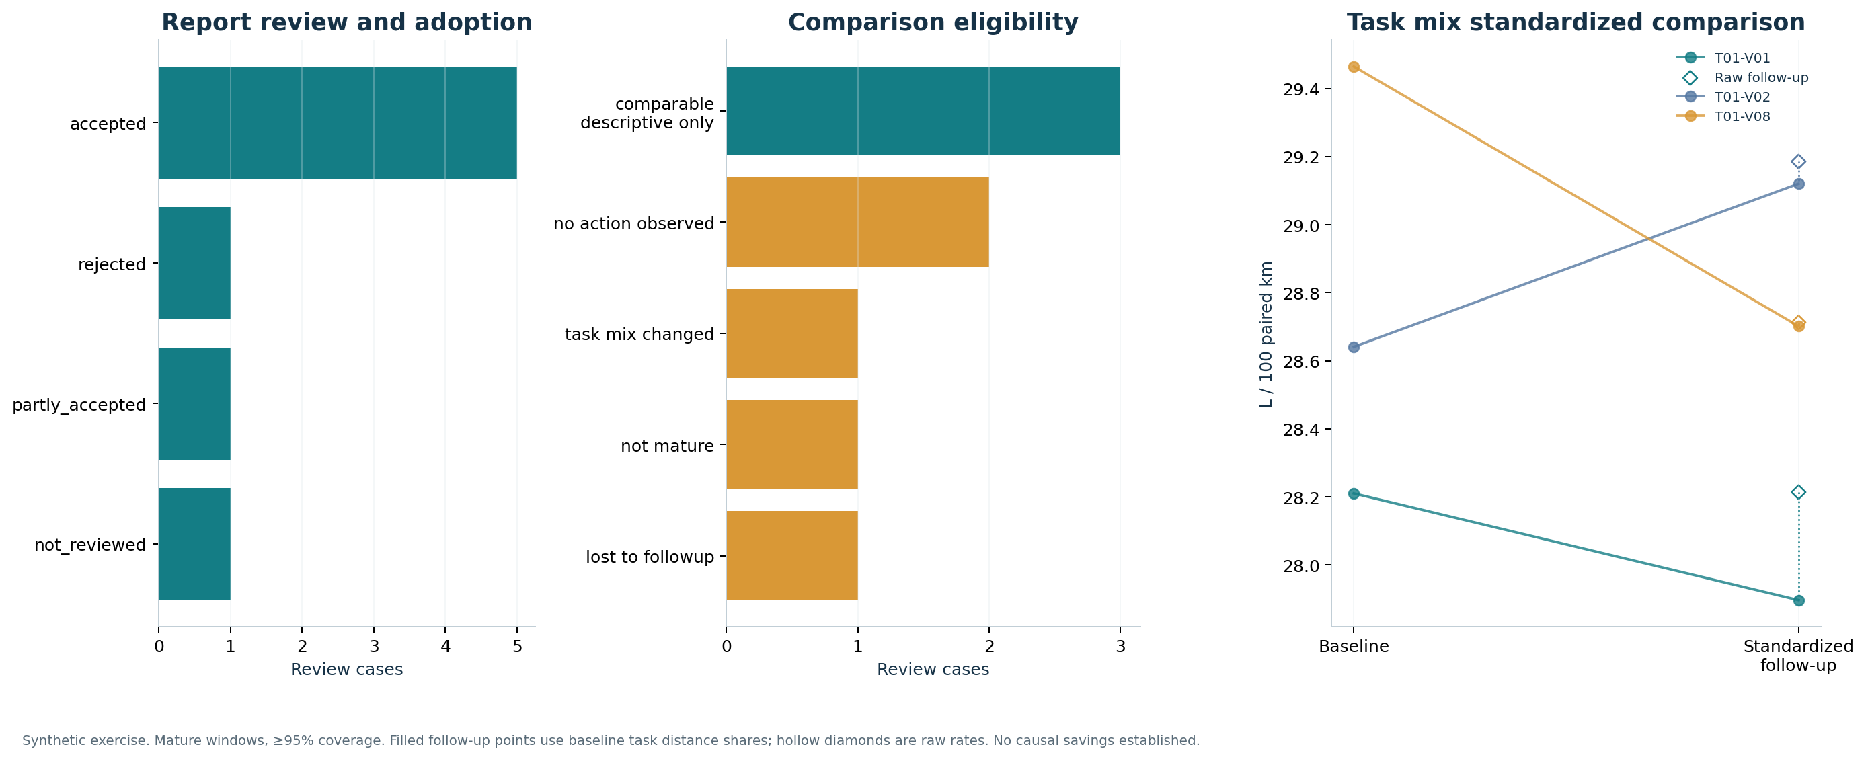
Vehicle | Baseline | Raw follow-up | Standardized | Change
T01-V01 | 28.21 | 28.21 | 27.90 | -0.31
T01-V02 | 28.64 | 29.19 | 29.12 | +0.48
T01-V08 | 29.46 | 28.71 | 28.70 | -0.76

All rates are L/100km. Standardized follow-up rates use baseline task distance shares. Hollow diamonds show raw follow-up rates. Holding this measured task mix constant still does not control every operating difference.
Recorded active review work totals 137.0 minutes against a recorded baseline of 240.0 minutes across 8 synthetic cases. Waiting is excluded. This exercises the workload fields; it is not a measured productivity saving.

Reproduce and inspect
The repository contains source definitions, generation and acquisition code, SQL transformations, independent validation fixtures, an analytical database build, an executed notebook and the offline report. Follow README and docs/runbook.md to rebuild the full profile and change a reporting threshold.
Do not combine initial, revised and retrospective views. A 2026 retrieval of a 2025 price does not establish its historical availability. Synthetic outcomes and before/after changes must not be presented as real fleet effectiveness or causal savings.

