**Team members:**   
Adane Adgo – 315721969  
Samuel Elie Levy – 345112148  
Jacob Elbaz – 336068895  
Elie Bracha - 204795900

**Sprint 2  
Spring planning Meeting**

**GitHub:** [**https://github.com/TechLeadersSce/CICD_Class**](https://github.com/TechLeadersSce/CICD_Class)

**Shortcut:** [**https://github.com/TechLeadersSce/CICD_Class**](https://github.com/TechLeadersSce/CICD_Class)

**Sprint 2 Report:**We began our sprint with a planning meeting in which we analyze the vision document we received from our guider, in which we organize the requirements to epics and user stories. Then we schedule an innovation meeting in which we added more requirements to add as a user stories.  
we divided the requirements that needed to be written in shortcut between all team members.   
We made a 30 mins daily meeting regularly in order to keep track on everyone progress.  
At this spring we also cohoused our conventions and tools to this project:  
  
**The conventions are:**

* CamelCase for variables
* Uppercase for const and
* Lowercase for functions.

**The tools are:**

* Shortcut,
* CI/CD
* Heroku
* GitHub
* Visual Studio Code
* Windows 10
* Google Chrome

**The procedure:**

After building the repo in GitHub We connected it to CircleCI in order to monitor our work over time and to be able to react to any improvements necessary for the continuity of the project.

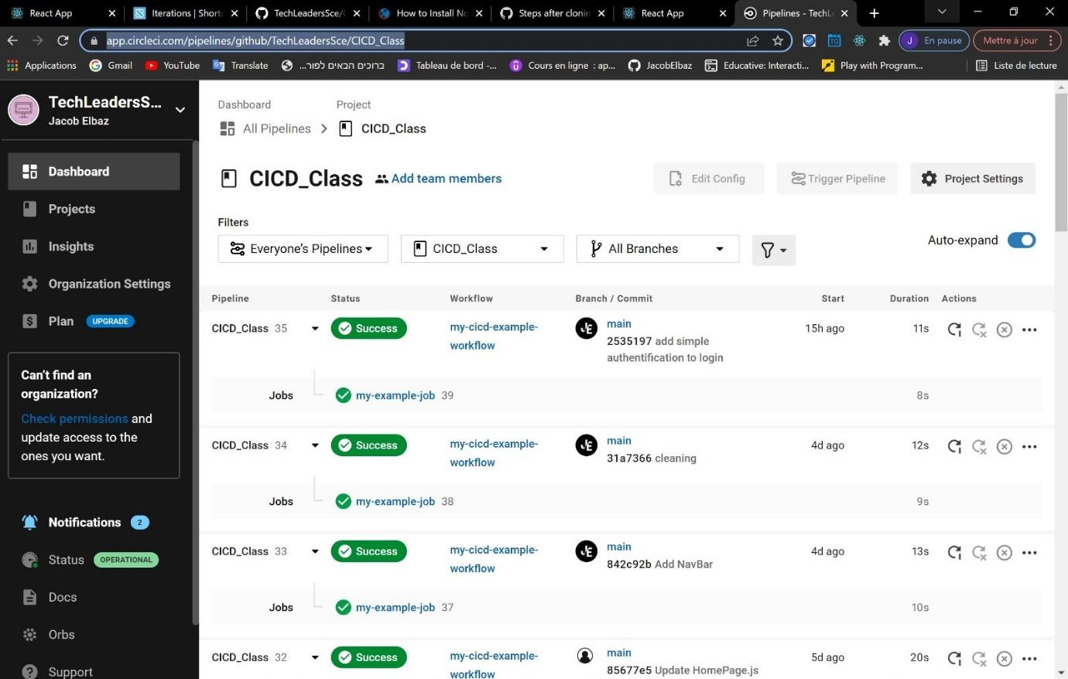

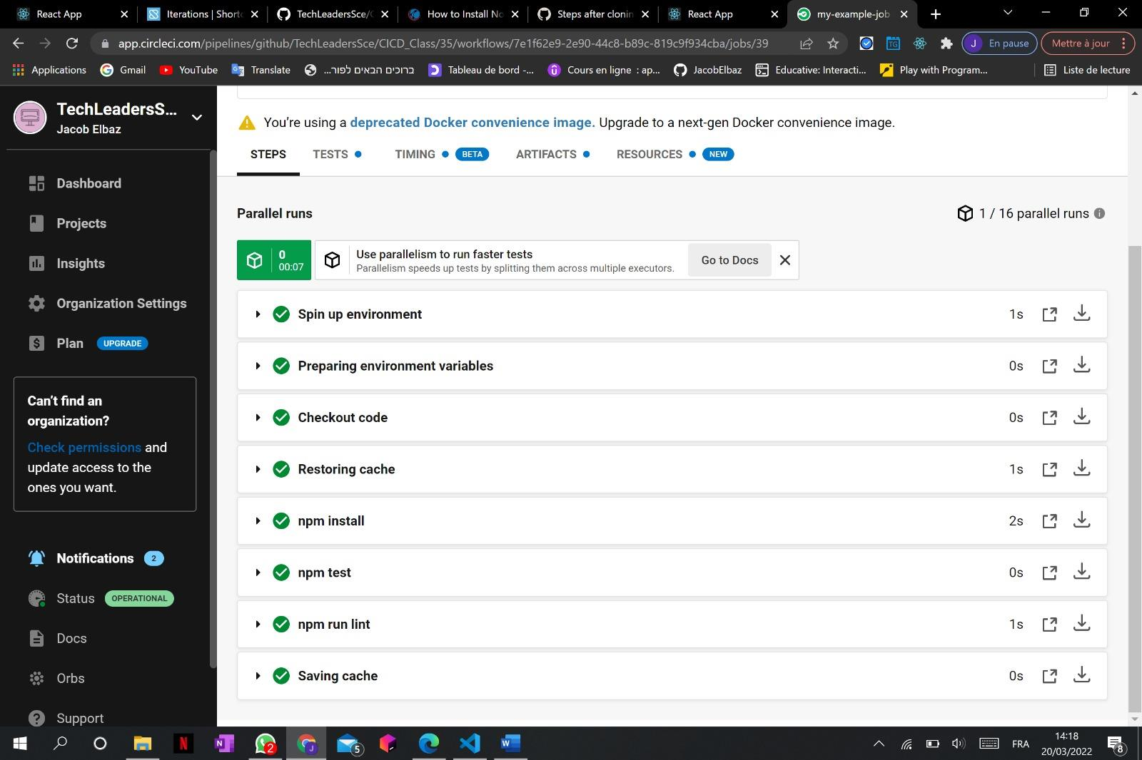

By connecting our repo to The Heroku we were allowed to host out project and have it visual.

