**Team members:**   
Adane Adgo – 315721969  
Samuel Elie Levy – 345112148  
Jacob Elbaz – 336068895  
Elie Bracha - 204795900

**Sprint 2  
Spring planning Meeting**

**GitHub:** [**https://github.com/TechLeadersSce/CICD_Class**](https://github.com/TechLeadersSce/CICD_Class)

**Shortcut:** [**https://github.com/TechLeadersSce/CICD_Class**](https://github.com/TechLeadersSce/CICD_Class)

**Sprint 2 Report:**We began our sprint with a planning meeting in which we analyze the vision document we received from our guider, in which we organize the requirements to epics and user stories. Then we schedule an innovation meeting in which we added more requirements to add as a user stories.  
we divided the requirements that needed to be written in shortcut between all team members.   
We made a 30 mins daily meeting regularly to keep track on everyone progress.  
At this spring we also cohoused our conventions and tools to this project:

**The technologies are :**

* **Mongo DB** – Data base that can manage document-oriented information, store or retrieve information.
* **Express** - Framework for building web applications
* **React** – Library for building user interfaces based on UI components.
* **Node –** Runtime environment**.**

**The conventions are:**

* **CamelCase for variable** – Variable’s name without spaces or punctuation, first letter of the second word in Capital character.
* **Uppercase for const variable** – All letters of const variable name in uppercase.
* **Lowercase for functions.** – All letters of function name in lowercase.

**The tools are:**

* **Shortcut** – Logiciel of task management
* **CicleCi** – Our CI-CD Framework
* **Heroku** – Our Web site host .
* **GitHub** – Version control
* **Visual Studio Code** - IDE
* **Windows 10** - OS
* **Google Chrome** – Browser

**The procedure:**

After building the repo in GitHub We connected it to CircleCI in order to monitor our work over time and to be able to react to any improvements necessary for the continuity of the project.

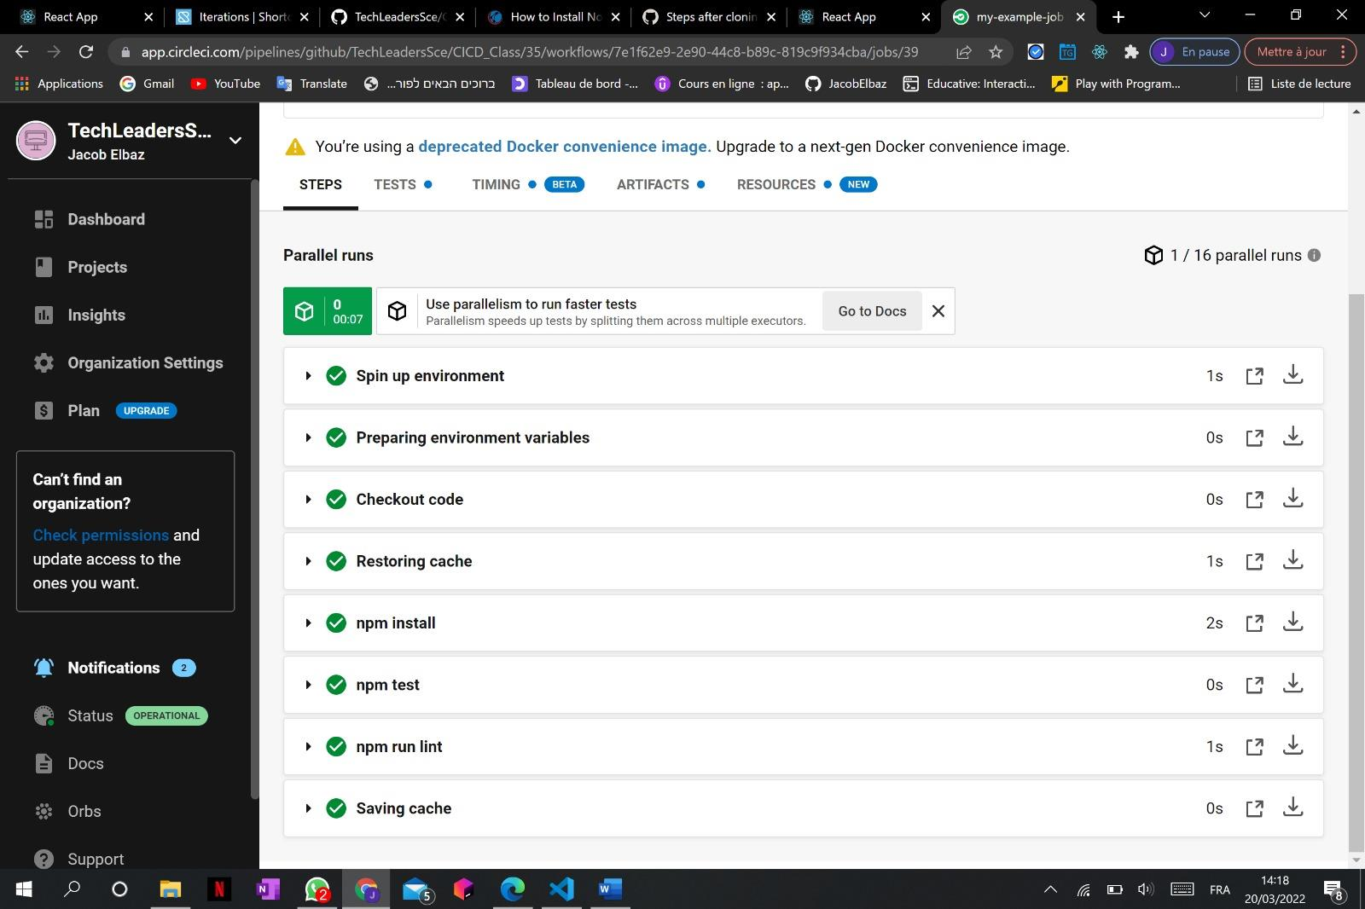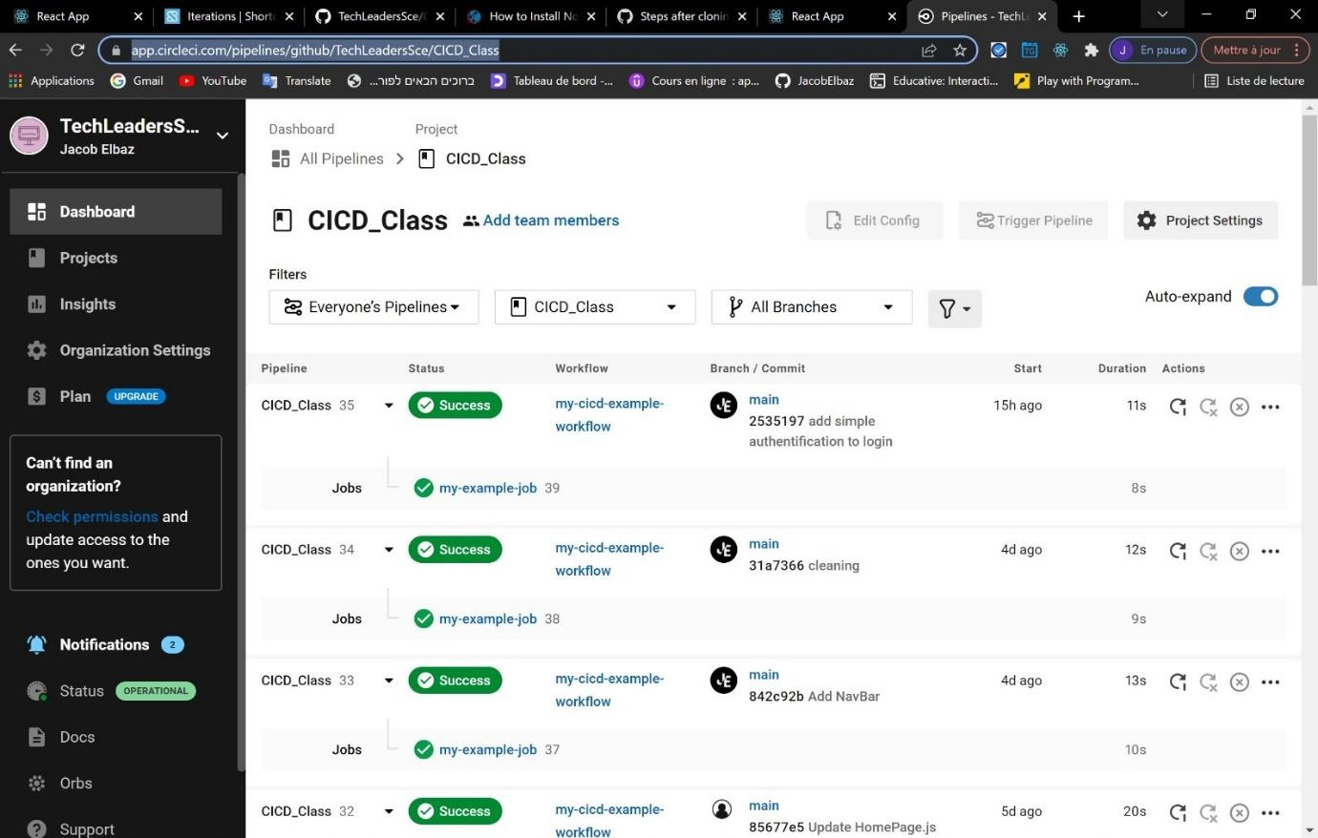

By connecting our repo to The Heroku we were allowed to host out project and have it visual.

