# USER MANUAL: Running the C++ Project:

1. Navigate to your lamp server and run docker start lamp-server

1. Open QT and load the .pro files for the server and the client:

1. Click Build and Clean All

1. Click Build and Build All

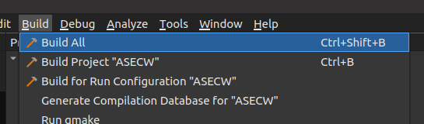

1. This should run through and successfully build the projects.
2. Right click the server project and click run

1. This will run the server and start it listening for connections

1. Right click the ASECW project and run

1. This will run the client and open the login screen

1. Click Register button to take you to the registration screen

1. Fill in your details and click register, if the registration is successful, you will be notified

1. Successful registration takes you back to the login screen, enter your username and password to log in

1. This takes you to the message screen, on the left you will see your contacts, a new account will have nothing listed here.
2. To add contacts based in the search bar at the top of the screen enter the username of a user or leave it blank to return all registered users and click search
3. This will take you to the search results page and list the search results from the server (it will not show your own user in the search results)

1. Click on the user that you want to add (this will highlight their row) as a contact and click the Add Contact button

1. This will add the contact to you userlist

1. Click on the username in the contacts list and it will take you to their messages page

1. If you have message history with the user it will display in the message screen prefixed with who the message is from

1. To create a group chat control click on several of the users in your contacts list in order to highlight everyone you want to add to the chat
2. Click the Create Group Chat button to create a group chat between the selected users

1. If there is a chat history once again it will load in the message screen

1. To send a message to the group just type into the message box at the bottom of the screen
2. Click send and if the other users are online the message will appear in their window otherwise it will appear when they login next and select the chat

1. Once you are done with your session go to the Update User tab and select Logout
2. This will update the database to signal that your account is logged out and close the application

